JAMU 2019-2 Hard bop - CD 1

1. Relaxin’ with Lee (Charlie Parker) 2:50
Dizzy Gillespie-tp; Charlie Parker-as; Thelonious Monk-p; Curly Russell-b; Buddy Rich-dr.
New York City, June 6, 1950
LP Clef MGC 512 / matrix number 415-4 * CD Verve 521 436-2 (1997)
Z alba BIRD AND DIZ

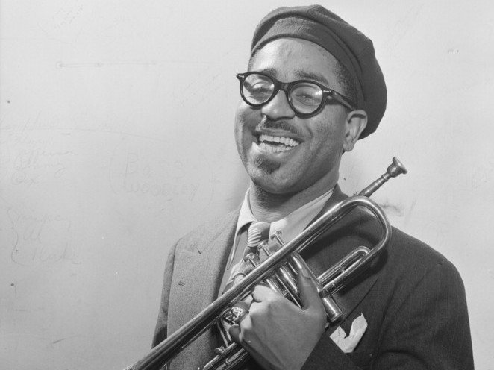
John Birks "Dizzy" Gillespie (October 21, 1917 – January 6, 1993)

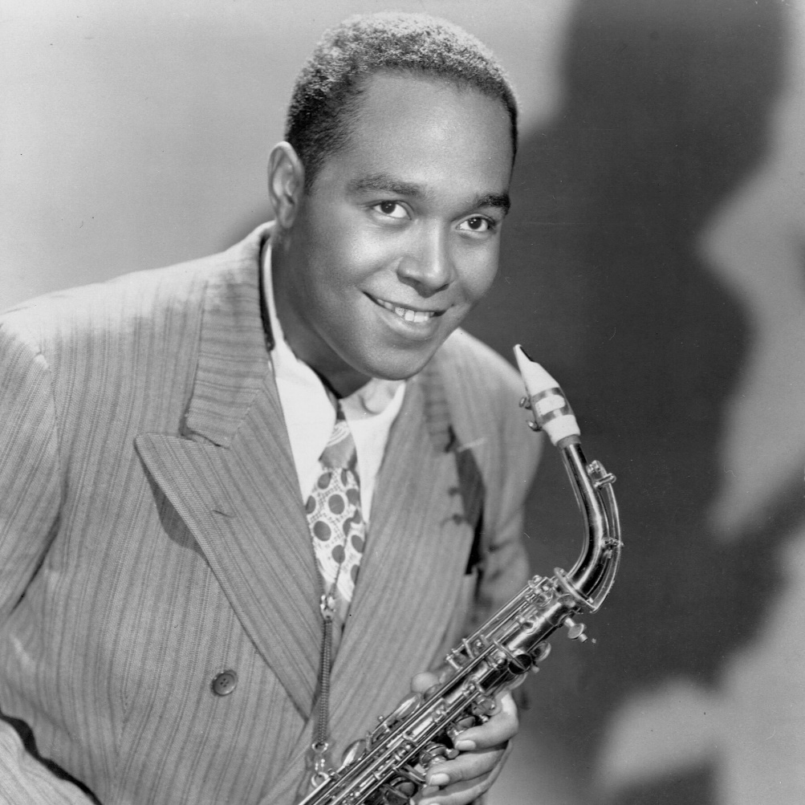
Charlie „Bird, Yardbird“ Parker (August 29, 1920 – March 12, 1955)

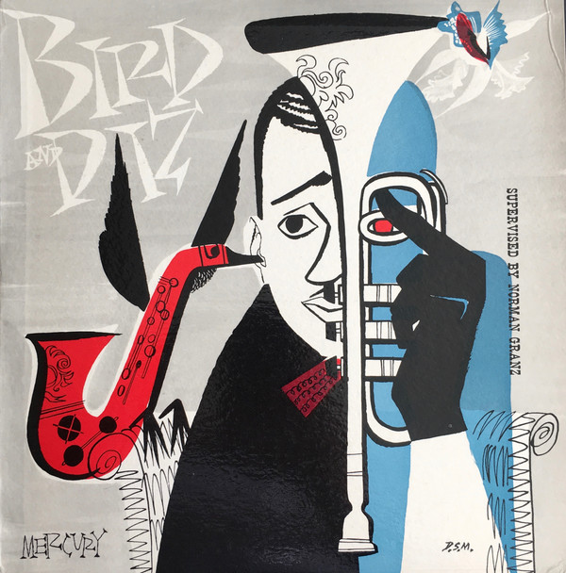

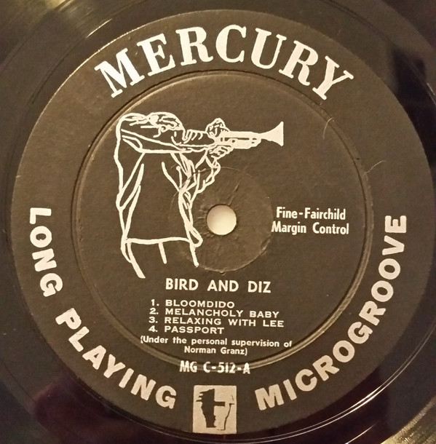

2. Manteca Theme (Gil Fuller-Dizzy Gillespie-Chano Pozo) 4:11
Dizzy Gillespie Orchestra: Dizzy Gillespie, Quincy Jones, Jimmy Nottingham, Ernie Royal-tp;
Leon Comegys, Jay Jay Johnson, George Matthews-tb; George Dorsey, Hilton Jefferson-as;
Hank Mobley, Lucky Thompson-ts; Danny Bank-bs; Ray Concepcion, Wade Legge-p; Lou
Hackney, Robert Rodriguez-b; Charli Persip-dr; José Manguel-bongo; Candido Camero, Mongo Santamaria-conga; Ubaldo Nieto-timbales; Chico O’Farrill-arr, cond.
Fine Sound, New York City, May 24, 1954
LP Norgran MGN-1003 / 1711-4 * CD Verve 517 052-2 (2002)
Z alba AFRO

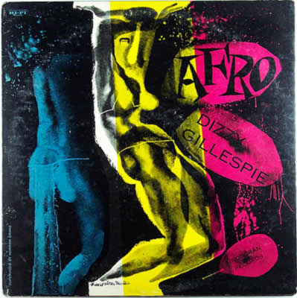

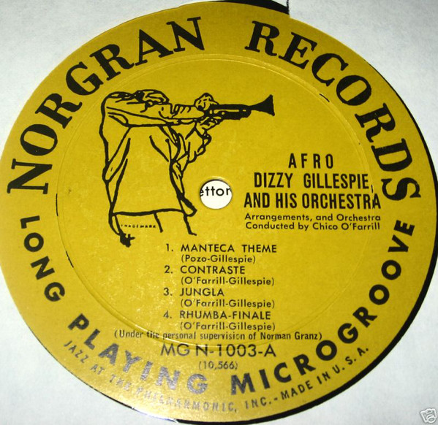
3. I Can’t Get Started (Vernon Duke) 3:10
Charlie Parker Big Band: Jimmy Maxwell, Carl Poole, Al Porcino, Bernie Privin-tp; Bill
Harris, Lou McGarity, Bart Varsalona-tb; Charlie Parker, Harry Terill, Murray Williams-as;
Flip Phillips, Hank Ross-ts; Danny Bank-bs; Oscar Peterson-p; Freddie Green-g; Ray Brown- b; Don Lamond-dr; Joe Lipman-arr, cond.
New York City, March 25, 1952
LP Clef MGC 609 / 758-1 * CD Verve 527 815-2 (1995)
Z alba CHARLIE PARKER BIG BAND / CONFIRMATION: BEST OF THE VERVE
YEARS

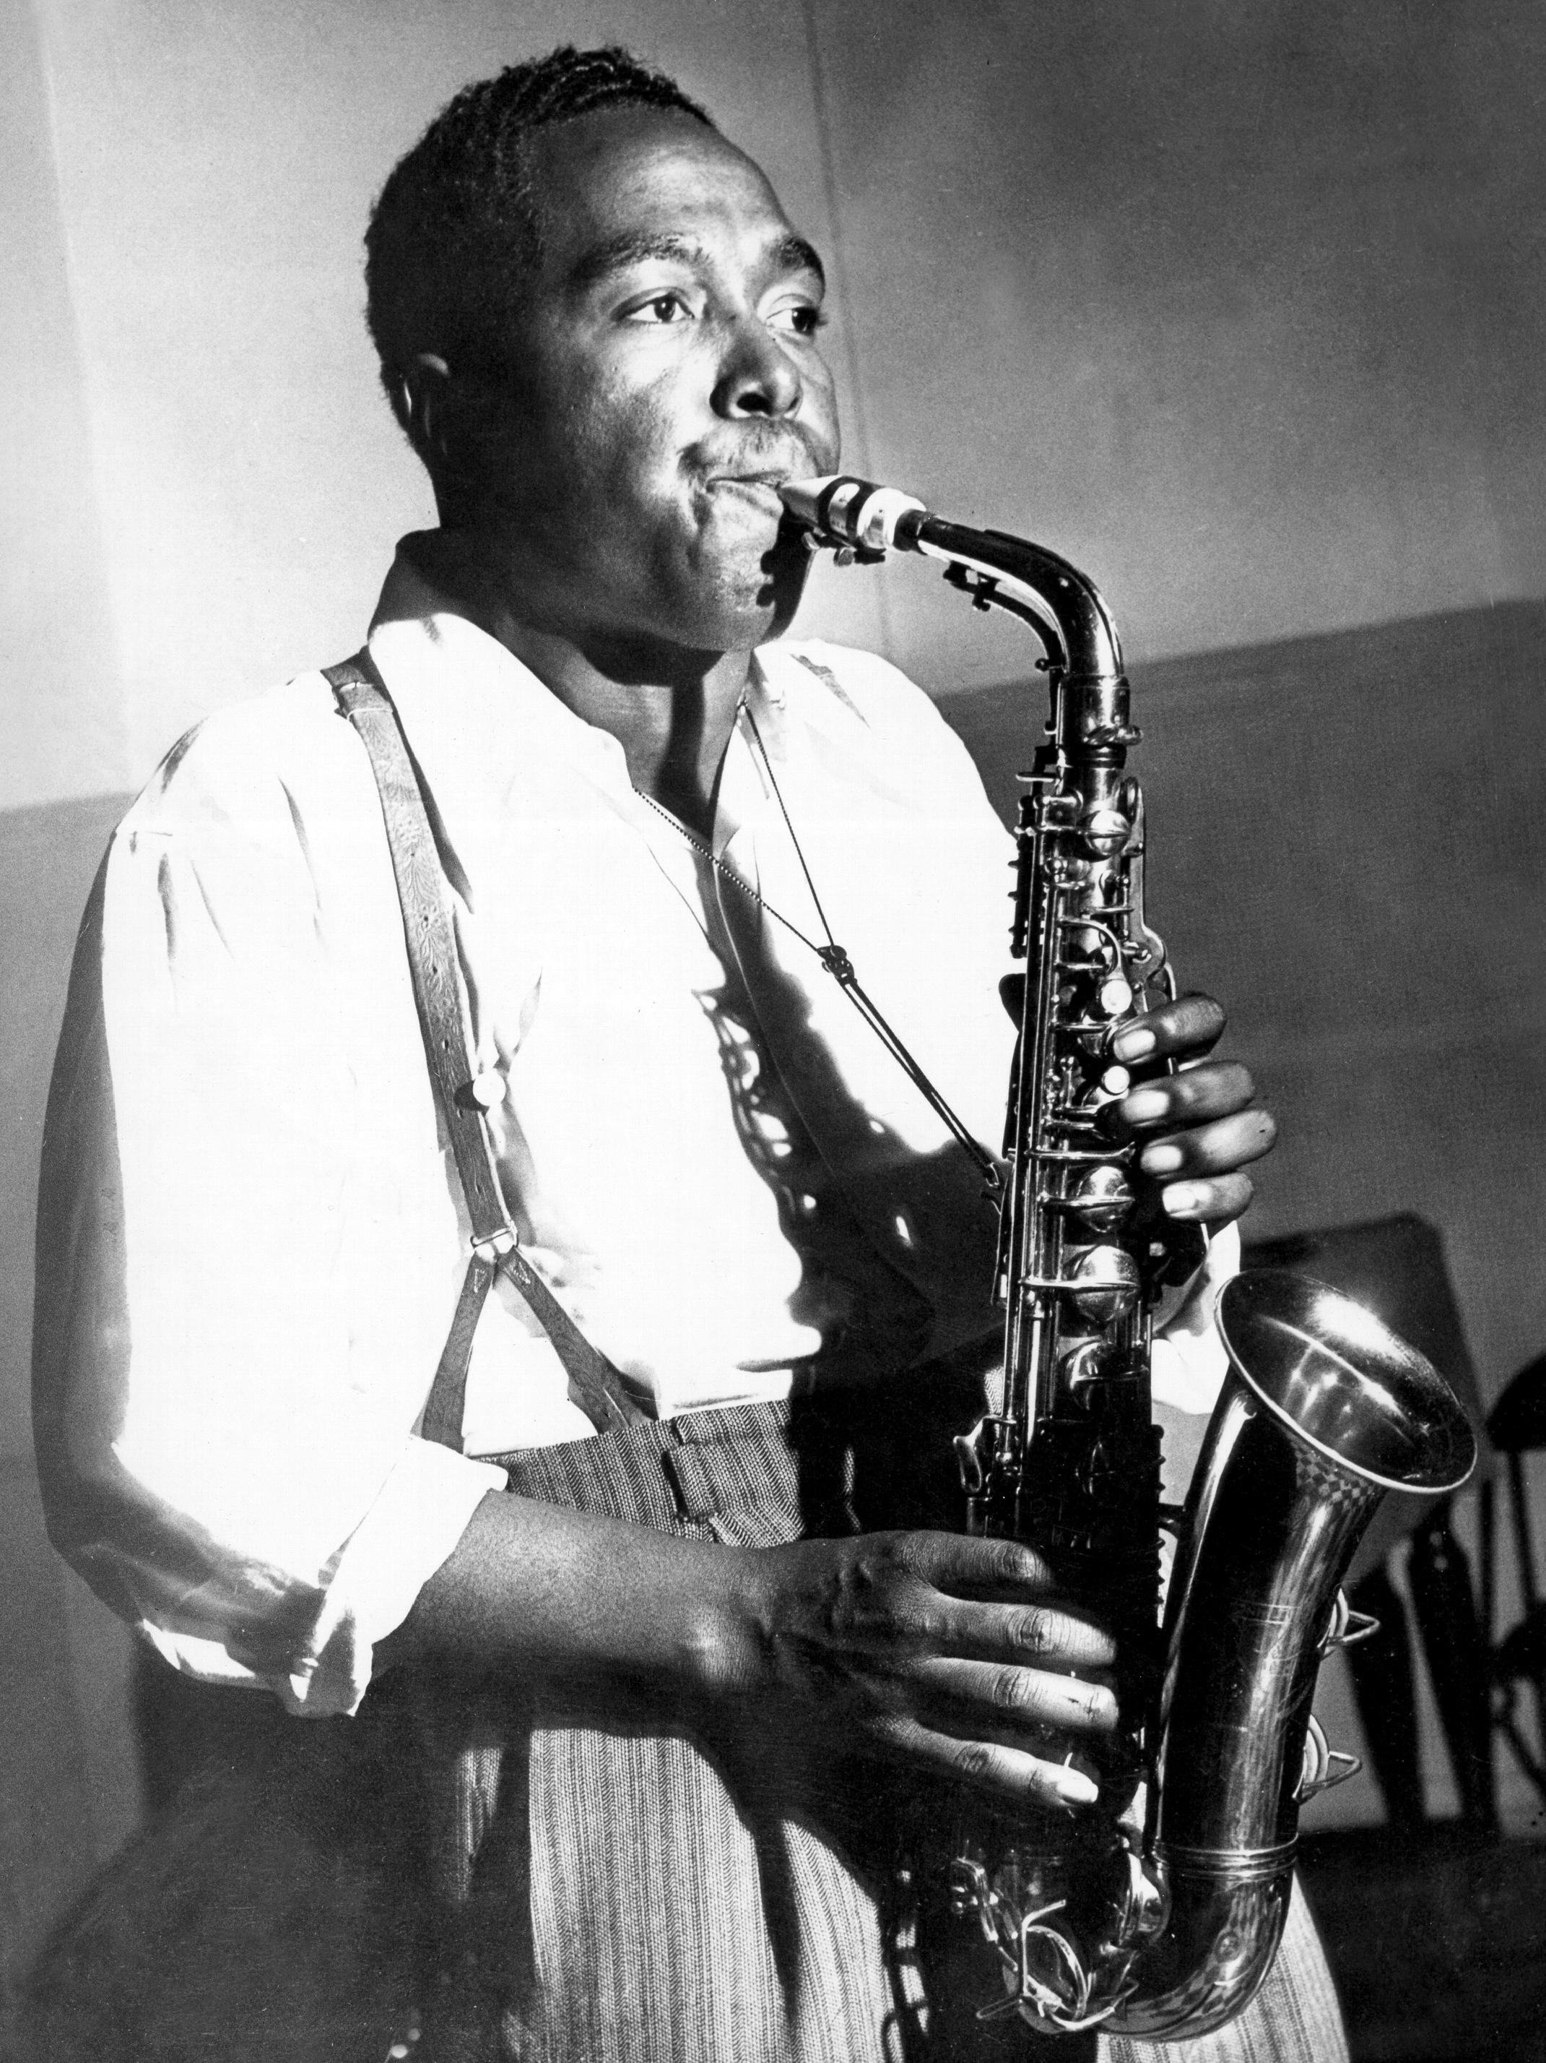

Charles Parker Jr. (August 29, 1920 – March 12, 1955)

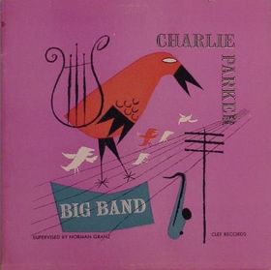

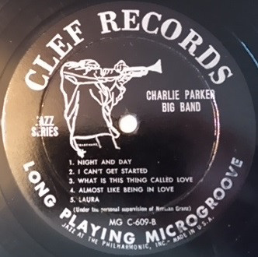

4. Ask Me Now (Thelonious Monk) 3:17
Thelonious Monk Trio: Thelonious Monk-p; Al McKibbon-b; Art Blakey-dr.
WOR Studios, 1440 Broadway, New York City, July 23, 1951
LP Blue Note 1591 / BN 396-1 * CD Blue Note 7243 5 32139 2 3 (2001)
Z alba GENIUS OF MODERN MUSIC, VOLUME TWO

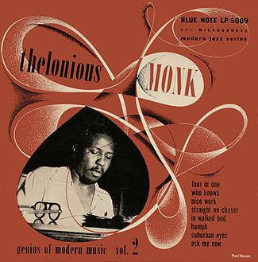

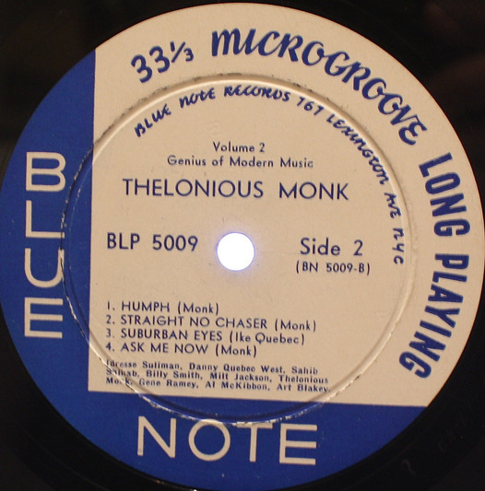
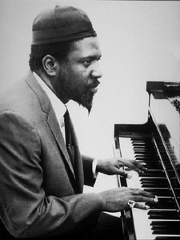

Thelonious Sphere Monk (October 10, 1917 – February 17, 1982)

5. Skippy (Thelonious Monk) 3:01
Thelonious Monk Sextet: Kenny Dorham-tp; Lou Donaldson-as; Lucky Thompson-ts;
Thelonious Monk-p; Nelson Boyd-b; Max Roach-dr.
WOR Studios, New York City, May 30, 1952
LP Blue Note 1602 / BN 434-1 take 2 * CD Blue Note 7243 5 32139 2 3 (2001)
Z alba GENIUS OF MODERN MUSIC, VOLUME TWO

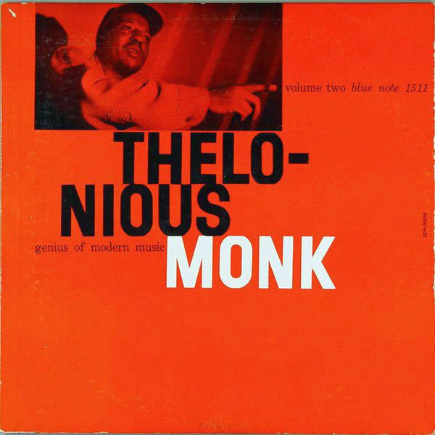

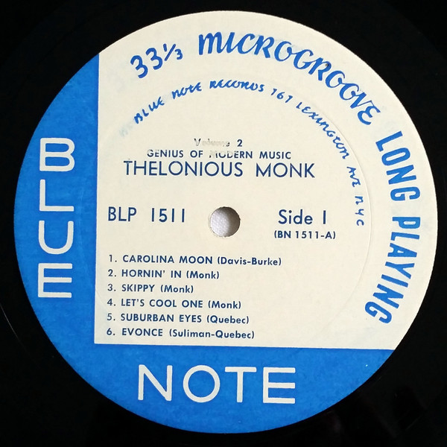

6. Kelo (Jay Jay Johnson) 3:18
Miles Davis Sextet: Miles Davis-tp; Jay Jay Johnson-tb; Jimmy Heath-ts; Gil Coggins-p;
Percy Heath-b; Art Blakey-dr.
WOR Studios, New York City, April 20, 1953
LP Blue Note BLP 1620 / BN 477-2 take 3 * CD Blue Note 7243 5 32611 2 2 (2001)
Z alba MILES DAVIS: VOLUME 2

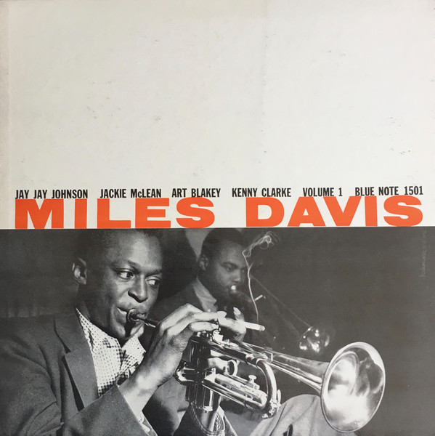

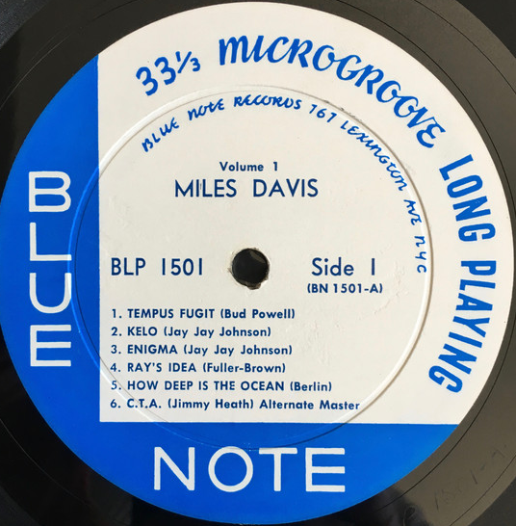
7. Take Off (Miles Davis) 3:40
Miles Davis Quartet: Miles Davis-tp; Horace Silver-p; Percy Heath-b; Art Blakey-dr.
Van Gelder Studio, Hackensack, New Jersey, March 6, 1954
LP Blue Note BLP 5040 / BN 548-3 take 4 * CD Blue Note 7243 5 32610 2 3 (2001)
Z alba MILES DAVIS: VOLUME 2

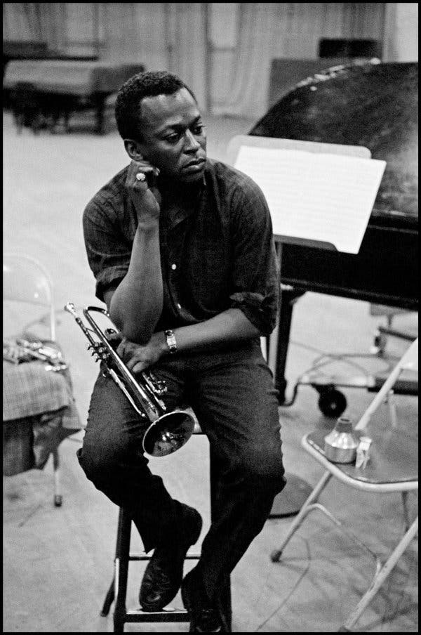

Miles Dewey Davis III (May 26, 1926 – September 28, 1991)

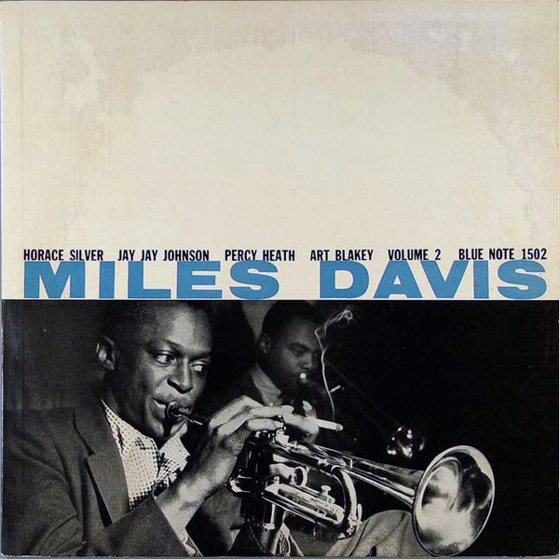

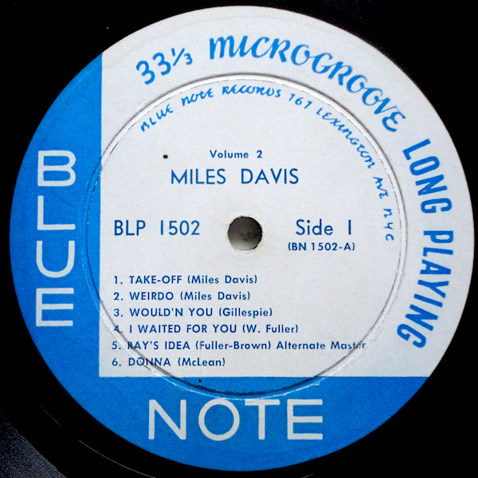

8. Two Bass Hit (John Lewis-Dizzy Gillespie) 3:21
Miles Davis [first] Quintet: Miles Davis-tp; John Coltrane-ts; Red Garland-p; Paul
Chambers-b; Philly Joe Jones-dr.
Columbia Studio D, New York City, October 26, 1955
previously unreleased take CO 54129-1 * CD Columbia/Legacy 516249 2 (2000)
Z alba MILES DAVIS & JOHN COLTRANE: COMPLETE COLUMBIA RECORDINGS

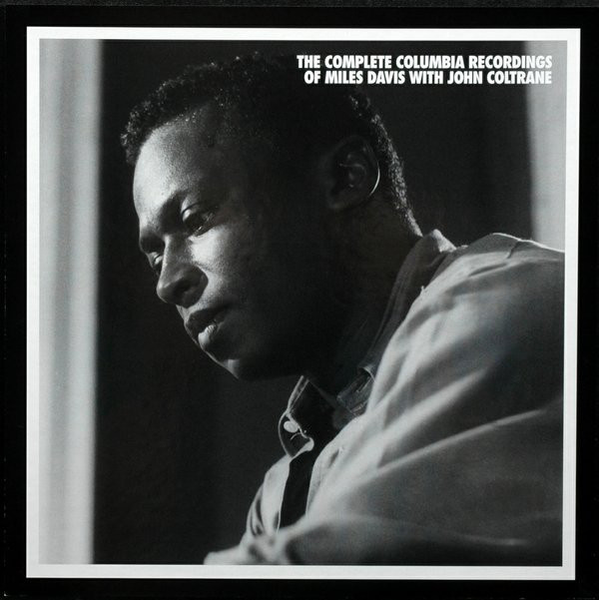

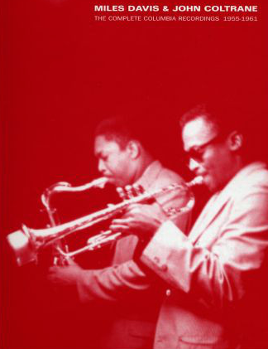
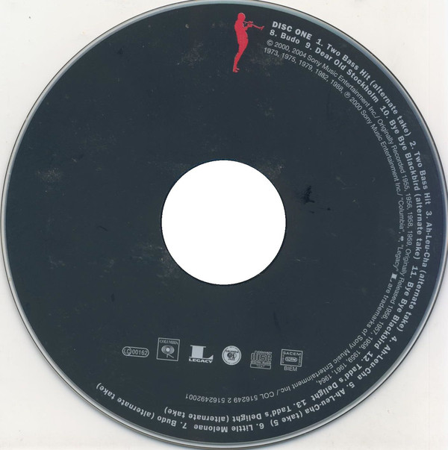

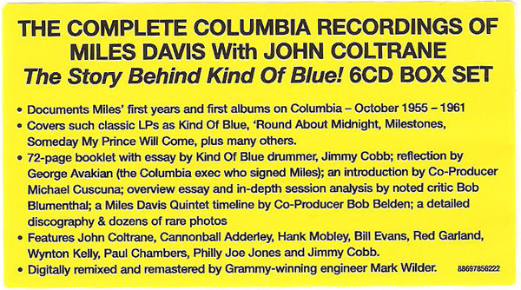

9. Doodlin’ (Horace Silver) 6:47
10. Room 608 (Horace Silver) 5:22
Horace Silver Quintet: Kenny Dorham-tp; Hank Mobley-ts; Horace Silver-p; Doug
Watkins-b; Art Blakey-dr.
Van Gelder Studio, Hackensack, New Jersey, November 13, 1954
LP Blue Note BLP 5058 / take 8 & take 3 * CD Blue Note CDP 7 91143 2 (1988)
Z alba HORACE SILVER QUINTET, VOL. 1 / THE BEST OF HORACE SILVER

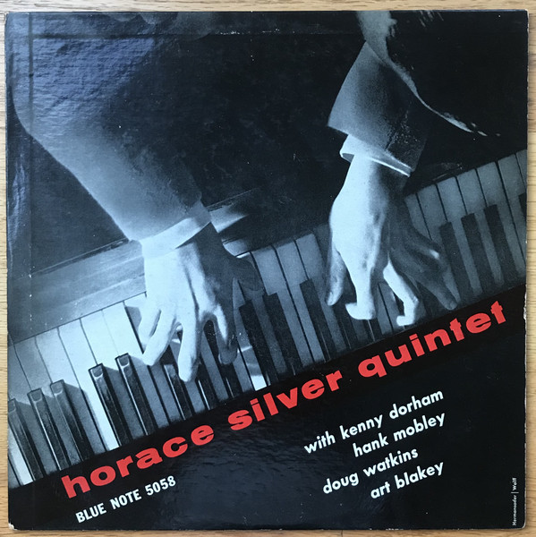

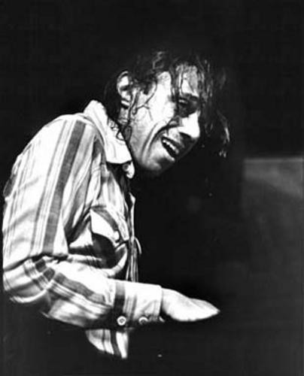

Horace Ward Martin Tavares Silver (September 2, 1928 – June 18, 2014)

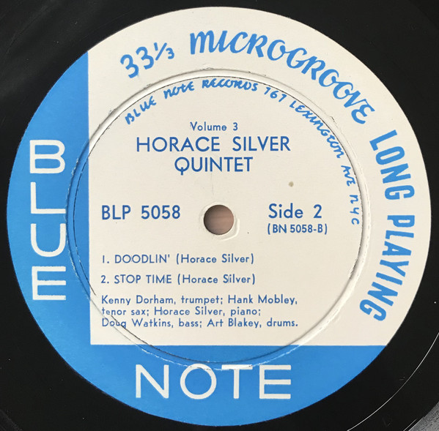

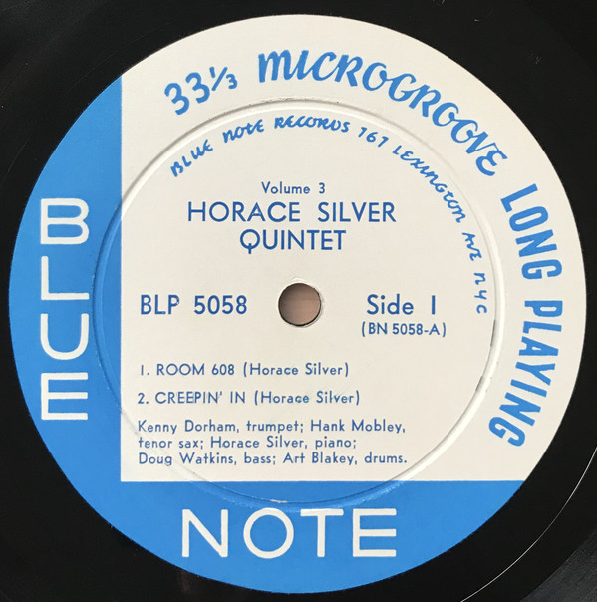

11. Mayreh (Horace Silver) 6:19
Art Blakey Quintet: Clifford Brown-tp; Lou Donaldson-as; Horace Silver-p; Curly
Russell-b; Art Blakey-dr.
Live at The Birdland, New York City, February 21, 1954
LP Blue Note BLP 5038 / take 6 * CD Blue Note 7243 5 32146 2 3 (2001)
Z alba A NIGHT AT BIRDLAND, VOLUME 2

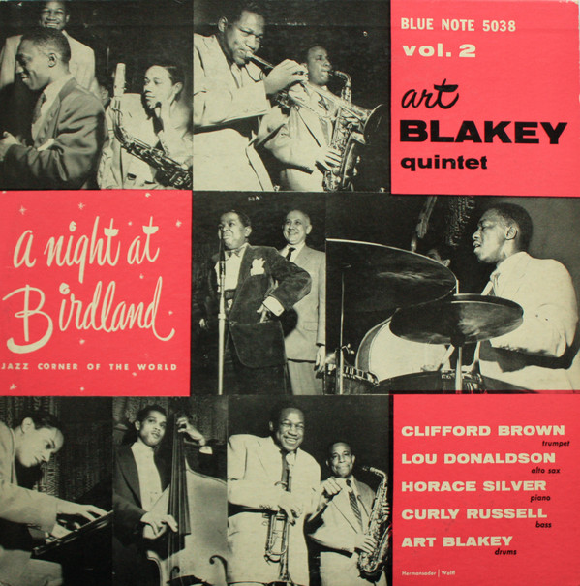

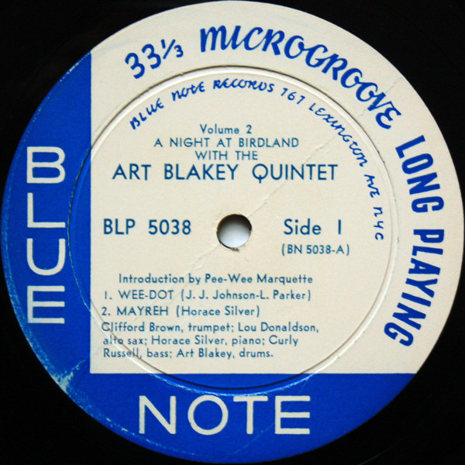

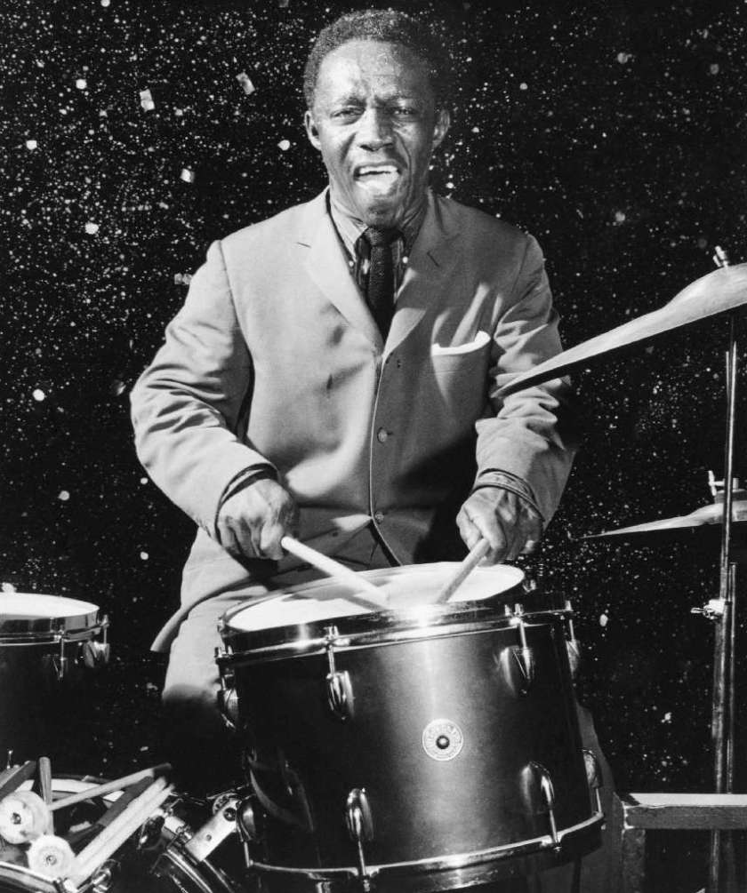

Arthur „Art“ Blakey (October 11, 1919 – October 16, 1990)

12. The Theme (Kenny Dorham) 6:11
Art Blakey and The Jazz Messengers: Kenny Dorham-tp; Hank Mobley-ts; Horace
Silver-p; Doug Watkins-b; Art Blakey-dr.
Live at The Café Bohemia, New York City, November 23, 1955
LP Blue Note BLP 1507 / take 19 * CD Blue Note 7243 5 32148 2 1 (2001)
Z alba AT THE CAFÉ BOHEMIA, VOLUME ONE

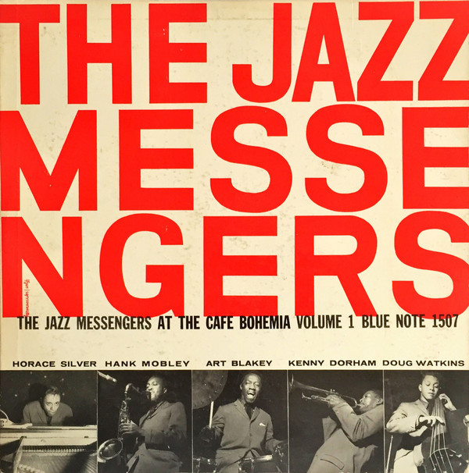

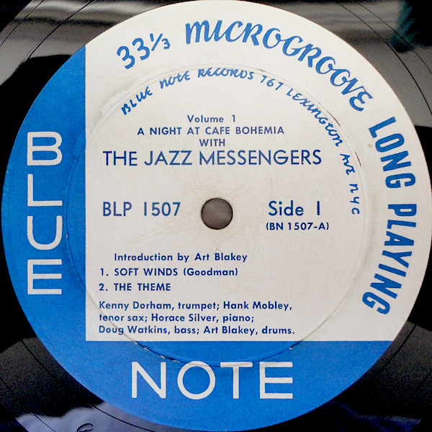
13. Daahoud (Clifford Brown) 4:04
Clifford Brown-Max Roach Quintet: Clifford Brown-tp; Harold Land-ts; Richie
Powell-p; George Morrow-b; Max Roach-dr.
Los Angeles, August 6, 1954
LP EmArcy MG 36036 / 10880 * CD EmArcy 838 306-2 (1989)
Z alba CLIFFORD BROWN AND MAX ROACH

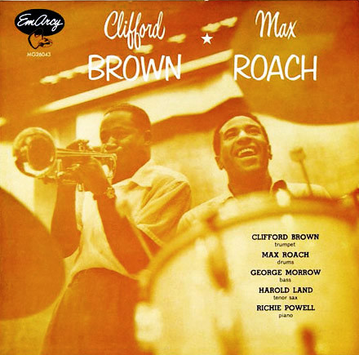

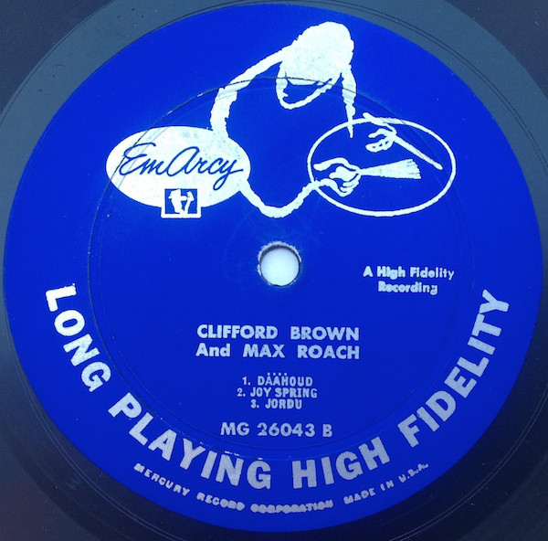
14. Swingin’ (Clifford Brown) 2:53
Clifford Brown-Max Roach Quintet (same personnel).
New York, February 23, 1955
LP EmArcy MG 36037 / 11361-15 * CD EmArcy 838 306-2 (1989)
Z alba STUDY IN BROWN

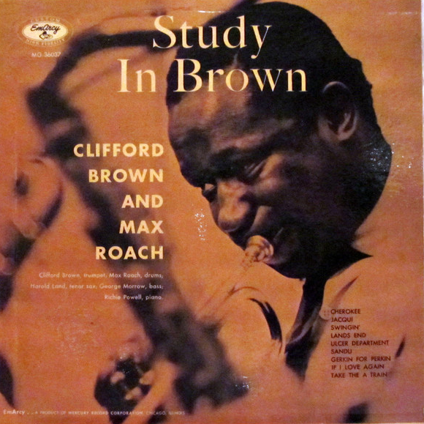

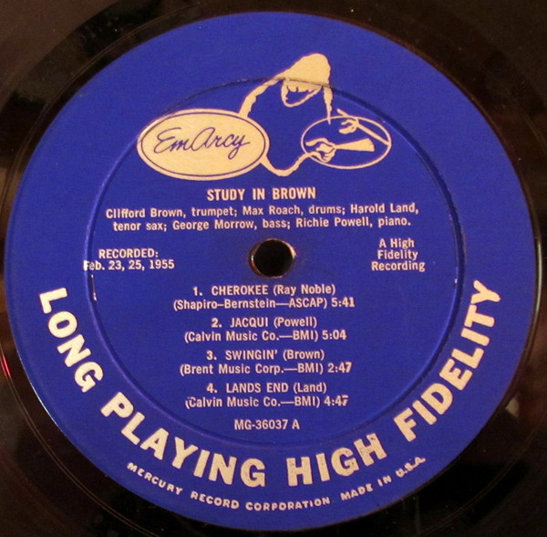
15. Love Is a Many Splendored Thing (Sammy Fain) 3:53
Clifford Brown-Max Roach Quintet (Sonny Rollins-ts replaces Harold Land).
New York, February 16, 1956
previously unissued incomplete take 12464-2 * CD EmArcy 838 306-2 (1989)
Z alba BROWNIE: THE COMPLETE EMARCY RECORDINGS OF CLIFFORD BROWN

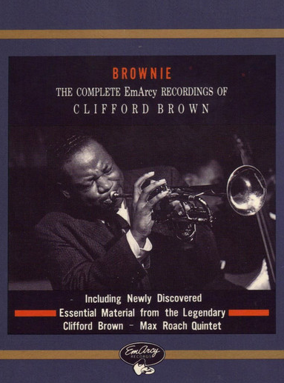

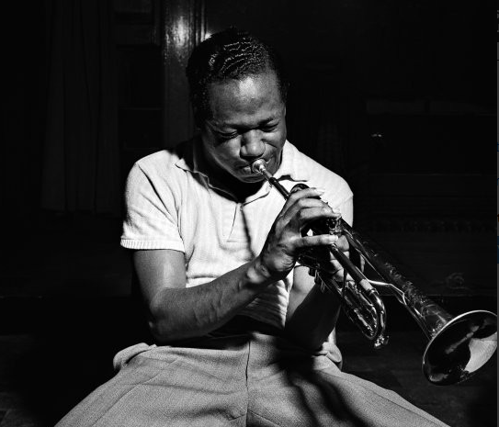

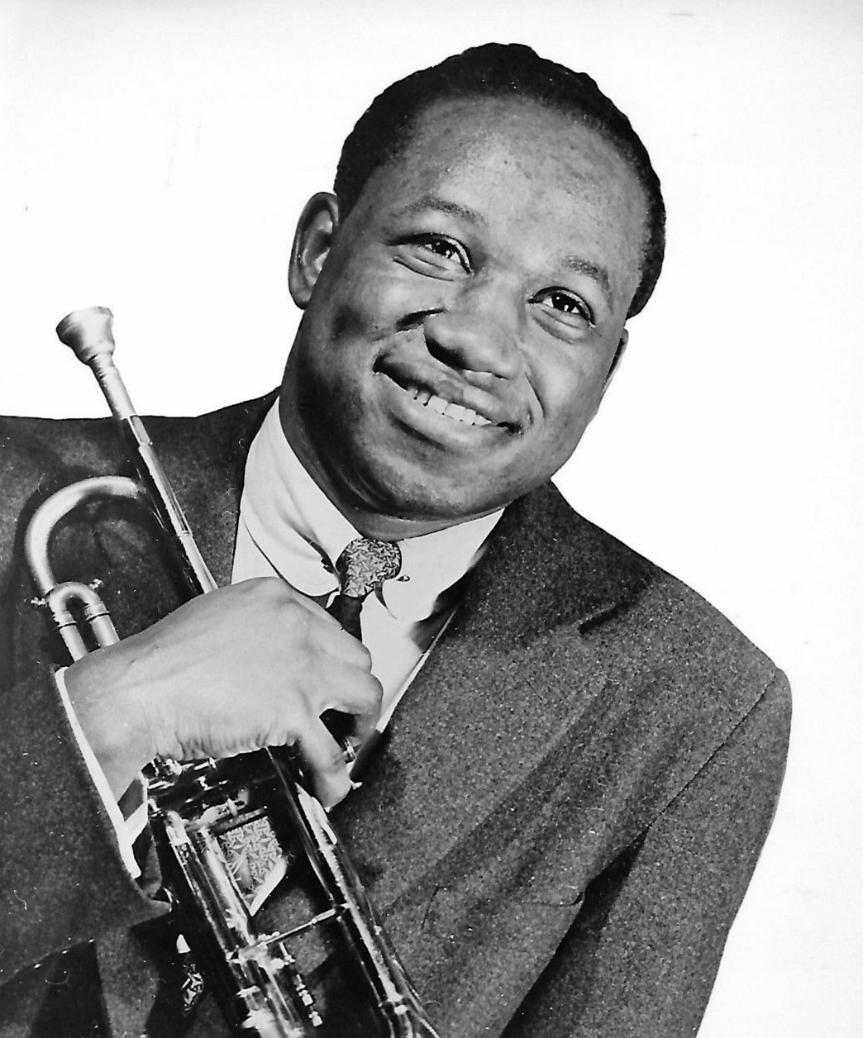

Clifford Benjamin Brown (October 30, 1930 – June 26, 1956)

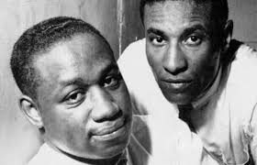

Clifford Brown & Max Roach

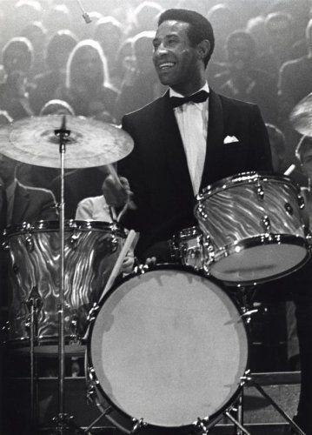

Maxwell Lemuel Roach (January 10, 1924 – August 16, 2007)

MUNI 2019-2 Hard bop - CD 2

mimo kompilaci – přímo z reedičního CD:
Blue Train (John Coltrane) 10:39
Moment’s Notice (John Coltrane) 9:06
John Coltrane Sextet: Lee Morgan-tp; Curtis Fuller-tb; John Coltrane-ts; Kenny Drew-p;
Paul Chambers-b; Philly Joe Jones-dr.
Van Gelder Studio, Hackensack, NJ, September 15, 1957
LP Blue Note BLP 1577 / take 9/8 * CD Blue Note 7243 5 91721 2 5 (2003)
Z alba BLUE TRAIN

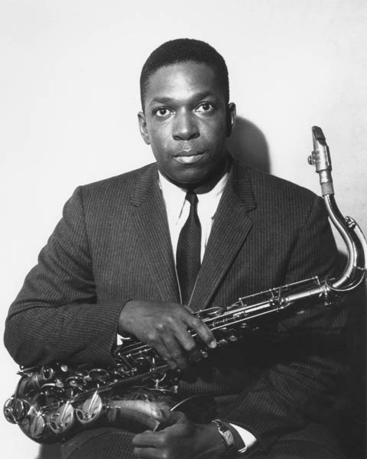

John William Coltrane (September 23, 1926 – July 17, 1967)

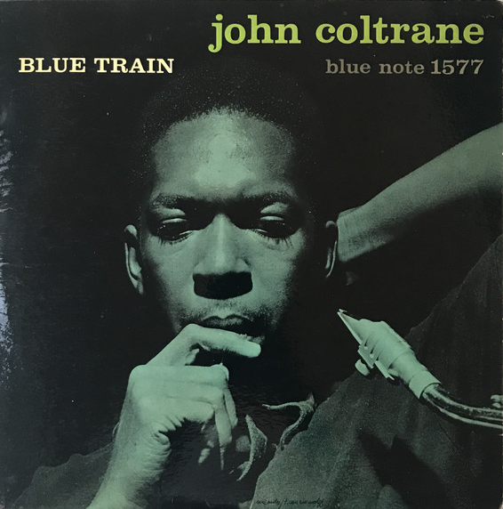

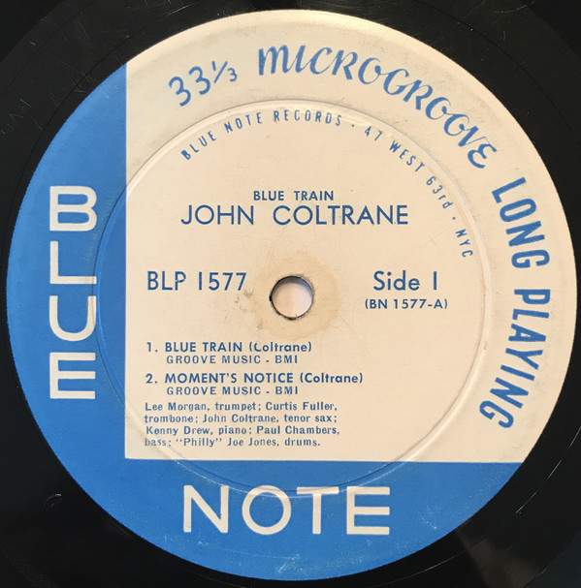

1. Turnpike (Jay Jay Johnson) 4:18
Jay Jay Johnson Sextet: Clifford Brown-tp; Jay Jay Johnson-tb; Jimmy Heath-ts, bs;
John Lewis-p; Percy Heath-b; Kenny Clarke-dr.
WOR Studios, New York City, June 22, 1953
Blue Note 1621 / BN 505-0 take 6 * CD Blue Note 7243 5 32143 2 6 (2001)
Z alba THE EMINENT, VOLUME ONE

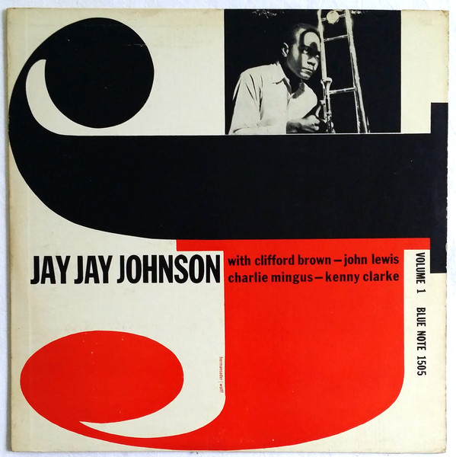

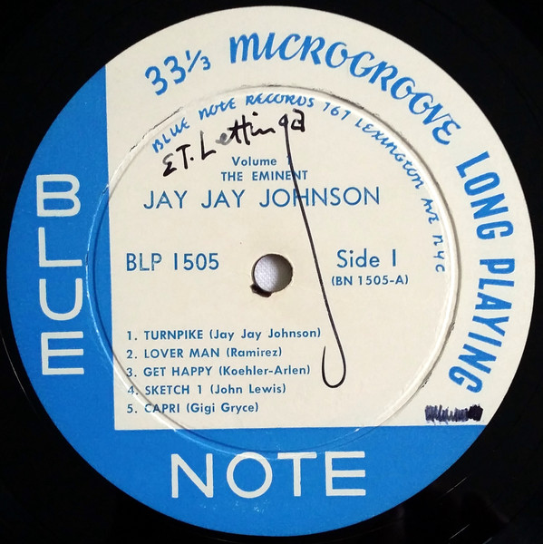

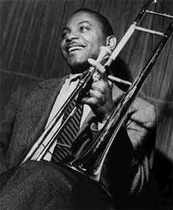

James Louis Johnson (January 22, 1924 – February 4, 2001)

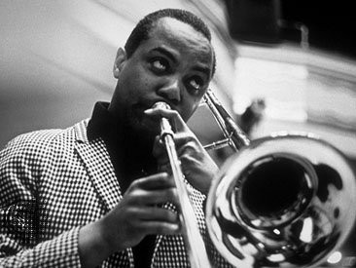

2. J. O. S. [James Oscar Smith] (Jimmy Smith) 11:56
Jimmy Smith Quintet: Lee Morgan-tp; George Coleman-as; Jimmy Smith-org; Eddie
McFadden-g; Donald Bailey-dr.
Manhattan Towers, New York City, August 25, 1957
LP Blue Note BLP 4011 / take 2 * CD Blue Note 7243 5 24541 2 9 (1999)
Z alba THE SERMON!

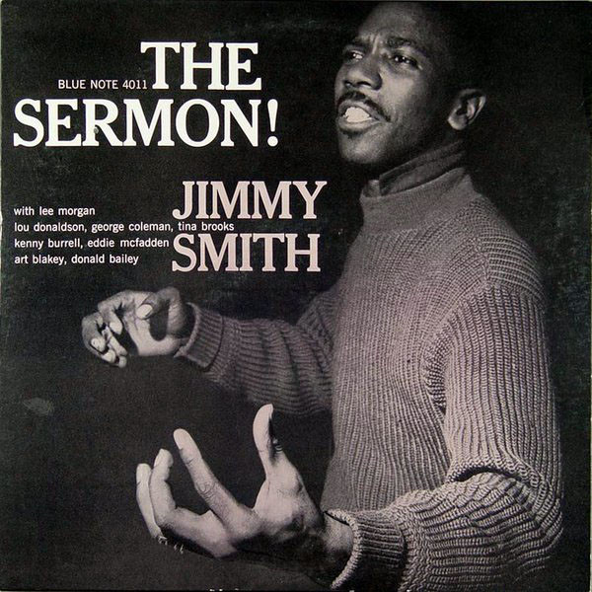

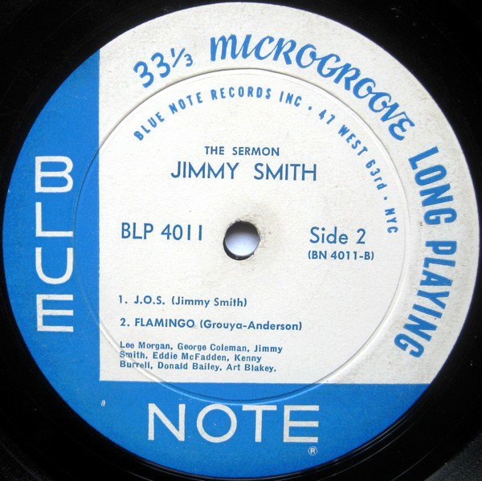

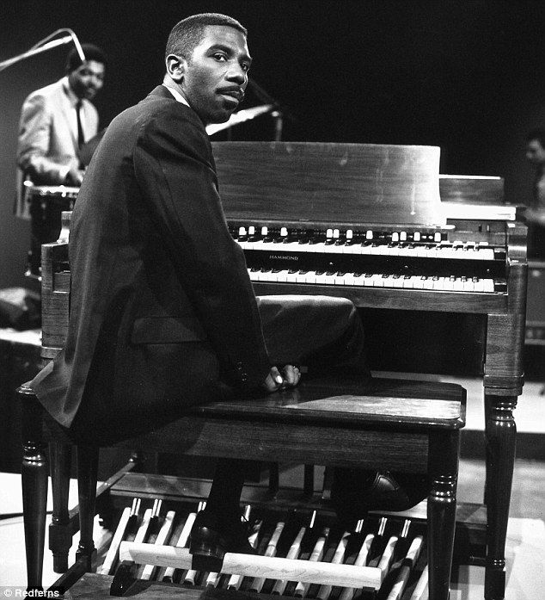

James Oscar Smith (December 8, 1928 – February 8, 2005)

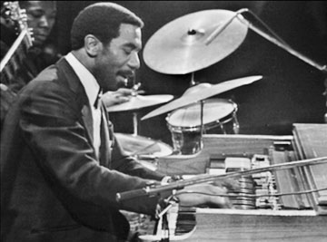

3. Audrey (Bud Powell) 2:58
Bud Powell Trio: Bud Powell-p; George Duvivier-b; Arthur Taylor-dr.
WOR Studios, New York City, August 14, 1953
LP Blue Note BLP 5041 / BN 515-0 take 25 * CD Blue Note 7243 5 32137 2 5 (2001)
Z alba THE AMAZING BUD POWELL, VOLUME TWO

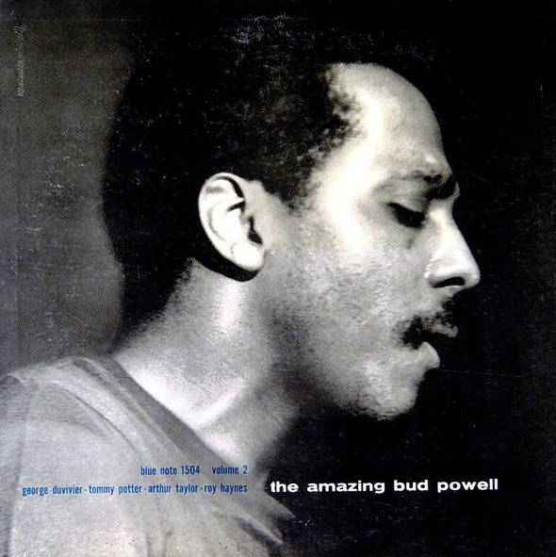

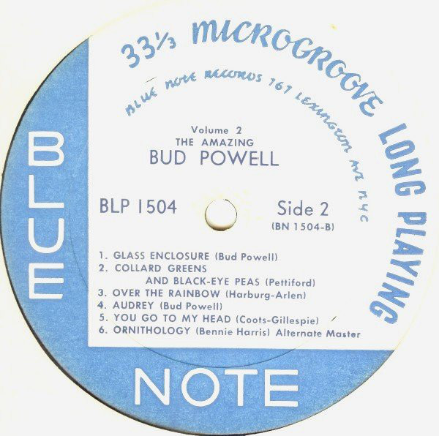
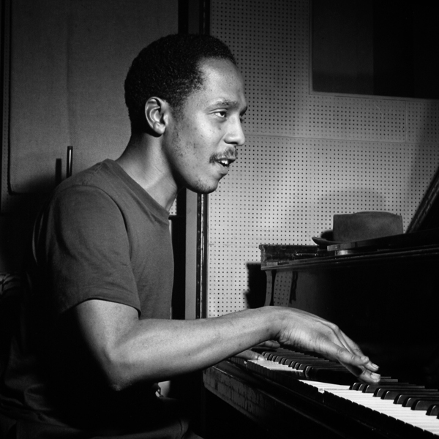

Earl Rudolph "Bud" Powell (September 27, 1924 – July 31, 1966)

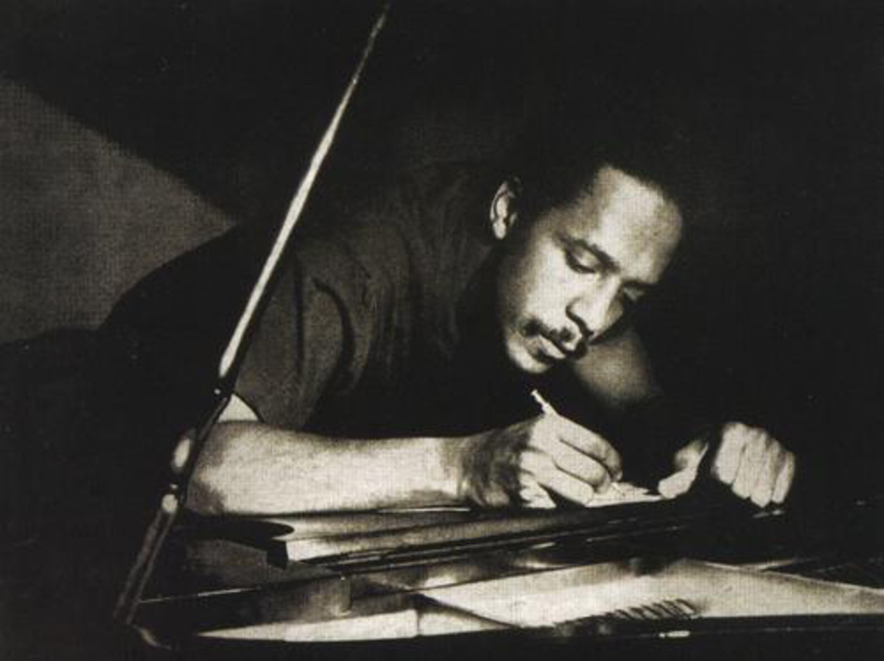

4. Two Bass Hit (John Lewis-Dizzy Gillespie) 3:45
Sonny Clark Trio: Sonny Clark-p; Paul Chambers-b; Philly Joe Jones-dr.
Van Gelder Studio, Hackensack, NJ, October 13, 1957
LP Blue Note 1579 / take 5 * CD Blue Note 7243 5 33774 2 7 (2002)
Z alba SONNY CLARK TRIO

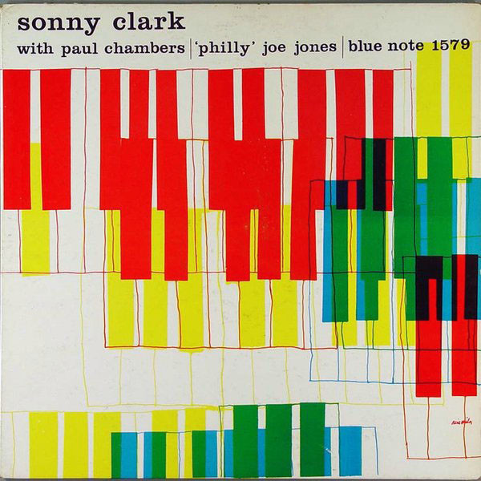

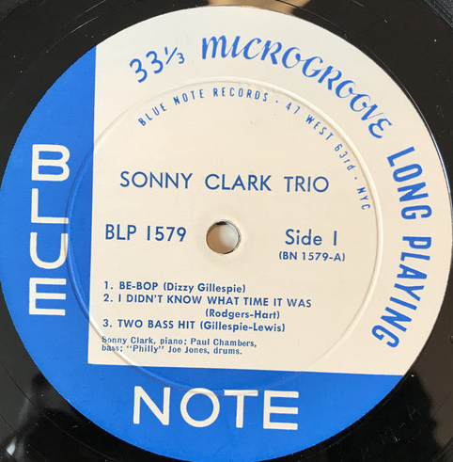

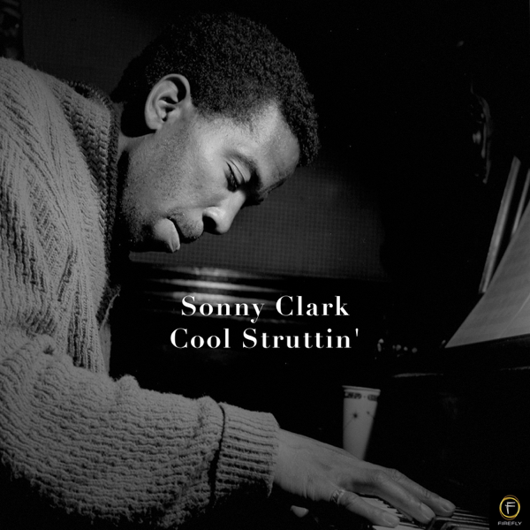

Conrad Yeatis "Sonny" Clark (July 21, 1931 – January 13, 1963)

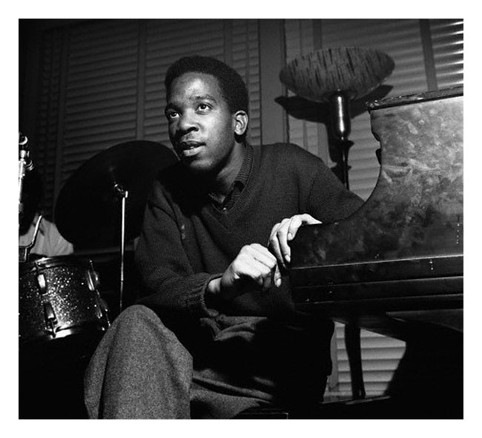

5. Ham’s Blues [Hamp’s Blues?] (Sonny Criss) 2:36
Sonny Criss Quintet: Sonny Criss-as; Barney Kessel-g; Kenny Drew-p; Bill Woodson-b;
Chuck Thompson-dr.
Los Angeles, March 23, 1956
LP Imperial 9006 / IM1 037 * CD Blue Note 7243 5 24564 2 0 (2000)
Z alba THE COMPLETE IMPERIAL SESSIONS

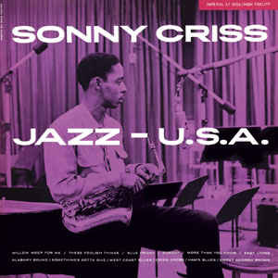

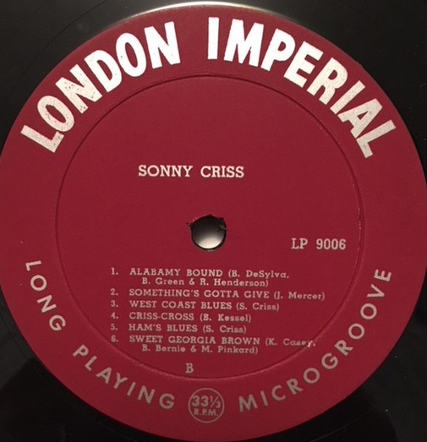

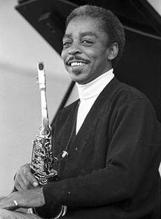

William "Sonny" Criss (23 October 1927 – 19 November 1977)

6. Thedia (Thad Jones) 10:35
Thad Jones Quintet: Thad Jones-tp; Billy Mitchell-ts; Barry Harris-p; Percy Heath-b;
Max Roach-dr.
Van Gelder Studio, Hackensack, NJ, July 14, 1956
LP Blue Note 1527 / no matrix * CD Blue Note 0946 3 92768 2 0 (2007)
Z alba THE MAGNIFICENT THAD JONES

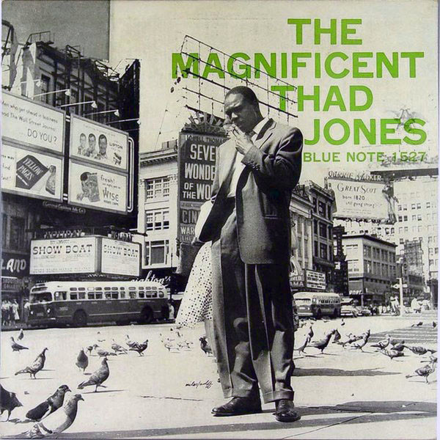

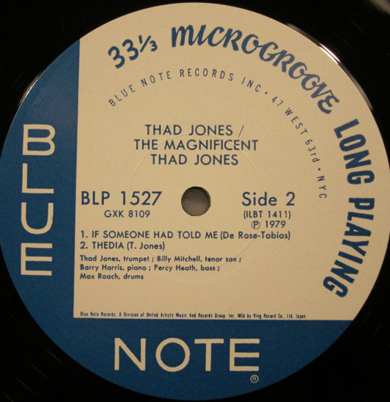

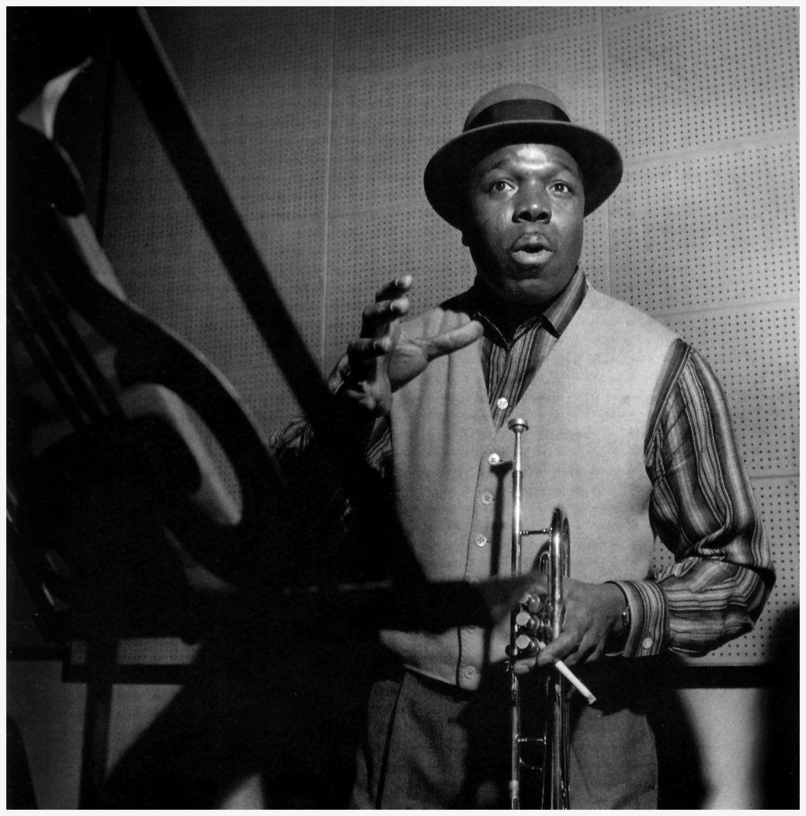

Thaddeus Joseph Jones (March 28, 1923 – August 20, 1986)

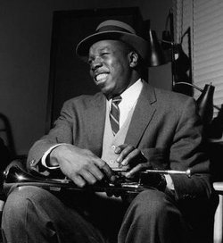

7. Home Cookin’ (Horace Silver) 6:28
Horace Silver Quintet: Art Farmer-tp; Hank Mobley-ts; Horace Silver-p; Teddy
Kotick-b; Louis Hayes-dr.
Van Gelder Studio, Hackensack, NJ, May 8, 1957
LP Blue Note BLP 1562 / take 17 * CD Blue Note 7243 5 40034 2 4 (2002)
Z alba THE STYLINGS OF SILVER

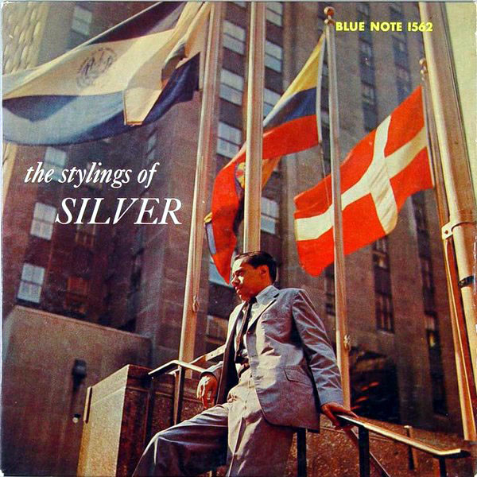

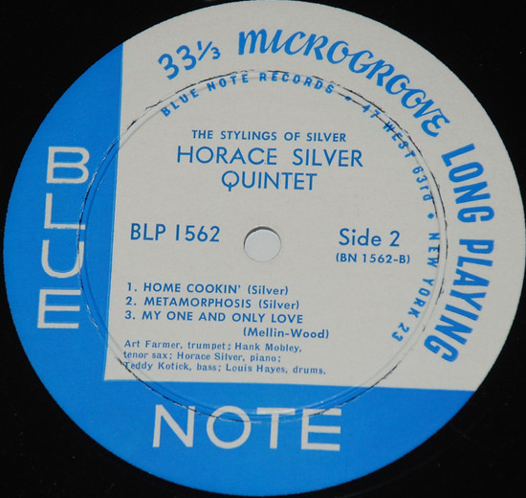
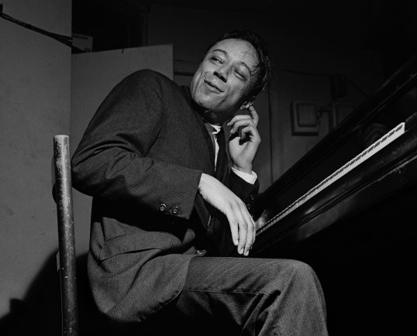

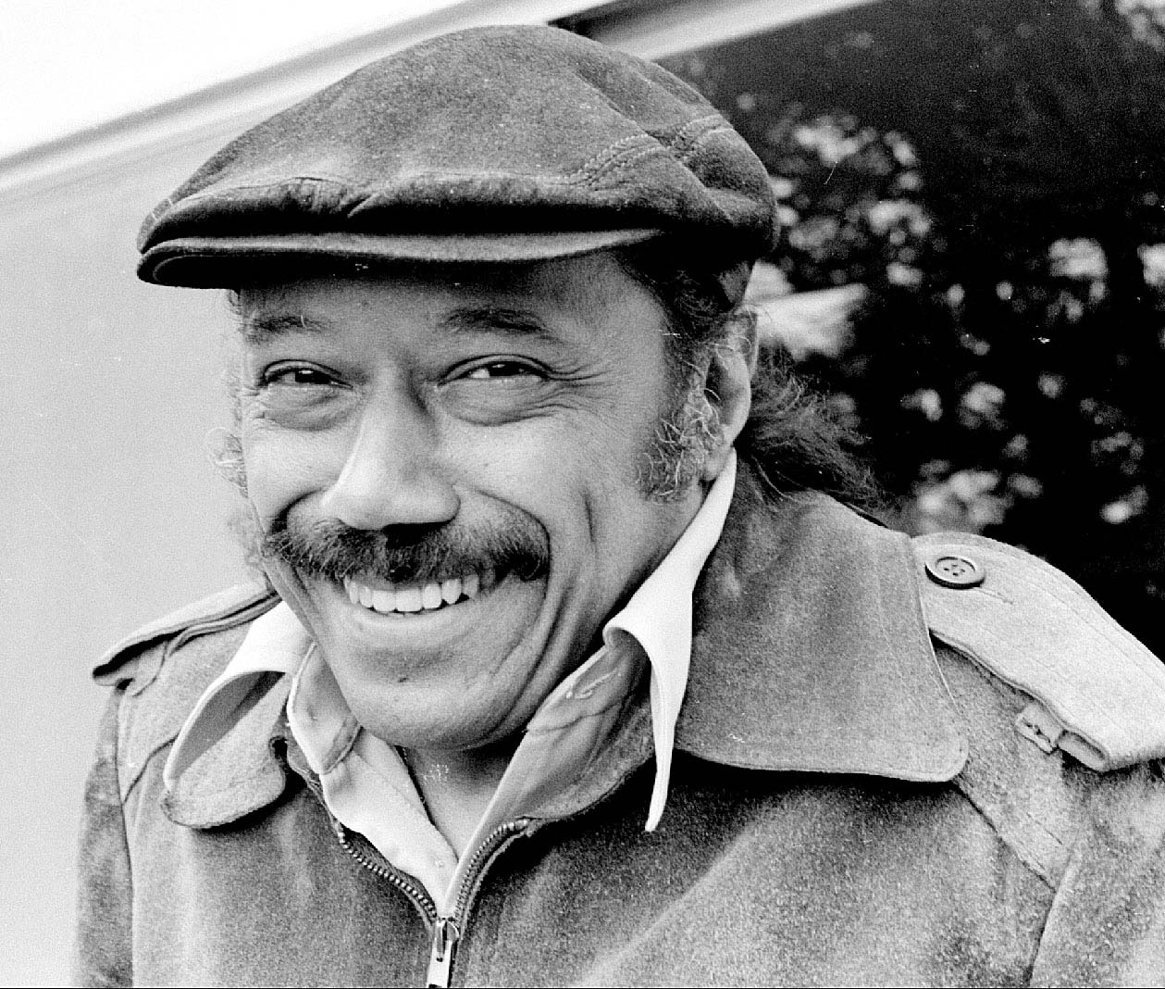

8. Somethin’ Else (Miles Davis) 8:14
Cannonball Adderley Quintet: Miles Davis-tp; Julian „Cannonball“ Adderley-as;
Hank Jones-p; Sam Jones-b; Art Blakey-dr.
Van Gelder Studio, Hackensack, NJ, March 9, 1958
LP Blue Note 1595 / take 4 * CD Blue Note 7243 4 95329 2 2 (1999)
Z alba SOMETHIN’ ELSE

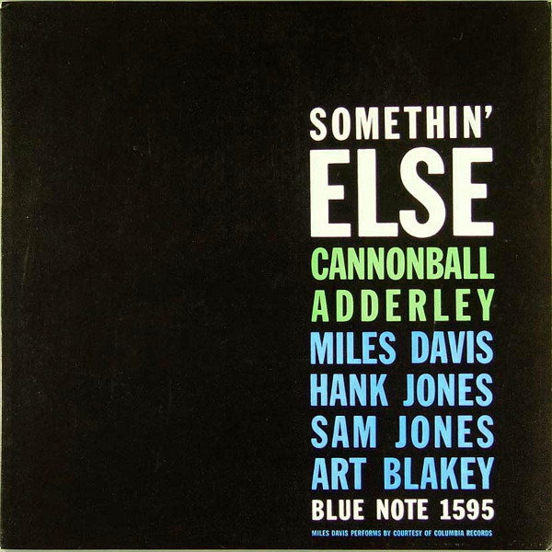

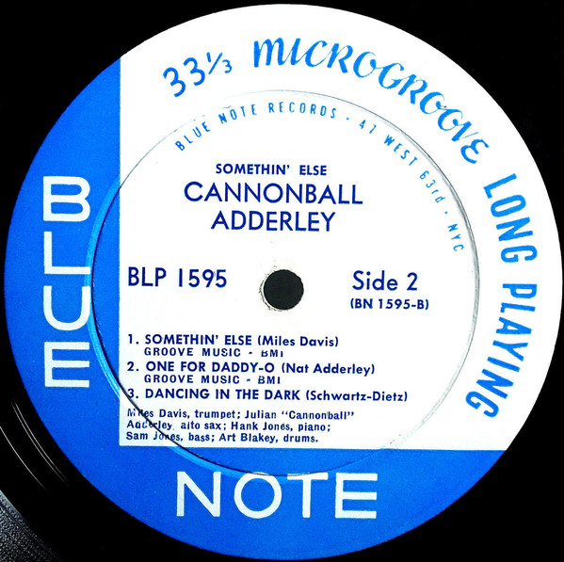

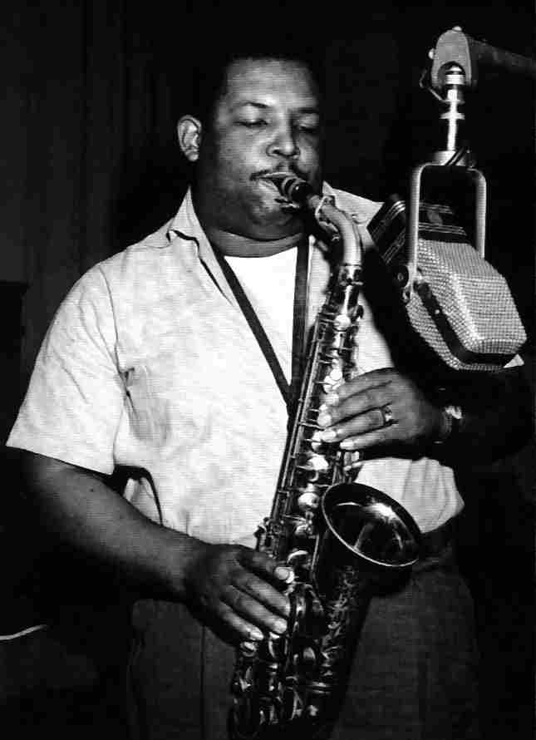

Julian "Cannonball" Adderley (September 15, 1928 – August 8, 1975)

9. This Here (Cannonball Adderley) 12:29
Cannonball Adderley Quintet: Nat Adderley-co; Cannonball Adderley-as; Bobby
Timmons-p; Sam Jones-b; Louis Hayes-dr.
Live at The Jazz Workshop, San Francisco, CA, October 20, 1959
LP Riverside 12-311 / no matrix * CD Original Jazz Classics OJC 20 035-2 (1989)
Z alba THE CANNONBALL ADDERLEY QUINTET IN SAN FRANCISCO

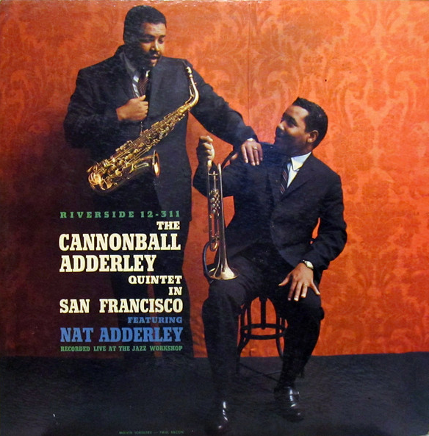

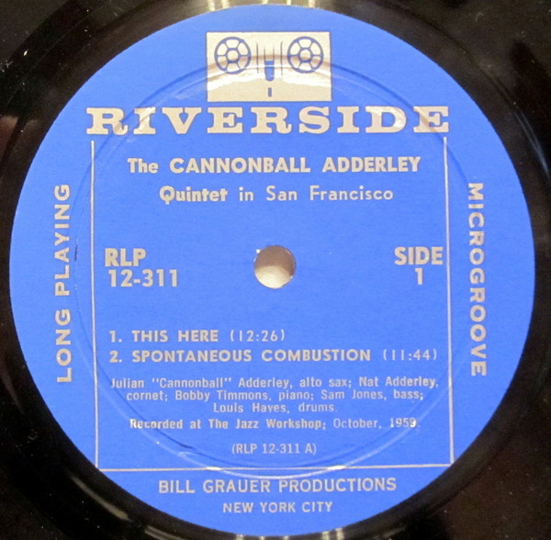

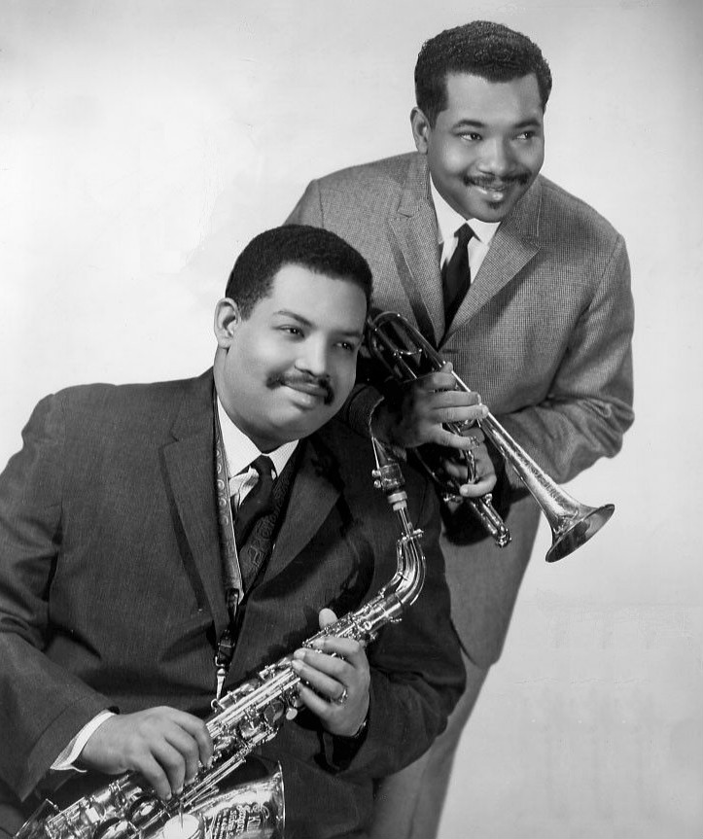

Julian „Cannonball“ & Nat Adderley (November 25, 1931 – January 2, 2000)

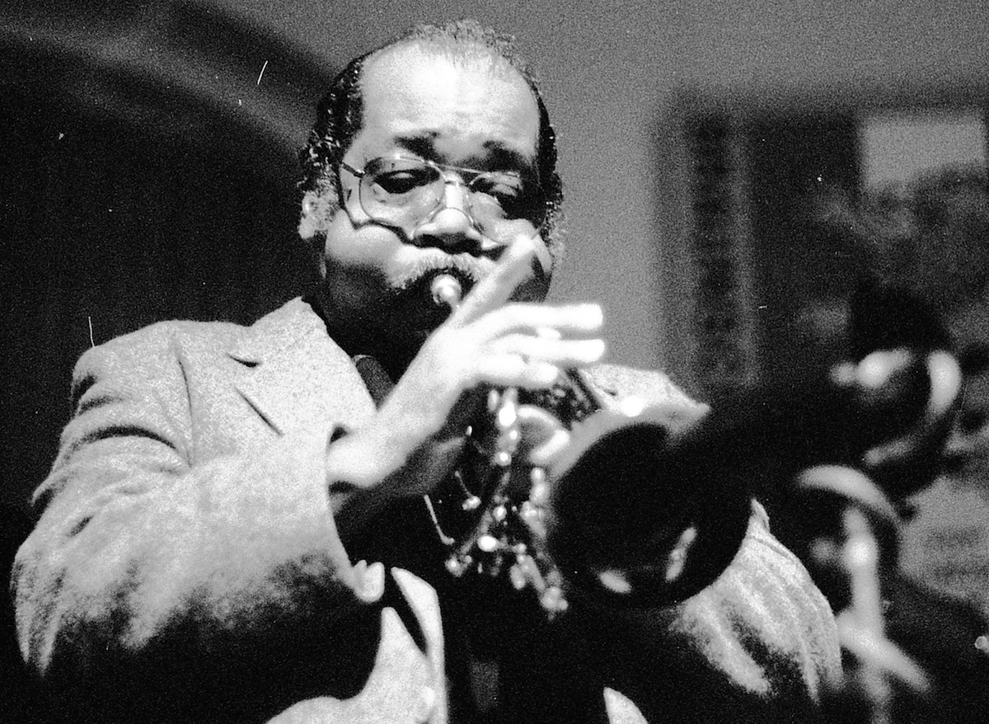

10. Bevan Beeps (Tadd Dameron) 5:15
Tadd Dameron Octet: Donald Byrd-tp; Curtis Fuller-tb; Julius Watkins-Frh; Sam
Rivers-ts; Cecil Payne-bs; Tadd Dameron-p; Paul Chambers-b; Philly Joe Jones-dr.
Van Gelder Studio, Englewood Cliffs, NJ, December 14, 1961
previously unreleased take 19 * CD Blue Note 7243 5 21484 2 4 (1999)
Z alba VARIOUS ARTISTS – THE LOST SESSIONS

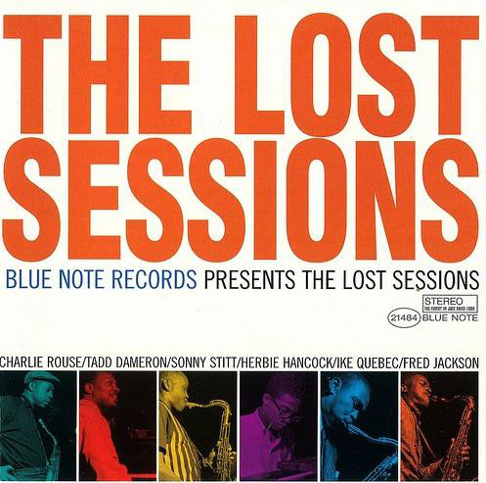

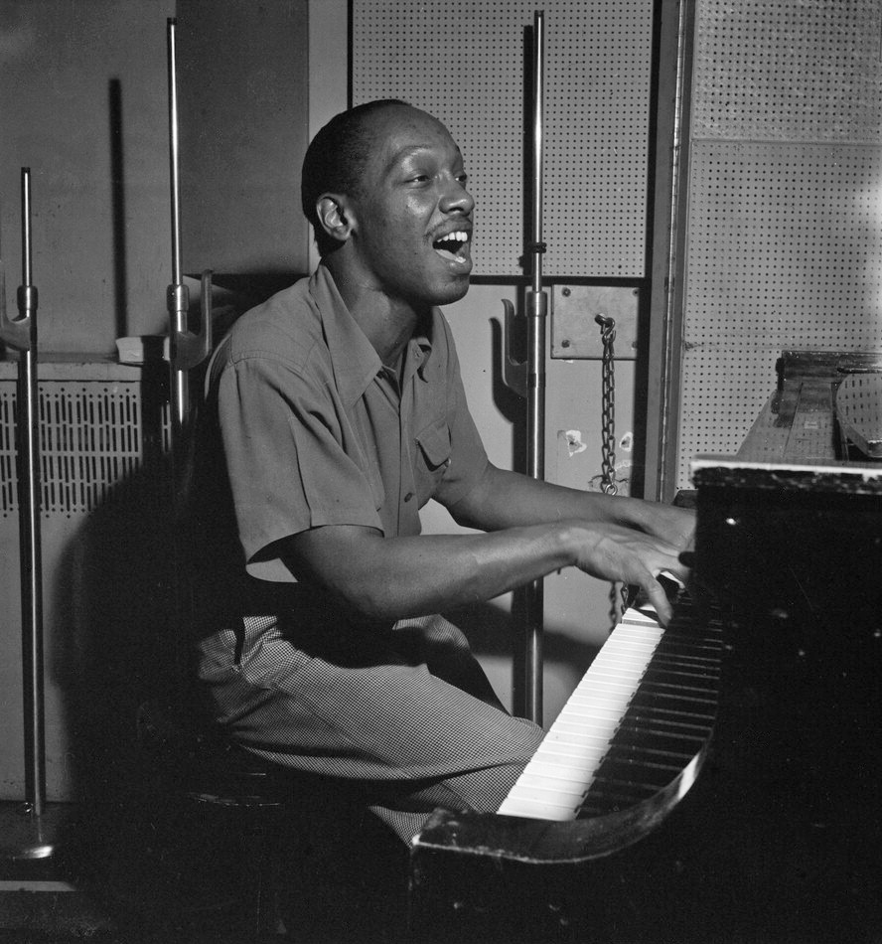

Tadley Ewing Peake Dameron (February 21, 1917 – March 8, 1965)

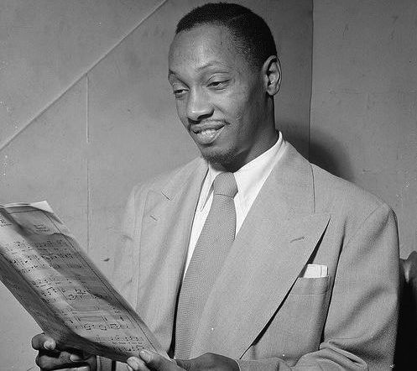

11. Take Your Pick (Hank Mobley) 5:27
Hank Mobley Quintet: Freddie Hubbard-tp; Hank Mobley-ts; Wynton Kelly-p; Paul
Chambers-b; Art Blakey-dr.
Van Gelder Studio, Englewood Cliffs, NJ, November 13, 1960
LP Blue Note BLP 4058 / take 7 * CD Blue Note 7243 5 40030 2 8 (2002)
Z alba ROLL CALL

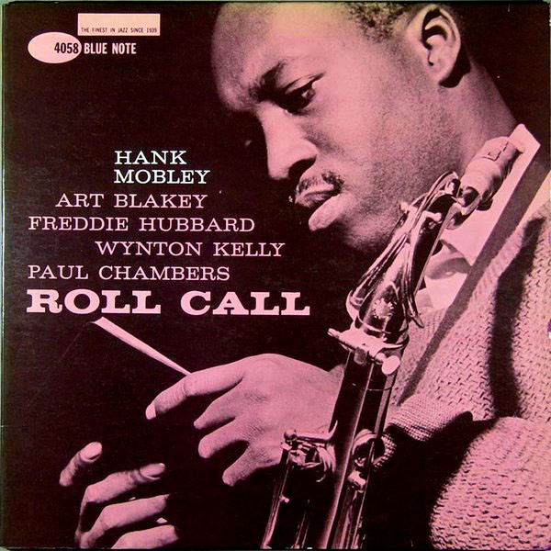

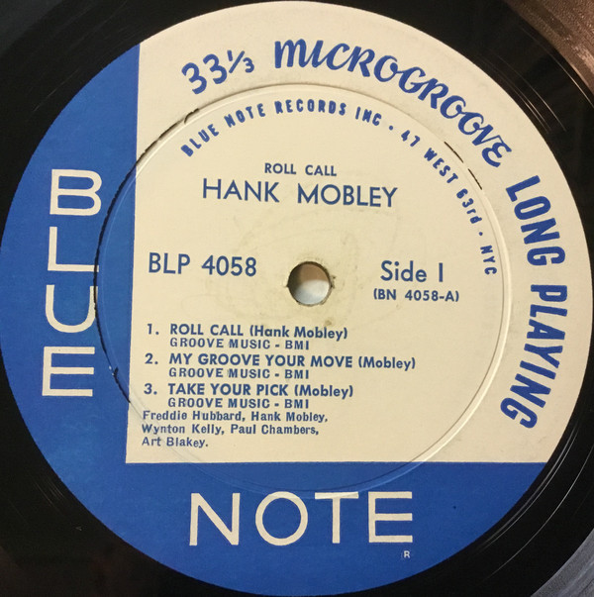

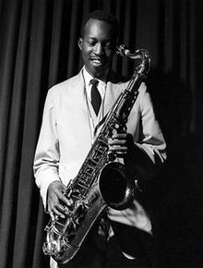

Henry "Hank" Mobley (July 7, 1930 – May 30, 1986)

12. You’ve Changed (Carl Fischer) 7:27
Dexter Gordon Quintet: Freddie Hubbard-tp; Dexter Gordon-ts; Horace Parlan-p; George
Tucker-b; Al Harewood-dr.
Van Gelder, Englewood Cliffs, NJ, May 6, 1961.
LP Blue Note BLP 4077 / take 12 * CD Blue Note 0777 7 96579 2 6 (1995)
Z alba DOIN’ ALLRIGHT (96504) / BALLADS (96579)

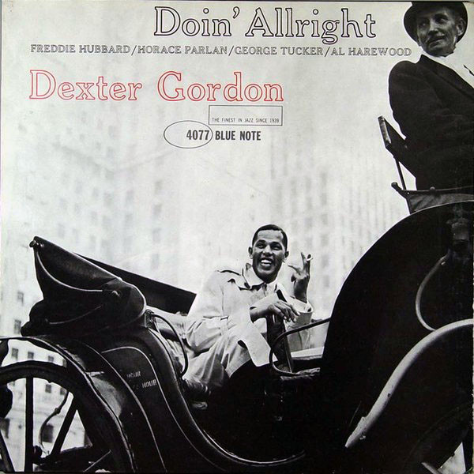

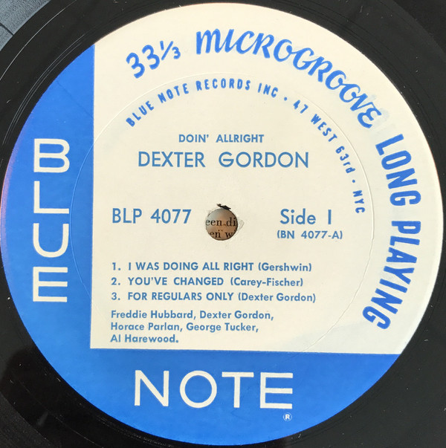

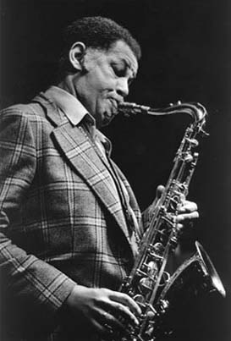

Dexter Gordon (February 27, 1923 – April 25, 1990)

MUNI 2019-2 Hard bop - CD 3

1. Spaceman Twist (Lou Donaldson) 5:38
Lou Donaldson Quintet: Tommy Turrentine-tp; Lou Donaldson-as; Grant Green-g;
John Patton-org; Ben Dixon-dr.
Van Gelder Studio, Englewood Cliffs, NJ, May 9, 1962
LP Blue Note 4108 / take 4 * CD Blue Note 7243 5 42307 2 1 (2003)
Z alba THE NATURAL SOUL

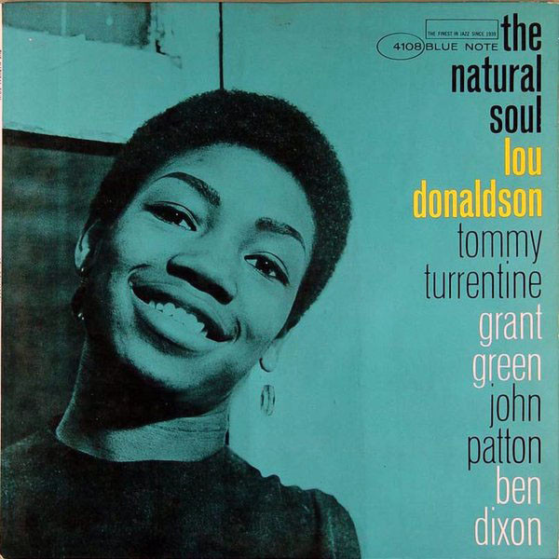

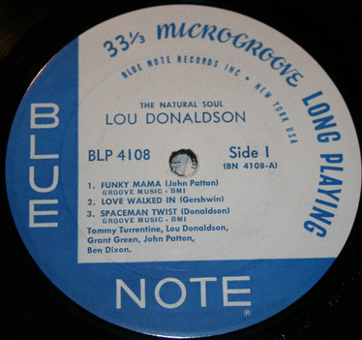

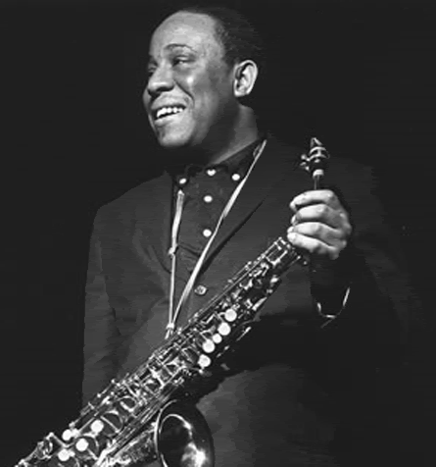

Lou Donaldson (born November 1, 1926)

2. Hub-Tones (Freddie Hubbard) 8:24
Freddie Hubbard Quintet: Freddie Hubbard-tp; James Spaulding-as; Herbie Hancock-p;
Reggie Workman-b; Clifford Jarvis-dr.
Van Gelder Studios, Englewood Cliffs, NJ, October 10, 1962
LP Blue Note BLP 4115 / take 20* CD Blue Note 7243 4 99008 2 0 (1999)
Z alba HUB-TONES

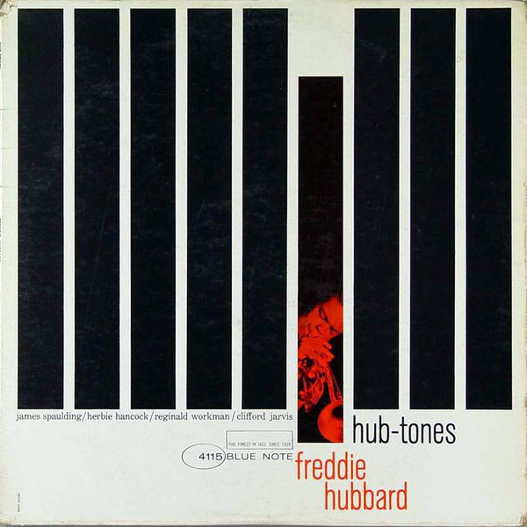

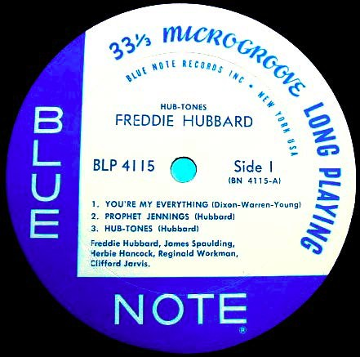

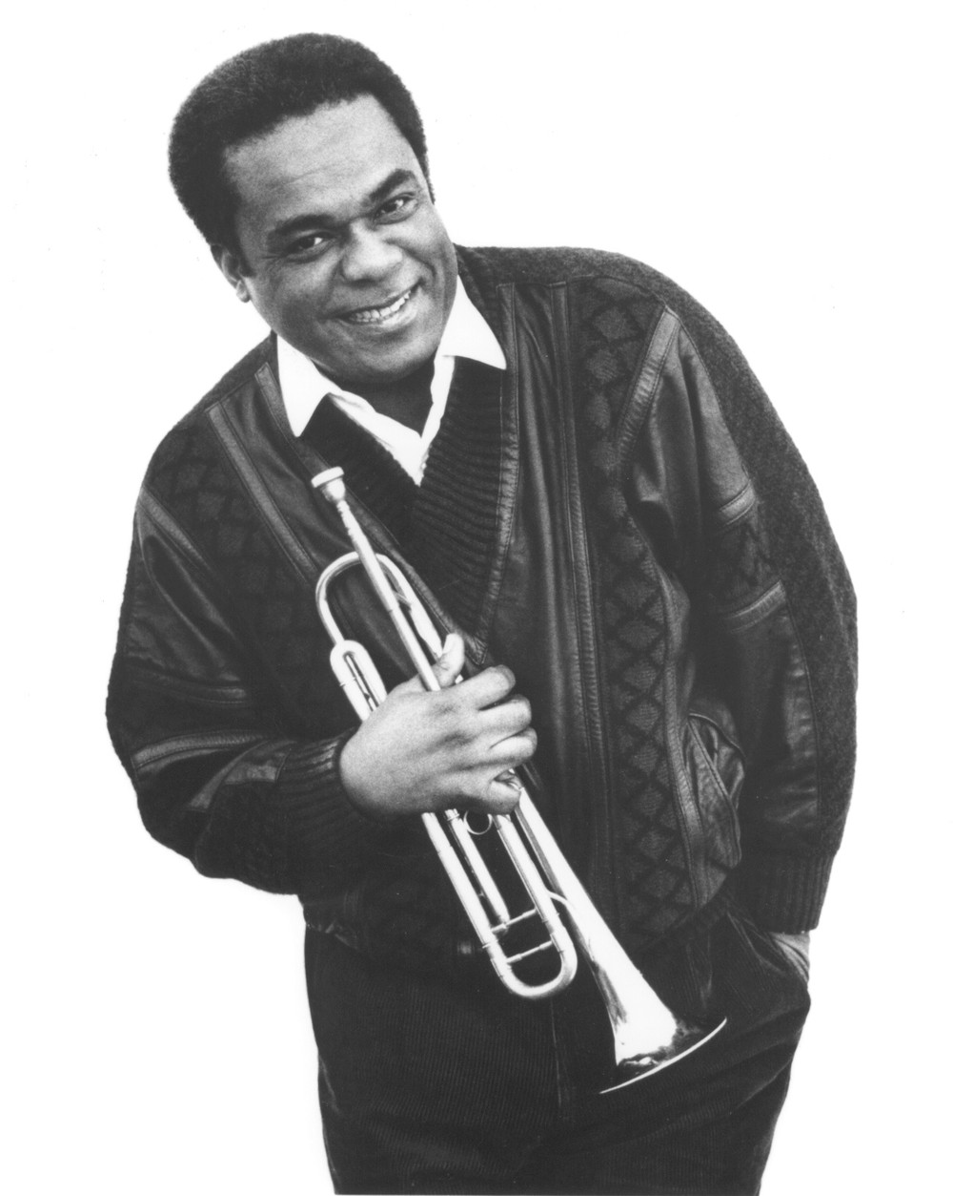

Frederick Dewayne Hubbard (April 7, 1938 – December 29, 2008)

3. Recorda Me (Joe Henderson) 6:01
Joe Henderson Quintet: Kenny Dorham-tp; Joe Henderson-ts; McCoy Tyner-p; Butch
Warren-b; Pete LaRoca-dr.
Van Gelder Studio, Englewood Cliffs, NJ, June 3, 1963
LP Blue Note BLP 4140 / take 6 * CD Blue Note 7243 4 98795 2 2 (1999)
Z alba PAGE ONE

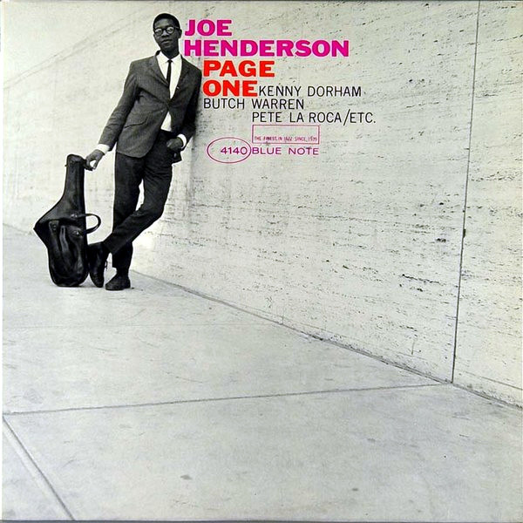

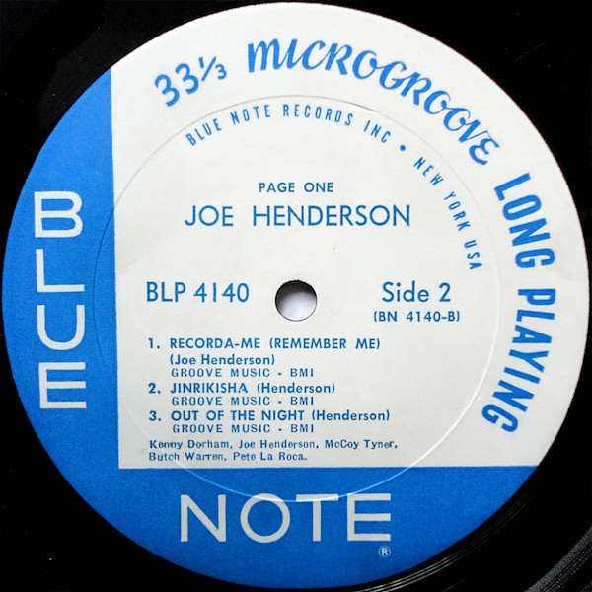

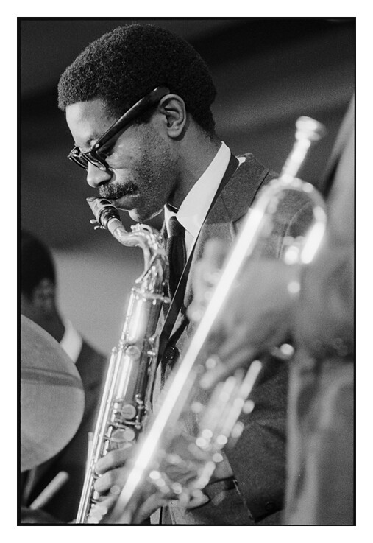

Joe Henderson (April 24, 1937 – June 30, 2001)

4. The Sidewinder (Lee Morgan) 10:25
Lee Morgan Quintet: Lee Morgan-tp; Joe Henderson-ts; Barry Harris-p; Bob Cranshaw-b;
Billy Higgins-dr.
Van Gelder Studio, Englewood Cliffs, NJ, December 21, 1963
LP Blue Note BLP 4157 / take 25 * CD Blue Note 7243 4 95332 2 6 (1999)
Z alba THE SIDEWINDER

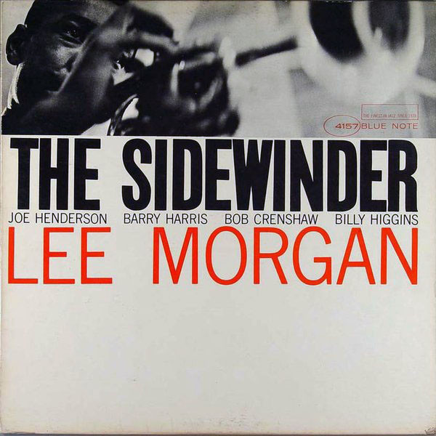

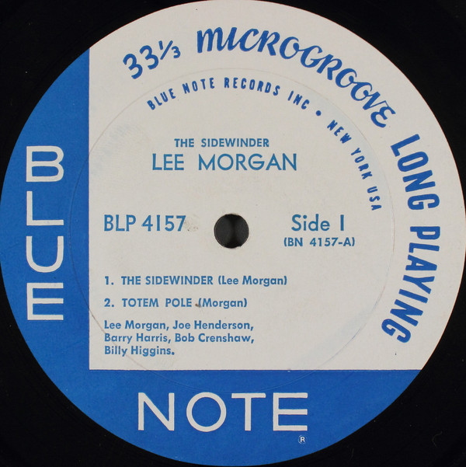

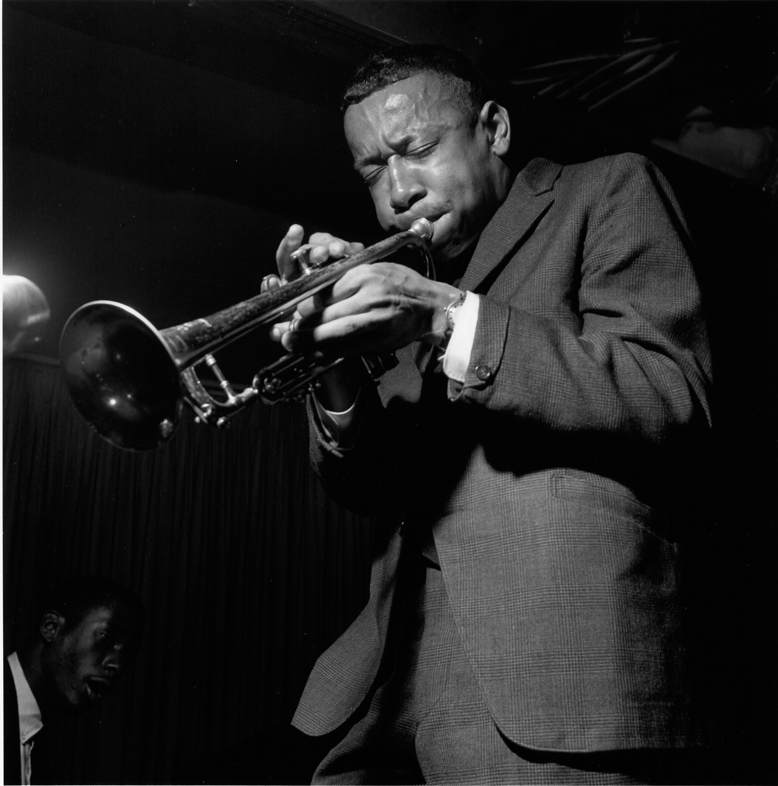

Lee Morgan (July 10, 1938 – February 19, 1972)

5. St. Thomas (Sonny Rollins) 6:49
Sonny Rollins Quartet: Sonny Rollins-ts; Tommy Flanagan-p; Doug Watkins-b;
Max Roach-dr.
Rudy Van Gelder Studio, Hackensack, New Jersey, June 22, 1956
LP Prestige PR 7079 / 919 * CD Prestige 0025218810524 (2006)
Z alba SAXOPHONE COLOSSUS

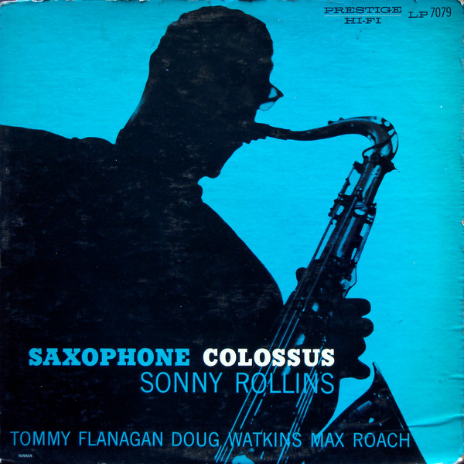

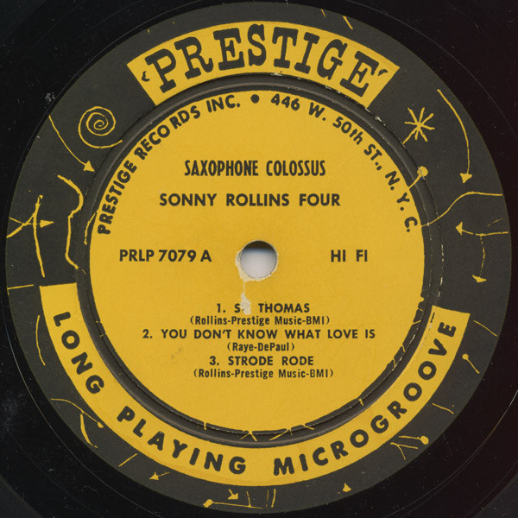

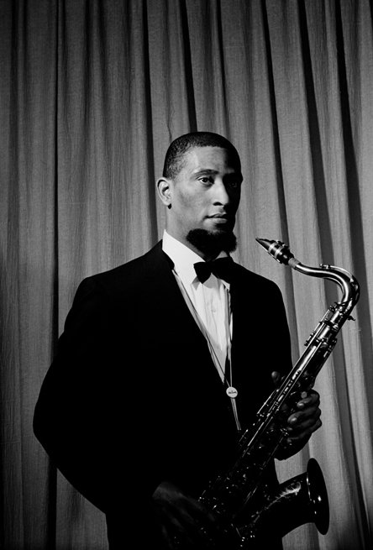

Walter Theodore "Sonny" Rollins (born September 7, 1930)

6. Striver’s Row (Sonny Rollins) 5:59
Sonny Rollins Trio: Sonny Rollins-ts; Wilbur Ware-b; Elvin Jones-dr.
Live at The Village Vanguard, November 3, 1957
LP Blue Note BLP 1581 / take 17 * CD Blue Note 7243 4 99795 2 9 (1999)
Z alba A NIGHT AT THE VILLAGE VANGUARD

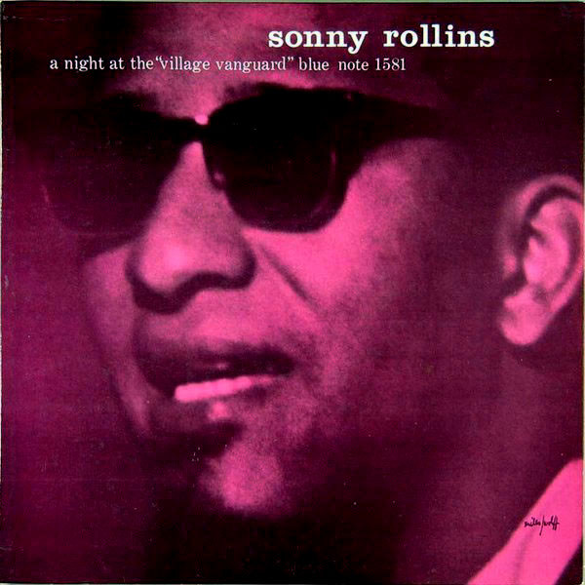

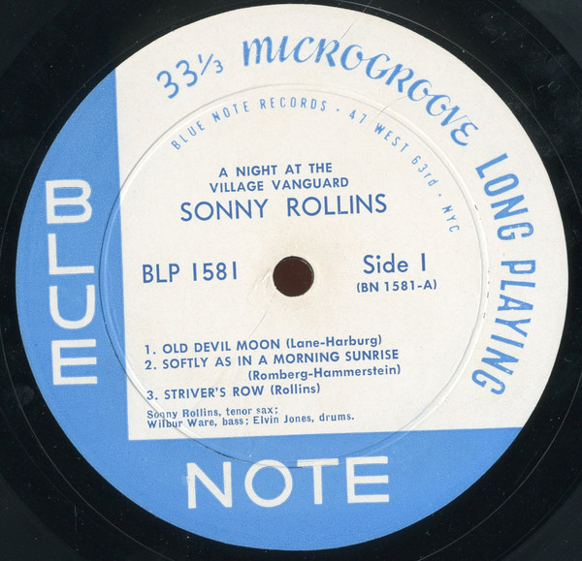

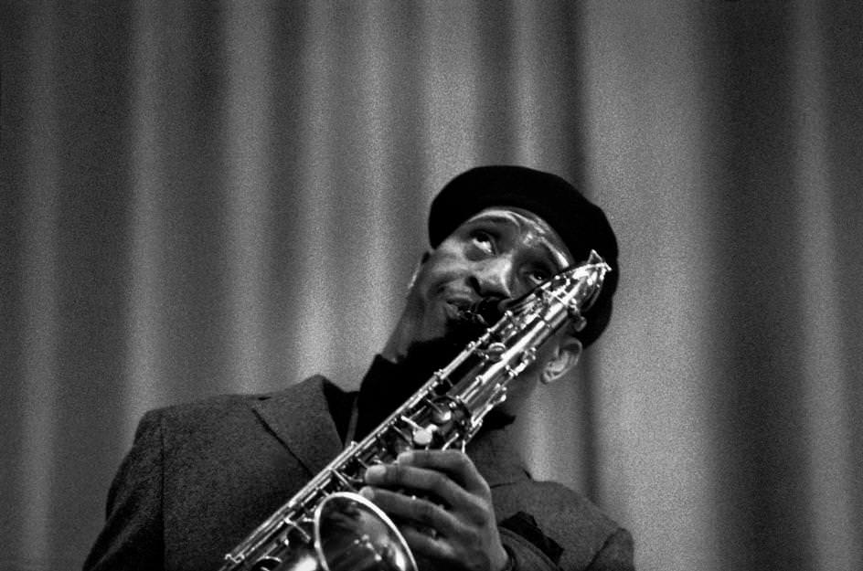

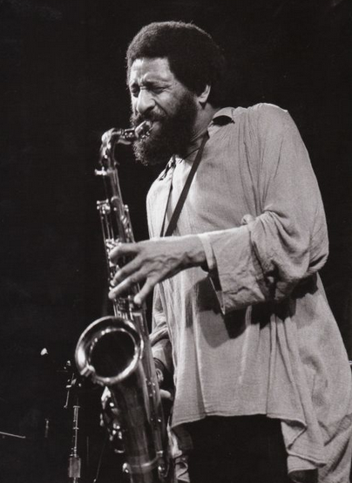

7. Grand Street (Sonny Rollins) 6:07
Sonny Rollins and the Big Brass: Nat Adderley-co; Reunald Jones, Ernie Royal, Clark
Terry-tp; Billy Byers, Jimmy Cleveland, Frank Rehak-tb; Don Butterfield-tu; Dick Katz-p;
René Thomas-g; Henry Grimes-b; Roy Haynes-dr; Sonny Rollins-ts solo; Ernie Wilkins-
arr, cond.
Metropolitan Studios, New York City, July 11, 1958
LP Metrojazz SE 1002 / no matrix * CD Verve 557 545-2 (1999)
Z alba SONNY ROLLINS AND THE BIG BRASS
8. Body and Soul (Johnny Green) 4:27
Sonny Rollins-tenor sax solo.
Beltone Studios, New York City, July 10, 1958
issues as last
Z alba SONNY ROLLINS AND THE BIG BRASS

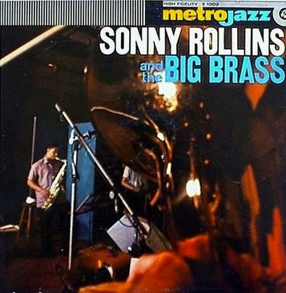

9. Along Came Betty (Benny Golson) 6:12
Art Blakey and The Jazz Messengers: Lee Morgan-tp; Benny Golson-ts; Bobby Timmons-p;
Jymie Merritt-b; Art Blakey-dr.
Van Gelder Studio, Hackensack, NJ, October 30, 1958
LP Blue Note BLP 4003 / take 16 * CD Blue Note 7243 4 95324 2 7 (1999)
Z alba ART BLAKEY AND THE JAZZ MESSENGERS/MOANIN’

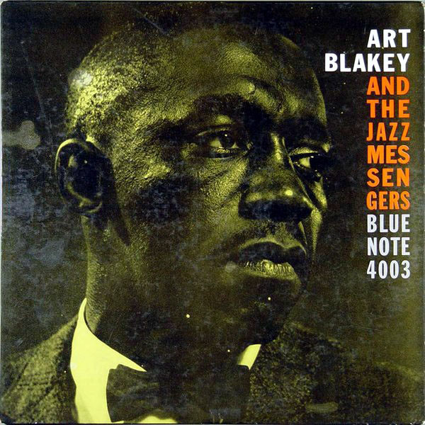

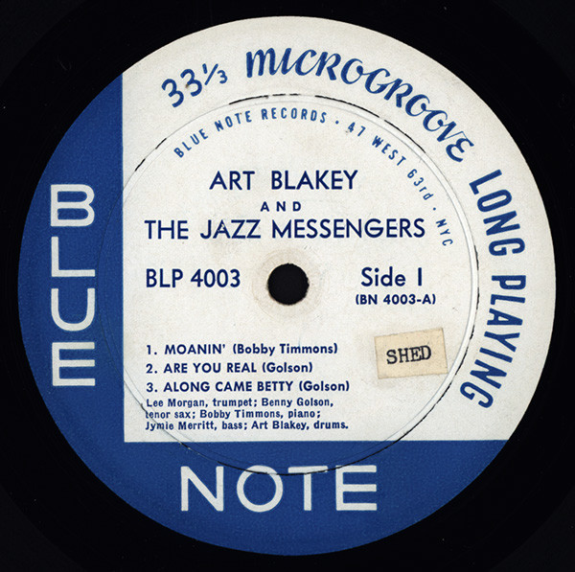

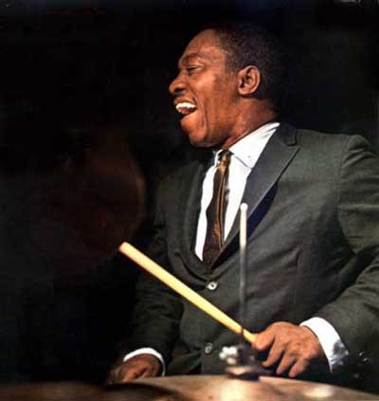

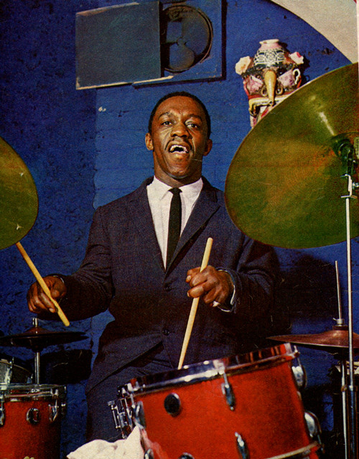

10. Sincerely Diana (Wayne Shorter) 6:51
Art Blakey and The Jazz Messengers: Lee Morgan-tp; Wayne Shorter-ts; Bobby Timmons-p;
Jymie Merritt-b; Art Blakey-dr.
Van Gelder Studio, Englewood Cliffs, NJ, August 7, 1960
LP Blue Note BLP 4049 / take 11 * CD Blue Note 7243 8 75261 2 9 (2005)
Z alba A NIGHT IN TUNISIA

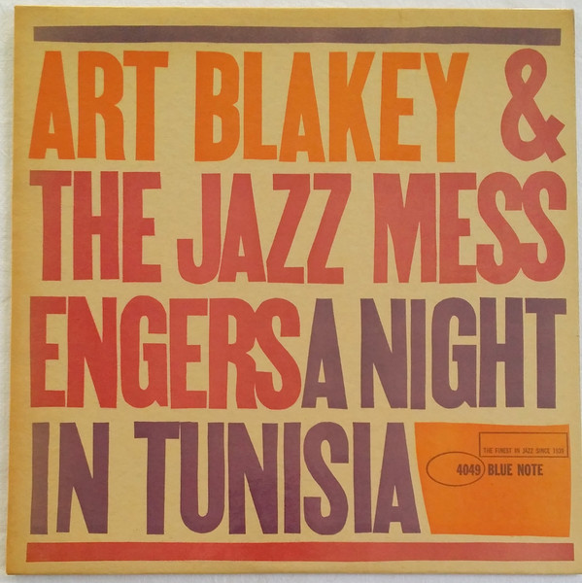

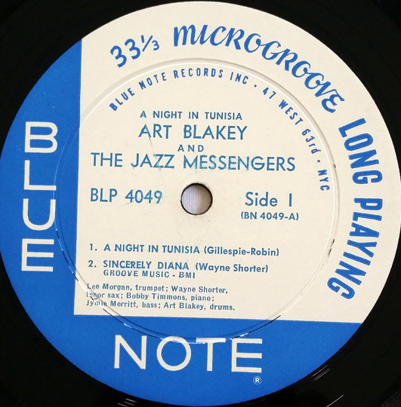

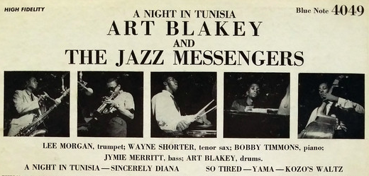

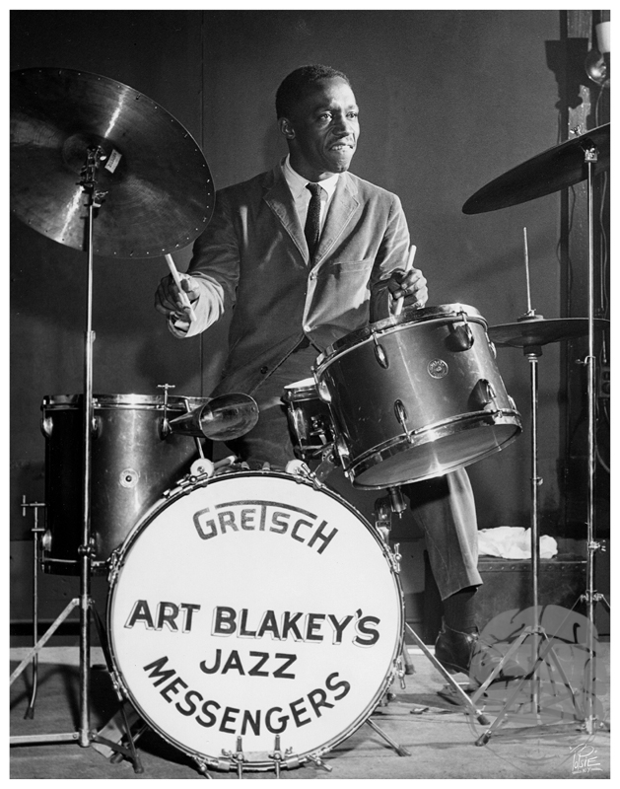

11. Buh’s Bossa (Lee Morgan) 5:36
Art Blakey and The Jazz Messengers: Freddie Hubbard, Lee Morgan-tp; Gary Bartz-as;
John Hicks-p; Victor Sproles-b; Art Blakey-dr.
New York City, May 12, 1965
LP Limelight LS 82018 / 36220 * CD Verve 314 516 107-2 (1993)
Z alba SOUL FINGER / ART BLAKEY: COMPACT JAZZ

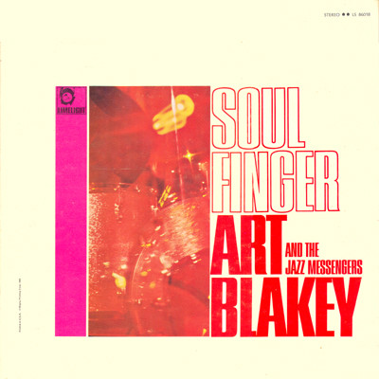

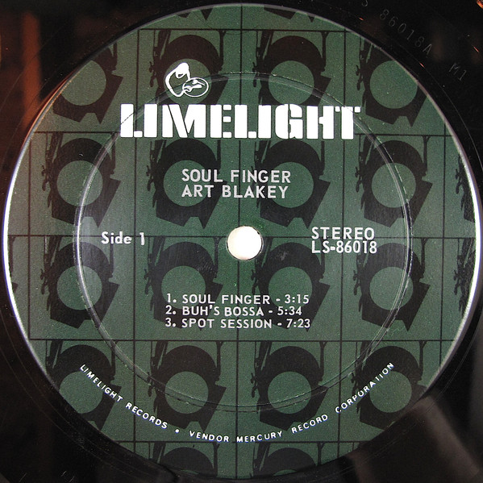
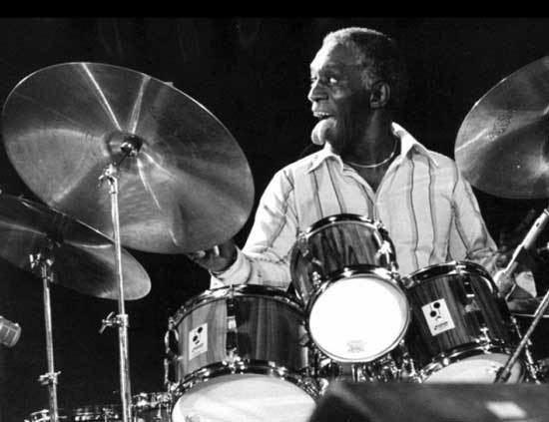

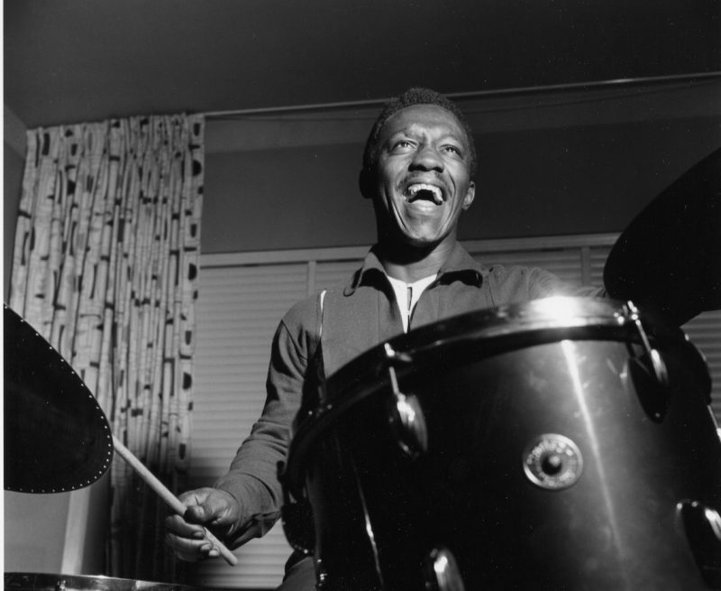

12. My Romance (Richard Rodgers) 7:00
Art Blakey and The Jazz Messengers: Chuck Mangione-tp; Frank Mitchell-ts; Keith
Jarrett-p; Reggie Johnson-b; Art Blakey-dr.
Live at The Lighthouse, Hermosa Beach, CA, January 1 & 9, 1966
LP Limelight LS 82034 / 35935 * CD Verve 314 516 107-2 (1993)
Z alba BUTTERCORN LADY / ART BLAKEY: COMPACT JAZZ

