JAMU 2019-2 WEST COAST JAZZ - CD 2

1. Bernie’s Tune (Bernie Miller) 2:58
Gerry Mulligan Quartet: Chet Baker-tp; Gerry Mulligan-bs; Bob Whitlock-b; Chico
Hamilton-dr.
Phil Turetsky’s House, Los Angeles, August 16, 1952
shellack Pacific Jazz 601 / 206 * CD Avid AVC 886 (2006)

2. Walking Shoes (Gerry Mulligan) 3:12
Same personnel.
Los Angeles, October 15 – 16, 1952
shellack Pacific Jazz 606 / 222 * CD issue as last

3. Walking Shoes (Gerry Mulligan) 3:39
4. Westwood Walk (Gerry Mulligan) 2:37
Gerry Mulligan Tentette: Chet Baker, Pete Candoli-tp; Bob Enevoldsen-vtb; John Graas-Frh;
Ray Siegel-tu; Bud Shank-as; Don Davidson, Gerry Mulligan-bs; Joe Mondragon-b; Chico
Hamilton-dr.
Los Angeles, January 29, 1953
Capitol EAP 439 / 11117 & 11114 * CD issue as last

5. Vicky’s Dream (Barney Kessel) 2:53
Barney Kessel Quintet: Bud Shank-as; Arnold Ross-p; Barney Kessel-g; Harry Babasin-b;
Shelly Manne-dr.
Los Angeles, November 14, 1953
LP Contemporary C 2508 / no matrix * CD Avid Jazz AMSC 921 (2008)

6. Barney’s Blues (Barney Kessel) 3:01
Barney Kessel Quintet: Bob Cooper-ob; Claude Williamson-p; Barney Kessel-g; Monty
Budwig-b; Shelly Manne-dr.
Los Angeles, July 1, 1954
LP Contemporary C 2514 / no matrix * CD issue as last

7. Street of Drums (Chico Hamilton) 3:22
Chico Hamilton Trio: Howard Roberts-g; George Duvivier-b; Chico Hamilton-dr.
Hollywood, December 6, 1953
LP Pacific Jazz 17 / PJ 330 * CD Avid Jazz AMSC 949 (2008)

8. A Nice Day (Buddy Collette) 2:58
Chico Hamilton Quintet: Buddy Collette-cl, ts, as, fl; Fred Katz-vcl; Jim Hall-g; Carson
Smith-b; Chico Hamilton-dr.
Los Angeles, August 23, 1955
LP Pacific Jazz PJ 1209 / no matrix * CD issue as last

9. Do It! (Jimmy Giuffre) 3:17
Jimmy Giuffre Quintet: Jack Sheldon-tp; Jimmy Giuffre-cl, ts, bs; Russ Freeman-p;
Curtis Counce-b; Shelly Manne-dr.
Capitol Studios, Los Angeles,February 19, 1954
LP Capitol T 549 / 12344-11 * CD Mosaic MD6-176 (1997)

10. Four Brothers (Jimmy Giuffre) 3:15
Jimmy Giuffre Septet: Shorty Rogers-fh; Jack Sheldon-tp; Bob Enevoldsen-vtb; Bud Shank-
as; Jimmy Giuffre-ts; Ralph Peña-b; Shelly Manne-dr.
Capitol Studios, Los Angeles, April 15, 1954
LP issue as last / matrix number 12558-5 * CD issue as last

11. So Low (Jimmy Giuffre) 2:50
Jimmy Giuffre-solo clarinet & foot-taping.
Capitol Studios, Los Angeles, March 21, 1956
LP Atlantic 1238 / 1996 * CD issue as last

12. The Sheepherder (Jimmy Giuffre) 5:24
Jimmy Giuffre Trio: Jimmy Giuffre-cl; Buddy Collette-acl; Harry Klee-bcl.
Capitol Studios, Los Angeles, March 22, 1956
LP Atlantic 1238 / 1989 * CD issue as last

13. The Side Pipers (Jimmy Giuffre) 5:08
Jimmy Giuffre Quintet: Jimmy Giuffre-cl; Buddy Collette-fl; Bud Shank-afl; Harry
Klee-bfl; Shelly Manne-dr.
Same session
LP Atlantic 1238 / 1990 * CD issue as last

14. The Train and the River (Jimmy Giuffre) 3:35
Jimmy Giuffre Trio: Jimmy Giuffre-cl, ts, bs; Jim Hall-g; Ralph Peña-b.
Capitol Studios, Los Angeles, December 3, 1956
LP Atlantic 1254 / 2284-4 * CD issue as last

15. California, Here I Come (Al Jolson-Buddy DeSylva-Meyer) 2:42
Jimmy Giuffre Trio: Jimmy Giuffre-bs; Bob Brookmeyer-vtb; Jim Hall-g.
Atlantic Studios, New York City, January 23, 1958
LP Atlantic 1282 / 2934 * CD issue as last

16. Four Brothers (Jimmy Giuffre) 3:25
Jimmy Giuffre Trio: Jimmy Giuffre-ts (4 overdubbed); Bob Brookmeyer-p; Jim Hall-g.
Lenox, Massachusetts, September 1, 1958
LP Atlantic 1295 / 3152 * CD issue as last

17. Hip (Hampton Hawes) 6:19
Hampton Hawes Quartet: Harold Land-ts; Hampton Hawes-p; Scott LaFaro-b; Frank
Butler-dr.
Los Angeles, March 17, 1958
LP Contemporary M3589, S7589 / no matrix * CD Essential Jazz Classics EJC 55557 (2012)

18. Bass Blues (John Coltrane) 15:18
Victor Feldman Quartet: Richie Kamuca-ts; Victor Feldman-p; Scott LaFaro-b; Stan
Levey-dr.
Live at The Lighthouse, Hermosa Beach, CA, September 1958
previously unreleased * CD Fresh Sound FSR-CD 370 (1992)

19. Thanks for the Memory (Ralph Rainger-Leo Robin) 3:48
Serge Chaloff Quartet: Serge Chaloff-bs; Sonny Clark-p; Leroy Vinnegar-b; Philly Joe
Jones-dr.
Capitol Studios, Los Angeles, March 14, 1956
LP Capitol T 742 / 15154 * CD Capitol Jazz 7243 4 94505 2 3 (1998)

JAMU 2019-2 WEST COAST JAZZ - CD 2

1. Bernie’s Tune (Bernie Miller) 2:58
Gerry Mulligan Quartet: Chet Baker-tp; Gerry Mulligan-bs; Bob Whitlock-b; Chico
Hamilton-dr.
Phil Turetsky’s House, Los Angeles, August 16, 1952
shellack Pacific Jazz 601 / 206 * CD Avid AVC 886 (2006)
https://secondhandsongs.com/performance/316919

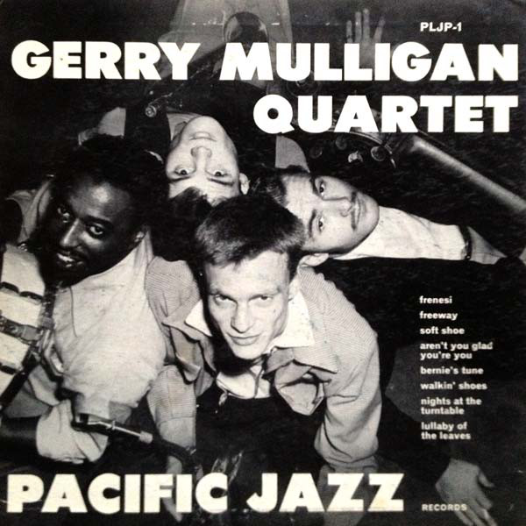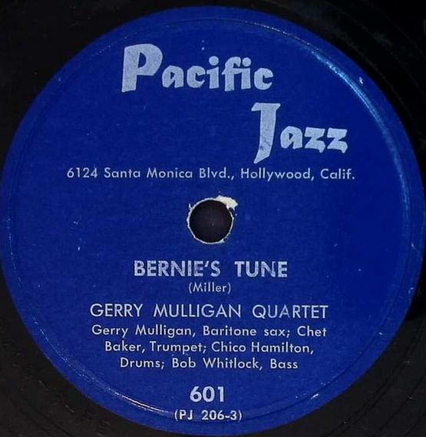

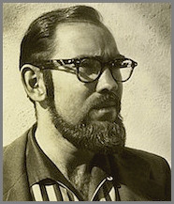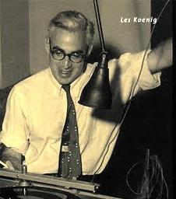
Richard Bock (1927 – 1988) Lester Koenig (1918 – 1977)
Pacific Jazz Records (1952) Contemporary Records (1951)

2. Walking Shoes (Gerry Mulligan) 3:12
Same personnel.
Los Angeles, October 15 – 16, 1952
shellack Pacific Jazz 606 / 222 * CD issue as last
https://www.youtube.com/watch?v=Lx-vsmRSDTw

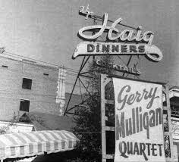

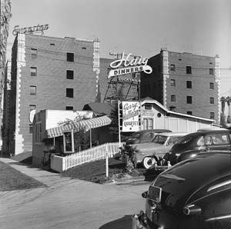

3. Walking Shoes (Gerry Mulligan) 3:39
Gerry Mulligan Tentette: Chet Baker, Pete Candoli-tp; Bob Enevoldsen-vtb; John Graas-Frh;
Ray Siegel-tu; Bud Shank-as; Don Davidson, Gerry Mulligan-bs; Joe Mondragon-b; Chico
Hamilton-dr.
Los Angeles, January 29, 1953
Capitol EAP 439 / 11117 * CD issue as last
https://secondhandsongs.com/performance/385395

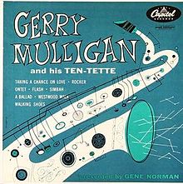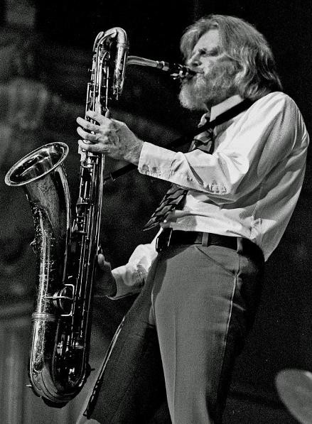
Gerry Mulligan (1927 – 1996)

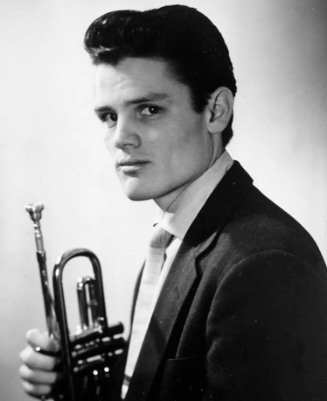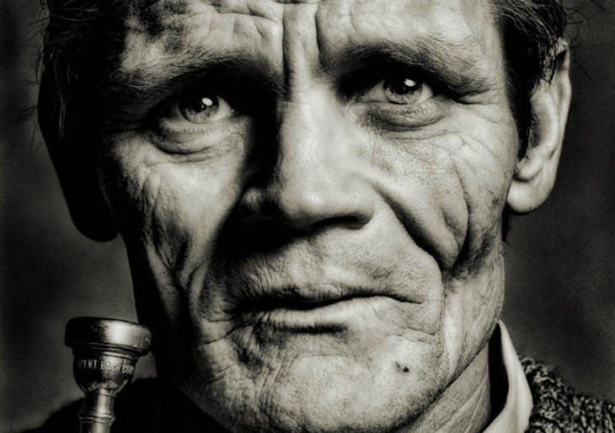
Chet Baker (1929 – 1988)

4. Westwood Walk (Gerry Mulligan) 2:37
Gerry Mulligan Tentette: Chet Baker, Pete Candoli-tp; Bob Enevoldsen-vtb; John Graas-Frh;
Ray Siegel-tu; Bud Shank-as; Don Davidson, Gerry Mulligan-bs; Joe Mondragon-b; Chico
Hamilton-dr.
Los Angeles, January 29, 1953
Capitol EAP 439 / 11114 * CD issue as last
https://secondhandsongs.com/performance/657027

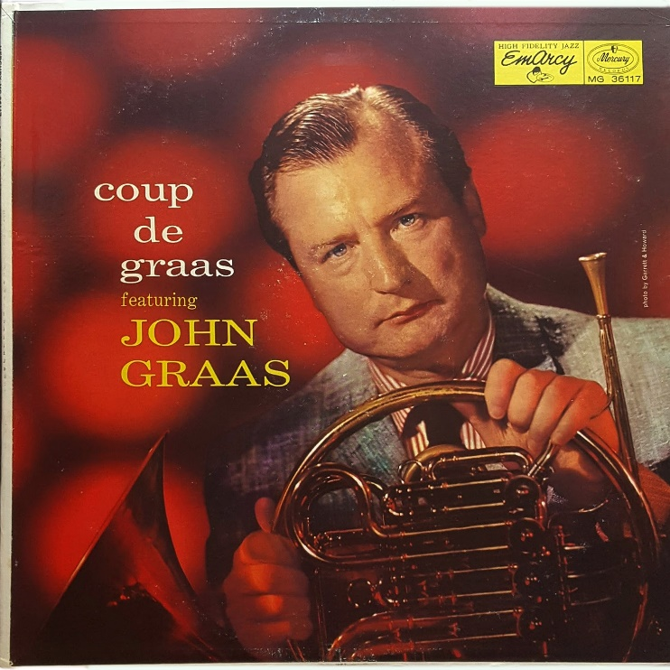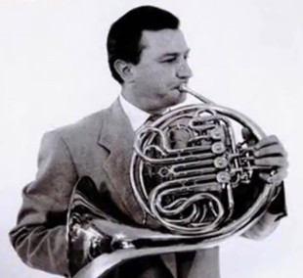
John Graas (1917 – 1962)

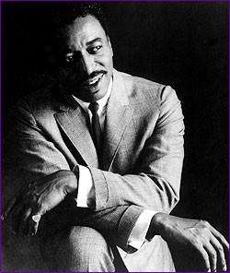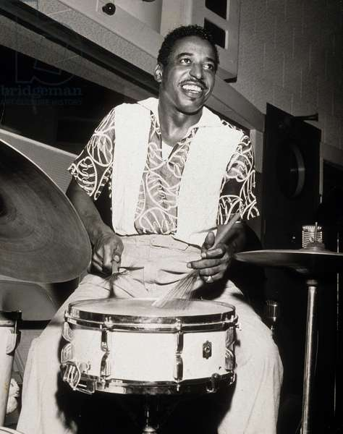
Chico Hamilton (1921 – 2013)

5. Vicky’s Dream (Barney Kessel) 2:53
Barney Kessel Quintet: Bud Shank-as; Arnold Ross-p; Barney Kessel-g; Harry Babasin-b;
Shelly Manne-dr.
Los Angeles, November 14, 1953
LP Contemporary C 2508 / no matrix * CD Avid Jazz AMSC 921 (2008)

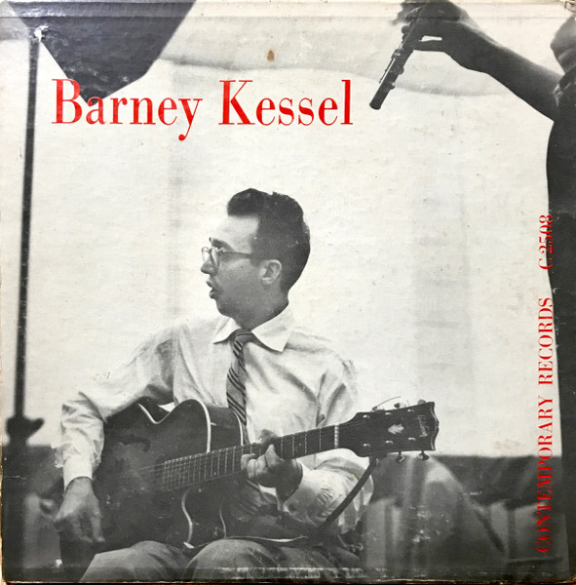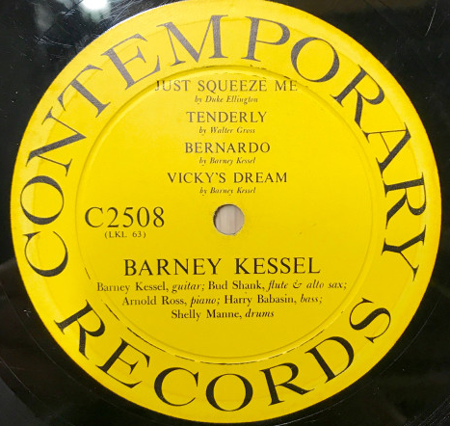

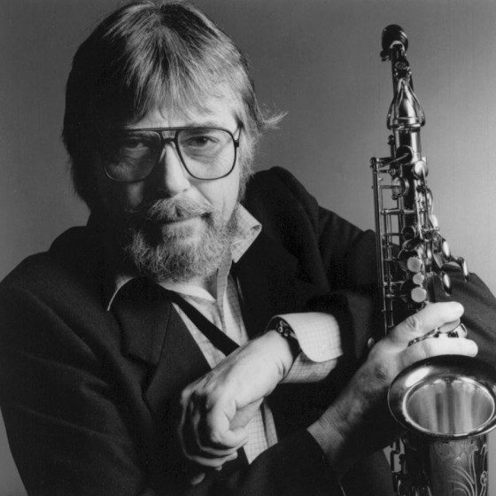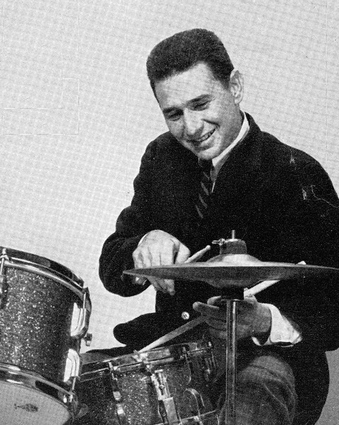
Bud Shank (1926 – 2009) Shelly Manne (1920 – 1984)

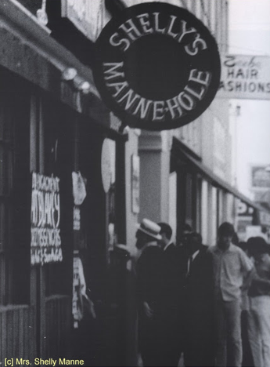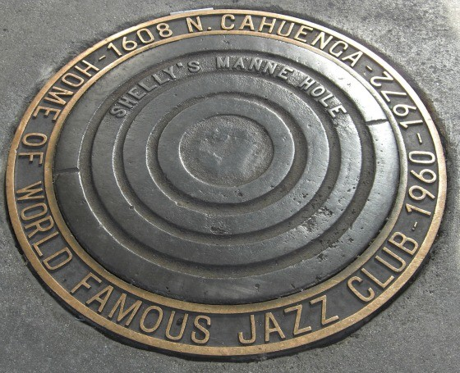

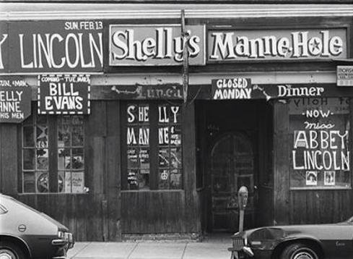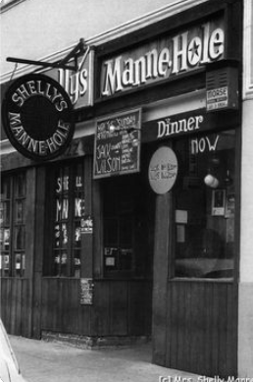

6. Barney’s Blues (Barney Kessel) 3:01
Barney Kessel Quintet: Bob Cooper-ob; Claude Williamson-p; Barney Kessel-g; Monty
Budwig-b; Shelly Manne-dr.
Los Angeles, July 1, 1954
LP Contemporary C 2514 / no matrix * CD issue as last

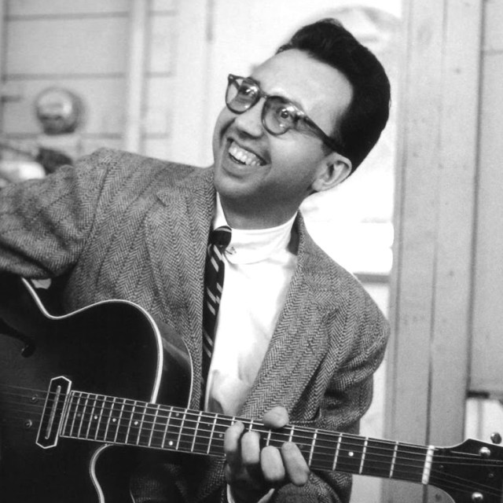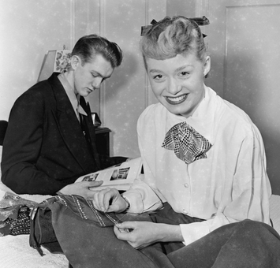
Barney Kessel Bob Cooper (1925-1993) & June Christy

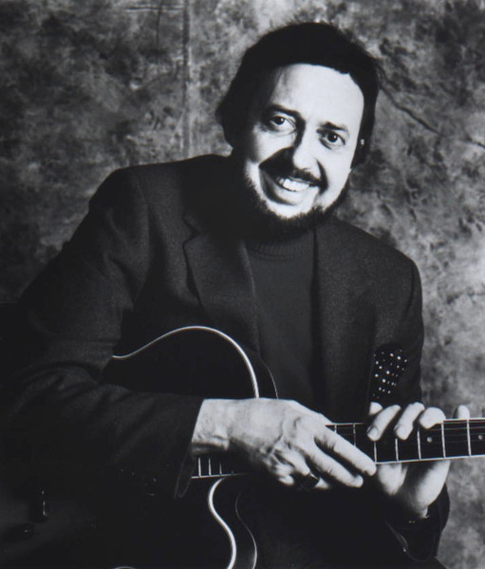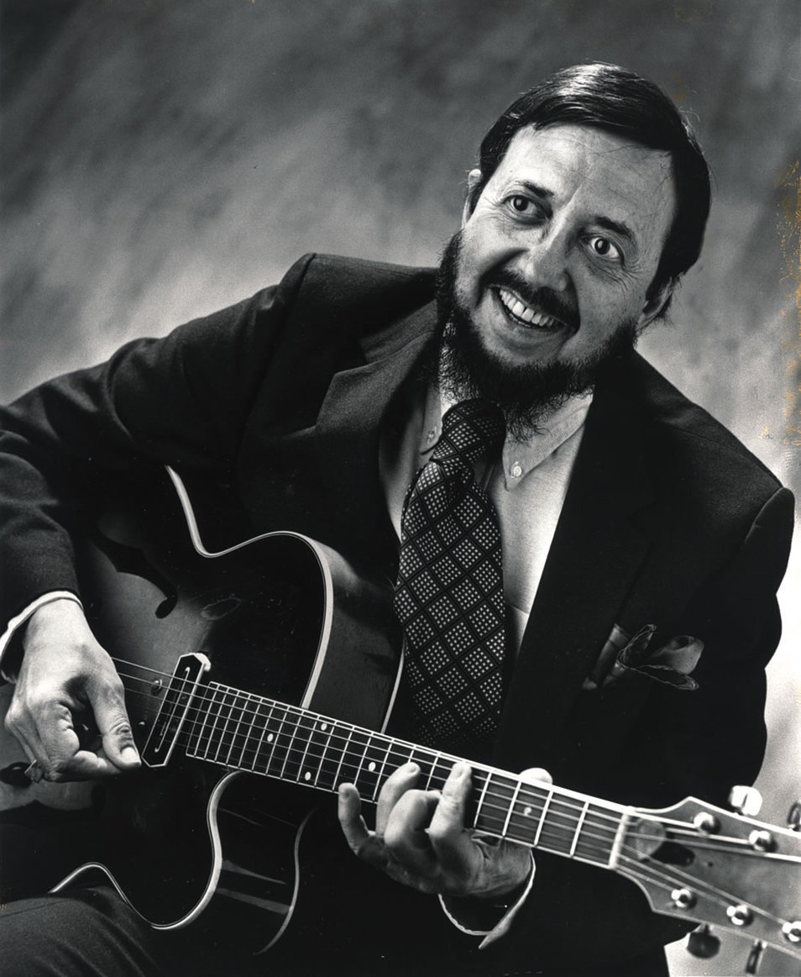

7. Street of Drums (Chico Hamilton) 3:22
Chico Hamilton Trio: Howard Roberts-g; George Duvivier-b; Chico Hamilton-dr.
Hollywood, December 6, 1953
LP Pacific Jazz 17 / PJ 330 * CD Avid Jazz AMSC 949 (2008)

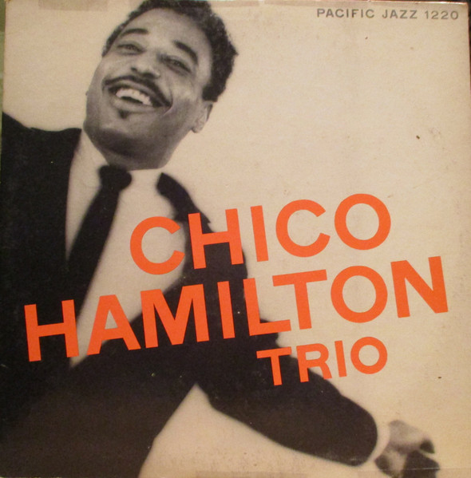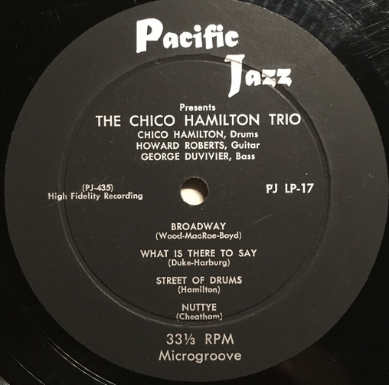
Chico Hamilton (1921 – 2013)

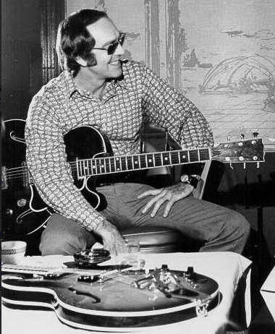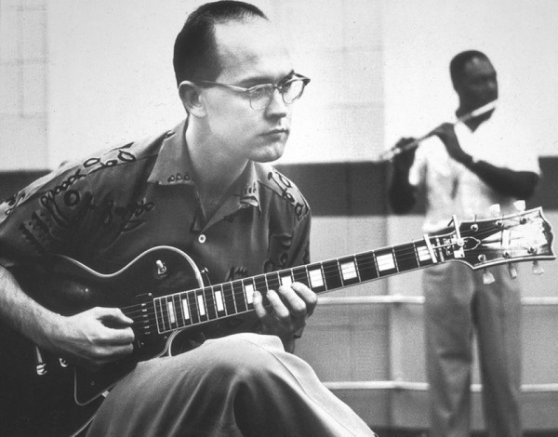
Howard Roberts (1929 – 1992) Jim Hall (1930 – 2013)

8. A Nice Day (Buddy Collette) 2:58
Chico Hamilton Quintet: Buddy Collette-cl, ts, as, fl; Fred Katz-vcl; Jim Hall-g; Carson
Smith-b; Chico Hamilton-dr.
Los Angeles, August 23, 1955
LP Pacific Jazz PJ 1209 / no matrix * CD issue as last

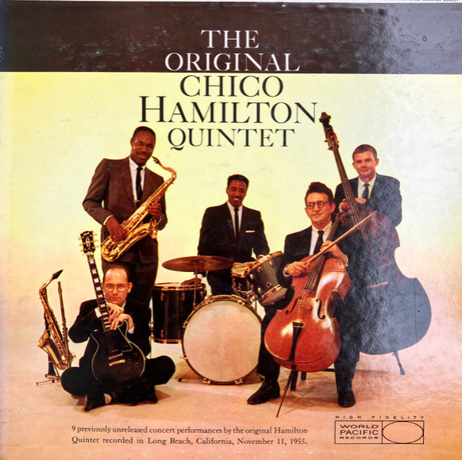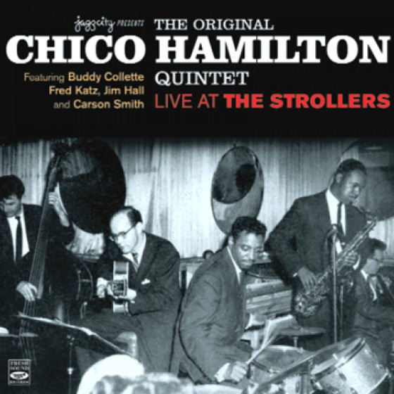

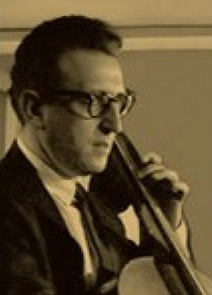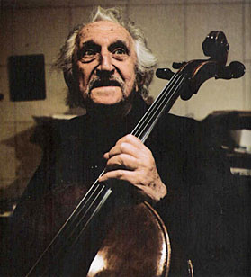
Fred Katz (1919 – 2013)

9. Do It! (Jimmy Giuffre) 3:17
Jimmy Giuffre Quintet: Jack Sheldon-tp; Jimmy Giuffre-cl, ts, bs; Russ Freeman-p;
Curtis Counce-b; Shelly Manne-dr.
Capitol Studios, Los Angeles, February 19, 1954
LP Capitol T 549 / 12344-11 * CD Mosaic MD6-176 (1997)

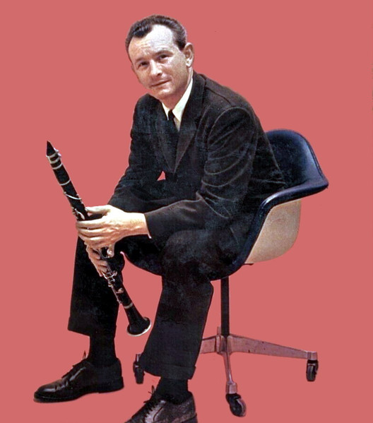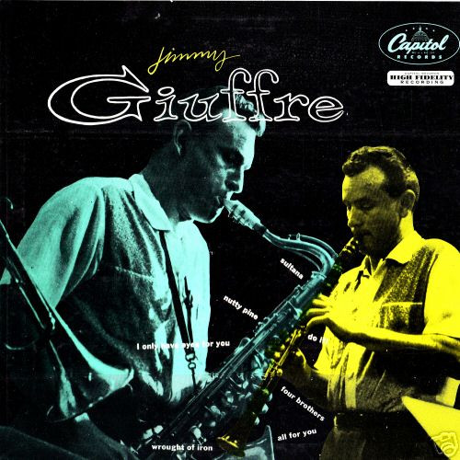
Jimmy Giuffre (1921 – 2008)

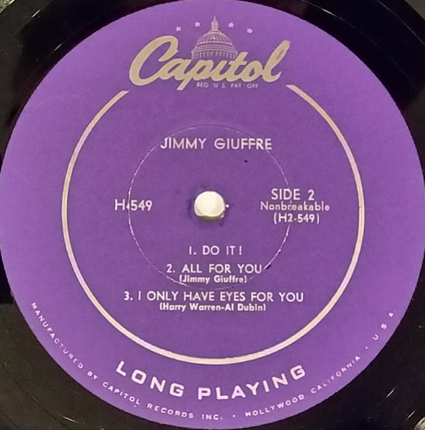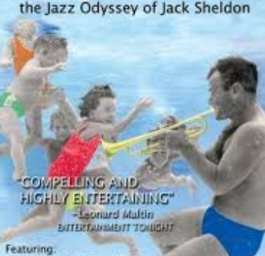
Jack Sheldon (1931 – 2019)

10. Four Brothers (Jimmy Giuffre) 3:15
Jimmy Giuffre Septet: Shorty Rogers-fh; Jack Sheldon-tp; Bob Enevoldsen-vtb; Bud Shank-
as; Jimmy Giuffre-ts; Ralph Peña-b; Shelly Manne-dr.
Capitol Studios, Los Angeles, April 15, 1954
LP issue as last / matrix number 12558-5 * CD issue as last
original recording – Woody Herman Orchestra & Four Brothers, December 27, 1947:
https://secondhandsongs.com/performance/291726

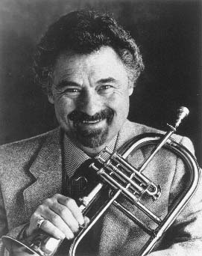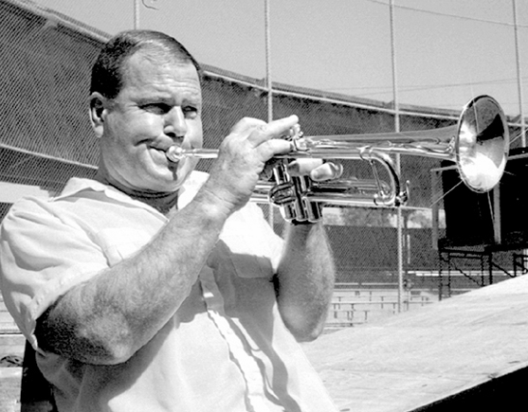
Shorty Rogers (1924 – 1994) Jack Sheldon (1931 – 2019)

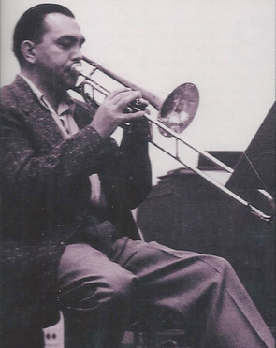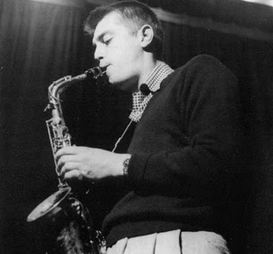
Bob Enevoldsen (1920 – 2005) Bud Shank (1926 – 2009)

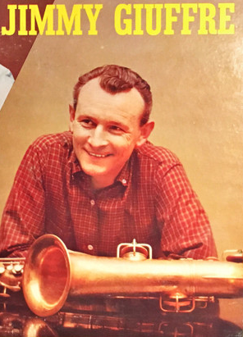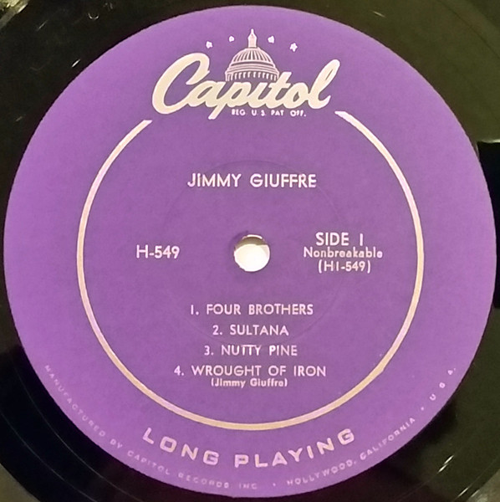

11. So Low (Jimmy Giuffre) 2:50
Jimmy Giuffre-solo clarinet & foot-taping.
Capitol Studios, Los Angeles, March 21, 1956
LP Atlantic 1238 / 1996 * CD issue as last

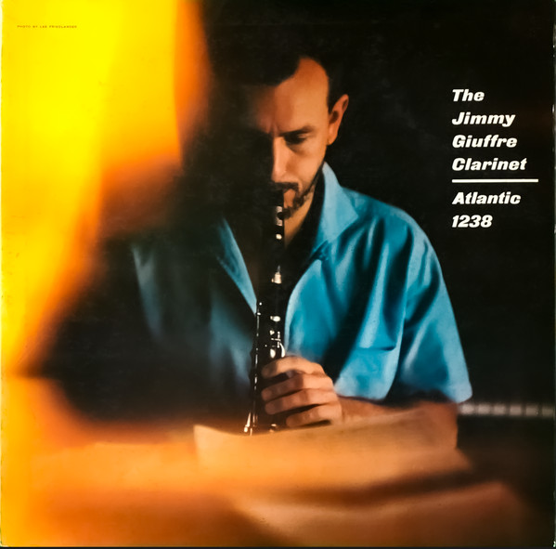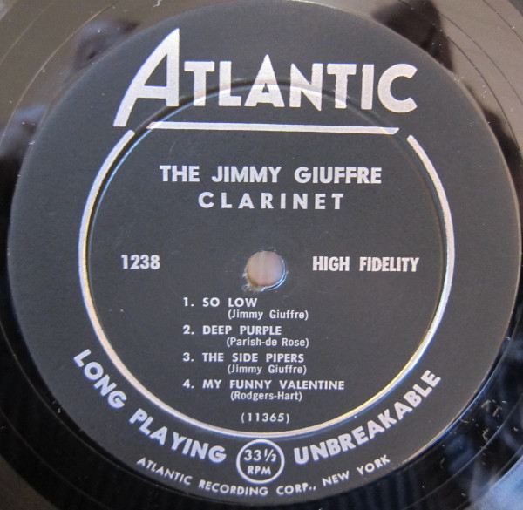

12. The Sheepherder (Jimmy Giuffre) 5:24
Jimmy Giuffre Trio: Jimmy Giuffre-cl; Buddy Collette-acl; Harry Klee-bcl.
Capitol Studios, Los Angeles, March 22, 1956
LP Atlantic 1238 / 1989 * CD issue as last

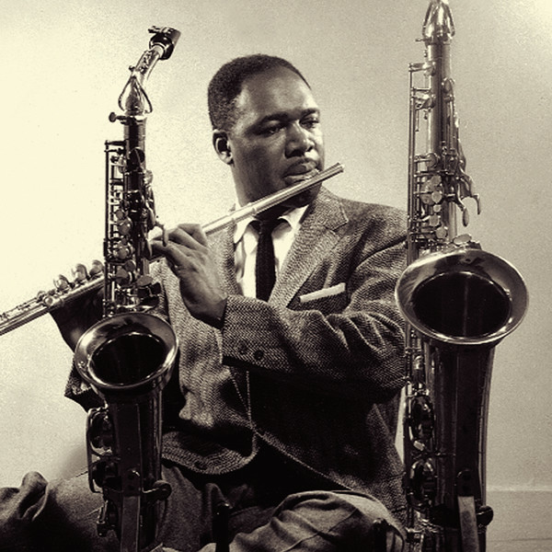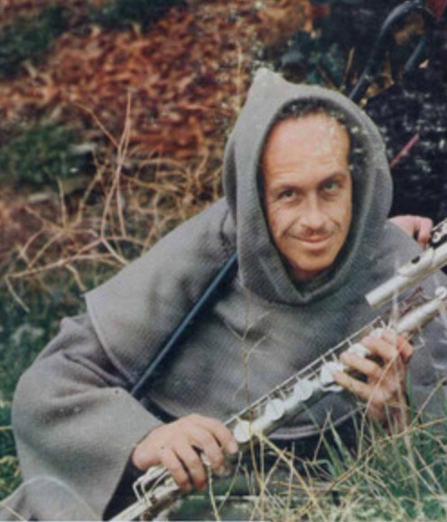
Buddy Collette (1921 – 2010) Harry Klee (? - ?)

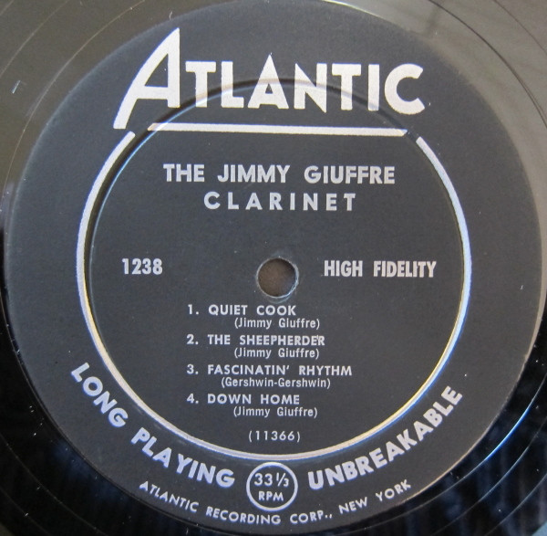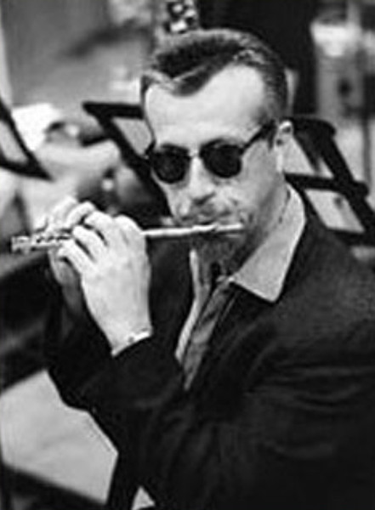

13. The Side Pipers (Jimmy Giuffre) 5:08
Jimmy Giuffre Quintet: Jimmy Giuffre-cl; Buddy Collette-fl; Bud Shank-afl; Harry
Klee-bfl; Shelly Manne-dr.
Same session
LP Atlantic 1238 / 1990 * CD issue as last

1984 reissue
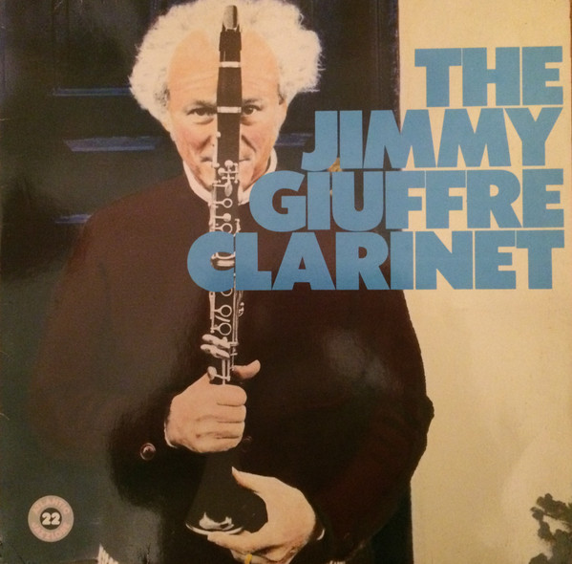

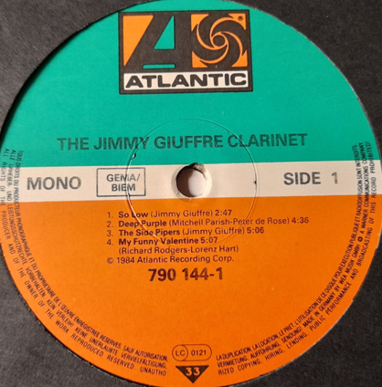

14. The Train and the River (Jimmy Giuffre) 3:35
Jimmy Giuffre Trio: Jimmy Giuffre-cl, ts, bs; Jim Hall-g; Ralph Peña-b.
Capitol Studios, Los Angeles, December 3, 1956
LP Atlantic 1254 / 2284-4 * CD issue as last
https://secondhandsongs.com/performance/378568

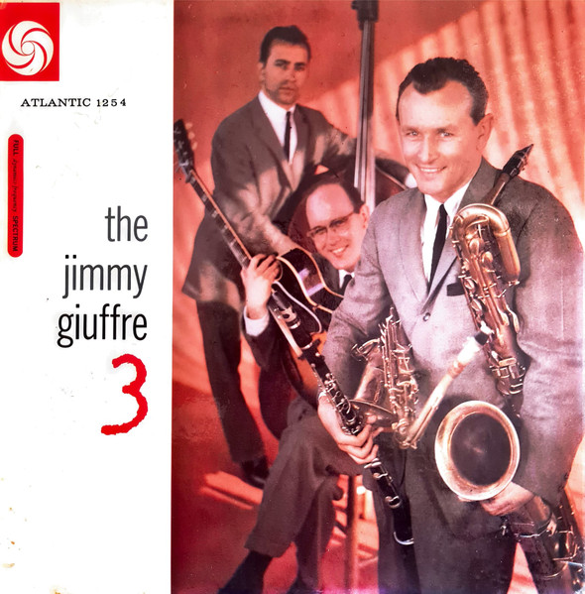

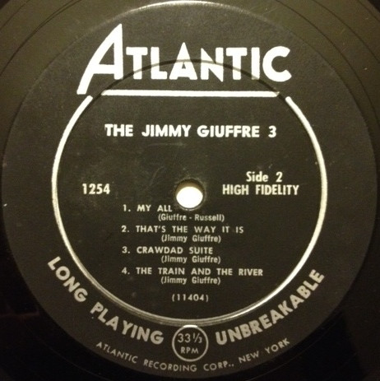

15. California, Here I Come (Al Jolson-Buddy DeSylva-Meyer) 2:42
Jimmy Giuffre Trio: Jimmy Giuffre-bs; Bob Brookmeyer-vtb; Jim Hall-g.
Atlantic Studios, New York City, January 23, 1958
LP Atlantic 1282 / 2934 * CD issue as last

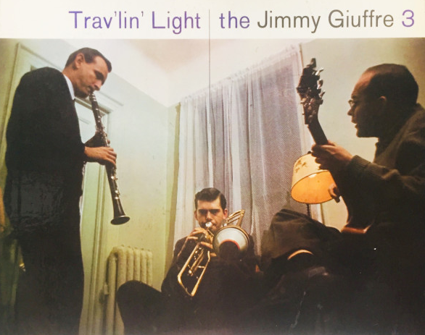
Bob Brookmeyer (1929 – 2011)

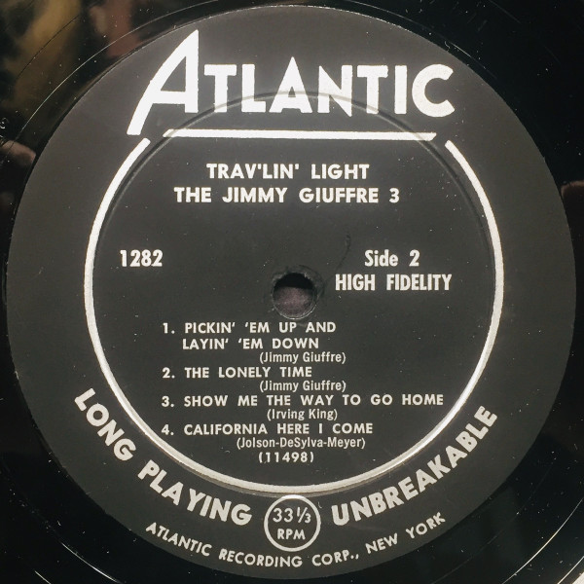

16. Four Brothers (Jimmy Giuffre) 3:25
Jimmy Giuffre Trio: Jimmy Giuffre-ts (4 overdubbed); Bob Brookmeyer-p; Jim Hall-g.
Lenox, Massachusetts, September 1, 1958
LP Atlantic 1295 / 3152 * CD issue as last
https://secondhandsongs.com/performance/11538

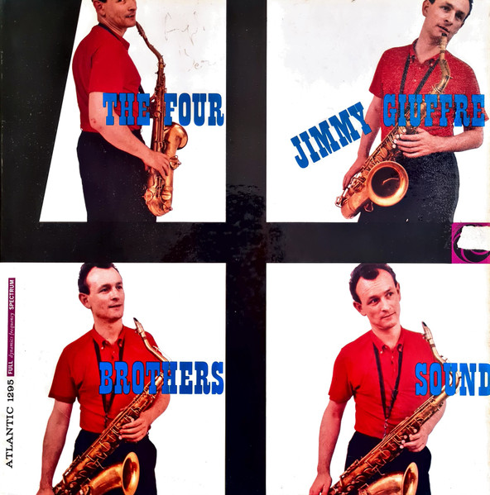

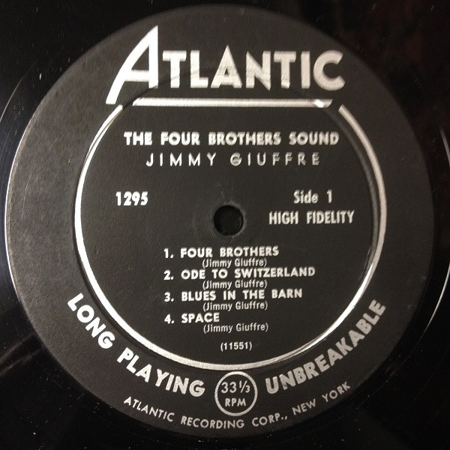

17. Hip (Hampton Hawes) 6:19
Hampton Hawes Quartet: Harold Land-ts; Hampton Hawes-p; Scott LaFaro-b; Frank
Butler-dr.
Los Angeles, March 17, 1958
LP Contemporary M3589, S7589 / no matrix * CD Essential Jazz Classics EJC 55557 (2012)

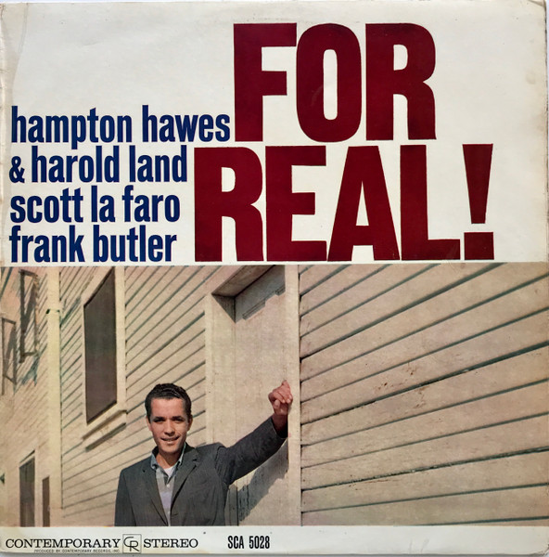

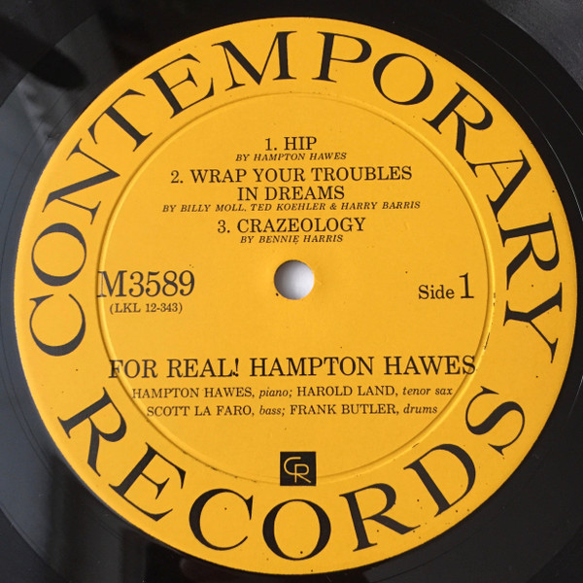

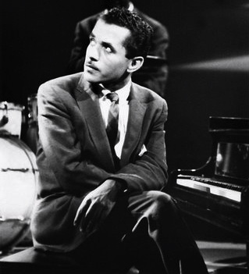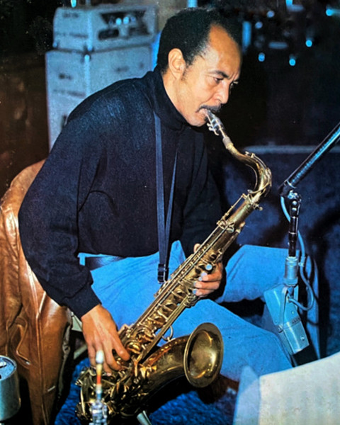
Hampton Hawes (1928 – 1977) Harold Land (1928 – 2001)

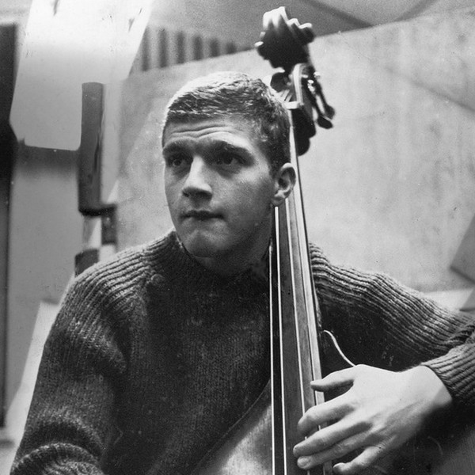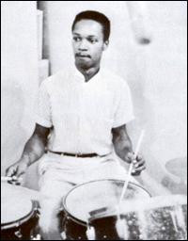
Scott LaFaro (1936 – 1961) Frank Butler (1928 – 1984)

18. Bass Blues (John Coltrane) 15:18
Victor Feldman Quartet: Richie Kamuca-ts; Victor Feldman-p; Scott LaFaro-b; Stan
Levey-dr.
Live at The Lighthouse, Hermosa Beach, CA, September 1958
previously unreleased * CD Fresh Sound FSR-CD 370 (1992)

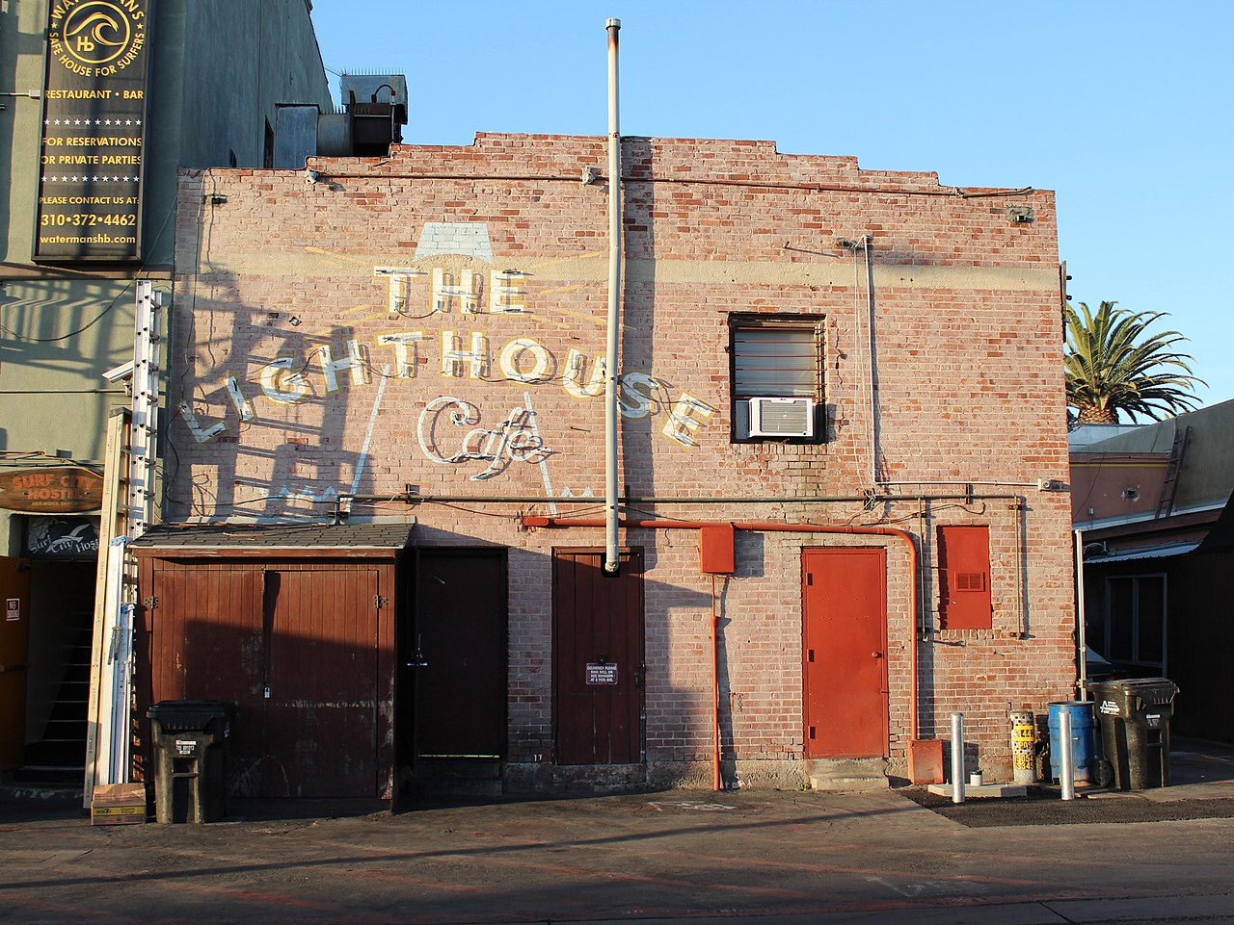

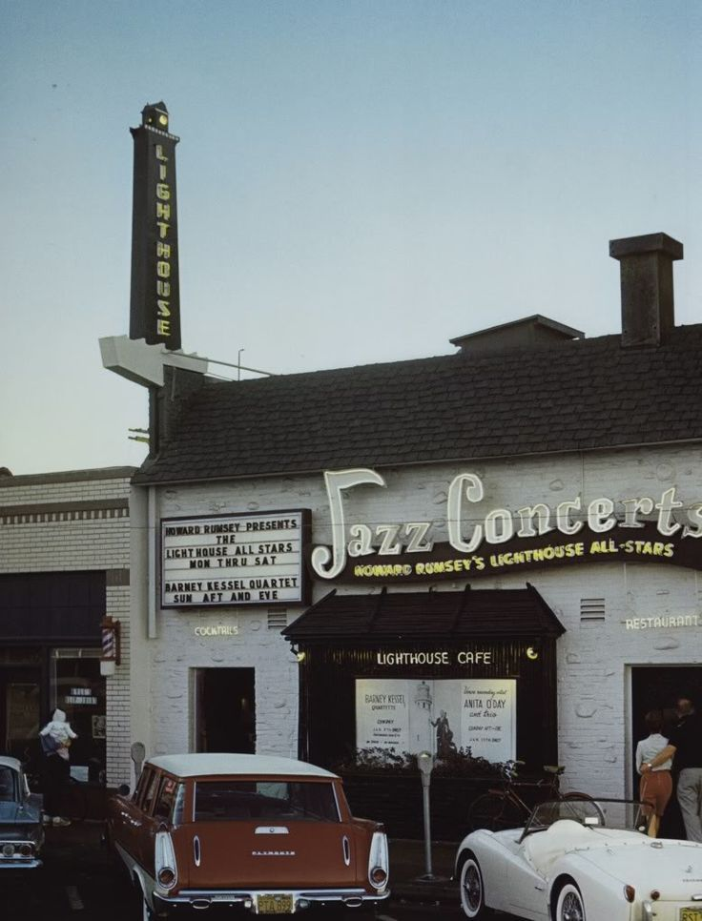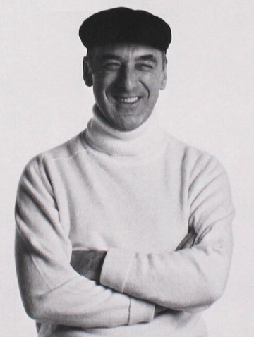
Lighthouse Victor Feldman (1934 – 1987)

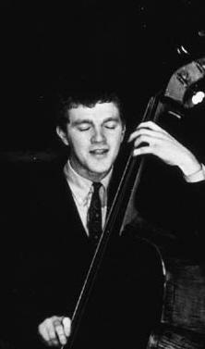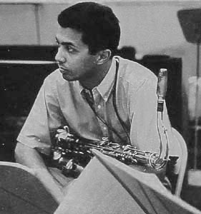
Scott LaFaro (1936 – 1961) Richie Kamuca (1930 – 1977)

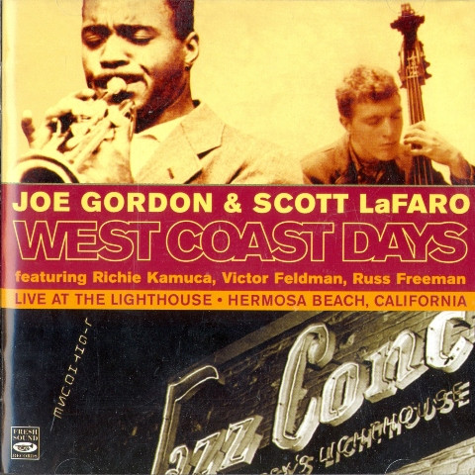

19. Thanks for the Memory (Ralph Rainger-Leo Robin) 3:48
Serge Chaloff Quartet: Serge Chaloff-bs; Sonny Clark-p; Leroy Vinnegar-b; Philly Joe
Jones-dr.
Capitol Studios, Los Angeles, March 14, 1956
LP Capitol T 742 / 15154 * CD Capitol Jazz 7243 4 94505 2 3 (1998)
https://secondhandsongs.com/performance/128659

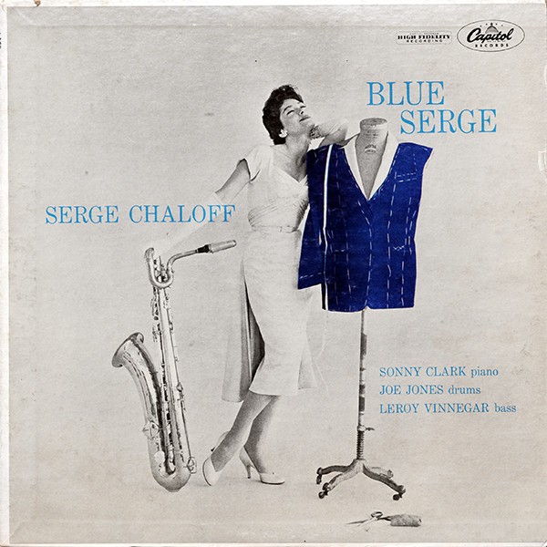

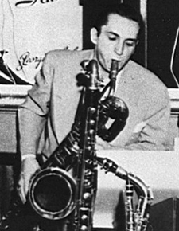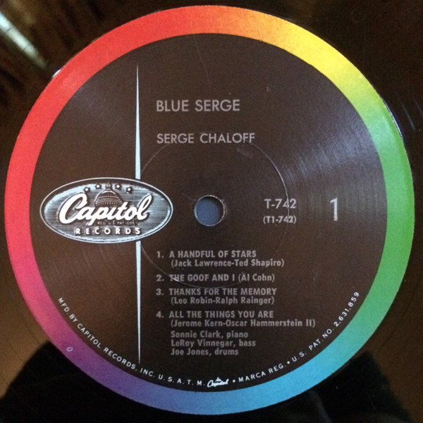
Serge Challof (1923 – 1957)

