https://www.youtube.com/watch?v=xJ46FcIrY4M -To je Lviv
https://www.youtube.com/watch?v=b4rcaRKl19s – Viktor Morozov
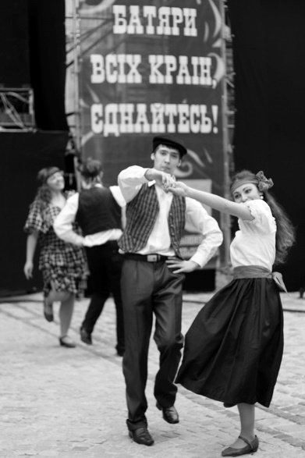
https://www.youtube.com/watch?v=iV_4XvldJw0 - Chervona Ruta - Zinkevych, Yaremchuk, Ivasyuk

