SKELETAL SYSTEM 

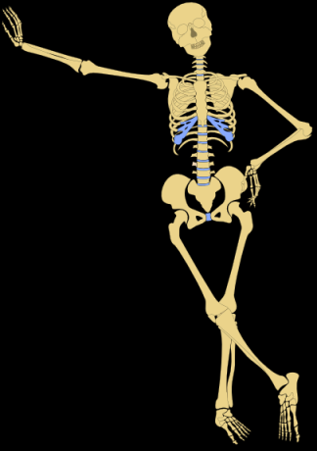
- bone, bone tissue, joints
  - types of bones
    - long
    - short
    - flat
    - irregular
  - bone calcium storage
  - bone structure
    - bone matrix
    - bone marrow
  - joint structure and cartilage
    - types of joints
    - types of cartilage
    - ligaments and tendons (vazivo a šlachy)
- axial skeleton
  - skull, face, inner ear
  - chest
  - vertebral column/spine
(páteř, obratle páteře)
- appendicular skeleton
  - bones of the shoulder
  - bones of the upper extremity (končetiny)
  - bones of the pelvis
  - bones of the lower extremity

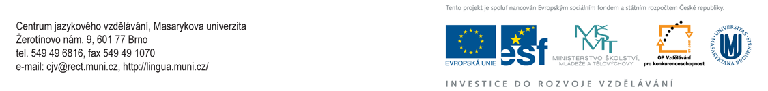

- Listen to the recording and put the items in correct order.
http://videos.howstuffworks.com/hsw/25404-human-body-the-skeletal-system-video.htm

protection of various organs
ligaments
arthroscopic surgery
cartilage
responsible for movement

joints
bone marrow
reservoirs for important minerals
support of the soft tissues

- Listen again and complete the gaps
  - The skeletal system ______________ a number of important roles in the body.
  - The most obvious are the support of the soft tissues of the body, the protection of various organs like the brain by the ______________, and the heart, lungs and other organs by the ______________ cage.
  - The skeletal system in ______________ with the muscle system is responsible for movement.
  - Tough bands of tissue called ligaments, as well as other connective tissues, ______________ bones ______________ at moveable joints.
  - At the ends of the bones there is a ______________ smooth surface called cartilage.
  - The cartilage is lubricated by a special body ______________.
  - Arthroscopic surgery ______________ doctors ______________ go in and repair joint tissues.
  - The bones of the skeletal system also ______________ two other critical functions, they ______________ ________reservoirs for important minerals.
  - Blood cells are ______________ in the bone marrow.

- Read the information on the skeletal system below. Then work in pairs and describe the skeleton and its role in the body. The expressions in the grey boxes are at your disposal.

Bones
- provide storage for calcium
- are the formation site for red and white blood cells,
- provide structural support and protection for the body´s internal organs

Calcium
- is stored primarily in bones and is released into the blood in response to hormones.
- is needed for one development, blood clotting, normal muscle and nerve activity,

Bone marrow
- is the site of red blood cells, white blood cell and platelet production (pleitlit)

Joints facilate movement between bones
Cartilage is a type of dense connective tissue
Ligaments and tendons connect muscle to bone or bones together

The axial skeleton
- provides structural support for the body
- provides attachment points for ligaments and muscles
- protects the brain, spinal cord and major organs of the chest.
- includes bones of the skull, inner ear, chest and spinal column

The appendicular skeleton
- is connected to the axial skeleton
- protects the organs of digestion, excretion and reproduction
Bones of the shoulder: The shoulder joint provides a connection between the chest and the arm.
Bones of the pelvis: The pelvis is located at the base of the spine and contains two sockets for articulation with the lower extremities.

VERBS

be composed of
consist of
be made up of
make up
contain
include
be linked to
have
divide into
arrange
extend from ... to ...
extend between
lie
enclose
protect
be connected by
connect ... to ...
allow to
cushion
be bound together
bind together
be located
span
be separated by
be attached to
control movement
support
join ... to ...
form st
provide attachments to

NOUNS

type
kind
sort
category
component
feature
structure
system
group
criterion,
pl.criteria

COLLOCATIONS

at the lower end of ... there are ...
above ... on either side are
down the sides of
along the sides of
its function is to
be the centre of
at the back of
similar to
different from
the same as
the front surface of

HOMEWORK

The following "odpovědníky" are available in IS (including the information on scoring). These tasks are compulsory.
https://is.muni.cz/auth/el/1431/jaro2010/JAB02/odp/HB_Skeletal_system_test.qref
https://is.muni.cz/auth/el/1431/jaro2010/JAB02/odp/HB_Skeletal_system_Video.qref

Sources:
http://www.rapidlearningcenter.com/biology/ Accessed Feb 6, 2010 http://www.innerbody.com/image/skelfov.html Accessed Feb 10, 2010 http://openclipart.org/people/metalmarious/metalmarious_Human_Skeleton%28Outline%29.png
http://videos.howstuffworks.com/hsw/25404-human-body-the-skeletal-system-video.htm Accessed Feb 17, 2010

