The Victoria Glacier in the Rocky Mts - Task list to CBS report

Glacier National Park
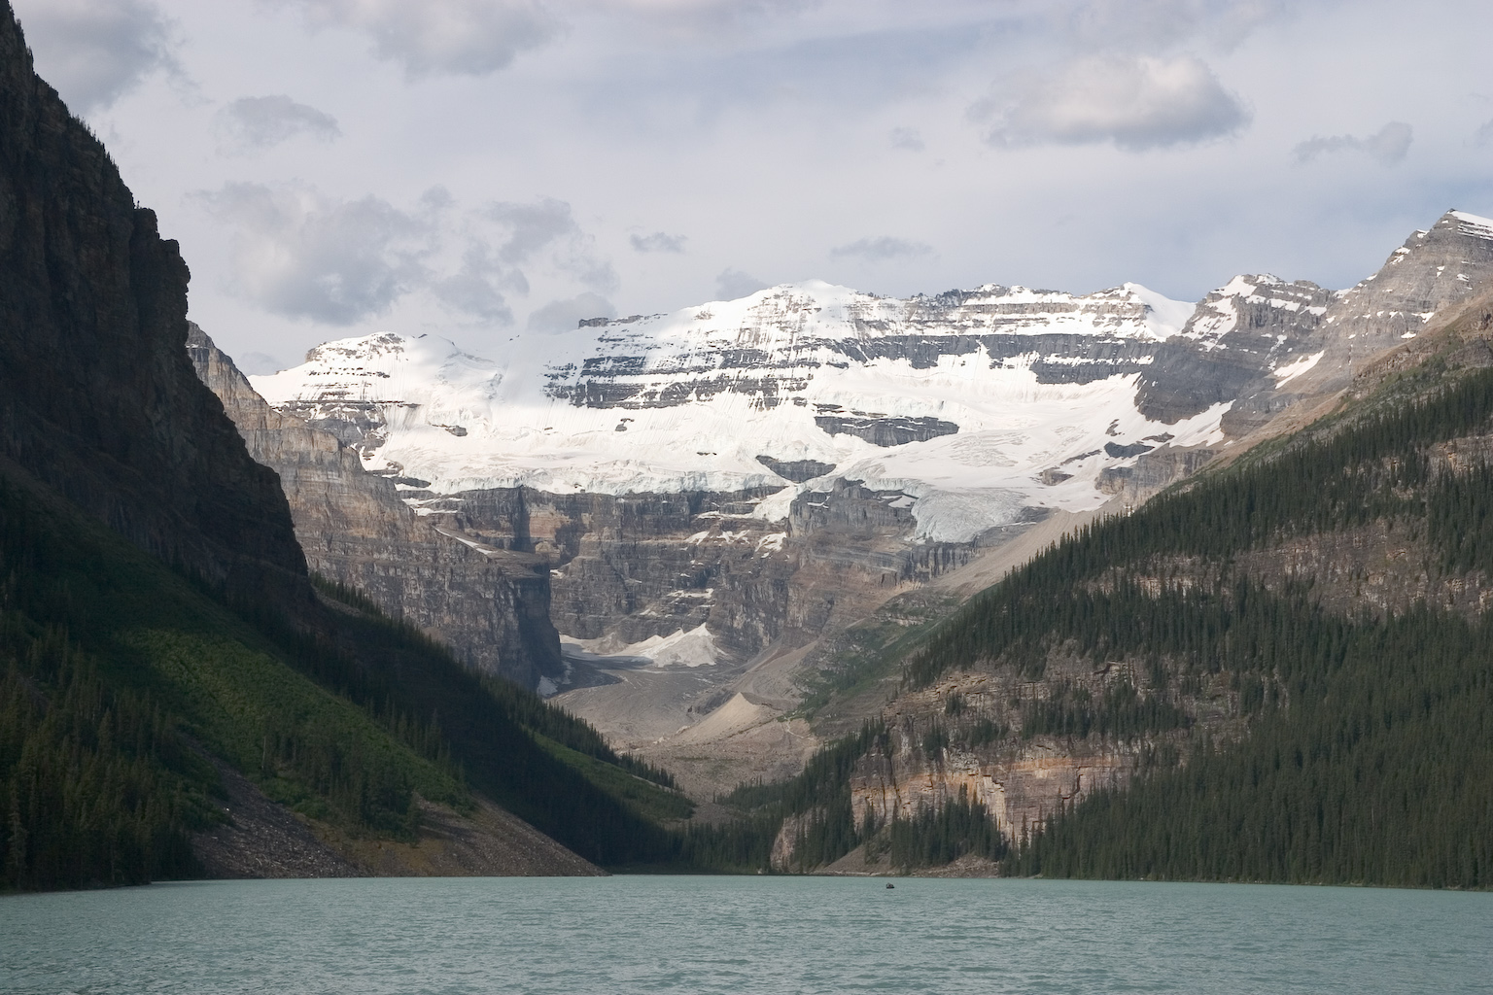

This is Mt. Victoria, looking across Lake Louise from the Chateau at the northeast end. The Victoria Glacier, mostly covered with rock at the bottom, can be seen flowing down the valley just left of center. The Plain of Six Glaciers Trail lookout is at the top of the upper scree slope to the right of the glacier.
Listen to the report and answer the following questions:
- What is the difference between the two glaciers on Mount Victoria which are being discussed at the very beginning of the report?
- Can the retreating of the glacier change the color of the lake it used to fill?
- What effect will the retreating glacier have on the area round the lake?

