SCIENTIFIC METHOD

- Pre-listening. In the following video five steps of the scientific method are mentioned. Put them in the right order. E.Čoupková, English for Students of Mathematics

HYPOTHESIS CONCLUSION QESTION EXPERIMENT RESEARCH

- These verbs combine with the steps. Match the verbs and nouns.

Come up with design conduct
Do ask reject
Form test pose
Draw carry out prove

- Watch the video and answer the questions.
https://www.youtube.com/watch?v=bNc9vWLDSCA

- What is important for doing science according to the speaker?
- What approach do scientists have in doing research?
- What question does the speaker pose?
- What is the difference between scientific and non-scientific hypothesis?
- What hypothesis does the speaker come up with?
- What experiment would he design?
- How did the student deal with the conclusion?
- What difference is there between a hypothesis and a theory?
- What is similar about hypothesis and a theory?
- Which example of rejected theory is mentioned?

5. Definitions. Look at the diagram and define the terms:
1. Hypothesis

2. Theory

3. Law

https://web.archive.org/web/20060526174713/http://pasadena.wr.usgs.gov/office/ganderson/es10/lectures/lecture01/lecture01.html
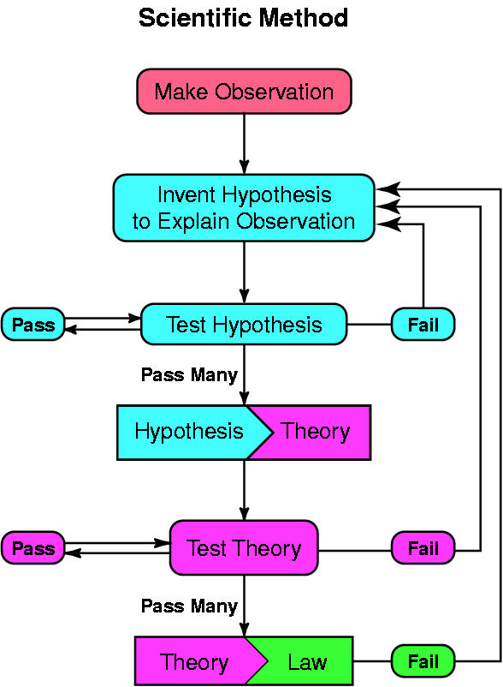

6. What are some of the areas generally considered pseudo-science?

7. Match the examples with explanations
1. Crypto-zoology | A a method of finding water, metals, or precious stones underground by using a divining rod
2. Psychoanalysis | B a system for treating illnesses that uses very small amounts of substances that would in larger amounts produce symptoms of the illnesses in healthy people
3. Astrology | C receiving data through seeing or hearing, while not being aware of receiving it
4. Homeopathy | D belief that humans are affected by the position of celestial bodies
5. Subliminal Advertising | E a method of studying the mid and treating and treating disorders based on revealing and investigating the role of the unconscious mind
6. Dowsing | F search for Bigfoot (Yeti), the Loch Ness monster, Chupacabra and other creatures that biologists believe do not exist

8. What characteristics make them different from real science? Think about goals, role of research, testing the beliefs, kinds of support, language.

Read the text and compare your answers. http://chemwiki.ucdavis.edu/Analytical_Chemistry/Quantifying_Nature/The_Scientific_Method/Science_vs._Pseudo-science%3A_Limitations_of_the_Scientific_Method
SCIENCE | PSEUDO-SCIENCE
Science never proves anything. | Pseudo-science aims to prove an idea.
Self-correcting methodology which involves critical thinking. | Starts with a conclusion and gives easy answers to complex problems.
An on-going process to develop a better understanding of the physical world by testing all possible hypotheses. | Often driven by social, political or commercial goals.
Involves a continual expansion of knowledge due to intense research. | A field has not evolved a lot since the beginning. If any research is done, it is done to justify the claims, rather that expand them.
Scientists constantly attempt to refute other scientists' works. | An attempt to disprove the beliefs is considered hostile and unacceptable.
When results or observations are not consistent with a scientific understanding, intense research follows. | Results or observations that are not consistent with current beliefs are ignored.
Remains questionable at any time. There are two types of theories: those that have been proven wrong by experimentation and data, and every other theory. Thus, no theory can be proven correct; every theory is also subject to being refuted. | Beliefs of the field can not usually be tested empirically so will likely not ever be proven wrong; Thus, Pseudo-scientists believe that they are right just because no one can prove them wrong.
Concepts are based on previous understandings or knowledge. | Pseudo-Scientists are often not in touch with main-stream science and are often driven by the egos of the "scientists". Furthermore, famous names and testimonials are often used for support rather than scientific evidence.
Findings must be stated in unambiguous, clear language. | Pseudo-science often uses very vague, yet seemingly technical terms.

9. Translate: refute ambiguous vague
questionable proven justify

