Poster

**Introducing Substituents on Cucurbiturils**

Markéta Enderesová, Laura Gilberg, Vladimír Šindelář*

*Department of Chemistry and RECETOX, Masaryk University, Kamenice 5, 625 00*

*e-mail: m.enderesova@mail.muni.cz*

Cucurbit[*n*]urils are macrocyclic compounds based on glycoluril monomer units connected by methylene bridges. They are able to bind cations, with biggest interest in ammonium salts, inside the cavity. Challenging is modification of cucurbiturils’ surface. There are known many examples of substituents on glycoluril positions, but one example of methylene bridges modification.1

Here we describes synthesis of cucurbit[6]urils modified on one methylene bridge. They were prepared by reactions of acyclic glycoluril hexamer and various aldehydes introducing substituent and even functional group on cucurbituril structure (Scheme 1).2 We also measured association constants of complexes between prepared cucurbituril and ammonium and diammonium guests.

Scheme 1

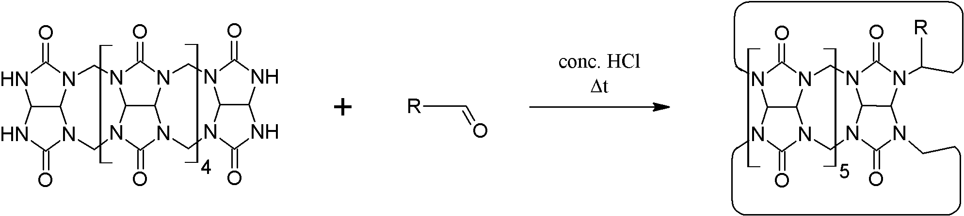

*This work was supported by the Czech Science Foundation (13-15576S).*

(1) Lucas, D.; Minami, T.; Iannuzzi, G.; Cao, L.; Wittenberg, J. B.; Anzenbacher, P.; Isaacs, L. *J. Am. Chem. Soc.* **2011**, *133* (44), 17966.

(2) Gilberg, L.; Khan, M. S. A.; Enderesova, M.; Sindelar, V. *Org. Lett.* **2014**, *16* (9), 2446.