Studijní materiál ke kap. 6
Výtah z
Climate in the past and present in the Czech Lands (Central European Context)
Jan Hradecký – Rudolf Brázdil
In: Pánek, T., Hradecký, J.: Landscapes and Landforms of the Czech Republic. World Geomorphological Landscapes. Springer, Dordrecht 2015

Tertiary climate of Central Europe
Unlike the subsequent period of the Quaternary, climatic conditions of the Tertiary were greatly different and led to the morphogenesis of different landforms that can be identified in the landscape of the Czech Republic even nowadays. Sediments that fill basin structures of the Czech Republic, namely organogenic sediments of the rank of coal (e.g. in Mostecká pánev Basin), are other important evidence of different climatic conditions of the Tertiary. From the point of view of palaeogeography, very important sediments are Miocene formations of the Carpathian Foredeep. Terciary climate was characterised by the alternation of warmer and colder oscillations with a tendency towards gradual cooling (Chlupáč et al. 2002). Climate has been reconstructed in the Wiesselster Basin in the vicinity of the border between Bohemia and Germany. Palaeobotanical analyses show that the climate in Central Europe in the period from the Middle Eocene to Lower Oligocene was tropical mean annual temperature ranged from 23°C to 25°C, mean annual precipitation from 1,000 mm to 1,600 mm and cold month mean (CMM) from 17°C to 21°C (Mosbrugger et al. 2005). Lower temperatures are associated with a majority of the Oligocene period with CMM around 5°C, while the latest Chattian was marked by a temperature peak which was recorded by Mosbrugger et al. (2005) from the Lower Rhine Basin. This peak corresponds to the Late Oligocene Warming known from isotope records (Zachos et al. 2001). The warmest period of the Neogene was the Miocene (Chlupáč et al. 2002) in which the trend of warming continued up to the Middle Miocene. This warming seems to be rather stepwise, while the curves show several short-term variations. In the Weisselster Basin record there is evidence of short-term cooling at the base of the Aquitanian (Mosbrugger et al. 2005). The temperature peak in Central Europe of the Middle Miocene corresponds to the Middle Miocene Climatic Optimum that is observed globally. After Mosbrugger et al. (2005), the Miocene cooling seems to be between 13.0 and 14.0 Ma when considering all different records and analysed climate variables. In the Molasse Basin, CMM decreased more rapidly than in both other regions, and, at the end of the Middle Miocene, CMM dropped below 4°C. The transition between the Miocene and the Pliocene shows a gradual trend in climate cooling. During the Late Pliocene the cooling intensified and CMM fell below the freezing point (Mosbrugger et al. 2005).
Quaternary climatic cycle
Quaternary evolution in Central Europe is connected with fundamental changes in environmental conditions and essential palaeogeographic changes that were related to the transgression of the continental glacier, temperature drop and changes in morphogenesis.
A comprehensive overview of landscape evolution is brought by Quaternary climate and sediment model compiled by Ložek (1973, 1999 a, b, 2007). The author characterises the evolution using four phases (Fig. X.1): early glacial period, pleniglacial period, late glacial and interglacial. It is evident that global trends of the climate system oscillation were reflected in regional cycles. On the basis of an extensive set of data of Quaternary sediments Ložek (1999a, b) was able to derive a rather general model that characterises not only climate parametres but it also points to the conditions of the evolution of soils and vegetation and the processes of weathering and material deposition. The four phases of Ložek`s model are described below.
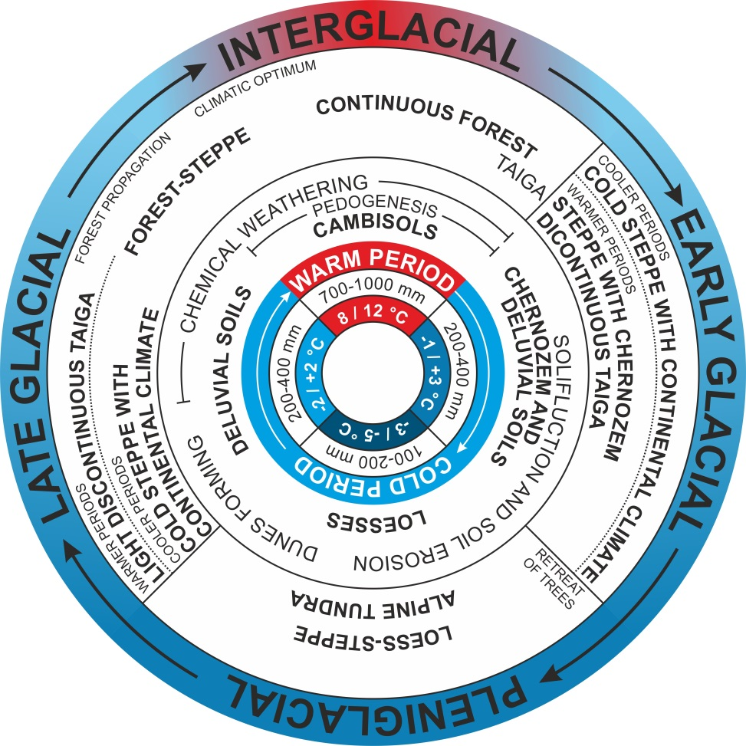
Fig. X.1 Simplified Quaternary climate and sediment model compiled by Ložek (2007)
The phase of early glacial is characterised by the onset of cold climate. Mean annual temperatures range between +3°C and -1°C depending on the location. Cooling brings a distinct decline in precipitation (mean annual precipitation totals are estimated to 200 – 400 mm). The landscape undergoes gradual aridization, which becomes evident in pedogenesis and vegetation composition. Interglacial forests are divided into smaller units whose species composition changes towards a boreal forest (taiga). Conifers start to appear, while the species of Central European temperate forest are in recession. Very dry periods bring forth chernozem steppes. The transformation of ecosystems gradually gives rise to cold continental steppes in which grasses and chernozems prevail. Temperatures and precipitation totals continue to decrease, while the cycle passes into the phase of the so-called pleniglacial.

Pleniglacial phase is characterised by the transgression of the continental glacier and conditions of periglacial climate in a great part of the territory. Glaciers start to appear in the topmost areas of mountain ranges and the continental glacier expands into the northernmost parts of the territory. Mean annual temperatures drop to -3°C to -5°C, which leads to the occurrence of permafrost. Tree vegetation recedes considerably, while groups of trees only survive in protected areas of vanish totally. The development of vegetation is limited by very low precipitation total ranging between 100 and 200 mm per year. Cold and dry climate is marked by strong atmospheric flow and loess deposit in our territory. This fact leads to the formation of cold loess steppes. However, the foreground of the glacier or higher locations witnesses the formation of tundras or sub-alpine ecosystems with developing cryogenic soils. Soil-forming substrates are very rich in salts and calcium carbonate, which leads to the spreading of halophile and calciphile species. The character of non-glaciated parts of the landscape is significantly affected by intensive congelifraction, presence of permafrost and gelifluction. The period of low temperature is replaced by gradual warming of the climate, which leads to temperature oscillation. The landscape starts to enter the period of late glacial.
Mean annual temperatures in late glacial phase are still relatively low and ranging between 2°C and +2°C, however, the warming trend and increasing humidity are evident (200 – 400 mm). The climate is characterised by significant instability, which is reflected by the fact that cold continental steppes are preserved at many places, while the onset of thermophilic vegetation is very slow. Degradation of permafrost makes itself felt both by the increase in the thickness of its active layer and gradual decompostion of continuous permafrost areas into isolated permafrost patches. The retreat of the continental glacier along with the deglaciation of the highest mountain ranges brings fundamental changes in environmental conditions. Periods of warm oscillations make conditions for light discontinuous taiga with birch, pine and sea-buckthorn. Colder phases still witness the occurrence of cold continental steppe. Large accumulations of material weathered during cold periods start to be influenced by chemical weathering. Towards the end of the late glacial, forest species start to appear and the area covered by forests gradually extends in the landscape of Central Europe.
Interglacial phase is a phase of warm climate. Annual temperature means increase greatly (8°C-12°C) and the climate becomes more humid (700 – 1000 mm per year). The landscape changes fundamentally. With the onset of climatic optimum the open landscape is gradually closed by the Central European forest that replaces forest-steppe communities. Soils rich in calcium enable intensive spreading of basophilic species and high temperatures predetermine the spreading of xerophilic communities. Intensive chemical weathering and leaching alkali out of soil gradually gives rise to cambisols. Forest formations change regarding the species and gradual acidification of the surroundings facilitates the spreading of acidophilic species. The continuous forest reaches the phase of species optimum. However, the climatic system undergoes further development and enters the phase of cooling, which involves the spreading of cold-loving species, acidification intensifies and taiga spreads in the landscape.

Quaternary climate in Central Europe
Climate cooling at the end of the Tertiary led to the evolution of the Pleistocene characterised by the alternation of cold (glacials) and warm (interglacials) periods. With the use of marine isotope stages (MIS) it is possible to identify 104 stages of cool (52) or warm (52) climate periods during the whole Quaternary (and 103 MIS within the Pleistocene). Early Pleistocene was characterised by the mean annual temperature below 0°C; however, this very old period in Central Europe is not covered well by precise data. On the basis of geomorphological proxy data, Czudek (2005) estimates that during cold phases of the Early Pleistocene mean annual temperatures dropped to -3°C to -4°C. The formation of cryogenic structures in the southern Moravia can indicate mean monthly temperatures of the coldest month to -20°C., which would point to the occurrence of continuous permafrost (Vandenberghe 2001 b). With respect to the climate of our territory, there is relatively little information on the Middle Pleistocene. Our conclusions are again drawn from proxy data (e.g. ice wedges and a range of pseudomorphoses). Mean annual temperature is estimated to -5°C. Temperatures of the coldest months were on average around -20°C or even lower. The Late Pleistoce was characterised by the peak in periglacial landform-shaping processes in the territory of the Czech Republic (Czudek, 2005). In the Eemian interglacial period mean annual temperatures were around 13°C and the climate was very humid (Czudek, 2005). Subsequent cooling of the Vistulian glacial again brought mean annual temperatures below the freezing point (-2 až -5°C). The greatest drop in temperatures came in the pleniglacial (73 – 13 ka BP) when in the phase of the Last Glacial Maximum (LGM) mean annual temperatures were -6 to -8°C; mean January temperatures ranged between -18°C and -20°C. The warmest summer months reached temperatures between 5°C and 6°C (Czudek 2005). Ložek (1999a) states that the climate had a greatly continental character with long and cold winters, short springs but relatively warm summers. He further mentions that annual precipitation totals ranged between 100 and 200 mm and they occurred particularly in the warm part of the year. An interesting approach in the reconstruction of conditions of the environment during the LGM is brought by the study of Corcho Alvaradoa et al. (2011) in which a drop in temperatures by 5-7°C was confirmed by the analysis of dissolved noble gases in groundwater of the Bohemian Cretaceous Basin, the Czech Republic. The end of the Pleistocene (Late Pleistocene) was characterised by a distinct increase in temperatures; however, with considerable oscillation between interstadials (bölling and alleröd) and stadials (Older and Younger Dryas). Mean annual temperatures in interstadials ranged between 2°C and 5°C, while during stadials they were around -2 to -3°C (Czudek 2005).
Warming at the end of the Younger Dryas brought radical changes into the environment parametres. Considerable retreat of the glacier led to the onset of the Holocene interglacial. The climate warming was accompanied by increased precipitation activity that accelerated the vegetation and changes in the pedogenetic conditions, weathering and relief evolution. Individual chronozones of the Holocene landscape evolution are shown in Fig. XX including reconstructed temperatures and precipitation totals after Ložek (2007) and Starkel (1990a). In the Preboreal (10 300 – 9 300 BP) mean annual temperature was by c. 3°C lower than nowadays. Continuing continental climate is warmed in the course of the Preboreal (9300 – 8400 BP); mean annual temperature is by 2-3°C higher than nowadays (Czudek, 2005).
Climatic optimum was reached in the Atlantic (8400-5100 BP) in which the mean annual temperature was up to 3°C higher (Czudek, 2005). An important characteristic of the Atlantic climate was significantly higher precipitation activity, namely by 100%, if compared with nowadays (Ložek 1999c). The beginnings of the Subboreal (5100-2400 BP) were by 1°C warmer than the present-day mean. The main feature of the Subboreal period was ambivalence and drier periods alternating with more humid ones and warmer periods alternating with colder ones (Czudek 2005). The period of the Subatlantic (2400 BP – the present day) brought cooling and, at the same time, increased precipitation (Ložek 1999c). Humid phases of the climate are reflected in the landslide phase in the Carpathian part of the Czech Republic (Pánek et al. 2010) that also corresponds with the Polish landslide activity chronology (Fig. X.2).
The latest pollen data proxies and the relationship of pollen and the climate changes during Holocene are brought by the research of Veron et al. (2014) from the peat bog of Boží Dar (Krušné hory Mts). The authors confirm very cold Late Glacial dominated by Cyperaceae grass land (12.5–11.0 kyr BP), the Early-Holocene warming and the onset of Pinus (B, 11.0–9.0 kyr BP). During the Boreal the temperature increased with an increase in the shade-intolerant Corylus and a concurrent decrease in Pinus (C, 9.0–8.1 kyr BP). The Atlantic chronozone is clasified as the warmest and wettest period of the Holocene characterised by the species of Alnus and Fraxinus (8.1–4.3 kyr BP). The following Sub-Boreal chronozone was detected as drier and possibly colder and characterised by the decline in temperature-sensitive species (<4.3 kyr BP). Similar results of temperature trends were brought by the synthesis of pollen data proxies of all Central Europe made by Davis et al. (2003).
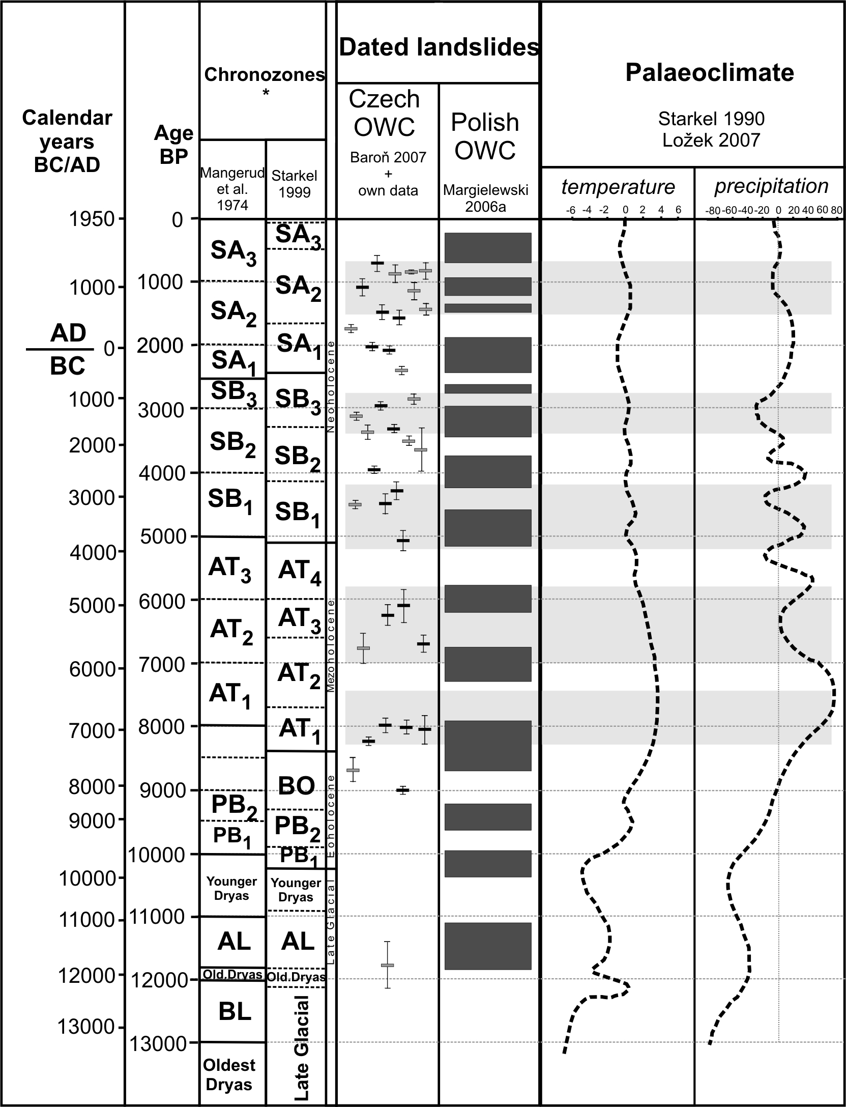
Fig. X.2 Correlations of dated landslides (both in the Czech and Polish parts of the Flysch Carpathians) with palaeoclimate (Pánek et al. 2010). The scheme is based on a diagram performed by Margielewski (2006); time-span of individual chronozones after Mangerud et al. (1974) and Starkel (1999); dated landslides in the Czech part of the Outer Western Carpathians (OWC) after Baroň (2007) (20 cases - black boxes) and dating performed by the authors of this study (15 cases - gray boxes); dated landslides (landslide phases derived from the dating of 67 landslides) in the western part of the Polish Outern Western Carpathians after Margielewski (2006); palaeotemperature and palaeoprecipitation after Starkel (1990). Despite the fact that landslides occurred in the Czech part of the OWC throughout the entire Late Glacial and Holocene, significant landslide aktivity clusters (horizontal grey bars) are correlated to periods characterized by high precipitation/low temperature.
Conclusion
The Czech Republic is located at the transition area where the climate is a result of the interaction of both maritime and continental air masses. The geographical position was crucial during the geological history and therefore the palaeoclimate was influenced by transgressions and regressions of the continental glacier. The palaeoclimate oscillations and historical fluctuations were reconstructed with the use of various proxy data. It is evident that a very important role in the evolution of landforms was played by warm and wet climate of the Tertiary. A complete change started at the end of the Tertiary when the climate pattern changed into Quaternary oscillations between colder and drier periods of the glacials and warmer and wetter periods of the interglacials. Climate changes created conditions for the evolution of periglacial landforms and limited areas were affected by glacier action (the highest mountains were glaciated and the northernmost areas of the Czech Republic were covered by masses of the Scandinavian ice sheet (Elsterian and Saalian glacials). Extreme temperatures during the whole Pleistocene are connected with the Last Glacial Maximum (73 – 13 ka BP) when mean annual air temperatures oscillated between ˗6°C and -8°C. The Holocene started with higher temperatures and higher precipitation and this fact led to the evolution of vegetation formations and the changes in landform evolution. Human activities during the Post-Atlantic landscape created new conditions for the acceleration of alluviation under more humid climate.
References

Baroň I, (2007) Výsledky datování hlubokých svahových deformací v oblasti Vsetínska a Frýdeckomístecka. Geologické výzkumy na Moravě a ve Slezsku v roce 2006, pp. 10–12.

Corcho Alvaradoa JA, Leuenberger M, Kipfer R, Pacese T, Purtschert R (2011) Reconstruction of past climate conditions over central Europe from groundwater data. Quaternary Science Reviews 30:3423–3429
Czudek T (2005) Vývoj reliéfu krajiny České republiky v kvartéru. Moravské zemské muzeum, Brno, 240 p
Davis BAS, Brewer S, Stevenson AC, Guiot J, Data Contributors (2003) The temperature of Europe during the Holocene reconstructed from pollen data. Quternary Science Reviews 22:1701-1716
Grove JM (2004) Little Ice Age: Ancient and Modern. Routledge, London, 718 p
Chlupáč I, Brzobohatý R, Kovanda J, Stráník Z (2002) Geologická minulost České republiky. Academia, Praha, 438 p.
Ložek V (1973) Příroda ve čtvrtohorách. Academia, Praha, 372 p
Ložek V (1999a) Ochranářské otázky ve světle vývoje přírody, 1. část – Okno do minulosti – klíč k problémům současnosti. Ochrana přírody 54:7–12
Ložek V (1999b) Ochranářské otázky ve světle vývoje přírody, 2. část – Vývoj současných ekosystémů. Ochrana přírody 54:35–40
Ložek V (1999c) Ochranářské otázky ve světle vývoje přírody, 5. část – Holocén a jeho problematika. Ochrana přírody 54:131–136
Ložek V (2007) Zrcadlo minulosti – Česká a slovenská krajina v kvartéru. Dokořán, Praha, 200 p
Mangerud J, Andersen ST, Berglund B, Donner J J (1974) Quaternary stratigraphy of Norden, a proposal for terminology and classification. Boreas 3:109–126

Margielewski W 2006a. Records of the Late Glacial – Holocene palaeoenvironmental changes in landslide forms and deposits of the Beskid Makowski and Beskid Wyspowy Mts. Area (Polish Outer Carpathians). Folia Quaternaria 76:1–149

Matthews JA, Briffa KR (2005) The ‘Little Ice Age’: Re-evaluation of an evolving concept. Geografiska Annaler 87A:17–36
Mosbrugger V, Utescher T, Dilcher DL (2005) Cenozoic continental climatic evolution of Central Europe. PNAS 102: 14964–14969
Pánek T, Hradecký J, Minár J, Šilhán K. (2010) Recurrent landslides predisposed by fault-induced weathering of flysch in the Western Carpathians. Weathering as a Predisposing Factor to Slope Movements. In: Calcaterra D, Parise, M (eds) Weathering as a Predisposing Factor to Slope Movements. Geological Society, London, pp. 183-199
Starkel L (1990) Stratygrafia holocenu jako interglacjału. Przegląd Geologiczny, 38:13–16

Starkel L (ed) (1999) Geografia Polski – środowisko przyrodnicze. Wydawnictwo Naukowe, PWN, Warszawa, 669 p
Stocker TF, Qin D, Plattner G-K, Tignor MMB, Allen SK, Boschung J, Nauels A, Xia Y, Bex V, Midgley PM (eds) (2013) Climate Change 2013: The physical science basis. Working group I contribution to the Fifth assessment report of the Intergovernmental panel on climate change, Cambridge University Press, Cambridge, UK, 1535 p
Svensson A, Andersen KK, Bigler M, Clausen, HB, Dahl-Jensen D, Davies SM, Johnsen SJ, Muscheler R, Parrenin F, Rasmussen SO, Roethlisberger R, Seierstad I, Steffensen JP, Vinther, BM (2008) A 60 000 year Greenland stratigraphic ice core chronology. Climate of the Past 4: 47-57.
Vandenberghe J (2001) Permafrost during the Pleistocene in the north west and central Europe. In: Paepe R, Melnikov VP, van Overloop E, Gorokhov VD (eds) Permafrost response on economic development, Environmental security nad natural resources, Kluwer, pp. 185–194
Veron A, Novak M, Brizova E, Stepanova M (2014) Environmental imprints of climate changes and anthropogenic activities in the Ore Mountains of Bohemia (Central Europe) since 13 cal. kyr BP. The Holocene 24:919–931

Vinther BM, Jones PD, Briffa KR, Clausen HB, Andersen KK, Dahl-Jensen D, Johnsen SJ (2010) Climatic signals in multiple highly resolved stable isotope records from Greenland. Quaternary Science Reviews 29: 522-538

Zachos J, Pagani M, Sloan L, Thomas E, Billups K (2001) Trends, rhythms, and aberrations in global climate 65 Ma to present, Science, 292:686–693

