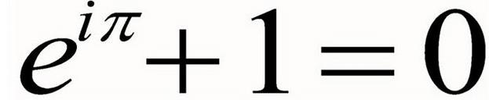
https://www.youtube.com/watch?v=AuA2EAgAegE
Pre-listening tasks.
- What is a mathematical constant? …………………………………………..
- Complete the missing information.
- Archimedes’constant …..
- ………………………. e
- Pythagora’s constant …..
- ……………………….. i
- The Feigenbaum constants …
- Apéry’s constant ………..
- The golden ratio ………
- The Euler-Mascheroni constant …
- …………………………………..
- ………………………………….
- How is the constant e different from π or √2? ………………………………………………..
- What is the constant e related to?.................................................................
- What is compound interest? …………………………………………………
- Imagine that your bank is extremely generous. You have 1 pound on your account and they offer you a 100% interest. How much money will you get if this interest is paid annually ?…………………..
- If you interest is 50% in every six months, is it better or worse? Why? ………………
- What happens if you do that more often? What about every month, week or day? How much will you earn? …………………………………………………………………………………….
- How would you define continuous interest?……………………………………..
- What interest can you get nowadays on savings accounts and how is it calculated? ……………………………………………………………………………………….
Listening. Now listen to the talk and note other important information about constant e. (when, why, how, where, what)

A Visual Guide to Simple, Compound and Continuous Interest Rates

https://betterexplained.com/articles/a-visual-guide-to-simple-compound-and-continuous-interest-rates/
- Study the first part and try to explain the underlined words – you can use a synonym.
- Complete the missing items in a survey.
Interest rates are confusing, despite their ubiquity. This post takes an in-depth look at why interest rates behave as they do.
Understanding these concepts will help understand finance (mortgages & savings rates), along with the omnipresent e and natural logarithm. Here’s our table:
Words to complete: growth inflation instant principal temperature yield
fixed annual
Term | Formula | Description & Usage
Simple | 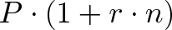 | a)…., non-growing return (bond coupons)
Compound  (b)…….) | 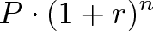 | Changes each year (stock market, c)………)
Compound  (n times per year) | 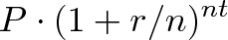 | Changes each month/week/day (savings account)
Continuous d)…….. | 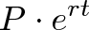 | Changes each e)…… (radioactive decay, f)………)
APR | Annual Percentage Rate (compounding not included)
APY | Annual Percentage g)……….. (all compounding effects included)
- P = h)……., your initial investment (i.e., $1,000)
- r = interest rate (i.e., 5% per year)
- n = number of time periods (i.e., 3 years)
- Have a look at graphs which show several kinds of interests. Try to suggest some key words for each graph and explain what happens. Add signposting language and present those three graphs.
- Try to consider and answer three questions. Explain your answers.
- Is a 4.5 APY better than a 4.4 APR, compounded quarterly? ………………..
- Should I pay my mortgage at the end of the month, or the beginning?.............
- Should I use several small payments, or one large payment?.............................

a)
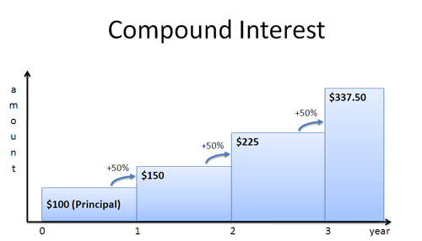
b)
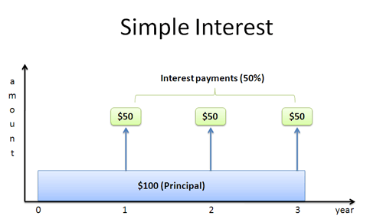
c)
