**Scientific Method**

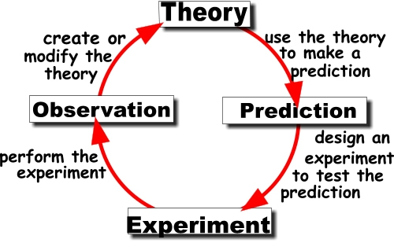

**Warm-up**

**In pairs, discuss the following questions:**

What processes do you need to describe in your field of research?

Which research methods do you use in your field of science?

**I. The scientific method is a process in which experimental observations are used to answer questions. Complete the collocations for describing the stages in the scientific method using the words and phrases in the list below.**

***a hypothesis an experiment (x2) conclusions data (x3) the question***

1. Analyse _________
2. Collect _________
3. Conduct (or run) _______
4. Define ________
5. Design __________
6. Draw __________
7. Form __________
8. Interpret ________

**Number the stages above in the order you would normally do them.**

**II. Hypotheses**

**1.Study and comment on the criteria for judging hypotheses:**

1. Hypotheses should be stated clearly, in correct terminology and operationally.
2. Hypotheses should be testable.
3. Hypotheses should state relationships between variables.
4. Hypotheses should be limited in scope.
5. Hypotheses should not be inconsistent with most known facts.

(Burns, R.B. *Introduction to Research Methods.* Pearson Education 2000.)

**2. Identify methodological mistakes in these hypotheses:**

1. Age determines whether a person is tolerant of social protest.
2. Is democracy the best form of government?
3. Reservoirs have a negative impact on the environment.
4. Nuclear power plants are too expensive.
5. Our universe is surrounded by another, larger universe, with which we can have absolutely no contact.

*Elaborated by Jana Kubrická, Zdeněk Hromádka*

**3. Complete the gaps in the text below with suitable words. Use the verb *falsify* to form words that fit in the gaps. You may use affixes such as un- / -able, etc.**

**Karl Popper**, an influential 20th century philosopher of science, thought that the fundamental feature of a scientific theory is that it should be ______________ . That does not mean that it is false. Rather, it means that the theory makes some definite predictions that can be tested against experience. If these predictions turn out to be wrong, then the theory has been _______________ , or disproved. So a _______________ theory is one that we might discover to be false – it is not compatible with every possible course of experience. Popper thought that some supposedly scientific theories did not satisfy this condition and thus did not deserve to be called science at all; rather they were merely pseudo-science.

Freud´s psychoanalytic theory was one of Popper´s favourite examples of pseudo-science. According to Popper, Freud´s theory could be reconciled with any empirical findings whatsoever. Popper argued that through the use of such concepts as repression, sublimation, and unconscious desires, Freud´s theory could be rendered compatible with any clinical data whatever; it was thus ______________ .

Popper contrasted Freud´s theory with Einstein´s theory of gravitation, also known as general relativity. Unlike Freud´s theory, Einstein´s theory made a very definite prediction: that light rays from distant stars would be deflected by the gravitational field of the sun. Einstein´s theory had made a definite, precise prediction, which was confirmed by observations, so his theory satisfies the criterion of ______________ .

(adapted from Okasha, S. *Philosophy of science.* OUP 2002.)

**III. Listening. Listen to and watch the video. Then answer Qs.** <http://www.youtube.com/watch?v=bNc9vWLDSCA>

1. In the speaker’s opinion, what is important for doing science? …………………………………………………………………………………………
2. What is typical for the scientist regarding his/her attitude to research? ………………………………………………………………………………………….
3. What kind of a question does the speaker pose? …………………………………………………………………………………………..
4. What is the difference between a scientific and non-scientific hypothesis? ………………………………………………………………………………………….
5. What sort of an experiment would the speaker do? ………………………………………………………………………………………….
6. Why is drawing conclusions a tricky step? …………………………………………………………………………………………
7. What is the difference between a hypothesis and a theory? ………………………………………………………………………………………….
8. Which theory does the speaker mention which was rejected by scientists in the past? ………………………………………………………………………………………….