Cucurbit[6]uril monofunctionalized on the methylene bridge position

Marketa Enderesova,ª and Vladimir Sindelar*ª

ª Department of Chemistry and RECETOX, Masaryk University, Kamenice 5, 625 00, Czech Republic
E-mail: m.enderesova@mail.muni.cz

Cucurbiturils are valuable cation receptors. Their big limitation in potential applications is difficult modification of cucurbiturils’ surface. In literature there are several methods to introduce substituent on either methine carbons or methylene bridges. Previously we published the first example of a cucurbituril substituted on the single methylene bridge.¹ Here we present that similar approach can be used to introduce a functional group on the surface of cucurbituril. Mono(p-nitrophenylethyl)cucurbit[6]uril was prepared by acid catalyzed condensation reaction of acyclic glycoluril hexamer and p-nitrophenylpropionaldehyde. Subsequently the nitro group was reduced to amino group and cucurbituril 1 as a hydrochloride salt was obtained (Figure 1). This new derivative has approximately 20 times higher solubility in water than unsubstituted CB[6]. ¹H NMR titration and isothermal titration calorimetry were used to investigate self-association of molecules of 1 and also their supramolecular interaction with cucurbit[7]uril.
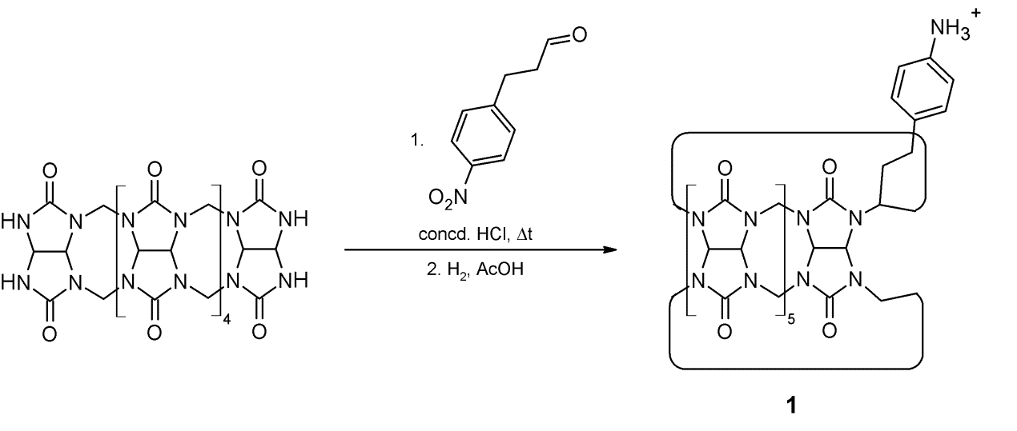

Figure 1. Your figure caption may be placed here. Delete this text box if not used.

Figure 1. Preparation of cucurbituril 1

References
¹ Gilberg, L.; Khan, M. S. A.; Enderesova, M.; Sindelar, V. Org. Lett. 2014, 16, 2446.

