Synthesis of Tin (IV) Heteroaryl Alkenols and Their Susceptibility Towards Fluorination

Podhorsky J.1, Moravec Z.1, Pinkas J.1, Hegemann C.2 and Mathur S.2*

*1 – Department of Chemistry, Masaryk University, Kotlarska 2,611 37 Brno, Czech Republic*

*2 – Institute of Inorganic Chemistry, University of Cologne, Greinstrasse 6, 509 37 Cologne, Germany*

In our work, we focused on reactions of organometallic tin (IV) precursors, such as Sn(O*t*Bu)4, Me3SnCl, and Me3SnF, with *β*-heteroarylalketonates: 3,3,3-triﬂuoro(pyridin-2-yl)propen-2-ol, 3,3,3-triﬂuoro(dimethyl-1,3-oxazol-2-yl)propen-2-ol, and 3,3,3-triﬂuoro(1,3-benzthiazol-2-yl)propen-2-ol [1]. Obtained compounds were exposed to various fluorination agents (HF, XeF2, and NH4F) and their reactivity towards them was compared to already published Sn (II) *β*-heteroarylalketonates [2-3]. Subseqent CVD experiments made by partner institution (Murauskas, Abrutis, University of Vilnius) have proved that our Sn (IV) *β*-heteroarylalketonates are suitable precursors for transparent SnO2 thin films used in optoelectronics.

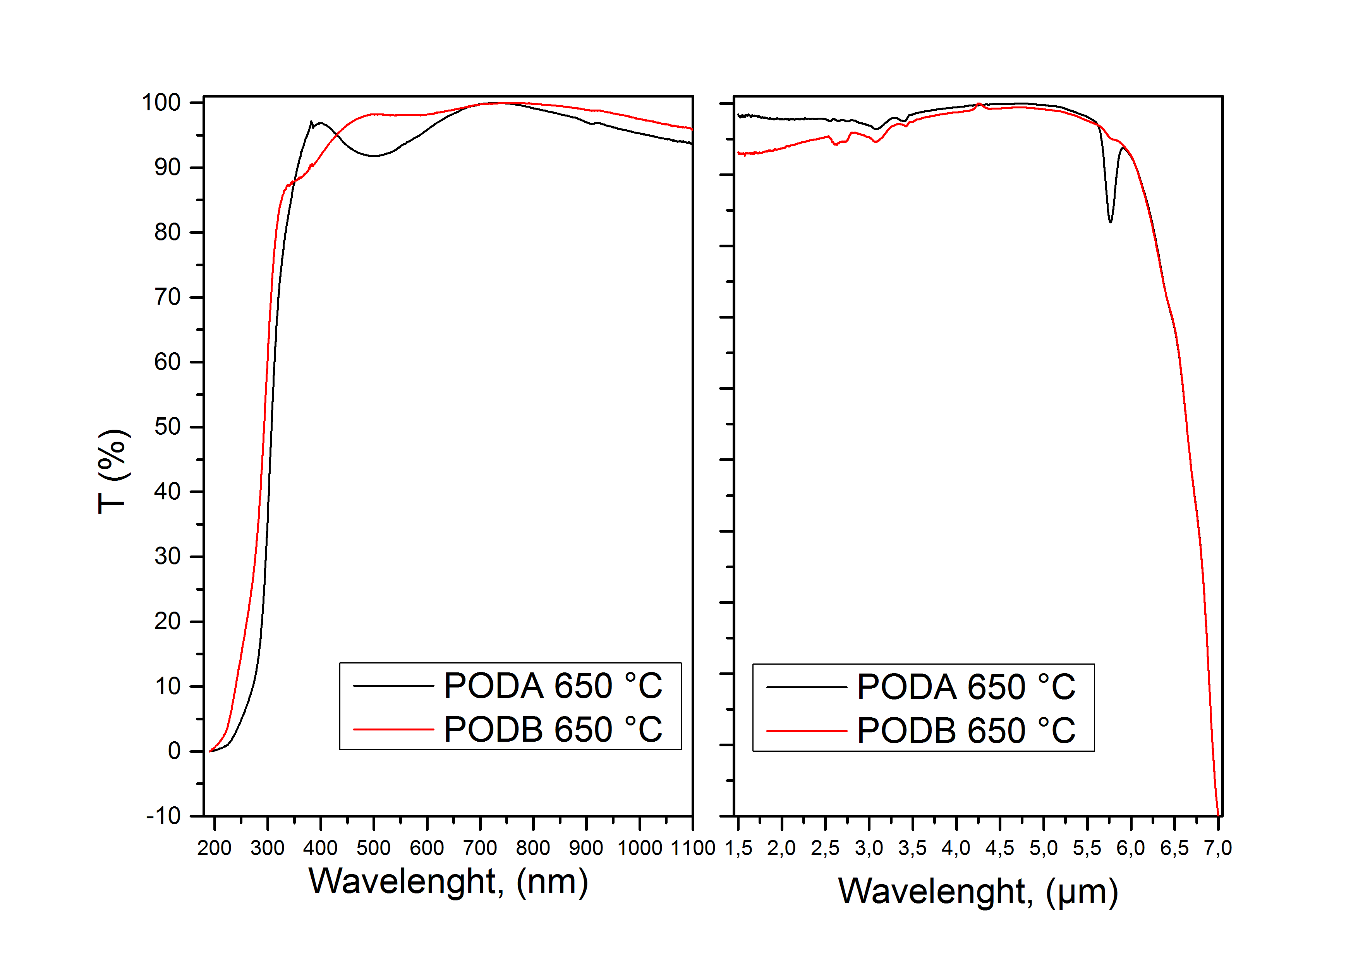

Figure 1 Transparency of SnO2 prepared by deposition at 650 °C of PODA (Sn(O*t*Bu)2(2-pyCHCOCF3)2) and POD B (Sn(O*t*Bu)2(4,5-meOxCHCOCF3)2)

**References:**

[1] M. Kawase, M. Teshima, S. Saito, S. Tani, *Heterocycles,* **1998**, 48, 2103.

[2] I. Giebelhaus, R. Müller, W. Tyrra, I. Pantenburg, T. Fischer, S. Mathur, *Inorg. Chim. Acta*, **2011,** 372, 340.

[3] T. Heidemann, S. Mathur, *Eur. J. Inorg. Chem.*, **2014**, 506.