Plagiarism
A Part of Conversation Questions for the ESL Classroom.
- Discuss these questions.
- What is plagiarism?
- Why do you think people plagiarize?
  - Homework?
  - Articles?
  - Books?
- If you're against CD burning, massive photocopying and pirate copies, what are your reasons for this? Have you ever had material on your webpage plagiarized?
- What do you think of the growing trend in downloading ready-made essays etc. from the Internet?
- What do you think of the growing trend in downloading music etc. from the Internet?
- How can countries prevent plagiarism?
- Which countries are known for plagiarism?
- Read the text and supply the right forms of words in brackets. (Adapted from Wikipedia)
In the 1st century, the use of the Latin word plagiarius (literally "kidnapper") to denote stealing someone else's work was pioneered by the Roman poet Martial, who complained that another poet had "kidnapped his verses". The ……….. (derivation) form plagiarism was introduced into English around 1620.
Although plagiarism in some contexts is considered theft or stealing, the concept does not exist in a legal sense, although the use of someone else's work in order to gain academic credit may meet some legal ……….. (to define) of fraud. People are asked to use the guideline, "if you did not write it yourself, you must give credit".
Plagiarism is also considered a moral offense against anyone who has provided the ………..(to plagiarize) with a benefit in exchange for what is …………(specific) supposed to be original content (for example, the plagiarist's publisher, employer, or teacher). In such cases, acts of plagiarism may sometimes also form part of a claim for …………(to break) of the plagiarist's contract, or, if done …………(to know), for a civil wrong.
Within academia, plagiarism by students, professors, or researchers is considered academic …………(dishonest) or academic fraud, and offenders are subject to academic censure, up to and including………….(to expel). Some institutions use plagiarism …………. (to detect) software to uncover potential plagiarism and to deter students from plagiarizing. Some universities address the issue of academic ……….(to integrate) by providing students with thorough orientations, required writing courses, and clearly articulated honour codes. Indeed, there is a virtually uniform ………………(to understand) among college students that plagiarism is wrong. Nevertheless, each year students are brought before their institutions’ …………….(discipline) boards on charges that they have misused sources in their schoolwork. However, the practice of plagiarizing by use of sufficient word ……………(to substitute) to elude detection software has rapidly evolved as students and unethical academics seek to stay ahead of detection software.
- How can plagiarism be avoided?
- What is the difference between a citation, paraphrase, and reporting? Which is which?

Peterson and Park argue that genetics is partially responsible for a person’s happiness, establishing a limit for how happy one can be (2009, p. 304).

“Happiness – more specifically positive mood – is influenced by genetics, leading theorists to propose a genetically determined set-point for happiness above which one cannot rise,” writes Peterson and Park (2009, p. 304).

Genetics is partially responsible for a person’s happiness, establishing a limit for how happy one can be (Peterson an Park, 2009, p. 304).
- Complete the quotations in the text with the following phrases:
    - analogues of Lakshmibai–Sandhya’s theorem
    - for a survey of known results
    - related to (rational) smoothness of the Schubert varieties
    - smoothness of Schubert varieties is equivalent to rational smoothness
    - a weaker condition called rational smoothness
    - in terms of the nil Hecke ring

Smoothness of Schubert varieties via patterns in root subsystems

https://ac.els-cdn.com/S0196885804001034/1-s2.0-S0196885804001034-main.pdf?_tid=5ce1b771-d449-4196-bc92-b931616dcc01&acdnat=1523962811_c8092c6938a0e2beafb2c914d9d252ed
There are several general approaches to determining smoothness of Schubert varieties.
See Billey and Lakshmibai [6] 1) ……………………. Kazhdan and Lusztig defined 2) …………………….. Rational smoothness can be interpreted in terms of Kazhdan–Lusztig polynomials [15, 16]. A Schubert variety is rationally smooth whenever certain Kazhdan–Lusztig polynomials are trivial. Kumar [18] presented smoothness and rational smoothness criteria 3) ………………….., defined in [17]. There are many other results due to Carrell, Peterson, and other authors 4)……………………………….. For example, according to a result of D. Peterson, see Carrell and Kuttler [9], 5) …………………………….. in the case of a simply-laced root system. Nevertheless none of these general criteria give a simple efficient nonrecursive method (such as the Lakshmibai–Sandhya criterion) for determining if a given Schubert variety is smooth or not. Recently, Billey [1] presented 6) …………………, for all classical types Bn, Cn, and Dn. However, these constructions, including the definitions of patterns, depend on a particular way to represent elements in classical Weyl groups as signed permutations.

Which sentences introduce these citations?
1)
2)
3)
4)
5)
6)
6) Reporting verbs in citing: Complete the table with the reporting verbs below according to similarity of meaning (prepared by A. Suchomelová)
discuss state indicate point out speculate on highlight believe stress feel argue demonstrate illustrate

say | talk about | think | emphasize | show | suggest

- Choose the best paraphrase of the original passage.
(adapted from Oshima, A. Hogue, Ann. Writing Academic English. Pearson Education, 2006).
Source: Page 16 of a three-page article in the October 15, 2003 issue of Space Science magazine. The tile of the article is “Manned Mars Flight: Impossible Dream?” The author is Patrick Clinton, a NASA physician.

Living aboard a space station in orbit around Earth for months at a time poses problems for astronauts’ bodies as well as for their minds.

- An article in Space Science magazine reports that lengthy space station duty may lead to physical and mental problems for astronauts (Clinton 16).
- An article in Space Science magazine reports that astronauts who live abroad space stations for long periods of time may experience physical as well as mental problems.
- An article in Space Science reports that astronauts will become physically sick and have mental problems if they visit a space station (Clinton 16).
- An article in Space Science reports that living in a space station orbiting Earth for a long time can cause difficulties for astronauts’ bodies and minds (Clinton16).

- Write paraphrases of these sentences, using citations and reporting verbs.
- For a minor per capita cost, political parties could be publicly-funded, thus avoiding charges that government policy can be influenced by large private donations (Smith, 2010:75).

……………………………………………………………………………………………

- In attempting to attract the peak-time audience, the BBC depends too heavily on costume drama (Sutcliffe, 2011:45).

……………………………………………………………………………………………

- Arts funding in the UK, whether by the state or by private philanthropists, is undoubtedly London-centric, with the result that the requirements of the regions are rarely met (Alberge, 2010:16).

……………………………………………………………………………………………

- A system whereby parents put themselves in serious debt so as to purchase a house near a highly-ranked primary school is clearly absurd (Gardner, 2011:26).

…………………………………………………………………………………………
- The failure of a business start-up is more often due to a lack of good guidance than a shortfall in its financing (Prosser, 2011:67).

………………………………………………………………………………………….
- Listening. How to spot a misleading graph.

https://ed.ted.com/lessons/how-to-spot-a-misleading-graph-lea-gaslowitz#watch

Discuss.
- Visual software has enabled more usage of graphs throughout all media, but it has also made them easier to use in a careless or dishonest way — and as it turns out, there are plenty of ways graphs can mislead and outright manipulate. Can you think of possible examples?
- Why do you think people tend to believe a false information when it is supported by a graph?

Now listen and answer questions.
- In an example with the reliability of trucks, how is the graph misleading? ………………..
- How is the line graph about rising American unemployment distorted? ……………………………………………………………………………………………
- What is cherry-picking? …………………………………………………………………
- How does the graph suggest that the number of super bowl viewers has risen dramatically? ……………………………………………………………………………..
- Why do two graphs in the last example show different information? …………………………………………………………………………………………….
- What is the best way to protect yourself from misleading information? ……………………………………………………………………………………………
- Now that you have watched the video, take what you have learned and analyse the graphs below.

1. Explain at least three problems with this graph.

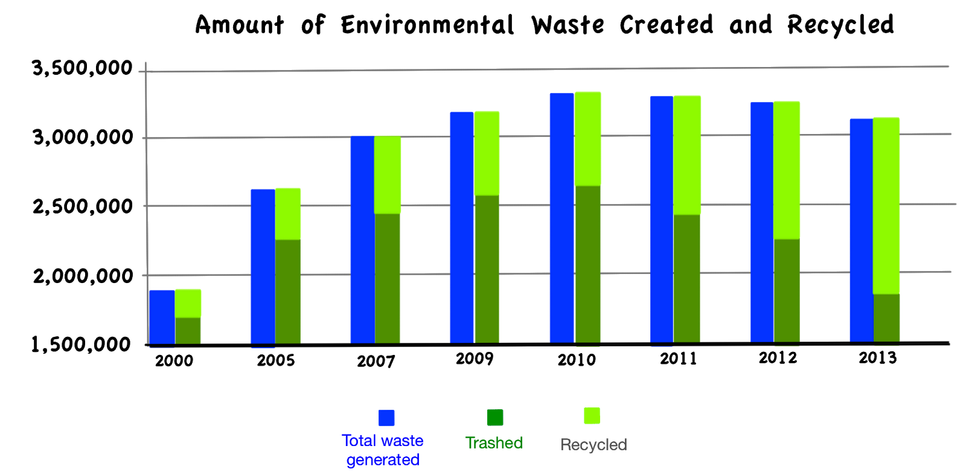

2a. The two graphs above show very different pictures of the rainfall in Atlanta. Explain how each graph is distorted.
2b. What information might help you decide if the variance in amount of rain in Atlanta is unusual?
