The fate and bioavailability of currently used and emerging pesticides in agriculturally used fluvisols - effects of soil and pesticide properties

Marek Šudoma¹, Natalia Neuwirthová¹, Markéta Svobodová¹, Lucie Bielská¹, Martina Hvězdová¹, Zdeněk Šimek¹, Lucia Škulcová¹, Kerstin E. Scherr² and Jakub Hofman^{1*}

¹ Research Centre for Toxic Compounds in the Environment (RECETOX), Faculty of Science, Masaryk University, Kamenice 753/5, 625 00 Brno, Czech Republic
² Institute for Environmental Biotechnology, Department for Agrobiotechnology, University of Natural Resources and Life Sciences, Konrad-Lorenz-Strasse 20, A-3430 Tulln, Austria

* corresponding author: hofman@recetox.muni.cz

Keywords: Conazole fungicides, microcosm, bioavailability

The class of conazole fungicides (CFs), among them epoxiconazole, tebuconazole, flusilazole and prochloraz are currently used pesticides and members of the triazole group, used as broad-spectrum fungicides that inhibit ergosterol biosynthesis and are typically applied as foliar sprays for cereals, sugar beet or oilseed rape (Li et al., 2015). Conazole fungicides are widely used in EU countries and their residues are frequently found in European arable soils (Hvězdová et al., 2017) which corresponds to their environmental properties. CFs are strongly sorbed to soil (logK_{OC} of 3–4) and have low to moderate water solubility (S_{W} of 7–150 mg/L).They are very persistent in soils and tend to form long-term residues as their typical DT₅₀ values range from 120 days to 1 year (Lewis et al., 2016). These attributes predetermine them to be highly bioaccumulative and hazardous.
However, in real ecosystems, complex interactions occur (between pesticides, soil, microbes, earthworms, plants...) and these are poorly understood. Hence, in this contribution (poster), we would like to present the novel microcosm experiment, where the combined effects of soil properties, microorganisms, plants and earthworms on CF multimedia fate and bioavailability were evaluated.
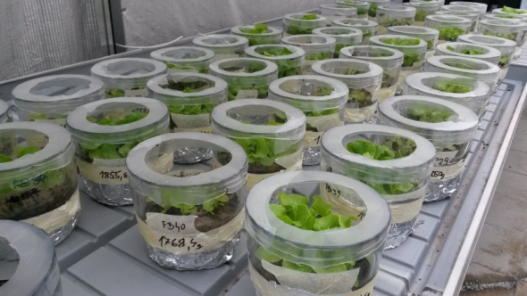
In particular, the CF fate (by means of total, desorbable and freely dissolved concentrations) and bioavailability (by means of uptake to model fauna, flora and passive samplers) is studied in complex microcosm systems consisting of agriculturally used fluvisols under the addition of selected model compounds (epoxiconazole, tebuconazole, flusilazole, prochloraz) at background levels (0.5 mg/kg), seeding plants (Lactuca sativa), earthworms (Eisenia fetida), SPME passive sampling fibers, Silicon rubber sheets and Chemcatcher® passive samplers.
A subset of 10 fluvisols was selected based on the DRIFT mid infrared portion using the Kennard-Stone algorithm (Stevens et al., 2013). These 10 soils are representative of a large fluvisols range in terms of their qualitative and quantitative SOM properties (TOC, DOC, HA,FA, WHC, pH, texture, etc.).

Acknowledgments:
This research is funded by the Czech Science Foundation (GAČR) grant number 15-20065S. This work was also partly supported by the Czech Ministry of Education, Youth and Sports (LO1214 and LM2015051).
References:
Hvězdová, M., Kosubová, P., Košíková, M., Brandstätter-Scherr, K.B., Šimek, Z., Brodský, L., Šudoma, M., Škulcová, L., Sáňka, M., Svobodová, M., Krkošková, L., Bielaská, L., Vašíčková, J., Neuwirthová, N., Hofman, J., 2017. Currently used pesticides and banned triazines in Central Europe arable soils.
Lewis, K.A., Tzilivakis, J., Warner, D.J., Green, A., 2016. An international database for pesticide risk assessments and management. Hum. Ecol. Risk Assess. 22, 1050–1064.
Li, Y., Dong, F., Liu, X., Xu, J., Han, Y., Zheng, Y., 2015. Enantioselectivity in tebuconazole and myclobutanil non-target toxicity and degradation in soils. Chemosphere 122, 145–153.
Stevens, A., Nocita, M., Tóth, G., Montanarella, L., van Wesemael, B., 2013. Prediction of Soil Organic Carbon at the European Scale by Visible and Near InfraRed Reflectance Spectroscopy. PLoS One 8.

