Locked & Loaded: Ruthenium-Capped Cucurbit[n]uril-Based Rotaxanes with Antimetastatic Properties

Martin Sojka

Department of Chemistry, Faculty of Science, Masaryk University, Brno, Czech Republic

martin.sojka@mail.muni.cz

Recent report highlights the importance of dinuclear Ru complexes for the specific mode of apoptosis induction.1 Cucurbituril inclusion complexes of biologically active Pt2 and Ru3 complexes are studied for the enhanced pharmacological effect caused by encapsulation of the drug. The abovementioned suggests that the combination of dinuclear Ru prodrugs with supramolecular carriers could be beneficial and is worth to be examined.

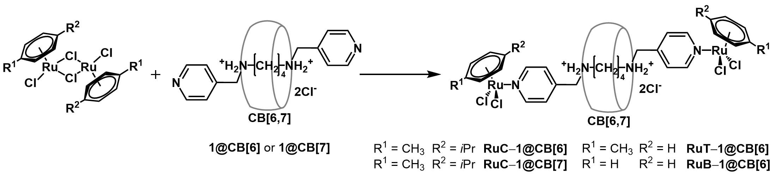

Figure 1. Schematic representation of synthetic approach for Ru molecular rotaxane.

Following our previous interests in Ru complexes,4,5 we report the first coupling of Ru(II) units with cucurbit[6/7]uril-based pseudorotaxane ligands meant for biological application. Resulting   
Ru-capped rotaxanes were characterized and a structure of one supramolecular system was determined by X-ray diffraction. Because the biological properties of Ru-based metallodrugs are tightly linked to the ligand-exchange processes, the effect of salt concentration on the hydrolysis of chlorides from the more stable Ru(II) center was monitored by using 1H NMR spectroscopy. Evaluation of biological activity of Ru(II)-based rotaxanes was performed for three selected mammalian breast cell lines, HBL-100, MCF-7, and MDA-MB-231. The antimetastatic activity of the assembled cationic Ru(II)-rotaxanes–evaluated in migration assays against MCF-7 and MDA-MB-231 cell lines–is notably enhances compared to that of the RAPTA-C, a reference used. The indicated synergistic effect of combining Ru(II) with pseudorotaxane unit opens a new direction in searching for anticancer supramolecular metallodrugs.

1. Davey, G. E.; Adhireksan, Z.; Ma, Z.; Riedel, T.; Sharma, D.; Padavattan, S.; Rhodes, D.; Ludwig, A.; Sandin, S.; Murray, B. S.; Dyson, P. J.; Davey, C. A. *Nat. Comm.*, **2017**, 8, 1575.
2. Cao, L.; Hettiarachchi, G.; Briken, V.; Isaacs, L. *Angew. Chem. Int. Ed*., **2013**, 52, 12033.
3. Li, F.; Gorle, A. K.; Ranson, M.; Vine, K. L.; Kinobe, R.; Feterl, M.; Warner, J. M.; Keene, F. R.; Collins, J. G.; Day, A. I. *Org. Biomol. Chem.*, **2017**, 15, 4172
4. Novotný, J.; **Sojka, M**.; Komorovsky, S.; Nečas, M.; Marek, R. *J. Am. Chem. Soc.* **2016**, 138 (27), 8445.
5. Novotný, J.; Přichystal, D.; **Sojka, M.**; Komorovsky, S.; Nečas, M.; Marek, R. *Inorg. Chem.* **2018**, 57 (2), 652.