Introduction
1. Find out information about your classmates, pay attention to the correct form of questions:
Find someone who …
… likes giving presentations on specialized topics in physics.
… has already decided about the topic of his/her master thesis.
… is studying theoretical physics.
… has written an article/abstract in English.
… has been to the library this week.
… will have to study hard this semester.
… would like to do research when he/she finishes his/her Master´s degree.
… would like to continue his/her postgraduate studies abroad.
You can practice making questions online, e.g. https://www.englisch-hilfen.de/en/exercises_list/fragen.htm
2. Common errors in academic English
a) Listening. Watch the introduction to the video about academic English and answer the questions https://youtu.be/mZQgd2sPxpk .
i) How does the speaker define academic English? ………………………….
ii) The speaker mentions three features of academic English:
- It is more ………………………….
- It is more ………………………….
- It uses …………………………
iii) Which serious problem does the speaker mention? ………………………….
b) The speaker mentions the following 12 common errors in academic English, which did you know and which can you explain?
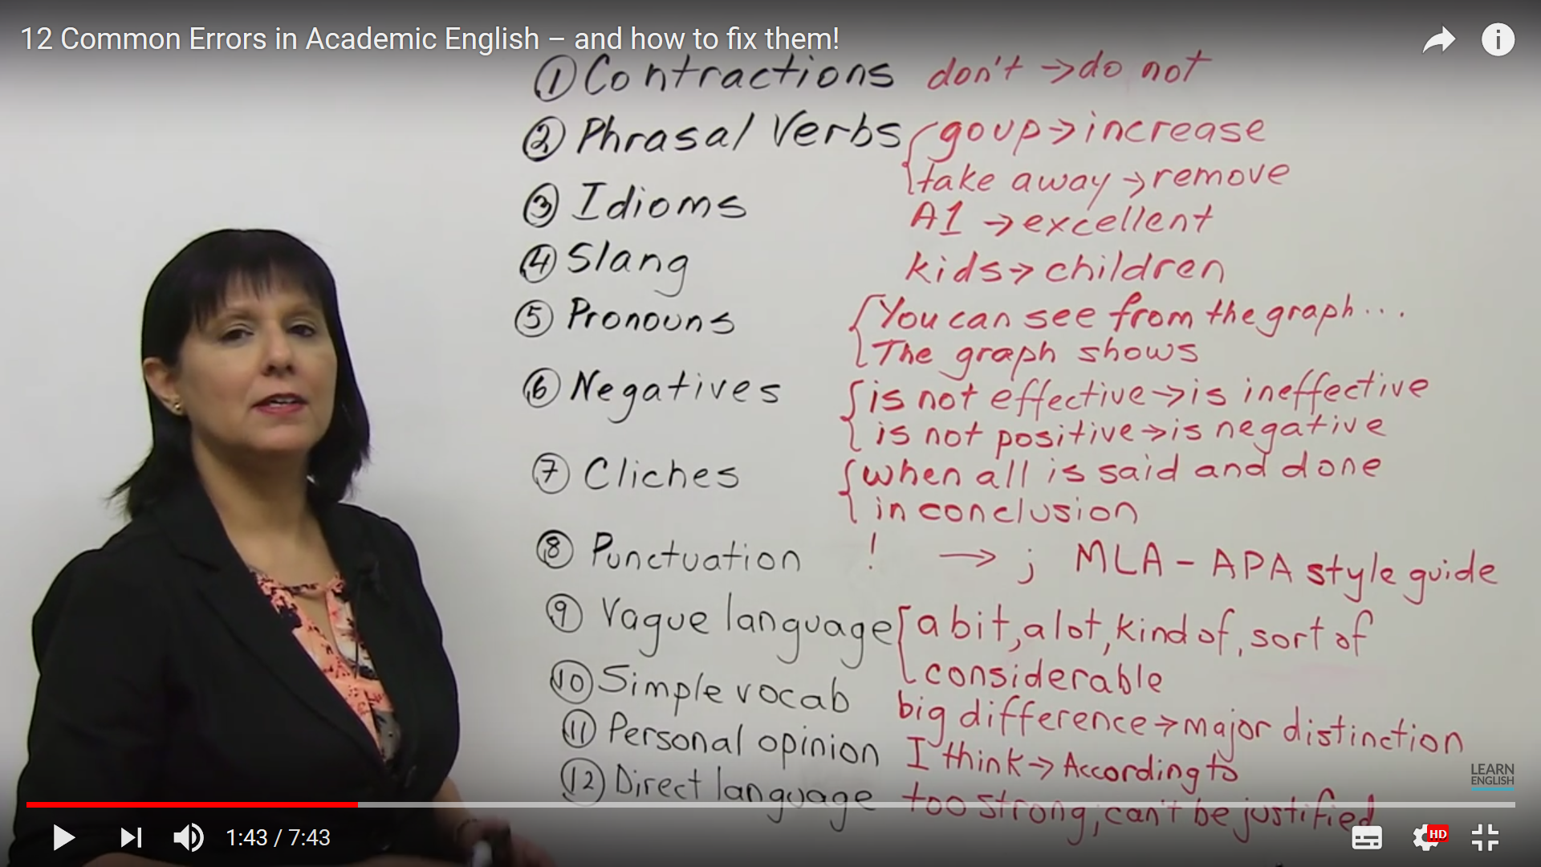

3. Academic Writing for Graduate Students
- A distinctive feature of academic writing style is choosing the more formal alternative when selecting various parts of speech.

Choosing a single verb instead of phrasal or prepositional phrases:
Researchers looked at the way strain builds up around a fault. - less formal style
Researchers observed the way strain accumulates around a fault. – academic style
Exercise I: Choose a verb from the list that reduces the informality of each sentence. Note that you may need to change tense of the verb from the list
assist reduce create investigate raise
establish increase determine fluctuate eliminate

- Expert Systems can help out the user in the diagnosis of problems.
- This programme was set up to improve access to medical care.
- Research expenditures have gone up to nearly $350 million.
- The use of optical character readers (OCRs) should cut down the number of problems with the U.S. mail service.
- Researchers have found out that this drug has serious side effects.
- Building a nuclear power plant will not get rid of the energy problem completely.
- Researchers have been looking into this problem for 15 years now.
- This issue was brought up during the investigation.
- Engineers can come up with better designs using CAD.
- The emission levels have been going up and down.

Exercise II: Substitute a single verb for the phrase in italics, so that the sentence sounds more formal
- The implementation of computer-integrated-manufacturing has brought about some serious problem.
- The process should be done over until the desired results are achieved.
- Plans are being made to come up with a database containing detailed environmental information for the region.
- Subtle changes in the Earth’s crust were picked up by these new devices.
- Proposals to construct new nuclear reactors have met with great resistance from environmentalists.

Other parts of speech: try to choose words which are not only less informal, but also more precise.

The government has made good progress in solving environmental problems.
The government has made considerable progress in solving environmental problems.
Exercise III: Supply a more academic word or phrase for the one in italics in each sentence
- We got encouraging results.
- The results of a lot of different projects have been pretty good.
- A loss of jobs is one of the things that will happen if the process is automated.
- The reaction of the officials was sort of negative.
- The economic outlook is mighty nice.
- The future of Federal funding is up in the air.
- America’s major automakers are planning to get together on the research needed for more fuel efficient cars.

- There are also some grammar related recommendations for maintaining a formal academic writing style

Avoid contractions: will not instead of won’t
Use the more appropriate formal negative forms:
not … any $→$ no
not … much $→$ little
not … many $→$ few

The analysis didn’t yield any new results.
The analysis yielded no new results.

Limit the use of “run on” expressions, such as “and so forth” and “etc.”:
These semiconductors can be used in robots, CD players, and so on.
These semiconductors can be used in robots, CD players, and other electronic devices.

Avoid addressing the reader as “you”:
You can see the results in Table 1. $→$ The results can be seen in Table 1.

Limit the use of direct questions:
What can be done to lower costs?
We now need to consider how costs can be lowered.

Place adverbs next to verbs rather than in the initial or final position:
Then the solution can be discarded. $→$ The solution can then be discarded.
Exercise IV: Reduce the informality of each sentence
- The government did not allocate much funding for the program.
- This problem doesn’t have many viable solutions.
- If you fail the exam, you can’t enter the university.
- OK, what are the causes of deformation? Many possibilities exist.
- A small bit of ammonium dichromate is added to the gelatin solution gradually.
- These special tax laws have been enacted in six states: Illinois, Iowa, Ohio, etc.

- Establishing a clear connection of ideas
Linking words and phrases can help a writer maintain flow and establish clear relationships between ideas. Here are some examples:
 | LINKING WORDS AND PHRASES
ADDITION | furthermore, in addition, , in addition to, moreover
ADVERSATIVE | although, even though, despite the fact that, however, nevertheless, despite, in spite of
CAUSE AND EFFECT | because, since, therefore, as a result, consequently, hence, thus, because of, due to, as a result of
CLARIFICATION | in other words, that is, i.e.
CONTRAST | while, whereas, in contrast to, however, on the other hand, unlike, conversely
ILLUSTRATION | for example, for instance, namely
INTENSIFICATION | on the contrary, as a matter of fact, in fact

Exercise V: Choose the right connector for each gap
- a) for example b) that is c) nevertheless d) on the other hand
- a) for example b)nevertheless c) whereas d) then
- a) and hence b)then c) on the other hand d) conversely
- a) conversely b) while c) despite d) and hence

“The job of theoretical physicists is not only to explain what their experimental colleagues have discovered but also to predict phenomena that have not yet been found. Quantum theory, 1______________, was largely driven by empirical results, 2____________ Einstein's general theory of relativity was more a product of speculation and thought experiments. Speculation, 3______________, is a vital part of the scientific process. When Paul Dirac wrote down his equation describing how quantum particles behave he wasn't just explaining the electron, whose properties had been well established in experiments. His equation also predicted the hitherto undreamed-of positron, 4_______________ the whole concept of antimatter. Such speculation is not a flight of fancy. It is always constrained by mathematical consistency and compatibility with established laws. It is a common fallacy that physics is only about what has already been confirmed in experiments. The Higgs boson had no foundation in empirical reality when it was predicted in 1964.”

Mike Duff, professor of theoretical physics at Imperial College London (cited in Guardian, June 16, 2013)
Punctuation depends on the type of clauses in the sentence:
nonfinite+ finite$→$ use a comma
Despite some complaints from new members, his speech was well
received.
Finite + finite $→$ use a semicolon + linking word + comma
Birds fly; however, fish swim.
Finite + nonfinite $→$ use a comma
Birds fly, while fish swim.

Exercise V: Edit the following passage by adding semicolons or commas where necessary
Aluminum alloys are now more important in the automobile industry than ever before. The government is pressuring the industry to produce cars of high quality and with high fuel efficiency hence car makers are replacing traditional iron-based alloys with aluminum alloys. Aluminum alloy parts are typically one-third to one-half the weight of those made with steel as a result cars with all aluminum use approximately 50% less fuel than those with steel components. Although most aluminium alloys are soft they can have a higher tensile strength than steel. Adequate alloy and solution treatment can increase their tensile strength thus resulting in a vehicle with good impact capacity.

Exercise VI: Read the following passage. Think of the ways of improving its flow (supply appropriate linking words or phrases, use pronouns to avoid repeating the same words, use proper punctuation)

Lasers have got so much use in medicine. Lasers play an important role in the treatment of eye disease and the prevention of blindness. Laser surgery suits the eye ideally. Most of the eye tissue is transparent. You can adjust the frequency and focus of the laser beam according to the absorption of the tissue. The beam “cuts” inside the eye with minimal damage to the surrounding tissue – even the tissue between the laser and the incision. Lasers are effective in treating some causes of blindness. Other treatments are not. We don’t understand the interaction between laser light and eye tissue fully.

HW - English Communication for Scientists
http://www.nature.com/scitable/ebooks/english-communication-for-scientists-14053993
1) Work first on your own, then compare your answers with your neighbours
A) Make an of the scientific communication for which you were part of the audience within the past six months or past year: the journals or magazines you read, the Web sites you consulted, the presentations you attended, and so on. For each item in this inventory, characterize yourself as an audience. Do you consider yourself specialized or less specialized in the topic or field discussed? If possible, think of what a similar inventory would have looked like a few years ago. In what sense were you a different audience than you are now?

B) In the previous inventory or simply in recent months, think of some of the communication instances that have frustrated or possibly offended you as an audience member. For each, try to identify the reason for your frustration. Was the content too complicated? (Did you perhaps feel excluded as a nonspecialist?) Was the structure confusing? Was the tone inappropriate?

Sources:
Swales, J & Ch. Feak, Academic Writing for Graduate Students, 2012
http://www.theguardian.com/science

