DFT CALCULATIONS ON NMR CHEMICAL SHIFTS FOR
PLATINUM BASED METALODRUGS

Ben Joseph R. Cuyacot, Jan Chyba, Jan Novotný, and Radek Marek

Faculty of Chemistry, Masaryk University and CEITEC-MU
Kamenice 5, CZ-62500, Brno, Czech Republic
benjoseph.cuyacot.muni.cz@gmail.com

Platinum-based drugs remain significant components in treatment of cancer. Recently however, there has been a surge of activity aimed at developing non-classical platinum complexes that operate a different mechanism from those of approved drugs that tantamount to a better delivery [1]. In this study, we demonstrate a protocol that is used to calculate NMR chemical complexation shifts for a series of Pt (IV) complexes derived from oxaliplatin.

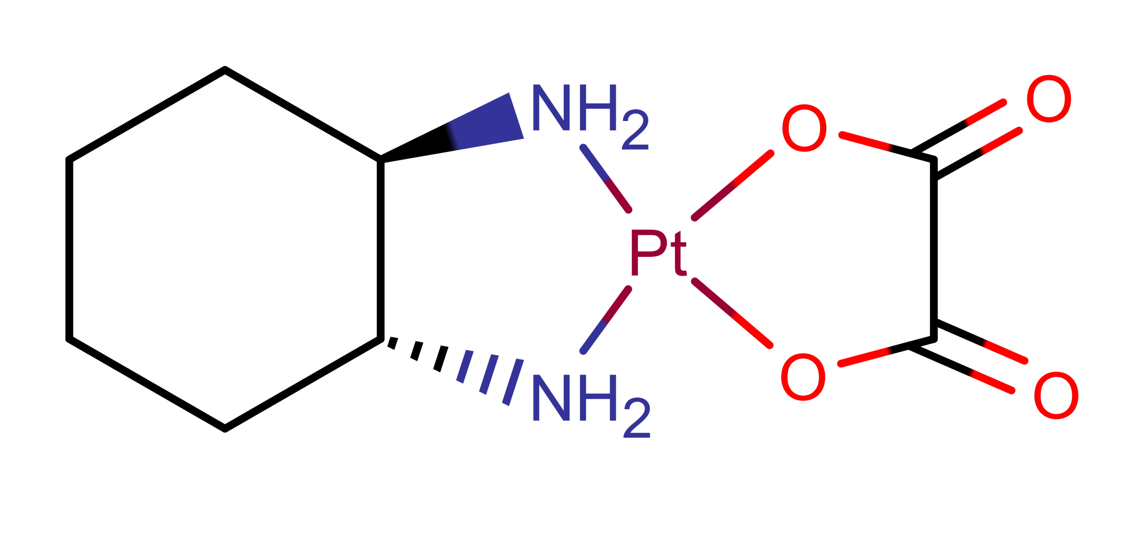
Fig. 1: Oxaliplatin

The standard PBE functional was used for optimizations and PBE0 functional was used for chemical-shift calculations using zeroth-order regular approximation (ZORA) for treatment of relativistic effects and solvation models to mimic the solvent environment [2]. We use experimental results as a benchmark for the calculated numbers. NMR shifts for Platinum and Hydrogens were evaluated.

[1] Johnstone T.C.; Suntharalingam K.; Lippard S.J. Chem. Rev., 116. (2016) 3436-3486.
[2] Vicha J.; Patzchke M.; Marek R. Phys. Chem. Chem. Phys., 15 (2013) 7740-7754.

