**Homework II:**

**(use MS EXCEL)**

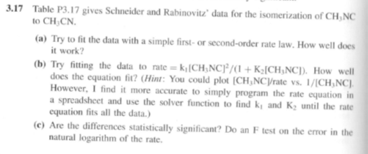



**The result (i.e. *.xls files send as *.zip file to teacher via E/mail).**