Describing Graphs
- Types of graphs

Match the types of graphs on the left below with their respective charts. Then complete the sentences below.

1
3
2

A column chart
A line chart
A pie chart
A bar chart
An area chart
4
5
6
An XY (scatter) chart
A stock chart
A surface chart
A doughnut chart
A bubble chart
A radar chart
9
8
7

11
10

- A surface chart is useful when you want to find optimum ___________ (combine) between two sets of data. As in a topographic map, colours and patterns indicate areas that are in the same range of _________ (evaluate).
- Pie charts show the size of items in one data series, proportional to the sum of the items. The data points in this type of chart are displayed as a _________ (per cent) of the whole chart.
- Area charts __________ (emphasis) the magnitude of change over time, and can be used to draw attention to the total value across a trend.
- Column charts are useful for showing data changes over a period of time or for illustrating _________ (compare) among items.
- You could use a stock chart to indicate the __________ (fluctuate) of daily or annual temperatures.
- Like a pie chart, a doughnut chart shows the relationship of parts to a whole, but it can contain more than one data series.
- A bar chart is a _________ (graph) method of displaying several data series in the form of a two-dimensional chart of three or more quantitative ____________ (vary) represented on axes starting from the same point.

- Identify the graph that matches each of the following stories:
  - I had just left home when I realized I had forgotten my books so I went back to pick them up.
  - Things went fine until I had a flat tire.
  - I started out calmly, but sped up when I realized I was going to be late.
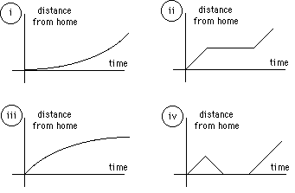

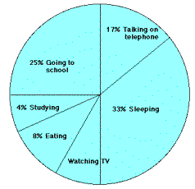

- The graph represents the typical day of a teenager. Answer these questions:
  - What per cent of the day is spent watching TV?
  - How many hours are spent sleeping?
  - What activity takes up the least amount of time?
  - What activity takes up a quarter of the day?
  - What two activities take up 50% of the day?
  - What two activities take up 25% of the day?
What would your graph look like? Draw it and then describe it using verbs like: spend, take up, consume, devote, (waste?), etc. in the correct form.

- Study the handout “Describing Graphs –IELTS exam preparation” and then decide which answer/answers best suits each of the graphs below
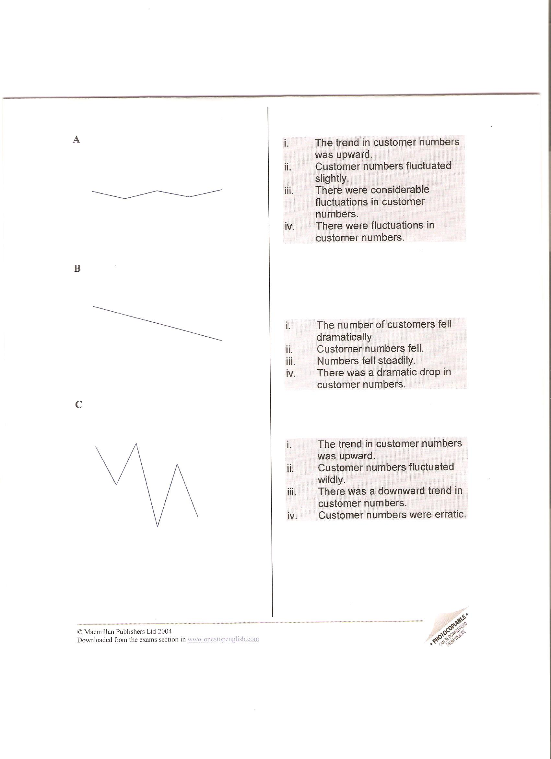

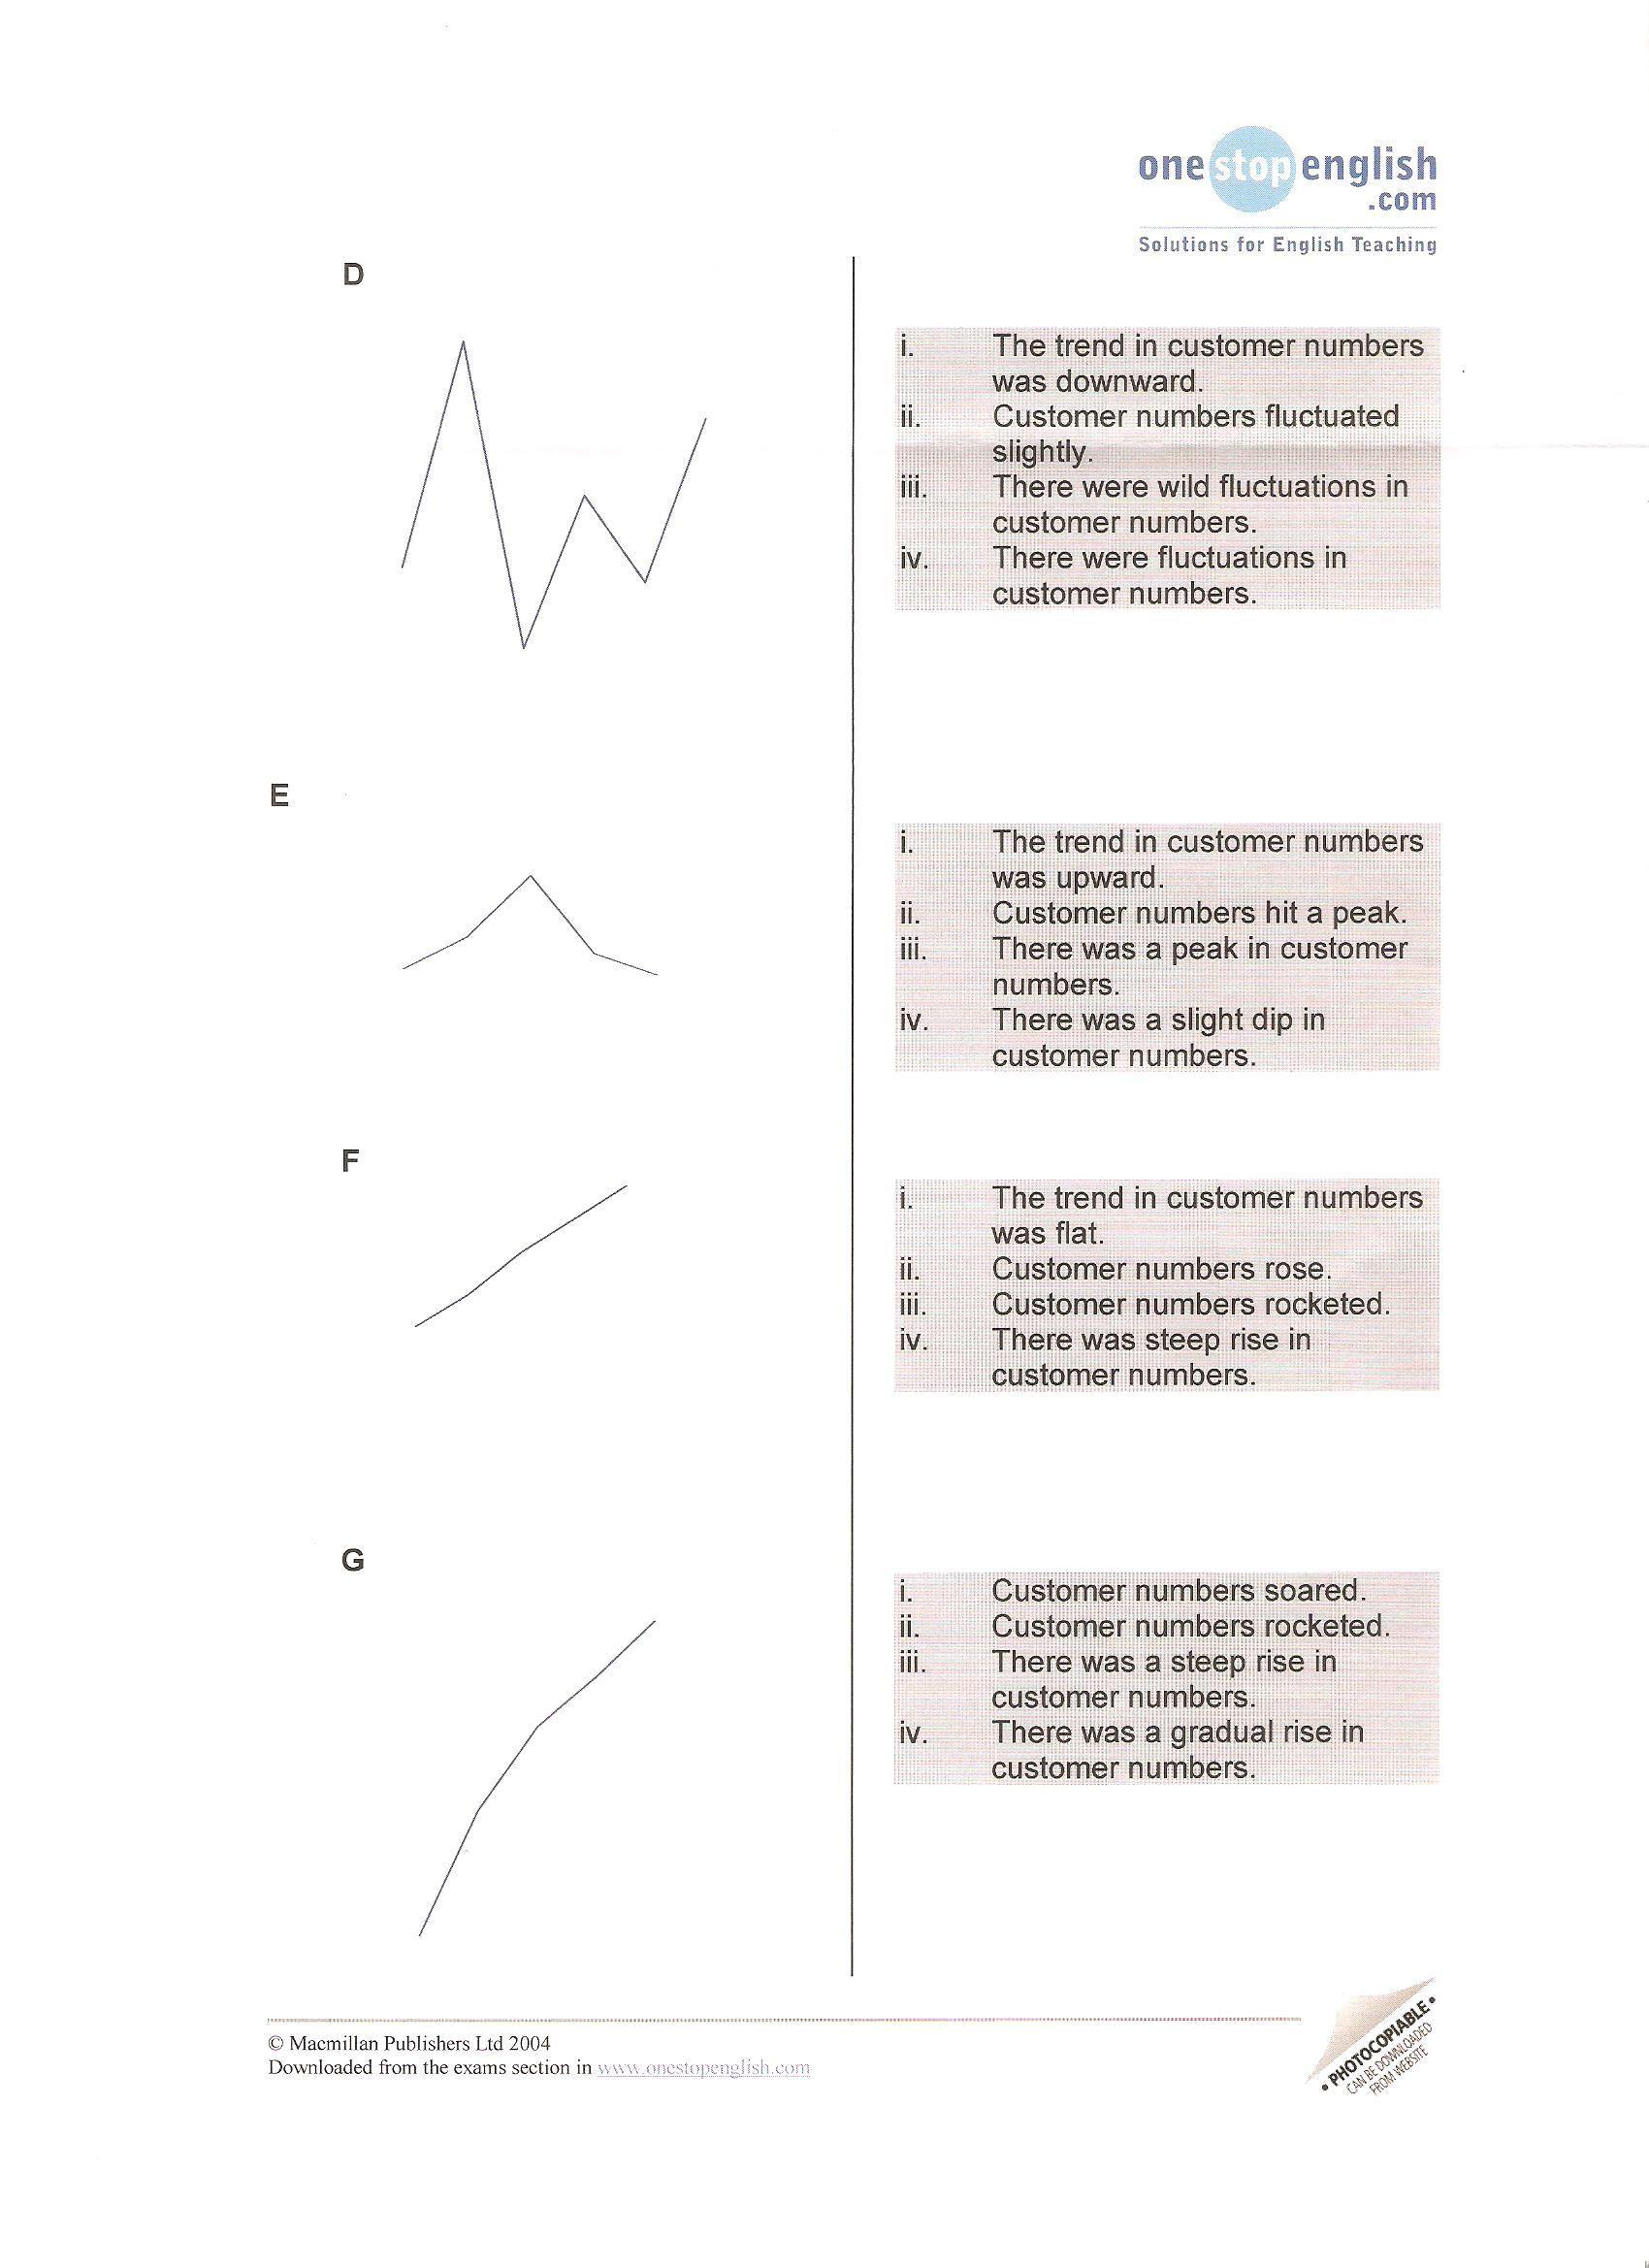

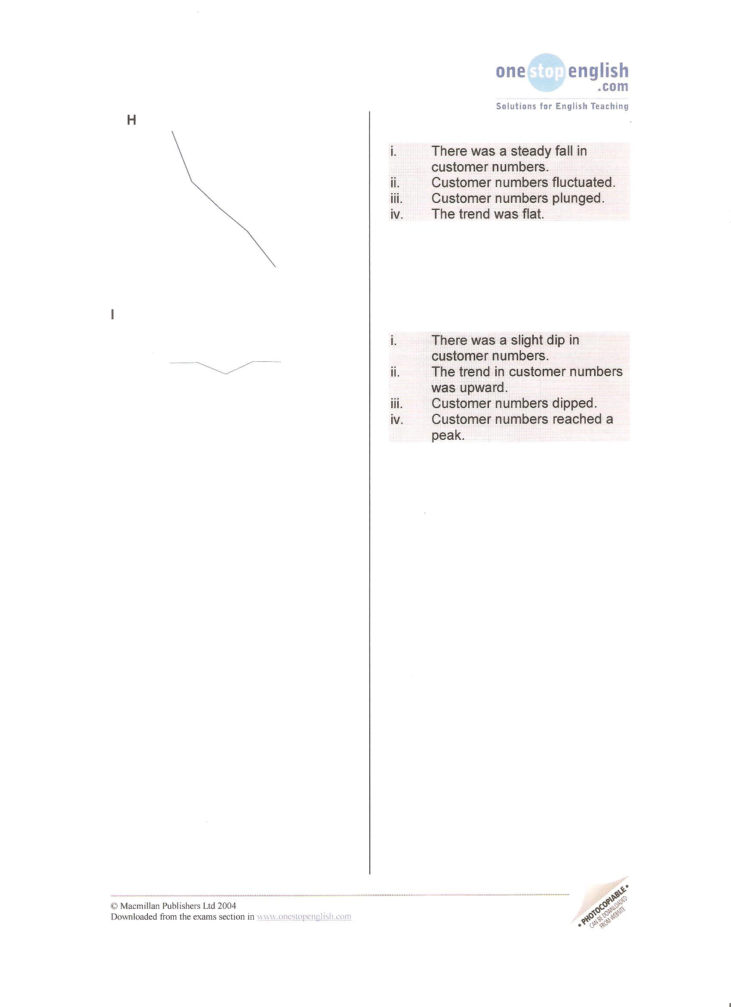

- Now transform these sentences using the given word so that they mean the same:
- There's been a slight decline in sales.
Sales …………………………………….
- We made a sharp increase in investment.
Investment ………………………………
- There was an abrupt drop in sales in March.
Sales………………………………………
- Unfortunately, consumer interest suddenly decreased.
There…………………………………………
- The dramatic growth has come after we invested in a new product line.
We've …………………………………………
- Profit has been flat over the past two years.
There………………………………………..
- There has been steady improvement over the past three months.
Sales ……………………………………..

- Look at the nouns below and decide whether they denote a trend of going up, going down, remaining the same or others. Think of the verbs you would change these nouns to (and appropriate prepositions that follow them)
a boom a slump a reduction a levelling out a recovery a peak a fluctuation plateau

- Vocabulary task – match words with their definitions:
extrapolation median discreet variable mode line of best fit mean interpolation range continuous variable negative correlation
- to estimate a value by following a pattern and staying within the values already known
- a relationship between two sets of data - it will show a positive correlation, a negative correlation, or no correlation
- upper extreme minus lower extreme
- to estimate a value by following a pattern and going beyond the values already known
- the middle value of all the numbers in the sample.
- the most frequently observed value of the measurements in the sample
- the sum of all the results included in the sample divided by the number of observations
- one set of data decreases as the other set of data increases
- measurements that are distinct, periodic, and unconnected between data points
- measurements are uninterrupted and connected between data points (e.g. growth of a plant)
- Read the following text, which describes the graph below. Complete it with the missing words.

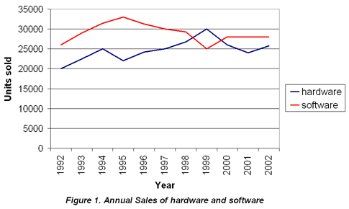
The graph 1._________ the sales figures for two products from 1992 to 2002. The 2._________ axis represents years and the 3.___________ axis represents units sold. The graph 4._________ both the 5.___________ and the 6.___________ in sales for both products, as sales 7.___________ during the ten-year period.

- Study the graph below. Write a brief paragraph describing the data shown in the graph.

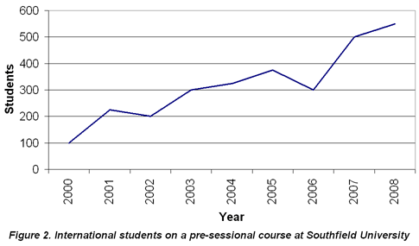

The graph shows…
Source: adapted from a lesson prepared by Jana Kubrická
www.microsoft.com
www.ielts.com
www.onestopenglish.com
www.elanguages.ac.uk

