M/K– 2/1, 5/2, 1/10

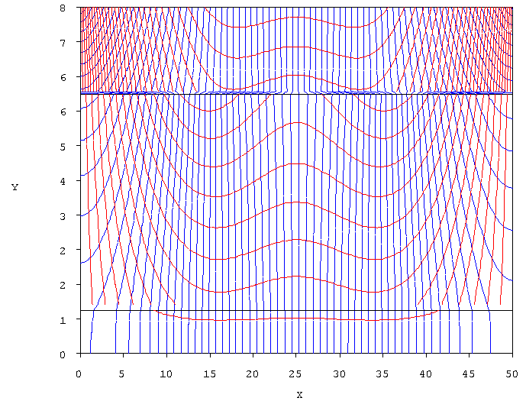

M/K– 5/1, 1/ 5, 5/1

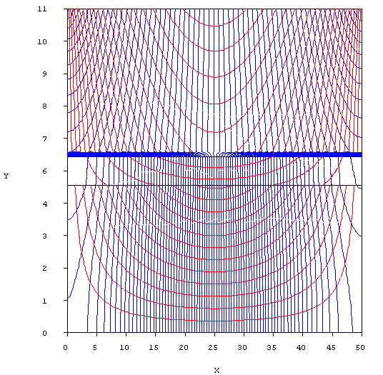

M/K– 5/100, 5/ 10, 5/1

