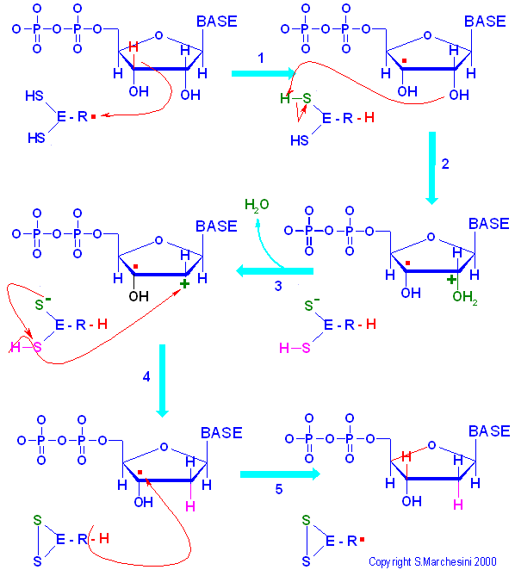
Ribonucleotide reductase reaction mechanism

The free radical of ribonucleotide reductase eliminates a hydrogen atom from carbon 3' of the substrate,generating a free radical on the substrate.
One of the thiol group of the enzyme donates a proton to oxygen on C2'.
A water molecule is eliminated.
The carbocation on C2' is reduced by the second sufhydryl group.
The enzyme donates a hydrogen atom to radical C3' to form the deoxyribonucleotide;the enzyme in converted in its radical form and must be reduced to its starting disulfhydryl form.

