AMINOKYSELINY

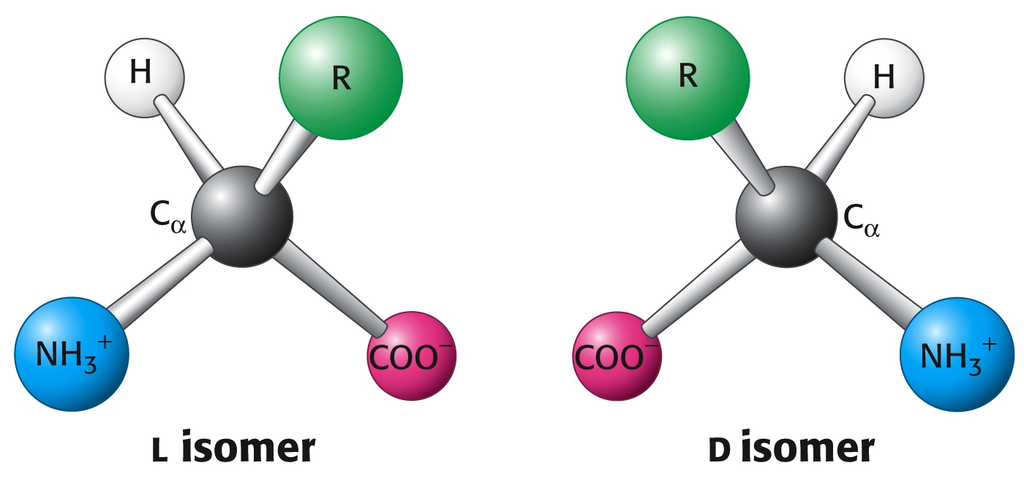

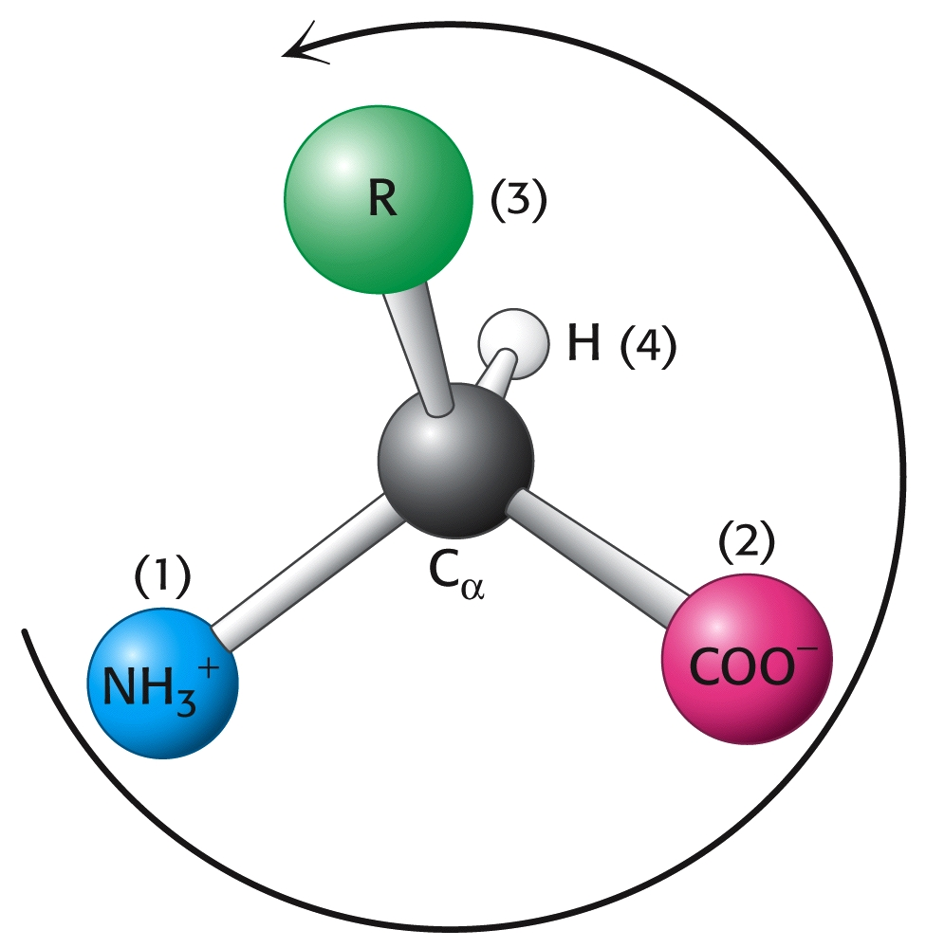

ACIDOBAZICKÉ vlastnosti

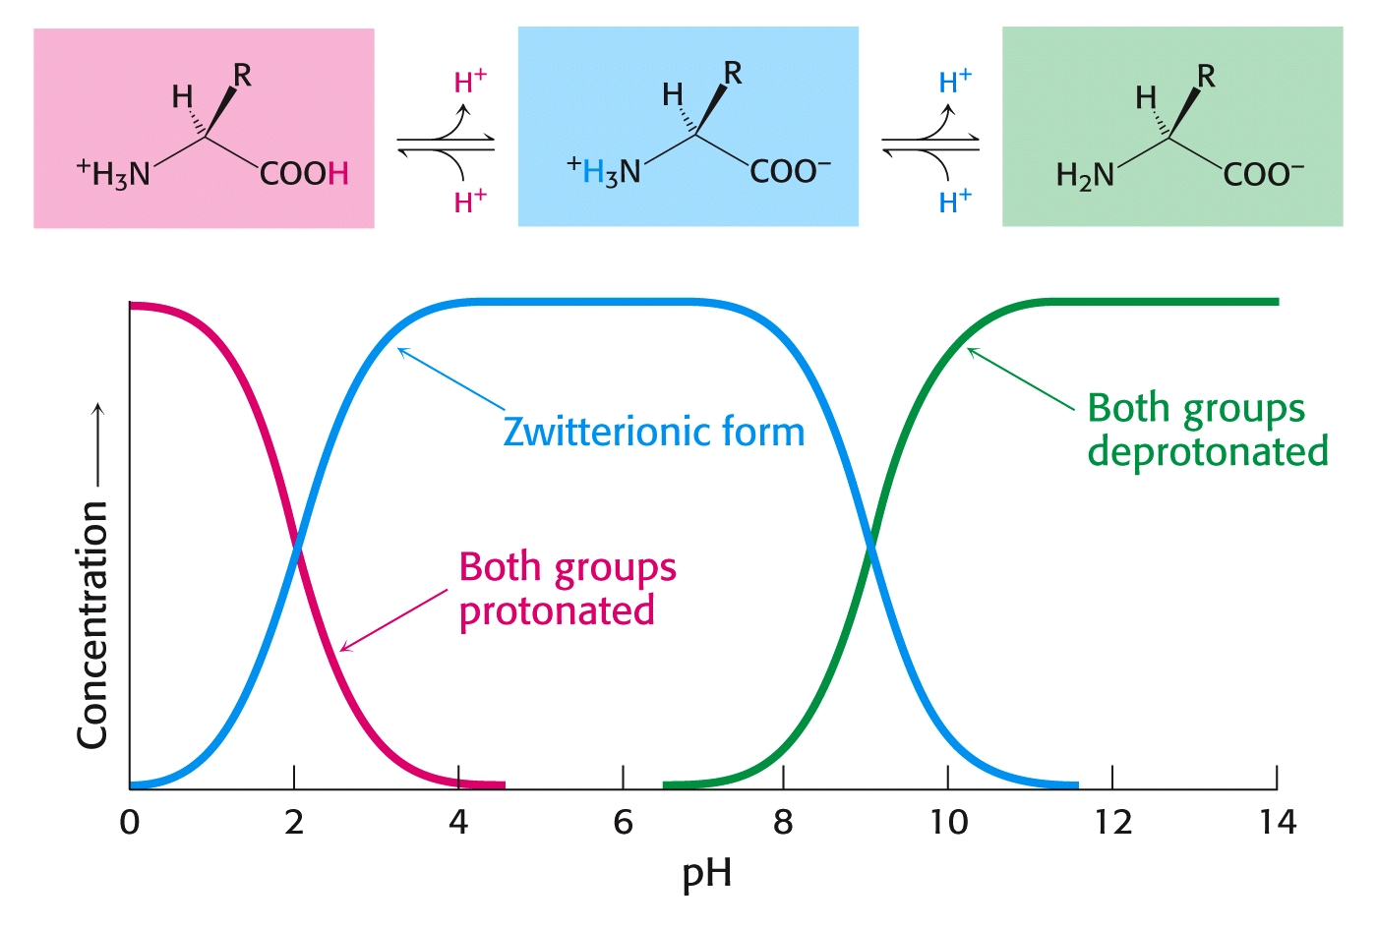

Izoelektrický bod $\text{pI = }\frac{\text{pK}\text{COOH}\text{ + pK}\text{NH}2}{2}$

Tabulka pK
Skupina | pK | Skupina | pK | Skupina | pK
α COOH | 1.8 - 2.5 | β COOH | 3.9 | γ COOH | 4.1
α NH₂ | 9 - 10 | ε NH₂ | 10.8 | guanidin | 12.5
imidazol | 6.0 | SH | 8.3 | OH | 10.1

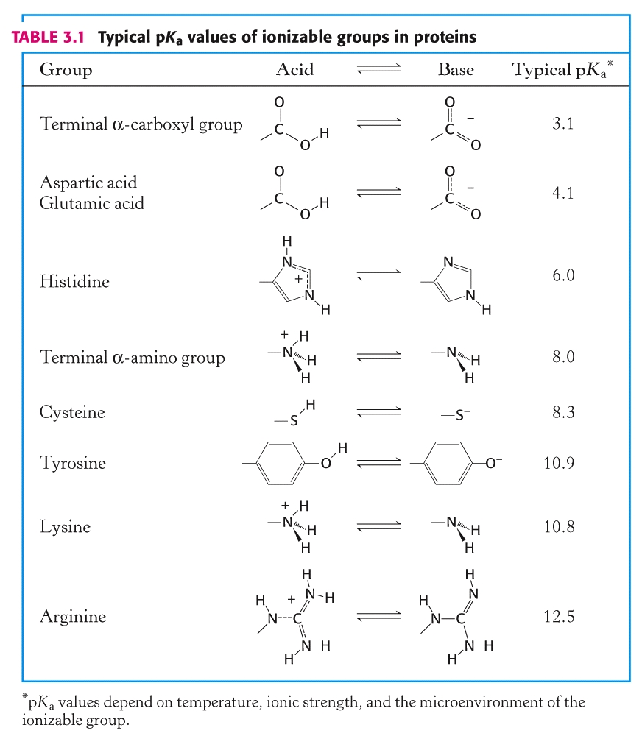

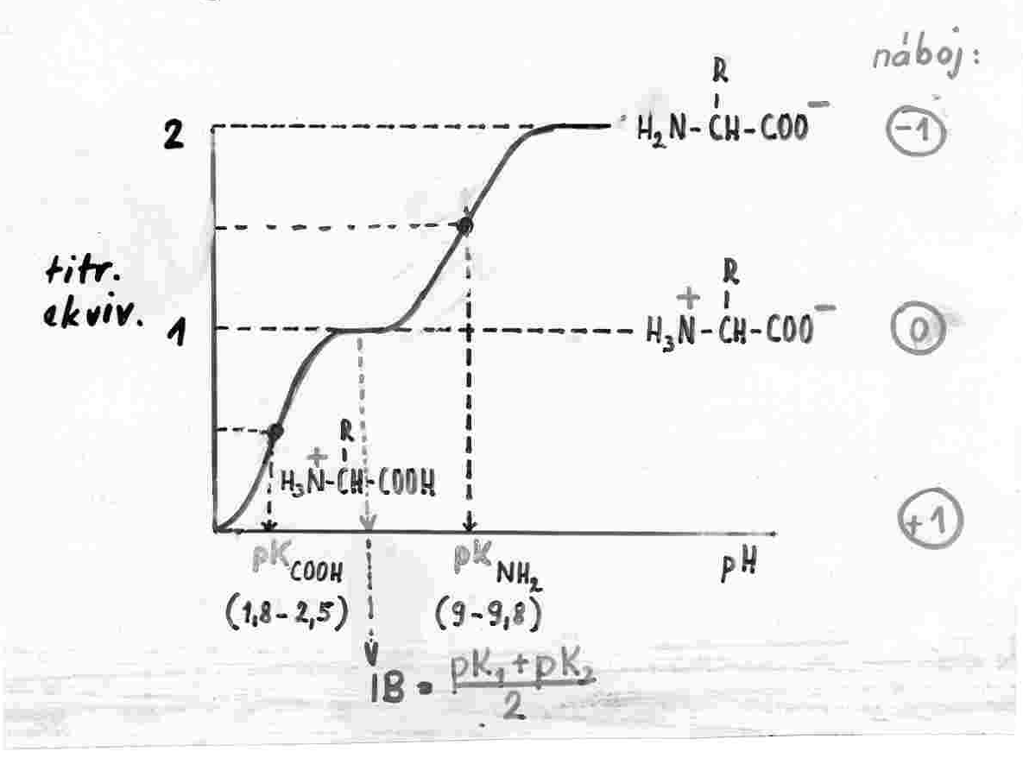
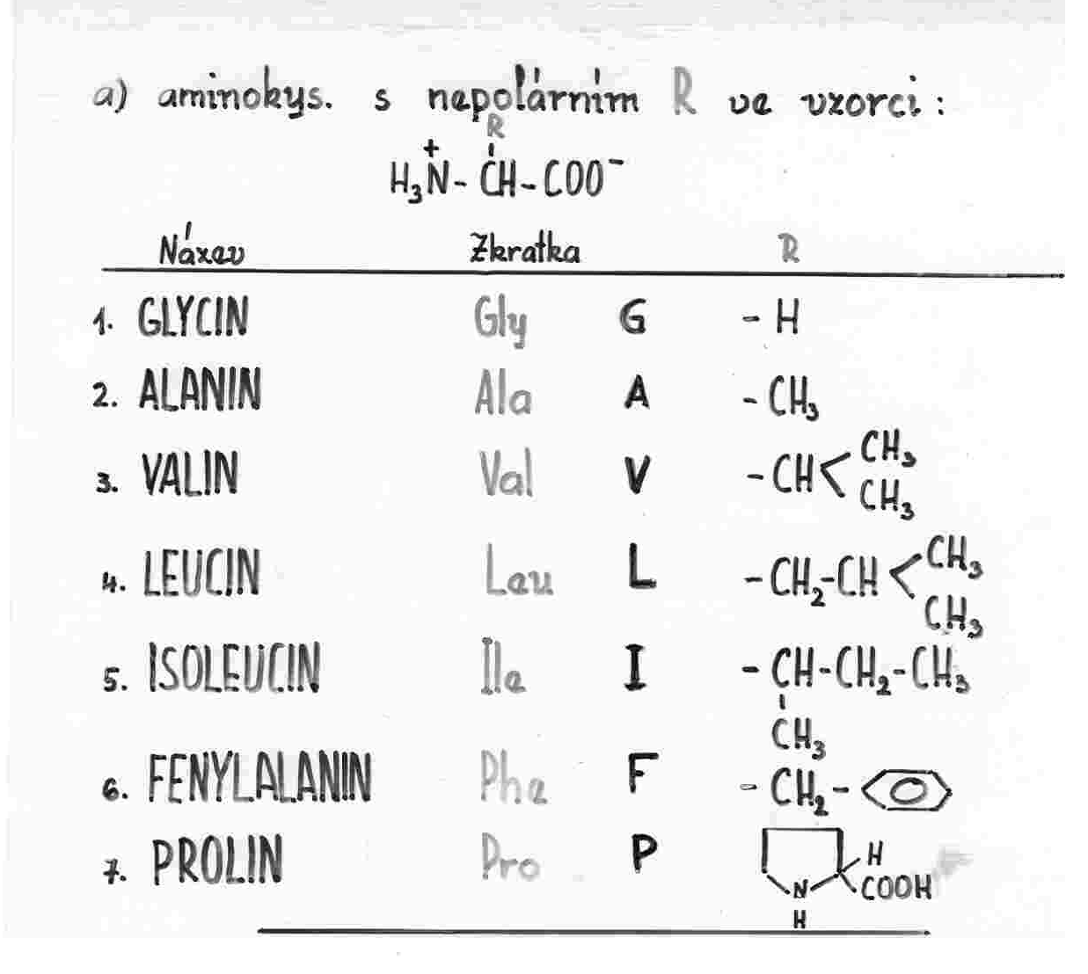

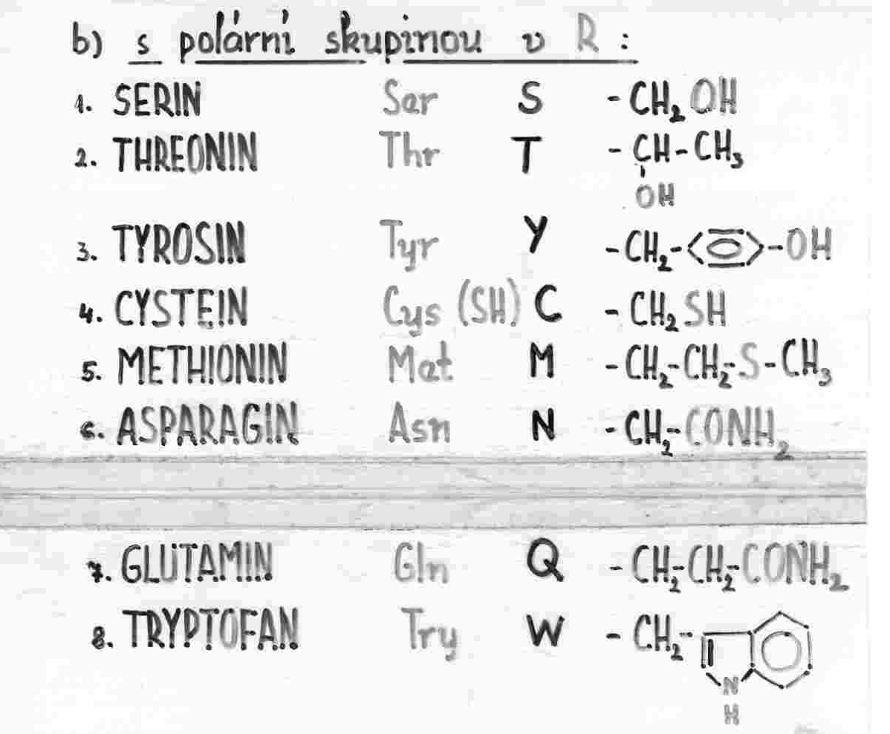

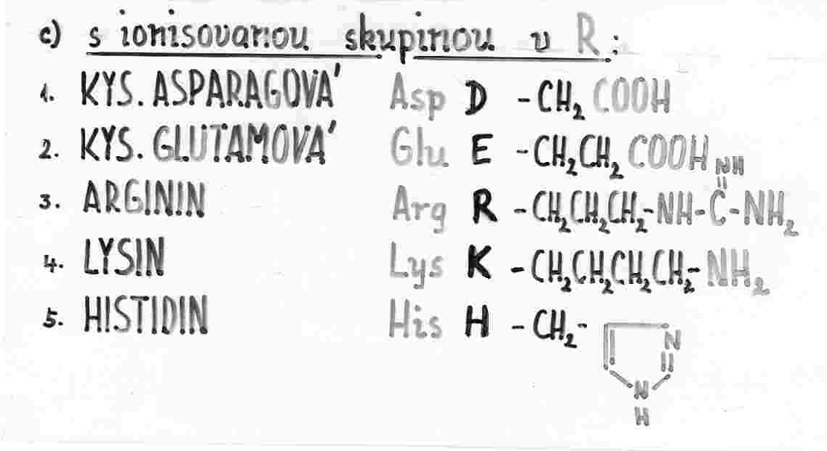

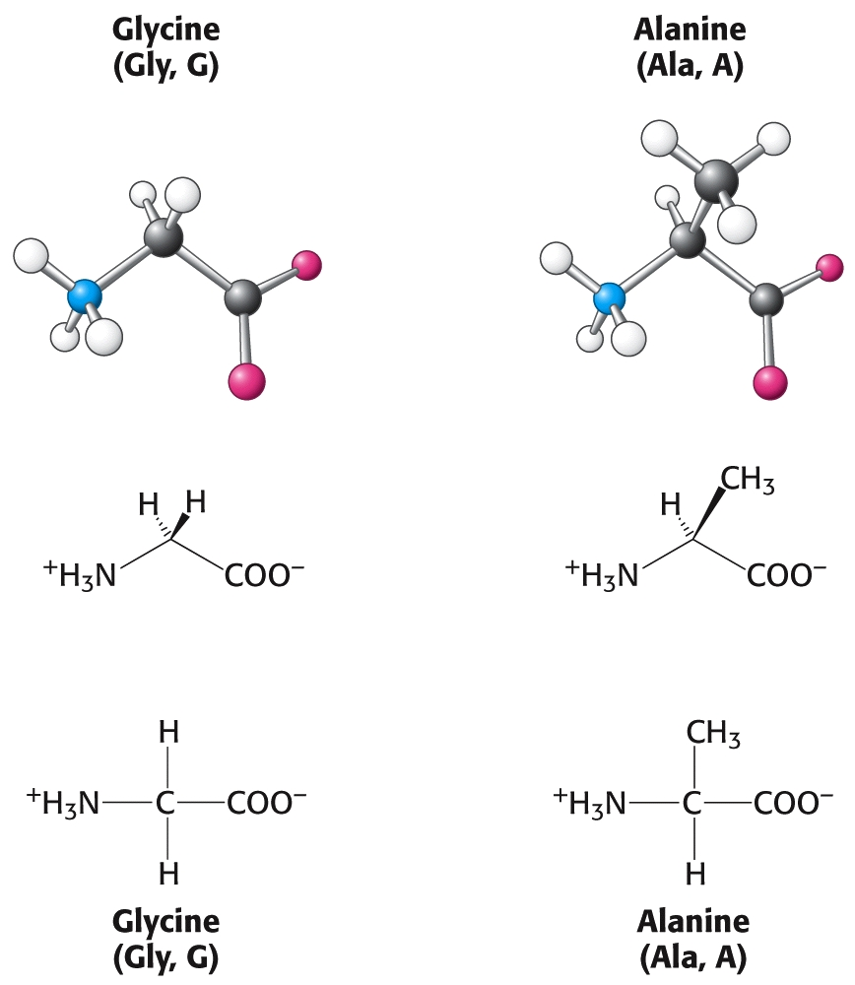

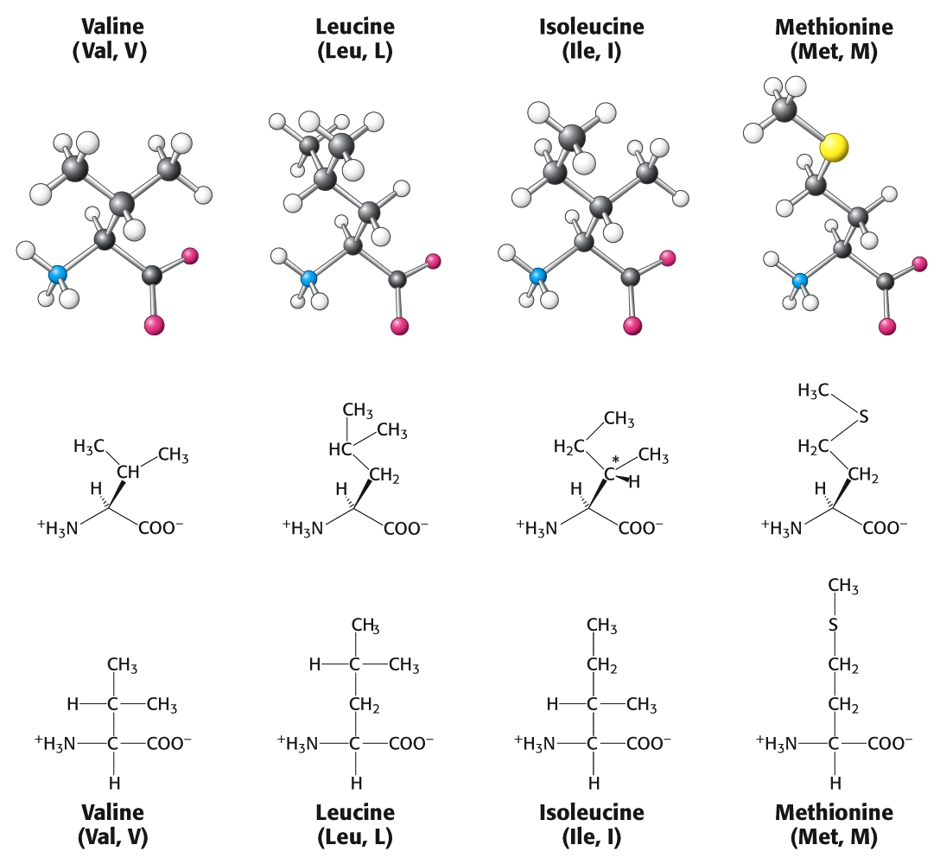

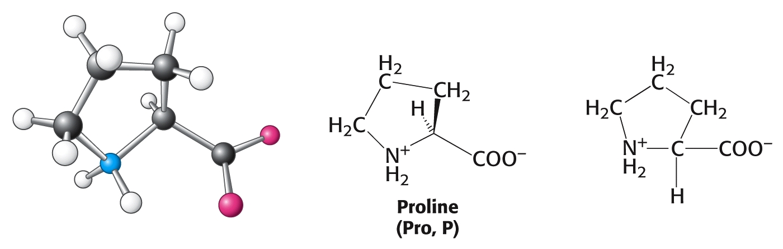

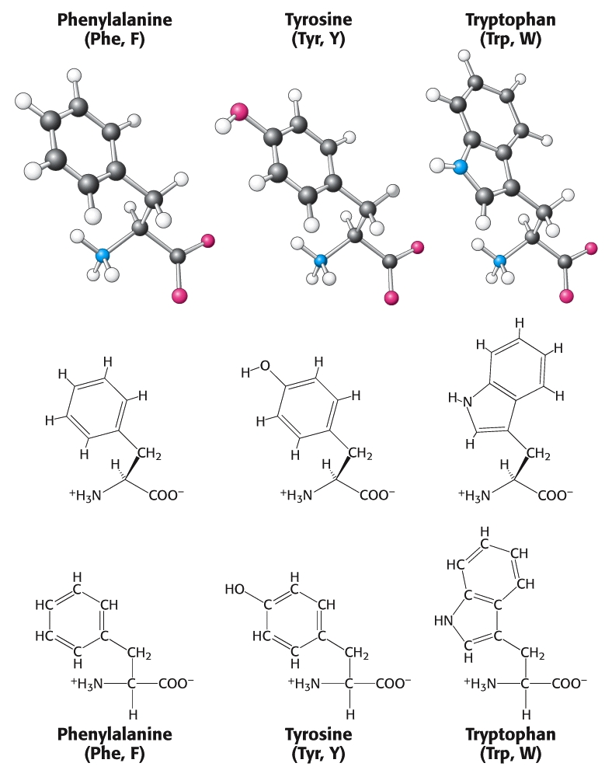

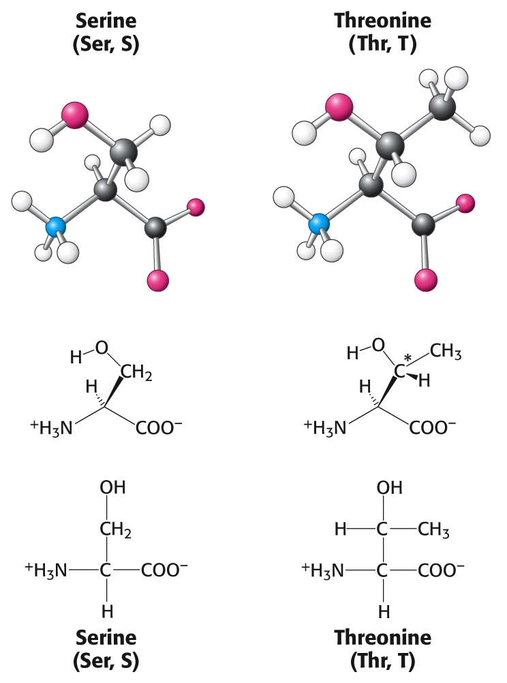

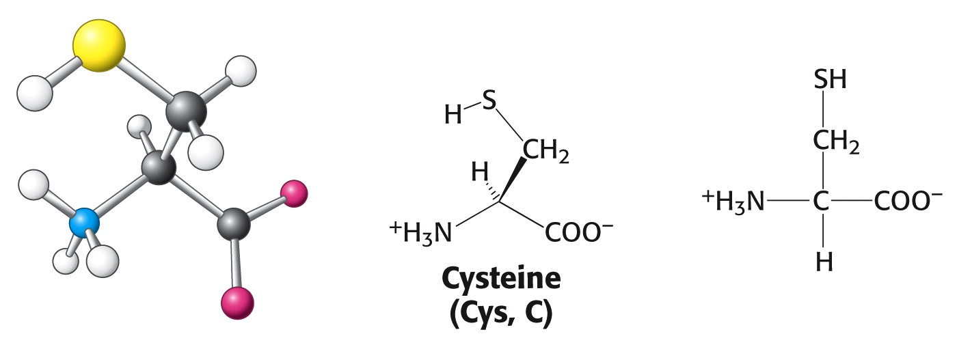

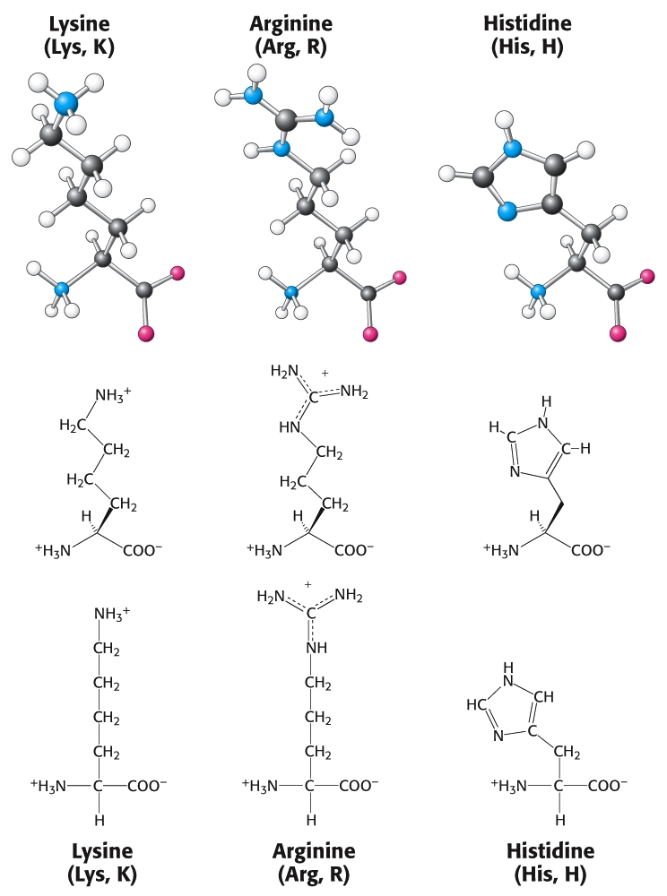

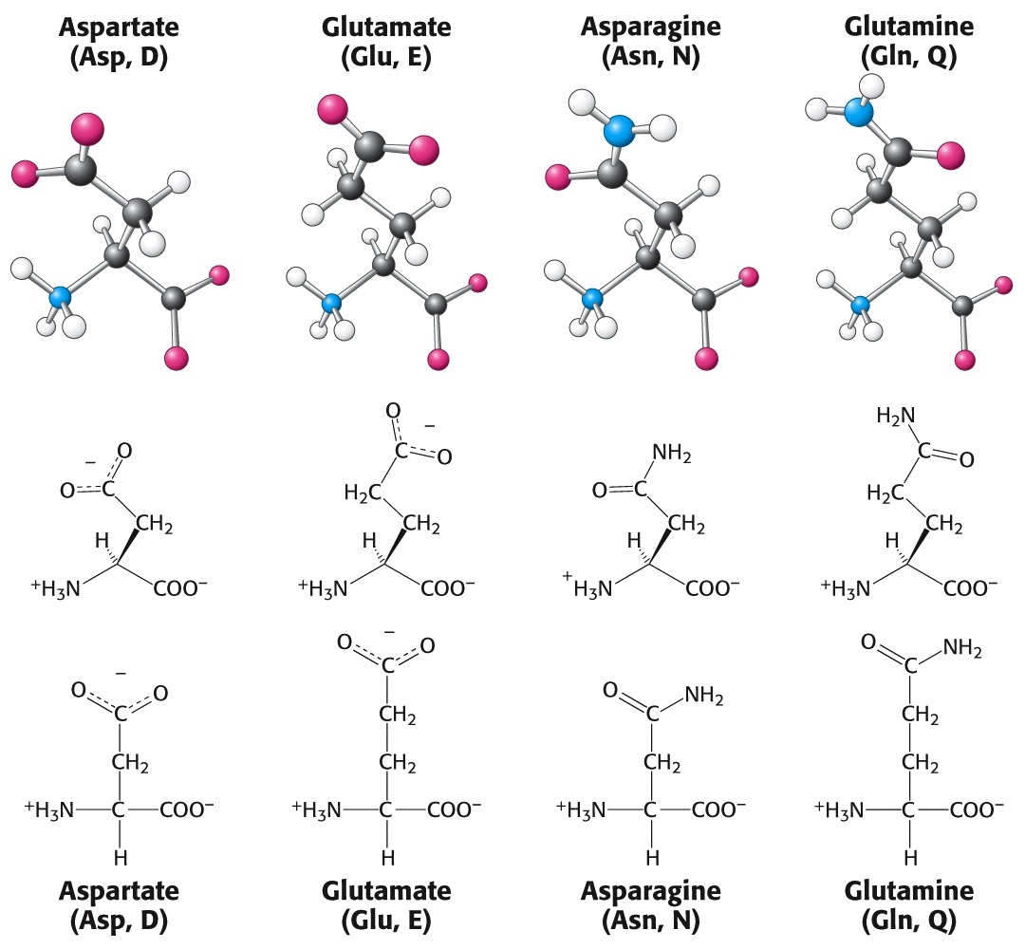

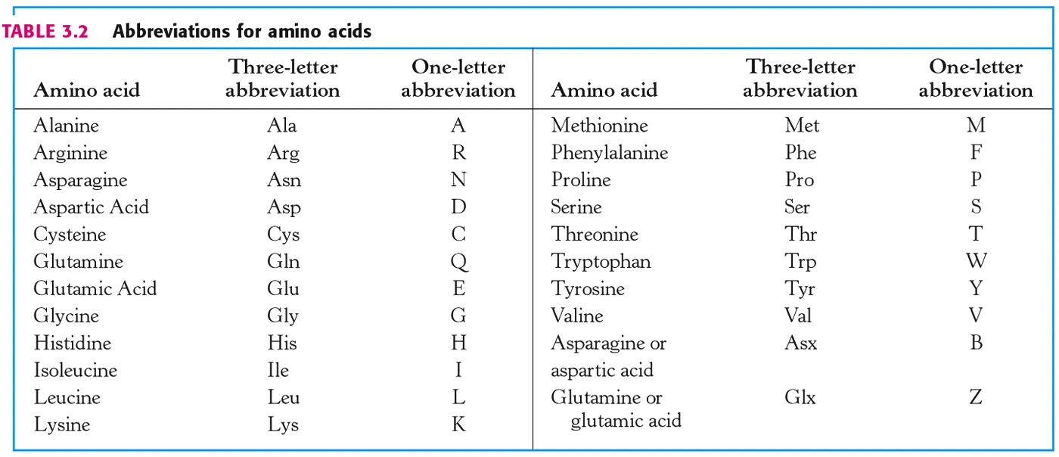

AMK | Symboly |  | AMK | Symboly
glycin | Gly | G | methionin | Met | M
alanin | Ala | A | glutamová k. | Glu | E
valin | Val | V | asparagin | Asn | N
leucin | Leu | L | glutamin | Gln | Q
izoleucin | Ile | I | lysin | Lys | K
serin | Ser | S | arginin | Arg | R
threonin | Thr | T | tyrosin | Tyr | Y
cystein | Cys | C | fenylalanin | Phe | F
histidin | His | H | tryptofan | Trp | W
prolin | Pro | P | asparagová k. | Asp | D

β alanin
ornitin a citrulin
γ aminomáselná
antibiotika - azaserin, cykloserin, chloramfenikol
nervové mediátory - DOPA, dopamin, adrenalin
hormony - thyroxin, trijodthyronin

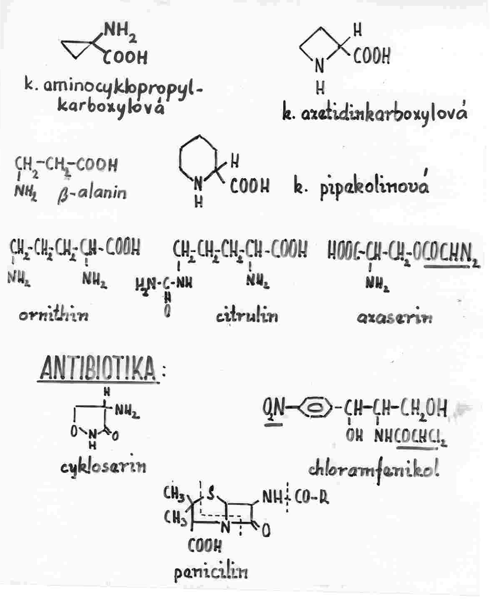

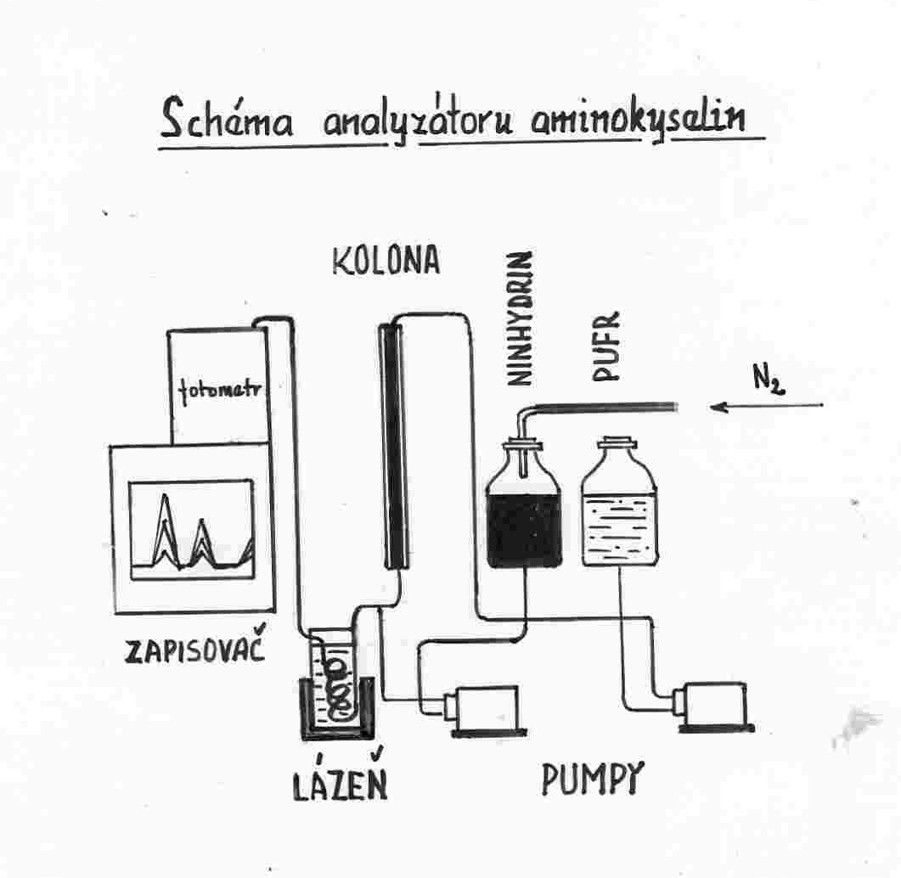

- Úplná hydrolýza - kyselá - 6 M HCl,, 100 - 120 ºC, 10 - 100 hod.
- bazická - 2 - 4 M NaOH, 100 ºC, 4 - 8 hod.
- enzymová - Pronasa

