Polarografie

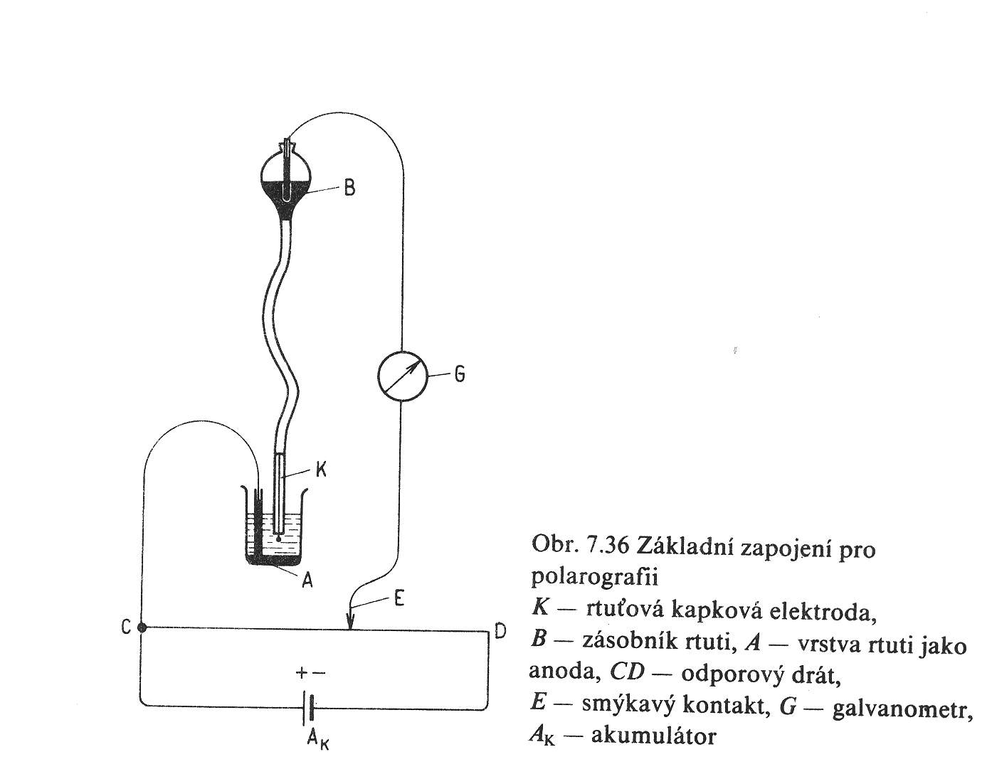

I_{d} = 0,627 cm² g^{-2/3}. n . F . D^{1/2} m_{h}^{2/3} . t₁^{1/6} . c
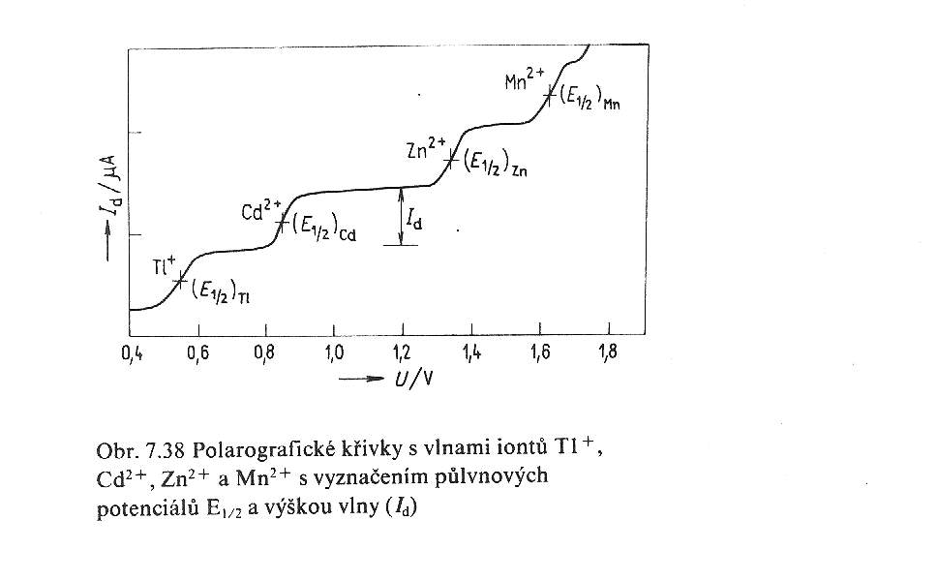

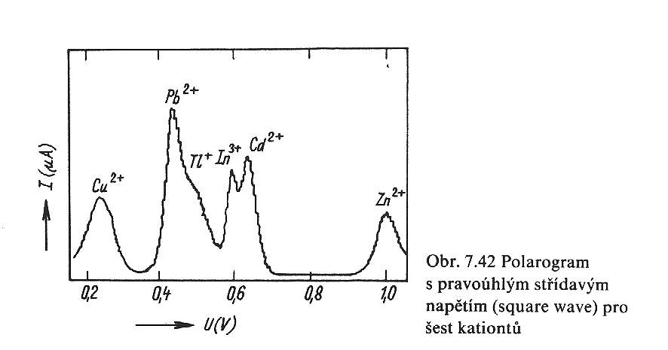

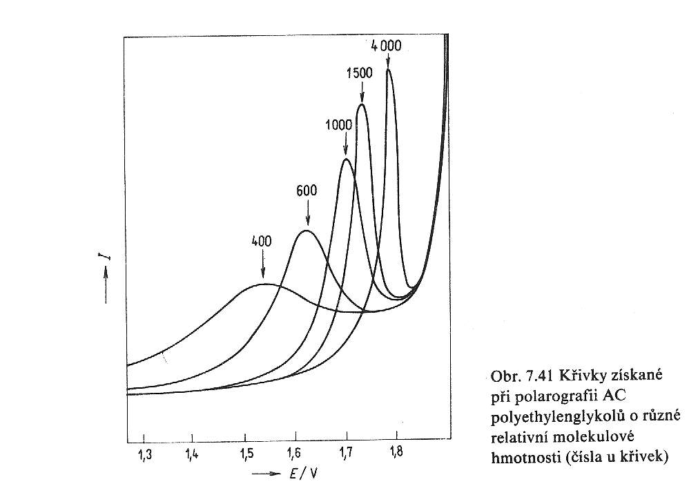

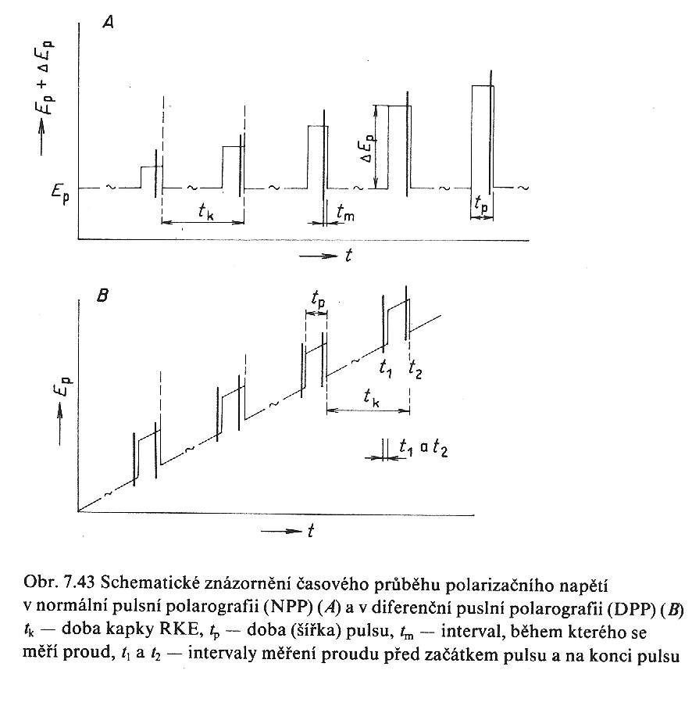

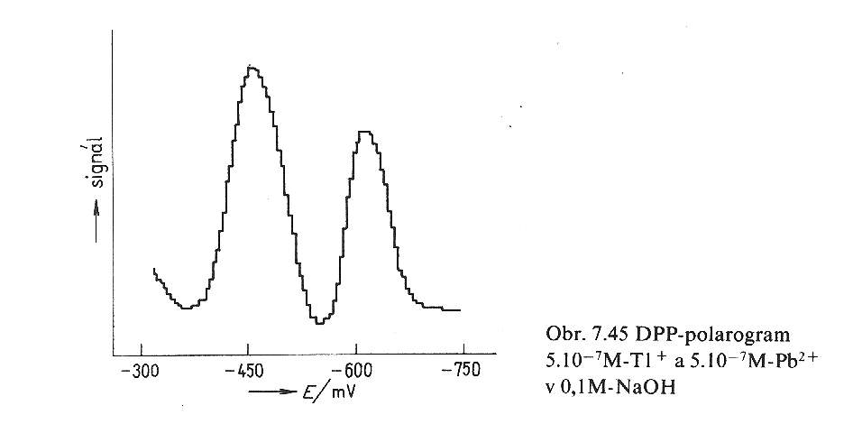

I_{d} = 0,620 cm² g^{-2/3} . n . F . Π . r² . D^{2/3} . ν^{−1/6} . ω^{1/2} . c

