JAF03 Lesson 13 Revision
- Combine the words in sentences:
- propagate – medium
- hydroelectric station – turbine
- control – artificial intelligence
- decay – nucleus
- statistics – graph
- light – wavelength
- universe – theory
- experiment – data

- Complete the gaps with suitable words.
  - Scientists…………………. experiments to find a cure for cancer.
  - Microscopes ………………..very small objects many times to make them visible.
  - Radio signals are now often ……………..by satellite.
  - Computers are able to ………………… vast amounts of data very quickly.
  - Solar power stations are able to ……………….. the energy of the sun.
  - Other …………… energy sources include wind and wave power.
  - In some types of power stations steam is used to ………………turbines.
  - The weight of lead is greater than that of aluminium, in other words lead ………………………more than aluminium.
  - As a black hole …………… particles, its mass and size steadily decrease.
  - The earlier a disease is ……………, the better the outcome.
  - Doctors can …………….. the substance as it is released into the bloodstream.
  - They use the Internet as a tool to ………………. their research.
  - The software can be ……………… to suit the needs of individual users.

- Describe the graph below:
(http://www.ecenglish.com/learnenglish/lessons/describing-graphs)

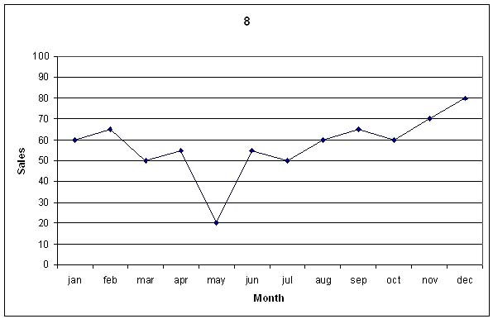
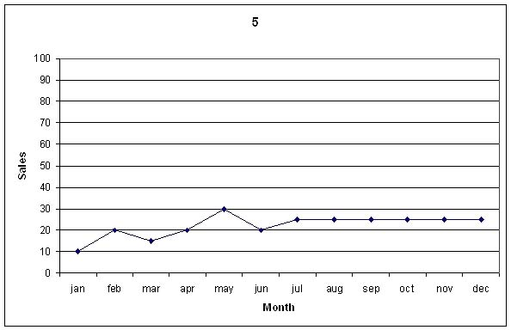

IV. Describing processes: The Mouse Trap
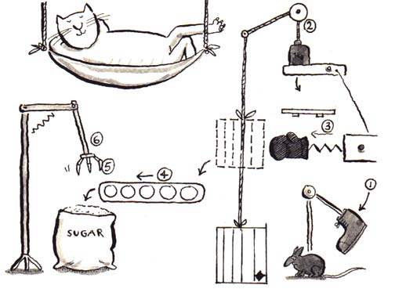

Try to work out how clever Tom manages to capture his mouse without even lifting a paw! Place the various steps 1-6 in the correct order.
The mouse then falls into the bag of sugar.
The cage is then raised by a rope attached to a pulley system.
When the cage has reached the level of the conveyor belt it is punched onto it by a boxing glove.
The mouse is kicked into the cage by the boot.
A crane then picks the mouse up and the cat then grabs it.
The cage is transported along the conveyor belt.
(http://claweb.cla.unipd.it/home/mcanapero/exercises/mousetrap.htm)

- Cause and effect. Form sentences about stress and high blood pressure.
Stress ……………..high blood pressure./ High blood pressure …………………. stress.
B. GRAMMAR
I. Transform the sentences into passive voice:
1. Researchers are developing new drugs. New drugs …
2. Researchers will develop new drugs. New drugs…
3. Researchers developed new drugs. New drugs …
4. Researchers have developed new drugs. New drugs…
5. Researchers may have developed new drugs. New drugs …

II. Tenses. Fill in the blanks with the correct form of the verb in brackets.
Researchers of the Institute of Mayhill ________(currently develop) a new anti-inflammatory drug. Despite the involvement of distinguished scientists in the project, they ___________ (not make) much progress yet. Nevertheless, they __________ (already test) hundreds of samples, and the total cost of the associated investigations _____________ (double). Dr. O´Connor __________ (coordinate) the efforts of the international team since the beginning of the project. However, as he is to retire due to health problems, Dr. Julia Dorson __________ (take over) in March. It is expected that the team _______________ (complete) the final stage of the research by the end of May next year.

III. Ask question only about the underline phrase.
The instrument is used primarily in medicine.
It was prof. Cladmont´s suggestion to try the other method.
The machine is controlled by a computer.
Students submit their essays to their supervisors.
I talked to a colleague of mine.
We encountered serious problems due to careless preparation.

IV. Translate from Czech:
málo informací – málo zkušeností – pár zážitků - hodně peněz – trochu energie – málo geologů – pár psychologů – málo znalostí – trochu hmoty – pár sekund – málo tepla – trochu času – hodně výzkumů – málo pokusů – pár rad

- Conditionals. Complete the sentences:
- If you strike a bell in a vacuum, you ……………………(hear) no sound.
- If you struck a bell in a vacuum, you …………………..(hear)no sound.
- If you had struck a bell in a vacuum, you …………….(hear) no sound.

- If you strike a bell in a vacuum, no sound ……………… (be heard).
- If you struck a bell in vacuum, no sound ………………….(be heard)
- If you had struck a bell in a vacuum, no sound ………….. (be heard).

Form sentences in conditional about James.
James did not design his experiment carefully and so it yielded incorrect data.
James did not check the results and drew wrong conclusions.
James did not consult his conclusions and his paper was not published.
James behaved foolishly and now he is ostracised by the scientific community.
- Modals
Rewrite the sentences using may/might/ must/ can´t in present and past:
I´m sure Sue is not at the conference, she is on holiday.
Probably she is in Greece as usual.
She is very likely to check her email from time to time, though.
Maybe she will reply to you quite soon if you need her advice urgently.
I´m certain she is having fun.
Certainly she did not fly to Greece, she has a fear of flying.
Perhaps she travelled with her friends.
Surely she has been to Greece before, she sent me a few postcards.

- Conjunctions. Match the clauses:
- Although I knew her very well,
- Although it was cold
- Ann arrived late because of
- Ann only arrived at 11 o´clock because
- It was very cold,
- She went on working in the company in spite of
- She went on working in the company although
- I never wear a cap
- You should bring warm clothes

- a problem at the airport.
- in case it gets cold in the evening.
- her plane was late.
- unless it is really cold.
- but he went out without a coat.
- she never talked to me about her problems.
- she was unhappy about the salary.
- the bad pay and conditions.
- he went out without a coat.

