JAF01 Lesson 12 Living Longer, Living Better?
- Discuss with a partner:
- Do you know any centenarians? Describe their lifestyle.
- Do you think you will live to be a centenarian?
- Do you think that world life expectancy will continue to increase? Why or why not? What are the main factors affecting it?
- According to researchers, people who live long lives stop eating when they are 80% full, often work hard and maintain a positive outlook on life. How do you think this helps them to live longer?
- Rate the adjectives describing a personal quality on a scale from 10 (the most important) to 0 (the least important) for a long life:
sociable independent religious healthy wealthy relaxed intelligent

- 1. Read the following passage and fill in the blanks with suitable forms of verbs in brackets:
Average life expectancy __________ (increase) rapidly in the past decades. In 1900, the average world life expectancy _______ (be) 30 years. Since then, life expectancy ___________ (increase) by about three years every 10 years, so that the world average is now 67 years. The maximum human life span – that is, the longest number of years a person _________ (live) – has also increased. In 1997, Jeanne Calment of France died at the age of 122. So far, she is the oldest known person ever to ________ (live).
During the twentieth century, increases in world life expectancy _________ (be) due to better sanitation, nutrition, medical practices, and healthcare. Today scientists _________ (try) to help people live longer by studying genes. As they learn how genes relate to health and aging, scientists may find ways to prevent cancer, heart disease, and other common diseases. They may even be able to slow the aging process. If genetic research ________ (be) successful, everyone may someday live to be 120 years old.
- Answer the following questions according to the information in the passage.
- What is the difference between life expectancy and life span?
- According to the numbers given, what was the average life expectancy in 1950?
- What are two ways that genetic research could help people be healthier and live longer?

- Examining graphic material
- Study the graph below. What information does it show? Did any information in the graph surprise you? Explain why.
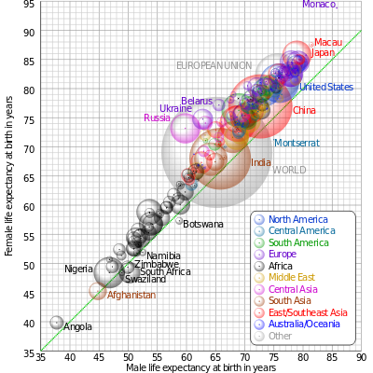
Comparison of male and female life expectancy at birth for countries and territories as defined in the 2011 CIA Factbook, with selected bubbles labelled. The dotted line corresponds to equal female and male life expectancy. The apparent 3D volumes of the bubbles are linearly proportional to their population. (wikipedia.org)
- Describing a graph in English

Going Up
- rose
- increased
- went up
- grew

Going Down
- decreased
- fell
- dropped
- declined

No Change
- stayed the same
- remained constant
- levelled off
- stabilised

Up and Down
- fluctuated
- zig-zagged
- fluttered

Small Changes - Adjectives / Adverbs
- gently
- gradually
- slightly
- steadily

Big Changes - Adverbs / Adjectives
- suddenly
- sharply
- dramatically
- steeply
- a lot

Low Points
- bottomed out, reached a low

Use the phrase from the previous page to describe the trends in the graph below.

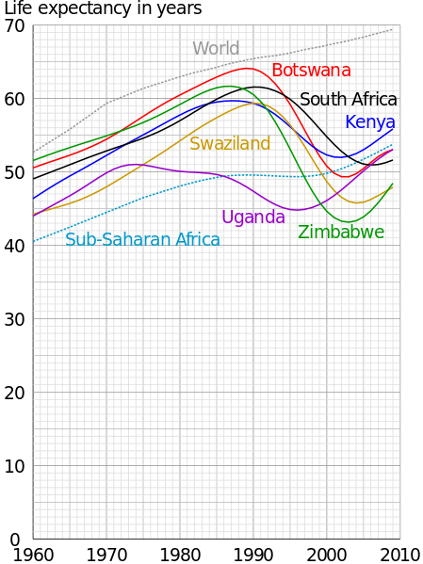

- Recording and calculating numbers
  - Scientists have identified factors that could make a person´s life longer or shorter and developed calculators for one´s life expectancy. Listen and follow the instructions to calculate your life expectancy.
  - Compare your total with a partner. Are your results lower or higher than you expected? Is there anything you could change in order to increase your life expectancy?
- Verbs + - ing or infinitive. Complete the sentences:
To live a long life doctors recommend…
My doctor strongly advised me to stop…
In many countries of the world people can´t afford…
When I am old I hope…
Older people hate…
I told my grandmother to try…
My grandfather remembers…

- Grammar: Are you the English tense master?
Read the sentences in various tenses about a computer game “Asteroids”.
Present
- Your spaceship has 5 lives left (Present Simple)
- You're playing a game called "Asteroids" (Present Continuous)
- You've been playing this game for 50 seconds (Present Perfect Continuous)
- You've destroyed 4 asteroids (Present Perfect)
Past
- I made this game about 3 days ago (Past Simple)
- I had been thinking about creating this game for several weeks (Past Perfect Continuous)
- Before I started making this game, I had refreshed my knowledge about trigonometry (Past Perfect)
- At this time yesterday, I was working hard to finish "Asteroids" (Past Continuous)
Future
- You will probably stop playing this game because it's a bit boring (Future Simple)
- By the end of April, I will have added more games of this type (Future Perfect)
- Will you still be playing this game in 10 minutes? (Future Continuous)
- I will have been trying to come up with a good Future Perfect Continuous sentence for an hour soon (Future Perfect Continuous)
(www.englishtenses.com)

Now write similar sentences about
  - writing an essay
  - doing an experiment
  - studying at university
  - ?

