9.2 DEFINING AND UNDERSTANDING SOCIAL ACTION 9.2.1: A definition
Social action can be understood as the acts, practices and strategies people implement individually or collectively to maintain, modify or challenge the structure/s and/or operation/s of the places, settings and societies in which they live. As noted in Figure 9.3, geographers may approach the study of such action by establishing their inquiries at a number of different points, most commonly by analysing the acts and purpose of the social actions themselves (foci (a) and (b)). Nevertheless the contexts and people involved in the actions (foci (c) and (d)) are often equally considered as influential in shaping the stimulus and character of the actions. Finally, it should be noted that the geographies of these actions are always highlighted as spatial issues (foci (e)), such as where the action is taking place and what struggles are occurring over space or the meaning of place. For example, in Chapter 7 the work of Claire Dwyer illustrated how something as 'simple' as choosing clothes to wear is, in reality, an action of considerable significance (see section 7.3.1). She explains:

the dress choices made by an individual are the result of an intersection of different factors including her ethnic heritage, socio-economic class, parental or familial attitudes, religious beliefs, political affiliations and personal orientations. ... [Tlhese decisions are mediated within the specific context of the social (and spatial) divisions at school as individuals negotiate their identities in relation to others. (Dwyer, 1999: 6)

Taking Dwyer's work and using the definitional elements depicted in Figure 9.3, we can observe the following:
- the actions (a) involve deciding on specific dress styles;
- the purpose of the actions (b) consist of young women's wish to experiment with identities and interests in ethnicity, religion and independence;
- the contexts (c) involve a variety of social factors - noted in the quote above;
- the actors (d) as young women are positioned as subjects in many contrasting discourses (e.g. pupil, daughter, Muslim); and
- the spaces involved in the action (e) are integral to the negotiations and consequences each young woman faces (be they the school toilets, the stage of the fashion show, local streets, family homes or 'inside' spaces under the traditional hijab).

184

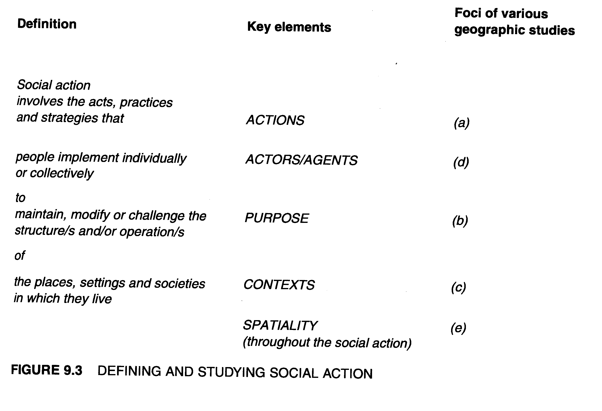

While this is a simple way of identifying a number of aspects of action that geographers study, wider dimensions and theoretical concepts are also involved as the following two sub-sections will show.

9.2.2 The scope of social action

The diversity of social action is immense. Nevertheless we can recognize at least two broad dimensions that characterize the scope of all actions. First, a temporal dimension can distinguish social actions in terms of whether activities are temporary or medium- to long-term endeavours. Second, we can identify the degree to which activities are maintaining or enhancing existing social structures and power relations, or the degree to which they are attempting some form of social change. Figure 9.4 depicts these broad qualities and illustrates how different forms of social action might be located across these axes of time and social purpose.
Figure 9.4 depicts three fields of action. The first involves those actions that support the continuing maintenance of existing social relations and structures of power. Melucci's (1996) conceptualization of collective action and the degree to which actions maintain or breach the limits of social systems is relevant here (see Figure 9.5). In the case of the first field of action in Figure 9.4, actions will be organized to operate within, and

185

maintain, the structures, relations and limits of a social system involved. Compliance with the legal system of a society and participation in the democratic processes of voting and submissions can be seen as actions by which people participate in maintaining existing social relations and power structures.

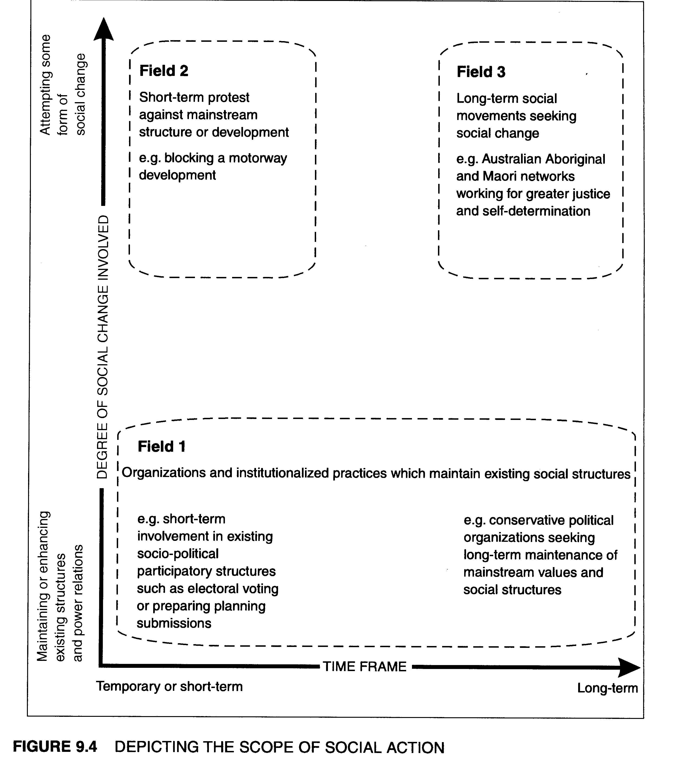

Figure 9.4 shows a second field of action which includes those actions that swiftly attempt to challenge or stop existing conditions or developments from within mainstream structures. Single, issue-based protests are a good example of this type of action, where interest and activity flares quickly in response to a concern and participants work strategically to challenge or halt a situation they oppose. This type of action best illustrates type of anti-war march presented in Figures 9.1 and 9.2. In 2001, responses to the military action in Afghanistan were widespread but relatively temporary - a longer-term social critique against the 'war on terrorism' is a more complex and challenging action, and better associated with the third field of action. This third field involves individuals, groups and social movements who are committed to extensive social change. Because the agendas are so complex, such actions tend to operate over a far longer period of time. As will be shown in section 9.3, these might include individuals organizing alternative craft economies and social movements associated with socio-political change. In Melucci's (1996: 26-33) terms, whether these changes are classified as 'individual resistance' or collective 'social movement', they will involve social codes being challenged, and the 'breaching of systems limits'.

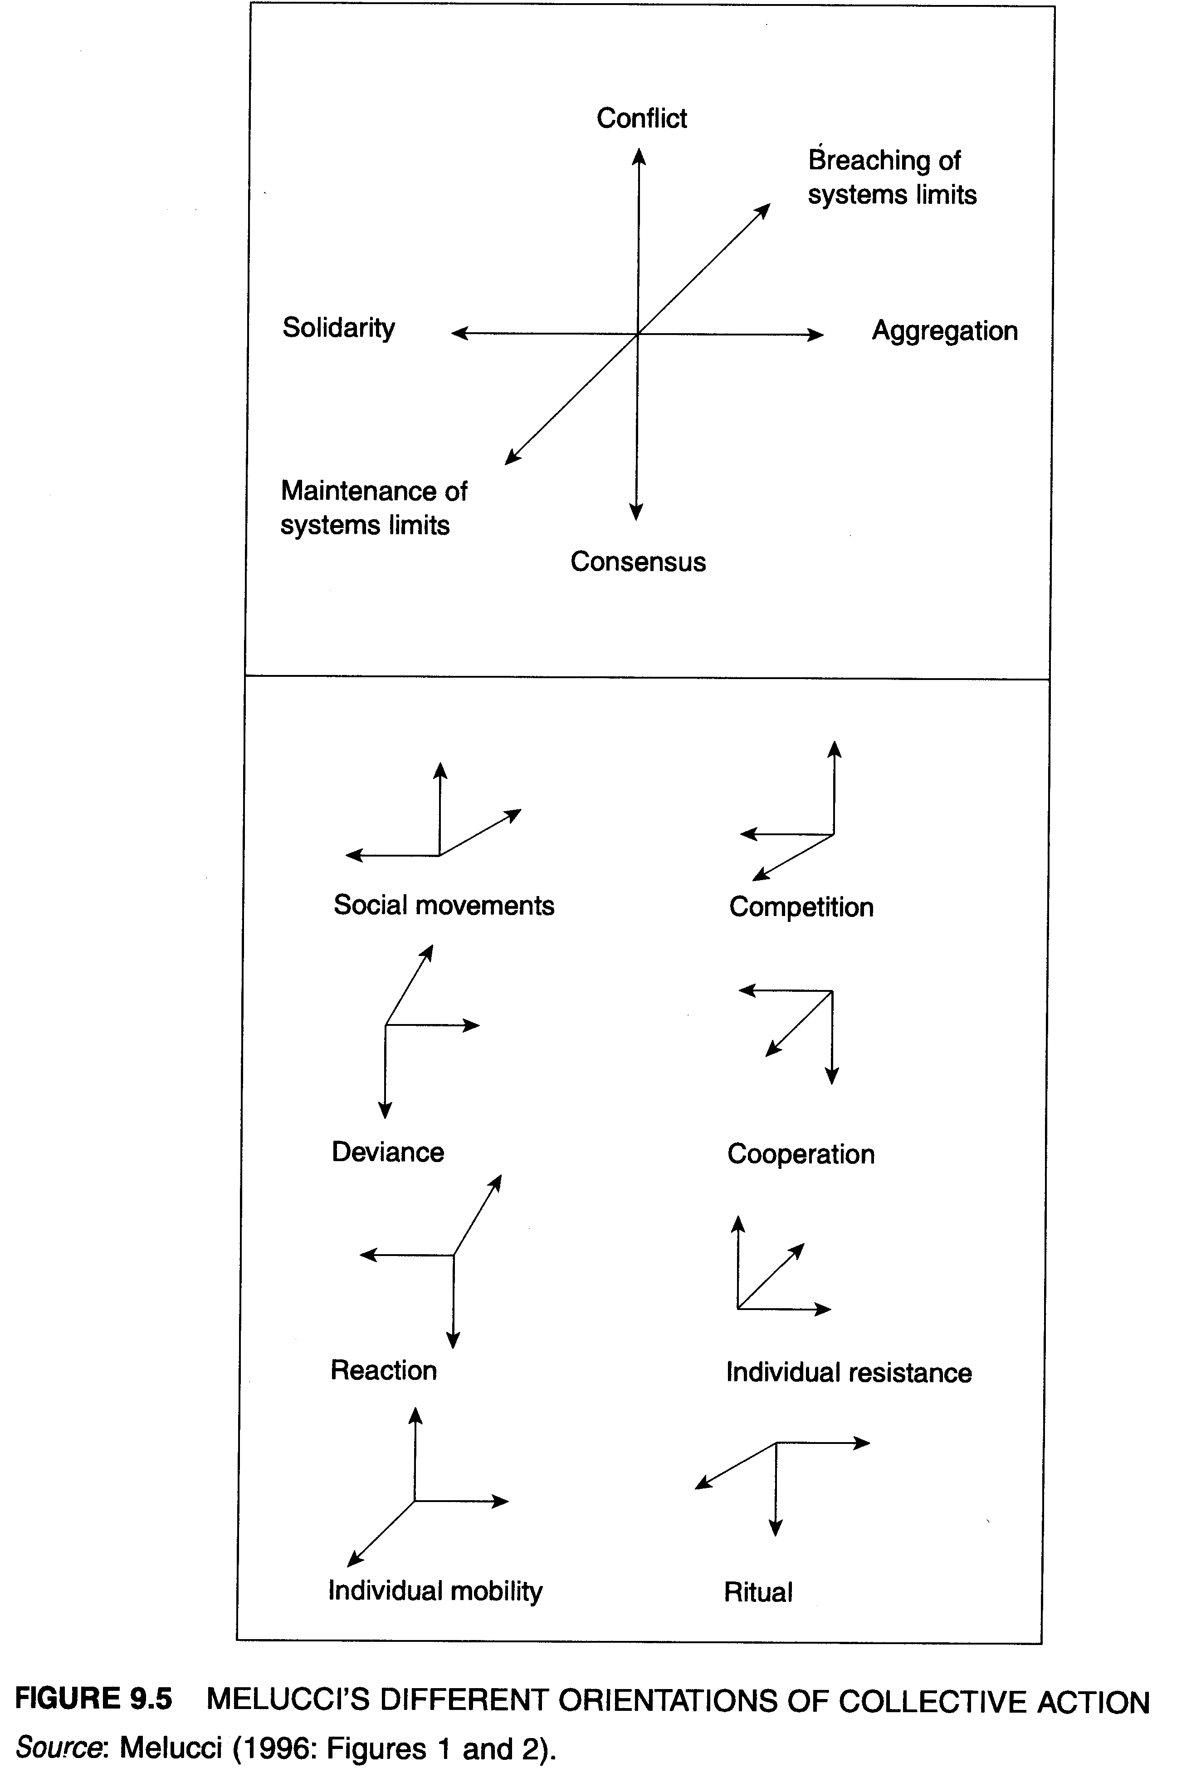

In both cases, participants hold long-term interests in making major changes to the socio-political and/or economic and environmental dimensions of life. They may include individuals in personal negotiations of domestic and economic needs and relations. Or, in terms of collective endeavours, the action may involve larger movements who engage extensively with power relations, including the construction of particular discourses and the use of diverse strategies of resistance or reconstruction. Geographies of each of these actions are discussed in detail in section 9.3.

9.2.3 Approaches and concepts

Variations in the way social action is explained and investigated depends greatly on the different theories and perspectives employed. As shown in Table 9.1, both the people and the actions themselves are conceptualized in a range of different ways. In each case, contrasting philosophical and theoretical perspectives result in different views of the people involved and the contexts and processes by which they establish action.
For instance, Weberian-inspired action theory works primarily from an individualist view of action (Weber, 1978) and categorizes actions according to whether they are traditional (based on past history), affectual (emotions-based), instrumental (goal-based), or value rational (value-goal related). In contrast, Marxist critiques of action are grounded within the broader critical political-economic perspective outlined in Chapters 2 and 3. In this case, people taking action are addressed in association with their class position and described in terms of their class-consciousness (or false-consciousness). Action is then explained in terms of class relations and class conflict where conservative action is seen to maintain class positions to the advantage of capitalist classes, while critical action is seen as class struggle as a means to adjust or address uneven conditions of disadvantaged classes (see section 3.3.2). Marxist approaches are one form of structuralist thinking; Giddens' structuration theory is another. Giddens equally views action as affected by structural contexts. However, he also places an emphasis on agency. This enables Giddens (1984) to argue for a 'duality of structure' whereby people produce society (its relations, institutions and events) but are also influenced, even constrained, by it. Consequently, action is a product not only of people's agency, but also of the 'rules and resources' of the particular social system in which they live.

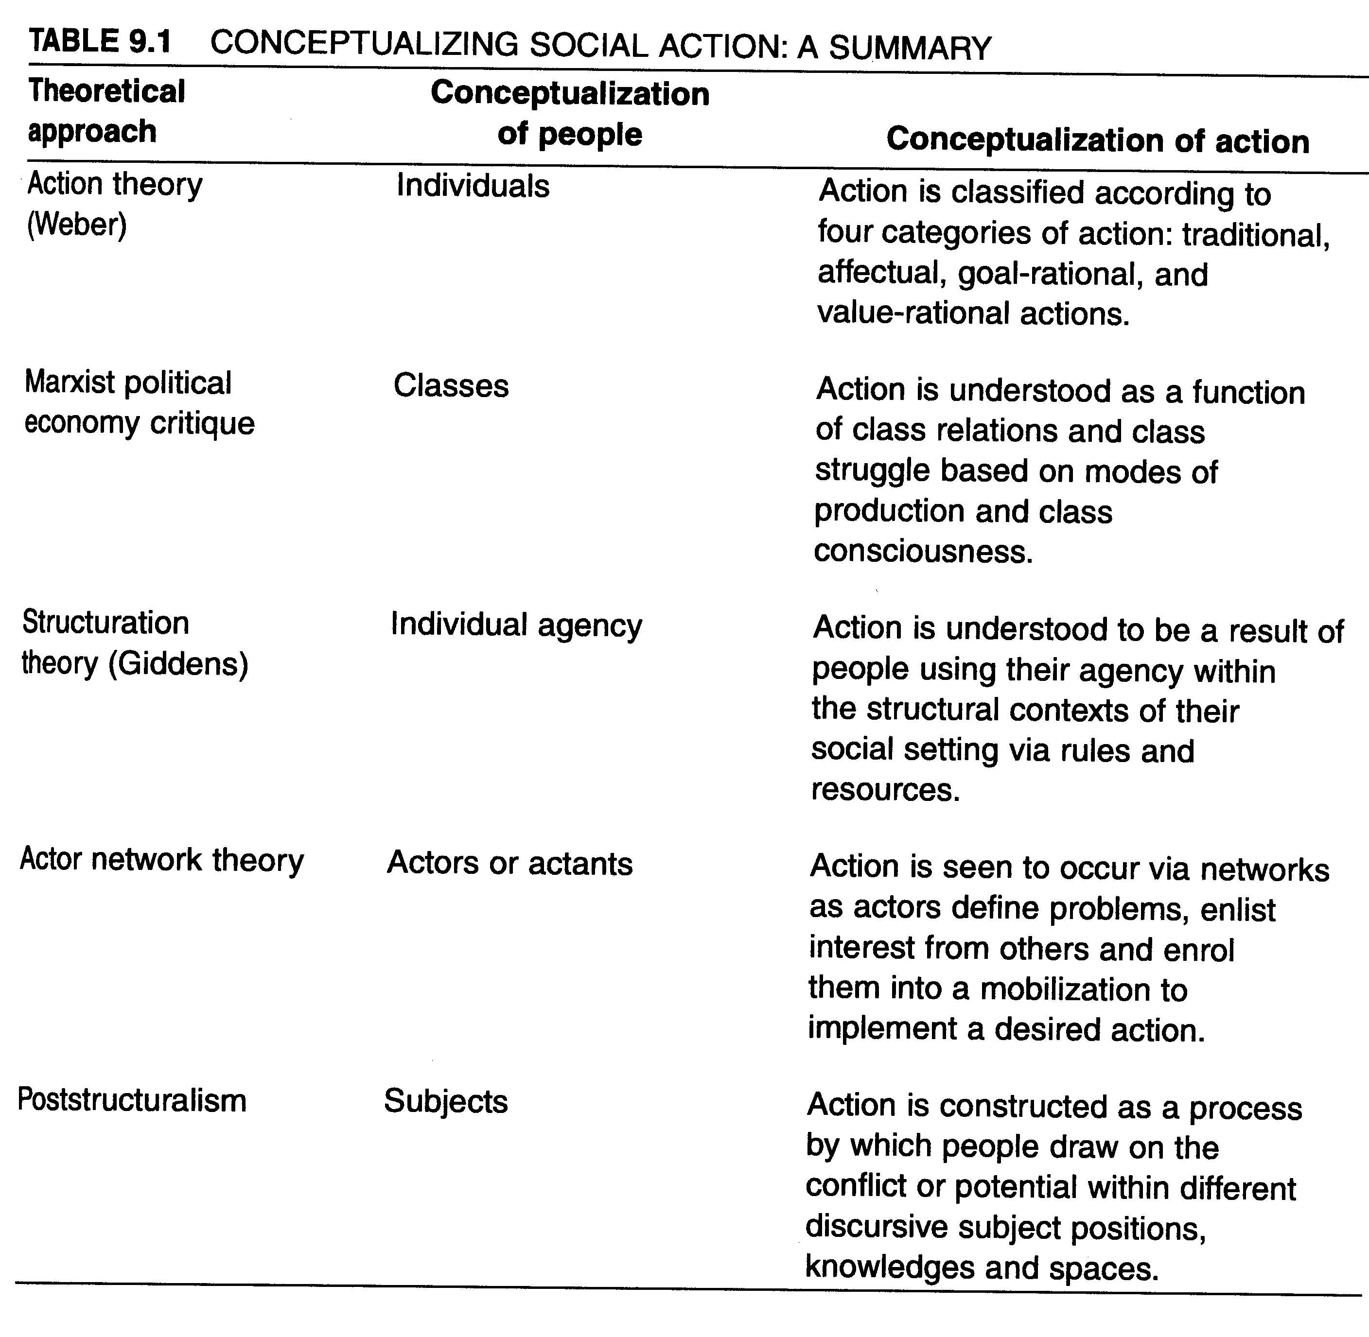

Finally, the two theoretical approaches that have gained widespread adoption in recent social geographies of action involve actor network theory and poststructural accounts of political subjectivity. Actor network theory draws on sociologies of science. It views action occurring via individual human, composite (e.g. institutional) and non-human actors or 'actants', who identify problems and then enlist others into a network to achieve an intended outcome (Callon, 1986; Law, 1994). This enrolment is known as a translation process and involves actors being attracted to a project or problem, enrolled and mobilized to take action. Geographies based on this approach are discussed in further detail in section 9.3 (see especially the work of Murdoch and Marsden, 1995).
Poststructural perspectives form the last influential approach to geographies of social action. Since poststructuralists do not see the human subject as a discrete and stable individual actor, they concentrate on the subject positions constructed through discourse and the articulation power relations. The diversity of subject positions set up contrasts, c flicts and choices for people to work through and select, as Davies explains:

The speaking/writing subject can move within and between discourses can see precisely how they subject her, can use the terms of one discourse to counteract, modify, refuse and go beyond the other both in terms of he own experienced subjectivity and in the way in which she chooses to speak in relation to the subjectivities of others. (Davies, 1991: 46)

A poststructural view of political subjectivity concentrates on h( certain positions are strategically highlighted and promoted and others , challenged or put to the background. Liepins' commentary on 'women agriculture' (in Chapter 8) provided one example of this work. In t following section, C. Gibson's (1998) account of aboriginal musicians a] draws on a poststructural discursive view of action to show how popular music can form a complex discursive field in which an alternative indigenous nous geopolitics can develop. Likewise, Gibson-Graham's research (1995, 1996a and 2003) - detailed in Part V - illustrates that poststructural view of political subjectivity can be used to recognize how different peop respond to economic conditions and the possibility of rearranging work and living arrangements beyond dominant capitalist wage-labour ones.

9.3 COMPARING GEOGRAPHIES OF SOCIAL ACTION

Geographers have long sought to engage critically and analytically with th social concerns and relations that result in people taking action over van ous matters. Early work in what might be called modern social geograph includes analyses of social protest against foreign military policy. Fc example, in a sobering echo from past concerns, current critiques of 'we on terrorism' can look back to the 'Confront the Warmakers' protest an Pentagon March of October 1967. Akatiff's (1974: 26) account of the earlier march illustrates the systematic spatial science culture in which he wrote his geography, arguing that 'geographic analysis of distribution dispersal, flows and environmental perception provide powerful analyti tools for the general understanding of these movements ... for social change'. Even though a 'spatial science' flavour to geographies of social action is not common any longer, he nevertheless foretells of the entwining of social and spatial dimensions that have continued to guide man geographies of social action. Indeed, while contemporary geographer employ many different approaches when theorizing or analysing empirica data on social action at the turn of the twenty-first century, two generi qualities emerge. These involve, first, the attention given to social processe by which people move from experience and difference through to an engagement with identity, power and action, and, second, the attention given
to the socio-spatial qualities and relations of the social action - both in the terms of the settings and also the ways spaces and places are strategically
shaped or consequently influenced by actions.

9.3.1 Social processes: from difference to action

In considering social action, especially that devoted to some form of change, geographers are faced with the need to recognize how people's diverse circumstances and experiences nevertheless result in sufficient stimulus for specific purposes and identities to form, through which power relations are engaged and actions are chosen and implemented. Thus, toto act - to participate, contribute, challenge or resist - involves intersecting social processes where difference, identity and power are negotiated.
People (as actors, subjects, agents, etc.) experience issues that concernconcern them and come to recognize differences and commonalities that provide them with opportunities. They can consider their own, and others', different positions/roles/subjectivities. Equally, they may become aware of the existing power relations/networks/discourses surrounding them and may choose to mobilize their positions and concerns through engaging in differentways with these power relations. One example of these processes is shown in the work of Murdoch and Marsden (1995), who trace the proposed development and opposition of expanding mining operations in Buckinghamshire, England. This is an example of social action within the first field of action (Figure 9.4), where the development - and responses to it - occurs within the existing structures and relations of a social systém as opposed to challenging it).
Analysing this local mining and environmental conflict, Murdoch andand Marsden employ actor network theory to identify the different groups of people and their interests and actions. The local planners and national mining company personnel are conceptualized as two sets of actors who, for different planning and commercial reasons, wish to support the investigation and development of mineral extraction in Buckinghamshire. Participating within the existing economic and political structures and networks, these parties mobilized the existing quota system and county interests to spread extraction activities more widely from the previous concentrations in the south of the region. They respectively proposed and
supported new developments of mineral extraction in a relativem untouched northern part of the county (see Figure 9.6). In opposition to these initiatives, local residents of the affected area formed a unity of shared concern for their area. A 'translation' process occurred as they connected with - and 'enrolled' - upper-class, political and cultural network at national levels in order to oppose the developments. Working within the planning appeal process and the national media, and drawing upon other non-local actors and networks (heritage, gardens and private school old boys networks), the local action group was able to counter and halt th investigation. In this case, Murdoch and Marsden argue that:

[t]he outcome [i.e. successful opposition] depended on which set of associations remained strongest and which meanings [i.e. economic development vs. cultural heritage] became dominant as two national/local networks came into conflict. ... There was nothing inevitable about the action group's success and it was only because a particular set of associations ere forged that the outcome took the form it did. ... In the course of collective action, resources will be mobilized in an attempt to cement the bonds which tie actors together (e.g. minerals for economic growth [vs] vestments in parks and so on). (Murdoch and Marsden, 1995: 378)

Murdoch and Marsden's application of actor network theory provides both analytical tools for conceptualizing the people involved and the rela between them. In the latter case, this theory supported the empirical findings that while obvious differences existed between different groups of actors working to oppose the development, nevertheless they were able to n a shared position and develop collective action (across a range of .es) on either side of the minerals extraction issue.
Looking at social actions more generally, a number of processes are often ultaneously involved in these situations. For simplicity's sake, they are crated out into four sets of activities, as shown in Table 9.2. Using the examples of constructing a gay identity in Hollywood (discussed in Chapter 7), agitating for women's recognition and participation in Australian agriculture (discussed in Chapter 8), these four processes are summarized thus.
First, people experience circumstances that allow them to recognize erence and tension. As shown in the previous chapters, gay males in 3t Hollywood and women involved in farming have equally experienced ns of social and political marginalization. Forest (1995) argues that -ginalization from citizenship was a stimulant for gay male interests in rooting West Hollywood's identity as a positive and creative gay district, while Liepins (1998a) notes that personal and industry-based exclusion from ,cultural decision-making provoked diverse Australian women to form 'women in agriculture' movement. Second, both geographers highlight different social and power relations that contextualize these situations provide activists with opportunities and arenas for action. Third, Forest Liepins identify the strategic identities or subject positions which vists select and publicize (creative, responsible gay males and farmers/ iness-partners/mothers, respectively). In the Australian case, using a tstructural approach, I have concentrated on the opportunities provided women's consideration of numerous subject positions:

The movement's exposure of multiple and contradictory subjectivities has provided women [with] political moments of choice ... subjects could realize agency and generate acknowledgement of a variety of knowledges based on the tensions and opportunities found in their particular positions and identities. (Liepins, 1998a:152)

Finally (row 5, Table 9.2), through the cumulative awareness of experiences, contexts and identities, Forest and Liepins argue that social action is implemented through the choice of specific strategies and/ort the construction and circulation of particular meanings. Forest argues that the construction of press narratives were crucial in projecting gay males as responsible and capable contributors to West Hollywood as a creative and design-oriented community (1995: 149-51). In a complementary fashion, I concluded that 'women in agriculture's strategies of personal support, public gatherings, media publicity, industry networking and political lobbying increased women's participation in farming at several levels:

In less than a decade, activists and supporters have seen growth in women's confidence and an insistence on being seen as farmers; they have encouraged greater participation of women in all aspects of farming (labor, administration, enterprise diversification, ownership and management); and they have forced an increased sensitivity to women's involvement in farming and industry decision-making. (Liepins, 1998a: 152)

While these types of generic process could be tabulated for many accounts of social action, it is important to note that these processes do not remove, or solve, social differences that occur within the groups undertaking the actions. Each case of social action discussed to date indicates various ways in which social and economic differences can potentially fracture the interest groups yet are temporarily set aside, or crossed in some fashion, so that collective goals can be achieved. For instance, differences between gay males or between farm women could have thwarted the goals and actions each group achieved in West Hollywood and Australia. A more graphic case of these differences illustrates how this can happen. As noted in Chapter 1, Valentine (1997) has reviewed the movement of lesbian separatism that developed in the USA in the 1970s (Box 1.2). She records lesbians actions in establishing and maintaining explicitly separate and alternative communities for lesbian lifestyles in rural USA. This is an example of the third field of action depicted in Figure 9.4, for these women were committed to a long-term alternative social environment involving the formation of land trusts and the development of women-only communities which aimed to foster non-hierarchical and self-sufficient lifestyles. In outlining these activities, Valentine noted the women's purpose in 'separating from heteropatriarchal society', reflects the context of the 1970s radical feminism that had begun to identify 'heterosexuality as the root of women's (lesbian, bisexual and heterosexual) oppression' (Valentine, 1997: 110). While this was an ambitious movement, the character and success of the actions were affected by the differences between the women. The 'Lesbian lands' were sites that accentuated women's differences in ethnicity, class, sexual practice, and attitudes to boy children. She writes:
[L]esbian separatist attempts to establish 'idyllic' ways of living in the countryside appear to have unravelled because, in common with traditional white middle-class visions of 'rural community', attempts to create unity and common ways of living also produced boundaries and exclusions. ... Lesbian lands wanted to recognize and value diversity among the inhabitants of their communities, [but] the reality was that in many lands, identities were not equally valued, rather some were privileged over others. The [sexual, racial and class] tensions within these lands developed as a product of the inequalities of power and hierarchies that were constructed between the women ( Valentine, 1997, 118-19, 120)

In short ˇLesbian lands´ demonstrated the oportunity for social chase but also the many social differences and negotiations of identity and power that have to be navigated.

196

Reports of the tensions and fragility of action for social change important. Social geographies could well be enriched if more contin or longtitudinal studies were made of social action and the fortunes negotiations of associated activist groups. This would occur especially where social geographers spent further energy on investigating hom ference and collective beliefs, identities and actions were negotiated. of the challenge remains in the need to recognize, and find suitable ceptual apparatus to read the complex coincidence of social processes as those identified in Table 9.2.
While tables might neatly divide components of social action, the r rial and cultural reality of most social action involves people in simul ous and overdetermined social processes. Experiences, contexts, iden and strategic choices are all closely interwoven in different 'enta ments' (Sharp et al., 2000). These interconnected processes are not li but rather they variously mesh, grind or ignite in social conflict and/or adjustment in a variety of ways. Consequently, people are drawn int need to interpret the contextual terrains of power relations surrounding them, and to choose specific identities and actions to fulfil their respective interests. Gibson-Graham's (1995) analysis of responses to changed conditions in Australian mines is a case in point. As shown at the b ning of this book (Box 1.1) miners and their partners in Queenslanc New South Wales had quite different responses to a new seven-day r that mining companies introduced. Gender and class differences, tog with different industrial histories and identities in the more conservative Central Queensland and more militant Hunter Valley locations, mean contrasting actions were taken. Rather than a standard Marxist analysis Gibson-Graham take a poststructural and anti-essential reading of actions (see Part V for further explanation and contextual detail abou change in interpretation). The Queensland miners and their wives ad( the new work arrangements and used the higher wages to purchase properties, take up other activities (farming and pig shooting) or investment properties on the coast while Hunter Valley workers and partners resisted the changes with industrial action.
It is the spatiality of these actions that emerges when such contrasts drawn. The spatial character of action results from the varying, context-specific specific ways space is encountered and shaped, and the way different r can become a medium through which differences are acknowledged bu ered in the moments and activities of a specific form of social action. the socio-spatial qualities and relations of social action require discussion.

9.3.2 Seeing social actions as socio-spatial phenomena

It may seem rather obvious to state that the distinction between geographic work and other academic accounts of social action rests in ´analysts´ and authors' attention to the spatial character of such activities. Yet the socio-spatial qualities of individual and collective actions reported in this book are rich the way they convey the social character of issues being contested. They -e also qualities that are crucial to the effectiveness of the politics volved in each case, as will become apparent in this section.
In a general sense, social action has been shown in this chapter to volve the complicated negotiation of differences, identities and power Matrons. Rose (1999: 249) argues that 'space is a performance of power'. She notes that where social action involves the collective mobilization of fferent power relations and activities, then the performance of these actions will both take up and constitute/reconstitute space. In short, about are not just about choosing to participate or not, or to maintain or range some aspects of one's individual or social frame. It also involves spatializations of the process. Delineating the issues, negotiating the surrounding terrains of power and implementing strategic actions all occur in ;ace. Such space may involve symbolic sites, such as the Pentagon in katiff's (1974) example opening section 9.3, or it may involve the holistic construction of an idealized place such as the gay imagination of West ollywood (Forest, 1995). Alternatively, this action-space may involve temporary sites, like those discussed by Winchester and Costello's (1995) analysis of the squats and hang-outs used by Australian street kids (see section 7.3.1). In all cases, however, the social processes constituting the actions (of protest, identity formation or the construction of marginal or ternative lifestyles) will be influenced by, and will shape, the spaces and tes in which the issues and people are positioned.
Murdoch and Marsden (1995) have termed this the 'spatialization of ´politics´ and have noted the importance of understanding how relations occurring at different scales will be drawn together through different cases local-national conflict. Parallel 'spatializations' can be seen in my reading of the 'women in agriculture' movement where activists mobilized across local, state, national and international arenas. They created relations ith supporters and other organizations and positions that operated simulneously across a number of scales (see section 8.3.3 or Liepins, 1998a; Panelli, 2002a). Both these cases illustrate what Massey (1999: 279) 'imagines' as space, being 'a product of interrelations ... constituted through a process [or continuous processes] of interaction'. Furthermore, in each of the cases introduced in this book, 'spaces of interrelation' could be identied and read.
Massey's imaginations about 'spaces of politics' are instructive for this review of social action. She presents two other imaginations of space, the second being where space is 'the sphere of the possibility of the existence multiplicity' and the third being where space is 'disrupted and ... a source of disruption (1999:279-80). Both of these constructions od space can be seen in geographies of social action, and Fisher´s (1997) study of alternative craft economies illustrates this well. Actions by these craft workers constitute the attempt to create long-term social and economic change in individual situations (part of the third field of action shown in Figure 9.4). Massey's space of 'multiplicities' can be seen in Fisher' description of how craft makers rework home spaces to achieve the wort life to which they aspire. Home spaces involve multiple and often corn peting demands, people and functions. Kitchens, living rooms and othe home spaces are simultaneously constructed as both productive and reproductive spheres - each with multiple facets.
It is also important to note that the social actions themselves further constitute space as a sphere of multiplicities. Fisher shows that craft pr( ducers' actions in creating an alternative economy for themselves cowl actively construct and delineate the multiplicities into their home spaces
Downstairs rooms often have spaces within them that are temporarily transformed in productive spaces. In these more indeterminate, temporary spaces, the boundaries between production and reproduction are necessary. What [craft] makers find desirable is an uninterruptible production space, yet at the same time an interruptible reproductive space. To achieve this, makers redraw boundaries between the two, by cordoning off such spaces with curtains and even bits of string, so creating permeable boundaries. Such membranes between the two filter out certain forms of interaction while allowing others. Pieces of string to mark out the space of production are reportedly among the most effective dividers between production and childcare: an invisible wall, allowing visual and verbal communication between maker and children, while in theory filtering out physical contact. (Fisher, 1997: 241)
Fisher's work illustrates the recognition of spaces as spheres of multiplicity, but she also demonstrates what Massey conceptualizes as 'disrupted space'. In the case of the Welsh craft producers, home spaces we clearly spaces of disruption and sources of disruption for workers who juggled multiple identities and responsibilities. Fisher writes of both the opportunities and frustrations of such space:
[T]he space they work from can be empowering. In controlling the use of their space [craft], makers play a multiplicity of roles, creatively muddling conventional gendered roles and locations for the performing of these roles. However, makers often have to (re/demarcate spaces of production, 'roping off' work space from play space and creating often permeable occluded spaces, the result being an ironic reference back to those delimited spaces of production and reproduction that they previously rejected (Fisher, 1997: 247).

202

9.4 CONCLUSIONS

This chapter has formed the final example of how social geographers can simultaneously acknowledge social differences yet construct valuable knowledges about how people work and act across those differences. In this case, social action has been the focus, for hopeful yet reflective geographies have been written to show how people will join across various differences to build lifestyles, places and protests that involve some degree of shared meanings and relations. In this chapter we have seen how great a range of social actions can be identified. It has also been important to acknowledge that all social actions 'across difference' involve a range of social processes by which people make meanings of their experiences (or grievances); identify relevant power relations and positions (or identities) from which to act; and implement specific actions to achieve their ends. Furthermore, after Massey (1999), the spatial qualities of social action have been illustrated as key arenas where actions are performed (in relational spaces) even while differences can be both sustained (in spaces of multiplicity) or capitalized upon (in spaces of disruption).
Geographies of social action are often invigorating and provocative to read once these generic social and spatial qualities are noted.

203

Renditions of social action are also important for the ongoing practice of social geography for at least four reasons. First, geographies of social action remind us of the rarely fixed, but rather dynamic and spatial dimensions of social life. These studies emphasize that it is insufficient to create social geographies of patterns and description if we do not also acknowledge the constantly changing and negotiated nature of social life.
Second, geographies of social action highlight the spectrum of differences that shape our social worlds and the knowledges we produce. To actis usually to begin with some issue about difference: self and other; your experiences/lifestyle/opportunities/needs compared to others. Thus geographies of social action can integrate the complex relations between multiple differences and the possibility of connections across those differences. While connections across difference may be studied through attention to households, neighbourhoods, communities and nations, attention to difference and/within social action challenges geographers to construct understandings of 'why' (and how) some form of unity can be achieved across difference in often transitory ways.
Third, geographies of social action raise the problems and challenges constantly faced by social (human) geography and social sciences in choices we make about how to write and re-present social life (in this case social action). Geographies of social action encourage us to consider our own multiple interests and agendas. The perspectives, theories and constructions geographers use to communicate analyses of action create particular and situated knowledges based on both the geographers' research choices and their own experiences and beliefs about what social geography can be and how it should be practised. This situation is not limited to studies of social action, yet the usually volatile and explicitly political nature of much social action magnifies the need for social geographers to present clear and reflective accounts of both the actions and their constructions of it.
Finally, geographies of social action remind us of the potential and depth in social geography, for in constructing geographies of socio-spatial life we constantly face the possibilities (hopes and anxieties) surrounding our choices, capacities and abilities to shape and change our social worlds. These possibilities may be conventionally explored through existing structures and relations or they may stretch along a continuum of critical thought and advocacy for social change. This then brings us full circle in this text - back to the questions closing Chapter 1 and the theoretical perspectives of Chapter 2. We have moved through the studies of diverse people and the relations and action.
202

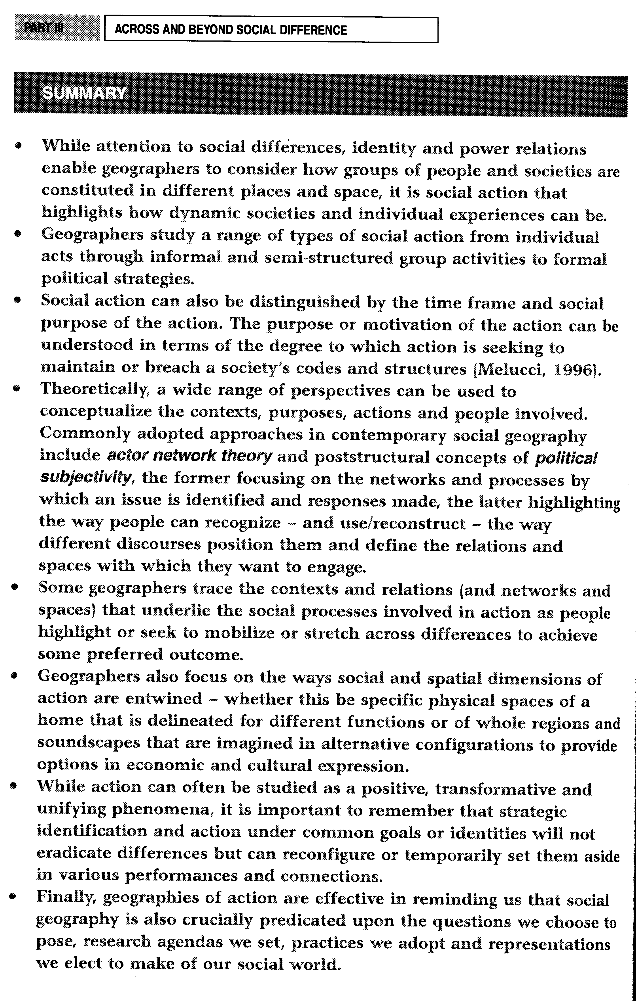
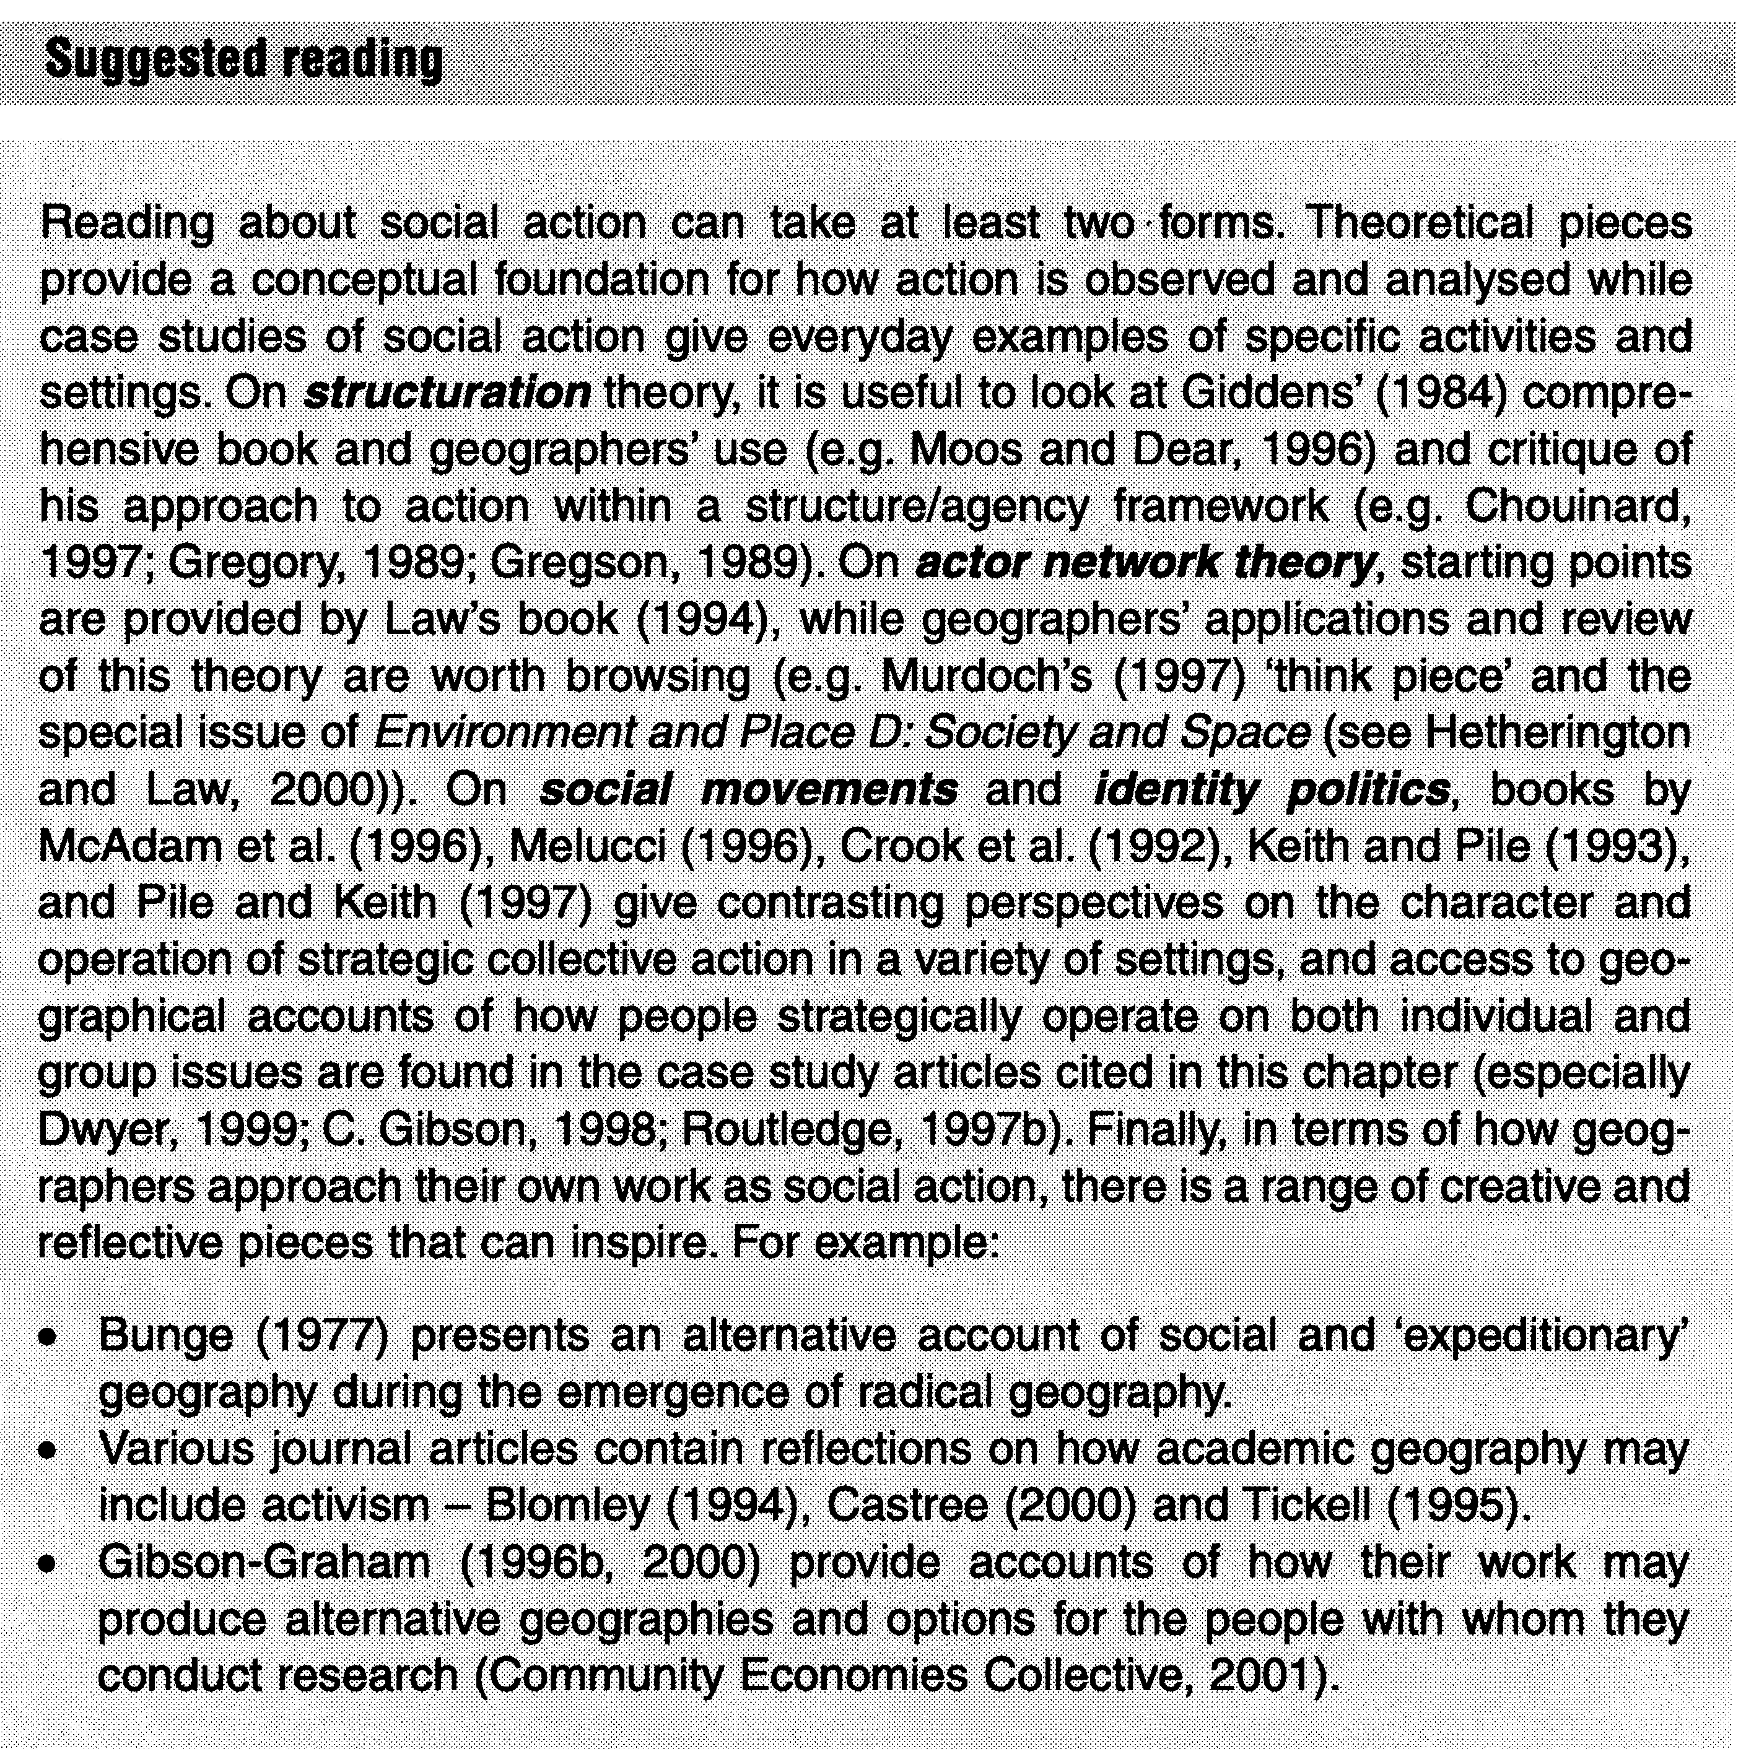

10.2 SYNTHESIS AND FUTURE DIRECTIONS

While this book has highlighted the individual core elements of social difference, identity, power and action as they relate to social geography, attention to the relations between them enables a basic synthesis to be made. Figure 10.1 portrays one such synthesis. It presents a reading of social geography where social life in all its diversity is acknowledged as situated in - and reproducing - spaces and places (central to the figure).
A social understanding of space, in non-essentialist terms, will not precede society but will be 'filled, contested, and reconfigured through contingent and partially determined social relations, practices and meanings' (Natter and Jones, 1997: 149). Such views of space and place not only avoid fixing dimensions or meanings of space, but also remind us of the constant making and remaking of space and place that occurs as we live our day-to-day lives (Massey, 1999). Indeed, Massey has argued that interrelational and open notions of space better support our endeavours in studying both the dynamic, changes and the political possibilities of space:
[I]magining space in terms of interrelations and of constitutive difference can provide one of the preconditions for this openness, for the possibility of the emergence of genuine novelty. Both the endless openness of spatiality (its loose ends) and its inherent disruptedness (its conflicting co-existences, its unexpected distancing, its dissonant or congenial juxtapositions ...) establish the grounds for such newness. Imagining space in terms of multiplicity and the possibility of interrelations guarantees the openness of the outcome of any interaction (or lack of interaction). The space is neither stasis nor closure. ... This 'spatial' is the very product of multiplicity and thus a source of dislocation, of radical openness, and so of the possibility of creative politics. (Massey, 1999: 287)
These perspectives on space and place encourage attention to interconnections with the other core elements under discussion in this book, and these linkages operate with all four of the other elements in Figure 10.1.

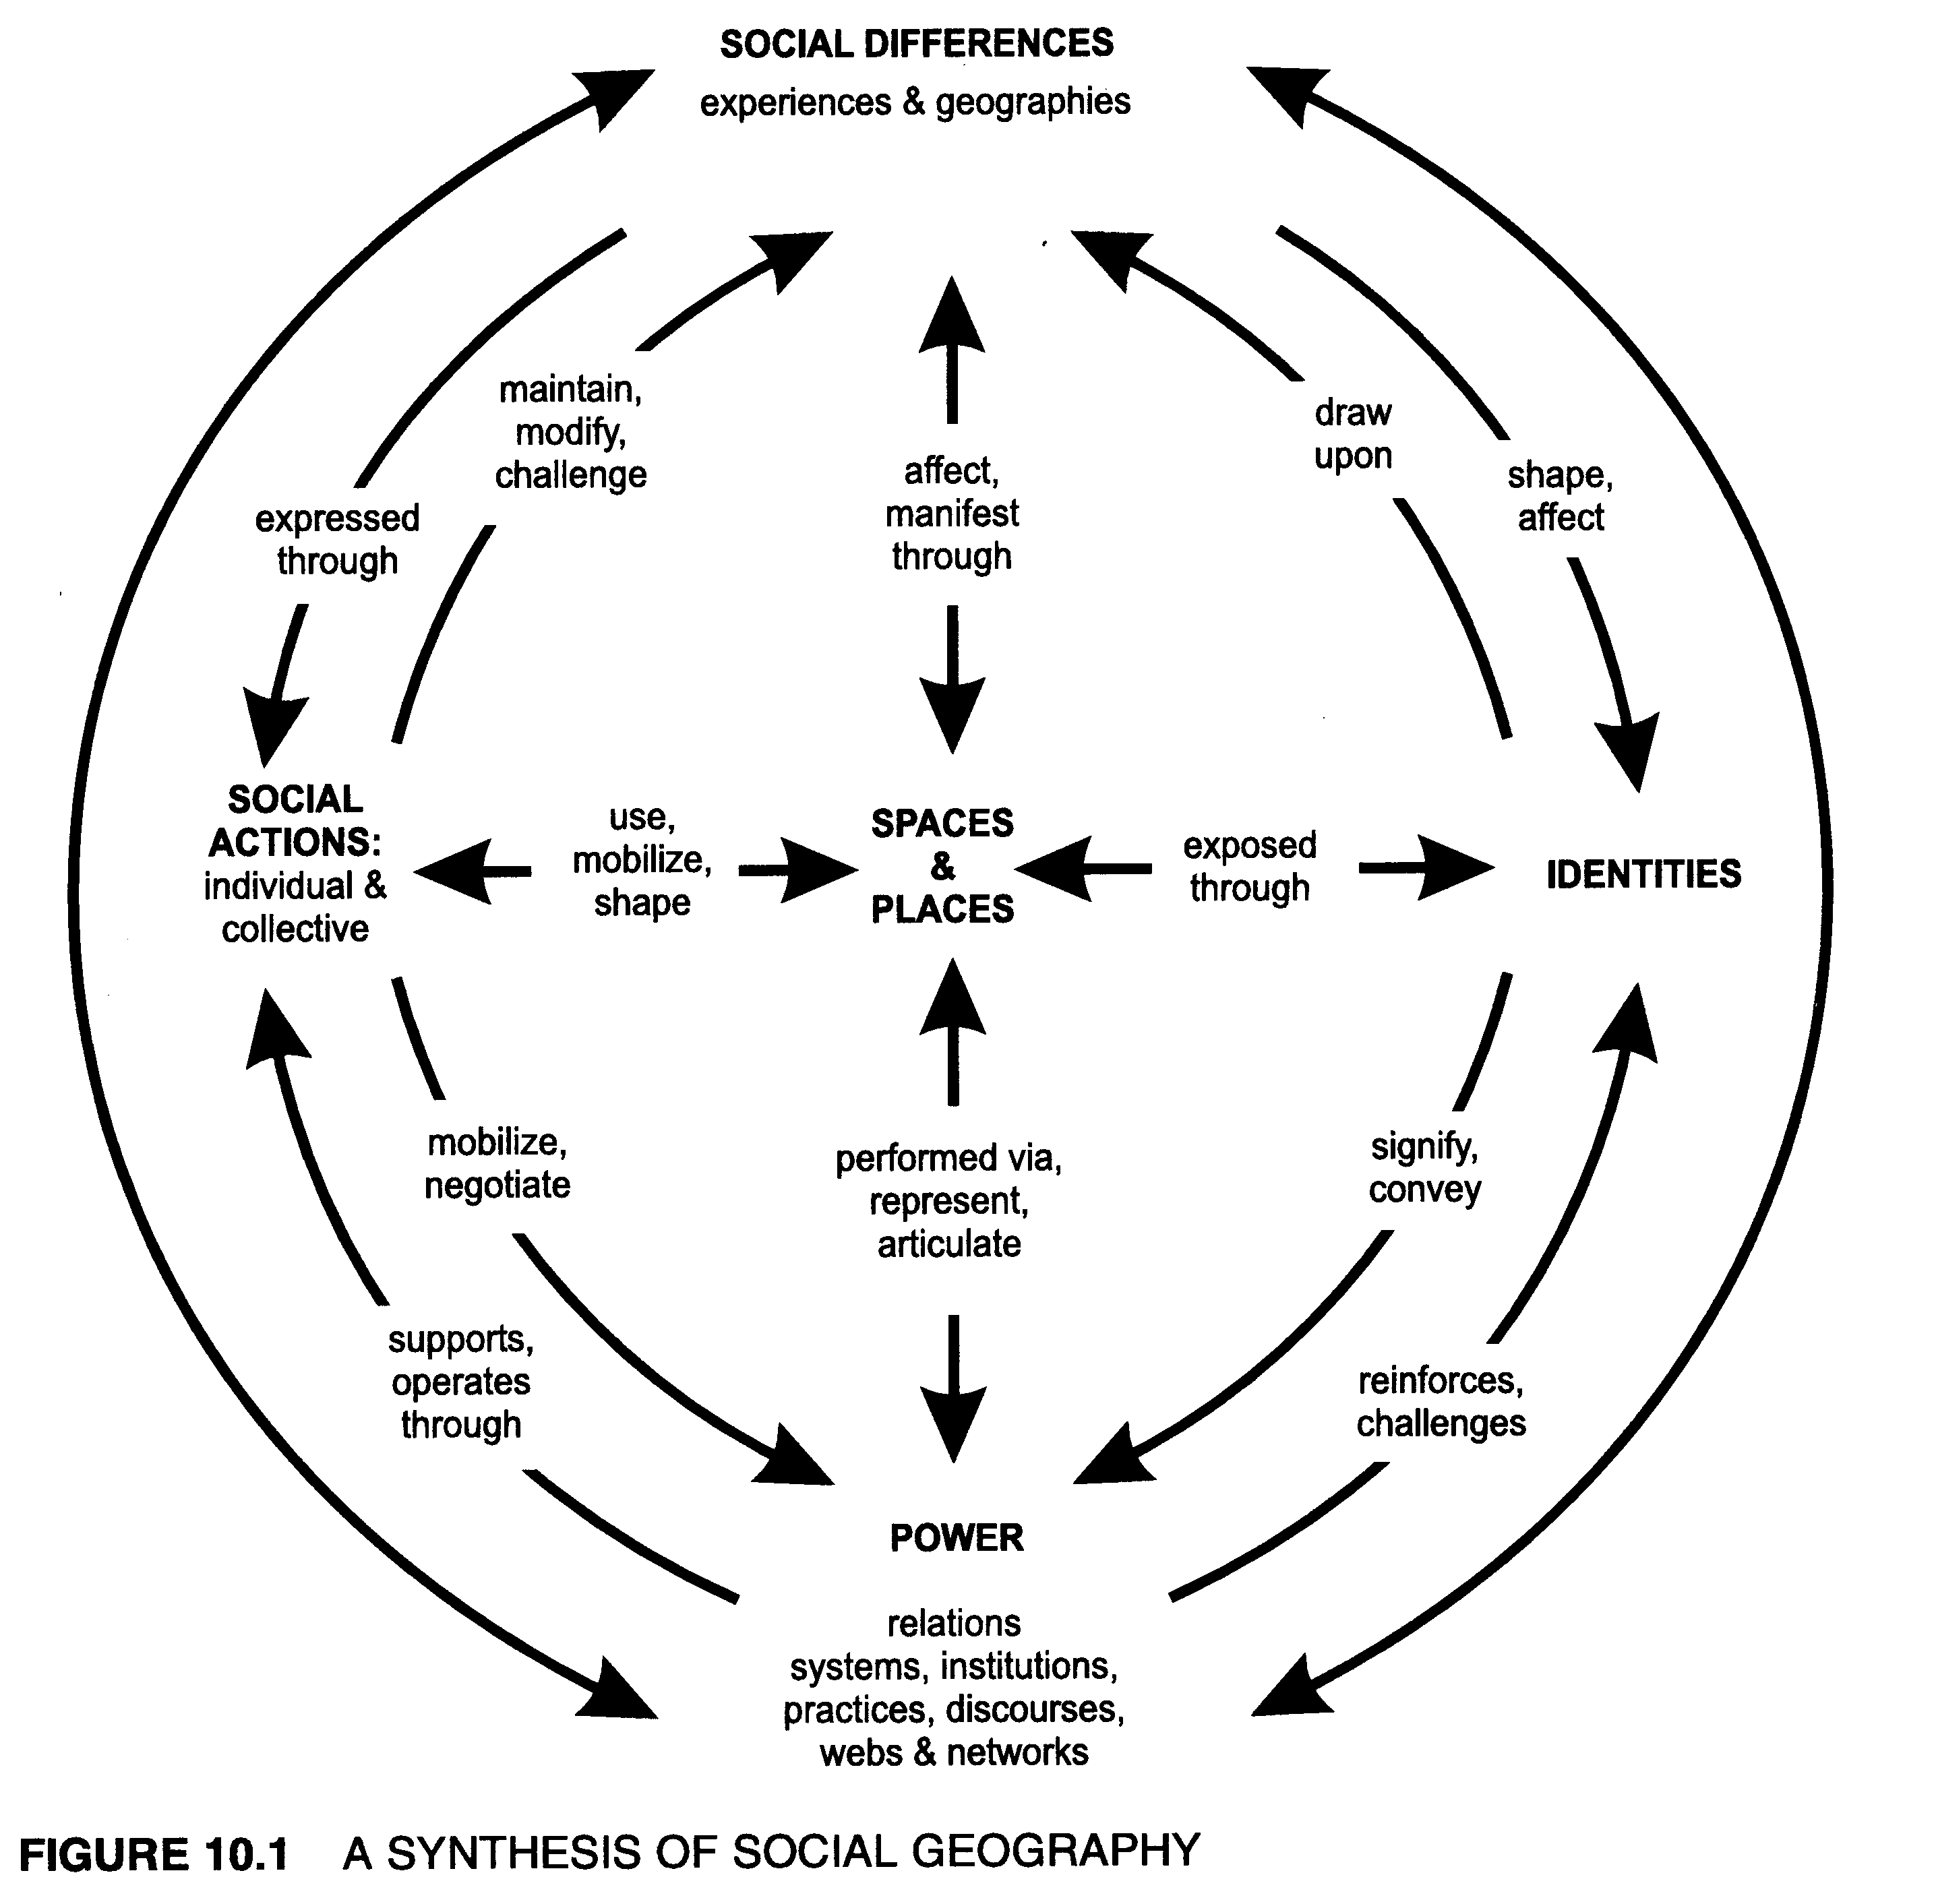

First, moving to the top of the figure, we can appreciate that social differences are experienced unevenly through space. These differences constantly reproduce places, reinforcing certain categories of difference as normal while others are marginalized or controlled (e.g. women participating in mainstream farming organizations, or gay and lesbian affection in public streets or restaurants).
Second, directly across from social difference, at the bottom of Figure 10. 1, power is portrayed as equally linked to each element. These links occur as power relations are implicated in the uneven experiences of social differences; power is represented and articulated through spaces and places; and, as will be shown below, power is directly involved in the performance of identities and the operation of social actions.

Then, to the right-hand side of Figure 10. 1, we note that social differences shape and affect the formation or practice of identities that are associated with individuals, groups or places. Conversely, when identities are being strategically assembled or even challenged and reconstituted, they draw up specific aspects and understandings of social difference (e.g. as shown in section 7.3.2, national identity formations in Finland or New Zealand drew on selective differences associated with gender, class and ethnicity). These identities convey certain power relations that privilege dominant categories of social difference (e.g. masculinity and whiteness) and they are expressed through varied spaces, ranging from the imagined sphere of a nation to the specific sites of symbolic places, landscapes, even buildings and bodies.
Finally, to the left-hand side of Figure 10.1, social action is depicted, again in a mutual relationship with social difference and power. Social differences may be highlighted through actions that in turn may be established to maintain or even challenge those differences (e.g. the rearticulation of a specific ethnicity through themes of indigenous self-determination in Aboriginal Australian music as shown in section 9.3.2). In addition, practices and webs of power will underpin and operate through social actions. This may occur by negotiating with specific institutions or relations of power (e.g. the dominant commercial music networks in Australia). In producing these social actions, spaces will be invoked and mobilized. In addition, specific places of significance may be promoted or even reconstituted as they form a terrain from which people can act and shape their lives and social worlds.
This synthesis provides one snapshot of contemporary social geography. The connections and interactions depicted here have been explicitly arranged to highlight the dynamic spatiality of social life - in all its material, cultural and political forms. As noted in section 1.2, this book has been written from a composite of explicit interests and this synthesis is no less a product of those interests. The critical, poststructural and non-essentialist approaches that I have used in research to date lie behind this snapshot. The figure thus attempts to portray some of the mutually connecting and overdetermined qualities of social life and the geographies that might be conceptualized.
But multiple linkages and mutual constitutions are not the only motivations for the content of this book, nor for many of the contemporary social geographies being written today. Instead there is also a continuing critical and political component that inspires the subdiscipline. Social geographies can contribute to what Massey argues as the 'spaces of politics': 'a reformulated politics and space revolves around the openness of the future, the interrelatedness of identities, and the nature of our relations with different others'
(1999: 292). While this reformulation is relevant more broadly throughout human
geography, social geography provides fertile ground for such practice. Returning to the
questions at the conclusion of Chapter 1, the material in this book has highlighted how a range of approaches can support the continuing identification of inequalities. The biographies included in Chapter 2 and Part V remind us that in each different era of geography particular theories and practices have dominated the 'way things are done'. The biographies have been particularly explicit in showing how geographers' contexts have influenced the forms of knowing that have prevailed in various academic environments. These frames of theoretical and research practice have shaped what is valued or critiqued in the social world and the research environment. However, Figure 10.1 and Massey's revisioning of 'spaces of politics' suggests that beyond the identification of difference, key questions regarding inequalities, power and the practice of identities and strategic actions will continue to be important in social geography inquiries.
While postmodern, poststructural and cultural interests have provided core energies in the writing of social geography over the last decade, there is also a continuing and reinvigorated commitment to the action, politics and material dimensions of our work. This has taken a number of forms that together provide five directions for future work.

FURTHER DIFFERENCES

The importance of recognizing social difference continues to infuse social geography. At times this is a case of being attentive to the heterogeneity and inequalities that characterize a particular social group that has been the focus of study for some time already. For instance, Geraldine Pratt's engagement with Filipino perspectives have further enriched her work on gender and employment (see Box 1.3). At other times, continued attention to difference is producing new bodies of work on other axes of difference beyond the traditional foci of class, gender, ethnicity and sexuality. These fields include geographies of disability, of youth and age, of homelessness, and of travellers, to name but a few. In some cases, a substantial literature now exists, but in each example we re-meet the challenges of reading social-spatial connections and the uneven power relations and possibilities for action that may present themselves in the lives of specific individuals and groups (see some examples in the work of Cloke et al., 2000; Davis, 1997; Gleeson, 1999; Holloway and Valentine, 2000; MacLaughlin, 1998; Mattingly, 2001; Panelli, 2002b).

THE MATERIAL AND THE EVERYDAY SPACES OF LIFE

The contexts, and even mundane settings, in which we conduct our lives at home and work, have continued to be of interest to social geographers. These places are recognized as important, for the negotiation of social differences such as class, sexuality or age are not simply conceptual social debates or cultural struggles; they are embedded in specific sites and material experiences (Jackson, 2000). Social geographies will continue to be written about how people live with (and sometimes across) difference in ways they use - and sometimes reshape - the everyday spaces of their lives. These will include the layered material and socio-cultural spaces of sites
215
known as 'home' and 'work', but they will also increasingly incorporate deepening analyses of other spaces: margins, thirdspaces and cyberspaces where new or reworked understandings of space can be further developed (Gough, 2001; Kitchin, 1998; Mowl et al., 2000; Panelli et al., 2002; Soja, 1999; Valentine and Holloway, 2002).

THE PERFORMED

Drawing on a range of recent theory, social geographies will increasingly document the practice of social life. In some cases this may be conceptualized in specialist theoretical terms through such notions of performativity or non-representational theory. However, whatever the perspective employed, some geographers will modify the popularity of cultural theories and highlight that our subject and the societies and individual lives we study are 'enacted' and can be thought of as a 'flow of events' - not just a cultural construction or representation (Barnes, 2002; Harrison, 2000; Longhurst, 2000a; Rose and Thrift, 2000).

THE POLITICAL AND ETHICAL

The political dimension of radical geographies continues to be relevant for social geography and is increasingly combined with reflections on the practice, methods and ethics of our research. While a fascination with postmodern and cultural approaches to geography can be questioned, social geographies can continue to highlight difficulties surrounding social relevance and inequality (Hamnett, 2003; Martin, 2001). For example, social geographies can combine opportunities for action, activism or policy development on the part of the scholars involved (Blomley, 1994; Pain, forthcoming). In a different form, Paul Cloke's (2002) recent writing includes a questioning of the ethical and political values and choices geographers can make in their work. Further questions on morality, ethics and the purpose of social geographies is likely to increase (Aitken, 2001; Gleeson and Kearns, 2001; Martin, 2001; Proctor and Smith, 1999; Roberts, 2000; Smith, D.M., 1999).

NEWER TERRITORIES - EMOTIONS AND SPIRITUALITY

Finally, as a result of the ongoing interest in the performance, politics and ethics of writing social geographies about difference and inequality, some authors are beginning to look at new dimensions of society and the geographies that have been absent to date in much of the subdiscipline. For instance, building on from earlier humanist and feminist geographies, some authors are arguing that emotions (a key set of social relations) should be more explicitly included in social geographies as both a subject and a theme for researchers' reflexive thought (Anderson and Smith, 2001; Widdowfield, 2000). In a similar way, other geographers are considering the role of values, religion and spirituality in either their research and/or the practice of their geography (Cloke, 2002; Holloway and Valins, 2002; MacDonald, 2002). These new directions may provide further tools and perspectives for
a continuing openness to the critique of societies and the power relations and actions that shape them in different settings.

SUMMARY

- Social geographies recognize social differences that are unevenly experienced across society and space.
- Geographers use a variety of contrasting approaches to study these socio-spatial phenomena.
- Different places (from individual bodies and hones, through to workspaces, urban neighbourhoods and rural communities) form settings in which multiple social differences occur at any given time within a society.
- Social differences are interconnected with each other (e.g. sexuality transected by gender, ethnicity and class and so forth) but in different. spatial manifestations.
- The meanings and uneven experiences associated with social differences result in people negotiating difference through identity choices, power relations and social actions.

Suggested reading

As social geography continues to develop as a topical and multifaceted subdiscipline of human geography, progress and trends can be traced through a variety of further readings. One step can involve following up many of the authors listed in the last section of this chapter, where the five current trajectories were identified.
A second step can be taken through a continuing reading of the core social differences that form cleavages in both society and space. This is often most usefully achieved by browsing recent issues of selected journals. Scholars writing on difference and action publish in a wide range of arenas so it is always useful to consult the contents pages and internet homepages of: Annals of the Association of American Geographers, Area, Journal of Social and Cultural Geography, Progress in Human Geography, and Transactions of the Institute of British Geographers. Also, for class, see Antipode, and Environment and Planning A; for gender, see Gender, Place and Culture, and for ethnicity and sexuality, see Environment and Planning D: Society and Space.
Finally, to consider the range of recent research and debate that informs social geography it is always informative to read the articles and progress reports that are regularly published in Progress in Human Geography, including those explicitly on social geography (e.g. Pain, forthcoming), as well as associated relevant topics such as ethics, ethnicity and race, gender and geography, qualitative methods, quantitative methods, rural geography, sexuality, urban geography and so forth.
217

