Panelli R. (2004): Social Geographies. From Difference to Action. SAGE, London, 287 pp.

8.1 INTRODUCTIONS: UNDERSTANDING SOCIAL DIFFERENCE THROUGH QUESTIONS OF POWER

While the past five chapters have each had a different focus, all of them have shown how social geography engages with issues of social difference. The way societies unevenly structure life based on those differences - be it access to housing, experiences of public space, negotiations of racism or whatever - always involves aspects of power. This chapter considers the notion of power as a way to understand the unevenness that occurs between classes, genders, ethnicities and sexualities, and as a means to explain and potentially challenge the way powerful knowledges are constructed and unequal power relations are maintained.
Far from being the exclusive property of the subdiscipline of 'political geography' (Painter 1995), power is one of the broadest and most crucial concepts human geographers of all persuasions must encounter as we build understandings of how and why human interaction and socio-spatial relations occur as they do. Massey (1999: 291, original emphasis) summarizes this in saying: 'always what is at issue is spatialized social power: it is the power relations in the construction of the spatiality ... that must be addressed'. Considerations of power in social geography have developed in at least two ways. First, it has been a central concept within individual geographies of difference, when constructions and implications of class or gender or ethnicity or sexuality have been investigated. For example, in Chapter 4 we saw how Whatmore's (1991) discussion of women's unequal experiences in a 'domestic political economy' of the farm were an expression of economic and gendered power relations, while in Chapter 5 we noted Berg and Kearn's (1996) account of the discursive power of 'naming and norming' the racialized and Europeanized landscape of 'New Zealand' via place names. Second, social geographies of power have provided rich analyses of how social formations and problems stretch across, and weave together, diverse categories of social difference. Just as we saw in considering identity (Chapter 7), social geographies of power are synthesizing projects
159
that often tackle the messy, mixed-up and mutually constitutive qualities of social differences through various formations (e.g. group identities, 'communities', 'places'), social relations and struggles (e.g. contests over material conditions, social participation and key sites). Considering how power is understood and experienced enables us to see that these dimensions overlap and influence each other.
This chapter outlines some of the ways social geographies of power have addressed social differences as they are defined and contested in different situations. This work commenced in Chapter 7 as we saw the politics involved in strategic identity formations. It will also continue in Chapter 9 as specific types of social action and different spatial struggles are considered - each implicating expressions and relations of power. For now, however, this chapter takes time to consider theoretical approaches to power (outlined in section 8.2) and then (in section 8.3) it shows how different social geographies document the complexities of what Sharpe et al. (2000) call geographies of 'domination, resistance and entanglements'. To complement this chapter, Part V presents a biography of Michael Woods, a social and political geographer who has worked with various approaches to power. This highlights the different ways he has undertaken power, ranging from geographies of formal politics to that of informal movements. While some of his work is discussed in detail in section 8.3.1, this broader biography provides an illustration of a social geographer who works across
number of concepts and theories, addressing questions of power within
variety of socially relevant situations.

8.2 APPROACHING POWER: CONTRASTING THEORIES
Power can be understood as an ability to achieve goals, results or specific ends. However, the concept has been theorized and debated at great length both within and beyond geography. In the past, social geographers' interests have often drawn on theories that conceptualize power as a capacity or resource that can be possessed or shared or even lost. In part this has been a result of the way different groups (e.g. classes) have felt the effects of power throughout their everyday life (e.g. when capitalist classes have controlled conditions of work, income and housing for labouring classes). Consequently, social geographers have concentrated on how power relations shape people's experiences of social difference (e.g. how some classes have the ability to control the living and working conditions of others, or how some ethnicities can feel powerless in relation to others).
Two contrasting classifications of power are shown in Table 8.1. While each perspective involves many contrasting philosophical and political theories, for the purposes of this book, an overview of the two classifications is sufficient for us to understand the different perspectives geographers have considered (and therefore produced accounts from research in contrasting ways).

TABLE 8.1 NOTIONS OF POWER: GEOGRAPHERS' CLASSIFICATIONS
Allen (1997) Sharp et al. (2000)
Power as an inscribed capacity Power as a resource  Power as technology: strategies, practices and techniques | Power through domination Power through resistance Power as entanglements

8.2.1 Capacity, medium and technology

Allen (1997) identifies power in terms of capacity, medium and technology/ techniques. Power as capacity concentrates on dimensions of influence or the ability to control or decide on how things are organized. In this way power is 'an inscribed capacity' or property that individuals, groups or institutions can possess. Power is seen as a capacity owned or controlled by an individual (e.g. king) or institution (e.g. government) that can commonly be described as powerful, while other individuals or groups are simultaneously considered to lack power or be powerless. Concentrating on social and economic dimensions of power, theorists of class (Weber and Marx - Chapter 3) both invoke forms of this thinking. They concentrate on the capacity of individuals or institutions (in the case of Weber), or on the inscribed potential for capitalist relations to control and reproduce uneven and unequal conditions (in the case of Marx). In sum, this view of power concentrates on capacity as acquired through uneven social and economic relations.
In contrast, Allen's description of the second perspective on power as a medium) is one that focuses on the resources or means by which ends can be achieved. Allen (1997: 62) notes that this view 'stresses the "power to" rather than the "power over"'. In this sense, power is related to resources that can be mobilized, a view that is developed in both structuration theory (Giddens, 1984) and resource mobilization theory (McAdam et al., 1996; McCarthy and Zald, 1973, 1977; Oberschall, 1973). Other theories that consider the means by which power is enabling include theories of networks (e.g. Mann, 1986). These latter approaches have been particularly popular with certain economic geographers, concentrating on the dynamics of industrial and globalizing economies (Amin and Thrift, 1992; Dicken and Thrift, 1992).
Power as a technology, or as a series of techniques and practices, forms the third conception Allen identifies. This view rests on the work of Foucault. In this case, power is conceived more as a flow than a capacity or resource. Consideration is given to the way power is exercised and practised. Rather than seeing power as a property or a means to achieve something, this view of power suggests something more elusive but also more widespread - a phenomenon that 'works on subjects, not over them'
161
PART III ACROSS AND BEYOND SOCIAL DIFFERENCE

(Allen, 1997: 63). This view concentrates on the impact of power or the relations of power between individuals, groups and organizations. It is not so much a possession (capacity or property) as an effect that circulates through a vast range of cultural practices, systems of meanings and technologies. As a form of poststructural thinking (see Chapter 2), this notion of power is one that focuses on the diverse, interconnected or fragmented; the dynamic or shifting; and the discursive.

8.2.2 Domination, resistance and entanglements

Turning to the second classification of theories of power, produced by Sharp et al. (2000), a number of differences and similarities are apparent. In this case, another three main approaches have been identified, based on how geographers have sought to understand and analyse power in different social settings. These approaches to power reflect the wider theoretical trends in social sciences, as tracked through Chapter 2. First, 'orthodox' theories of power focus on domination, and Sharp et al. (2000) identify these as including liberal and pluralist conceptions of power, through to Marxist and other radical accounts of struggle based on core power relations, for example of class or gender. In contrast, a second, more recent, set of theories focuses on resistance and gives attention to identity politics and resistance movements, seeking to counter some of the hegemonic tendencies of previous approaches. These latter works often take a 'bottom-up' approach to power, seeing agency in community activism, informal social movements and the capacity for individuals or groups continually to construct moments and spaces for resistance and contestation. I discuss both of these approaches in more detail below.
Sharpe et al. (2000) argue that these first two sets of approaches maintain a binary of domination/resistance. Their third classification therefore highlights postmodern and poststructural approaches that have more explicitly recognized the interconnected forms of domination/resistance. Since the groundbreaking work of Foucault, power is conceived more broadly as a series of entangled weavings where relations and tactics for technologies in Allen's typology) are constantly dynamic and intersecting. These tactics include relations and strategies of domination, resistance and other less dualistic constructions and performances of power (Foucault, 1990; Sharp et al., 2000). This section outlines these three approaches in a brief fashion. However, further readings for detailed study are strongly encouraged and some suggestions are given at the end of this chapter.
Power as domination involves conceptualizing power in terms of control and coercion, where an institution or individual has the capacity to exert force over other people and a variety of spaces. Paddison explains:

a widely held view is that a power relationship exists where A is able to get B to do something that the latter would not otherwise do. ... How A is able to bring about this change depends upon the strategies it adopts ... power is a broad concept and ... it has become virtually interchangeable with such concepts as force, coercion, persuasion, etc. (Paddison,
1983: 3)

Parallel, to Allen's 'capacity' perspective, this view of power can focus on the power of the institutions to 'control' certain spaces (at least temporarily) and coerce people into following particular rules about movement and access to spaces. In Marxist theory, this view of power (as a particular form of material and social domination) enabled geographies to be written explaining how unequal capitalist power relations maintained capitalist classes in a dominant position over working classes - via both direct economic relations and also cultural and political relations mediated through the state. Capitalist power over labourers was understood in terms of capitalists' economic control of wages, profits and prices, as well as the state and wider social processes that promote economic 'growth' and 'progress' and liberal individualist effort and success over collective conditions.
Radical geographies based on Marxism and feminism were also important for developing an increasing interest in alternative resistance-based approaches to power, with special attention being given to 'bottom-up' activism that could produce resistance movements. Notions of resistance provided an alternative way to theorize power. Power was recognized not just in institutions and practices of domination (via the apparatus of the state or the control of territory, etc.), but also in the informal, dynamic 'grass-roots' actions of people who adopt a range of subtle-through-toviolent actions in order to counter established power structures and relations. Together with academics working on questions of nationalism and ethnicity, Marxists and feminists participated in wide-ranging studies of activism and social movements that aimed to resist certain conditions and support the emergence of alternative politics and social conditions.
Sharp et al. (2000) explain how both 'resource mobilization' theories and 'identity-oriented' approaches have also sought to explain how resistance occurred through collective action and special social movements. Identity-oriented approaches intersect with social and cultural geographies' broader interests in identity and consequently geographies of identity politics and social movements have flourished in the 1990s (see books such as Keith and Pile, 1993; Pile and Keith, 1997; Routledge, 1993).
Moving on from these two schools of thought, and drawing on much of the critical reflection within geographies of resistance, an important advance in theorizing about power centres on geographers' consideration of the problems of a dominance/resistance binary. First, resistance has been shown not to form in unique spaces 'outside' power (Keith, 1997; Moore, 1997), but rather as a socio-spatial process that is multiply entwined and visible within webs and sites of power (see detailed discussion of Foucault below). As a product of wider postmodern and poststructural theory, geographers have recently become increasingly attentive to
163

PART III ACROSS AND BEYOND SOCIAL DIFFERENCE

the fact that domination and resistance are not discrete and separate. For instance, Routledge (1997a) has shown how Nepali 'resistance' illustrated a range of powerful - sometimes dominating - practices. Such writings have moved away from homogenizing impulses that construct systems of domination as absolute or movements of resistance as heroic and virtuous. Instead they have begun to highlight how practices and power relations within the associated political entities are often far more complex and blurred. Massey (2000) points out there is nothing necessarily morally better about resistance movements per se. Indeed, she cautions against 'romancing the margins' without paying attention to the politics of different resistance movements. The multiple nature of power has thus been recognized whereby systems of domination will include moments and practices of resistance, just as resistance movements will sometimes struggle with - or founder on - relations of dominance and force (Massey, 2000; Sharp et al., 2000).
These recent, more 'messy' and multiple approaches to power have drawn heavily on the work of Michel Foucault. Foucault has conceived power not as an object/resource to be held by some and not others in a hierarchical system of society, but as a circulation or a web or net:

Power must be analysed as something which circulates, or rather something which only functions in the form of a chain. It is never ... in anybody's hands, never appropriated as a commodity or piece of wealth. Power is employed and exercised through a net-like organization. And not only do individuals circulate between its threads; they are always in the position of simultaneously undergoing and exercising this power. (Foucault, 1980: 98)

The metaphoric definition of power as a web also allowed Foucault to argue that analysis of power should concentrate on localized and specific features and relations: '[Analysis] should be concerned with power at its extremities, in its ultimate destinations, with those points where it becomes capillary, that is, in its more regional and local forms and institutions' (Foucault, 1980: 96).
This type of thinking has attracted enormous interest from geographers who could see subsequent analytical implications whereby geographies of power could 'map' the webs and entanglements of power, and the relations and processes by which power can be seen circulating throughout a given society, neighbourhood, industry or group. Furthermore, in considering Foucault's interest in micro-technologies and extremities, and the specifici
ties of different historical eras and places, geographers refocused their analyses on the particularities of different localities, sites and micro-geographies being performed, for instance, through media texts, buildings and bodies.
Importantly for our discussions of domination/resistance, this view of power brought Foucault to argue later that resistance was not somehow external, or other, to power. Indeed, he stated:
164

Where there is power, there is resistance ... resistance is never in a position of exteriority in relation to power ... points of resistance are present everywhere in the power network. ... Just as the network of power relations ends by forming a dense web that passes through apparatuses and institutions, without being exactly localized in them, so too the swarm of points of resistance traverses social stratifications and individual unities. (Foucault, 1990: 95-6)

A further aspect of Foucault's theories of power that has been adopted widely in social and cultural geographies involves his ideas about power, discourse, knowledge and truth. Foucault theorizes that power is exercised through the production of knowledge and truth that occurs through the expression of discourse. Approaching knowledge and truth as multiple sometimes conflicting) sets of ideas that are discursively constructed enables geographers interested in power relations to examine how power is practised through discourse (see Box 8.1) and the positioning of people in different subject positions. If truth is partial and discursively created in power-filled ways, then notions of gender, sexuality, race and so forth can be approached not as fact but as historically and geographically contingent social constructions. This set of ideas has allowed geographers to read the competing discourses that socially and spatially construct meanings about different groups of people in particular places. Such a strategy can be implemented to look at examples such as the particular constructions of women or youth or disabled people as developed through government discourses: policy texts and bureaucratic practices. Equally, discursive analyses can and have been made of how community groups and social movements have actively constructed (or appropriated and reconstructed) discourses that serve their own ends and subvert other more established knowledges, and to 'undermine and expose' power (Foucault, 1990: 101). Examples of these works are provided in the next section.

8.3 GEOGRAPHIES OF POWER
Social geographies of power have drawn on each of the theoretical dimensions outlined in the previous section. The sense of power as a capacity has often been attached to Marxist accounts of the social relations occurring in capitalist societies. For instance, the early work of Fincher (1981, 1991) illustrates a Marxist geography of the state that concentrated on how state relations could maintain/reproduce capitalist class relations. Fincher argued that state relations and capacities were historically and spatially contingent. She therefore explained varying but nevertheless controlling capacities of the state to maintain capitalist social relations of production by the provision and control of housing and social service programmes. In a similar vein, feminist social geographies also initially focused on power relations whereby systems of patriarchy and capitalism were seen to
165
create material and social relations by which men's interests and patterns of life dominated in unequal ways over women (Foord and Gregson, 1986). Both Marxist and feminist perspectives on power created a foundation for later research, focusing on resistance. This developed through the 1980s and 1990s and included the investigations of struggle around labour, gender, ethnic nationalism and state-based resistance (Bookman and Morgen, 1988; Clark, 1989; Clark and Dear, 1984; Smith, G., 1985). It extended into
166
a flourishing set of international literatures in the 1990s (see, for instance, Pile and Keith, 1997; Radcliffe, 1999; Radcliffe and Westwood, 1993; Routledge, 1996, 1997a).
Most common contemporary works, however, draw on the 'entangled' poststructural views of power. The following discussion illustrates this through three different types of work. In each case, the entangled practice and technologies of power are tackled, while showing both the discursive and (social) relational qualities of power-filled situations ranging from formal political arenas through to social protests. In the first two examples, formal institutional examples of power are considered (local government and industry control of workers). Geographies of power are read via the discourses that communicate and circulate different meanings and practices through local government (section 8.3. 1) and industrial working conditions (section 8.3.2). But institutional examples are not the only focus for social geographies of power. Instead, accounts of power involved in informal attempts at social change are also possible. This is not a simple analysis of resistance, however, since poststructural approaches see societies as multiply and discursively constituted. Keith (1997: 278) argues that Through processes of subject making, institutions, individuals, nation-states and societies alike are revealed as plural rather than singular, the composite products of many subjectivities'. While this view might be thought to have a constraining impact on radical politics and research that is interested in social change, contemporary geographies of power have generally moved from binary analyses of domination/resistance to focus on these multiple and composite conditions. For, if groups and organizations are diversely constructed, then spaces open up for action where one set of discourses and subjectivities can be read against (and challenge) other more established ones. Section 8.3.3 provides an example of this type of work.
166-167
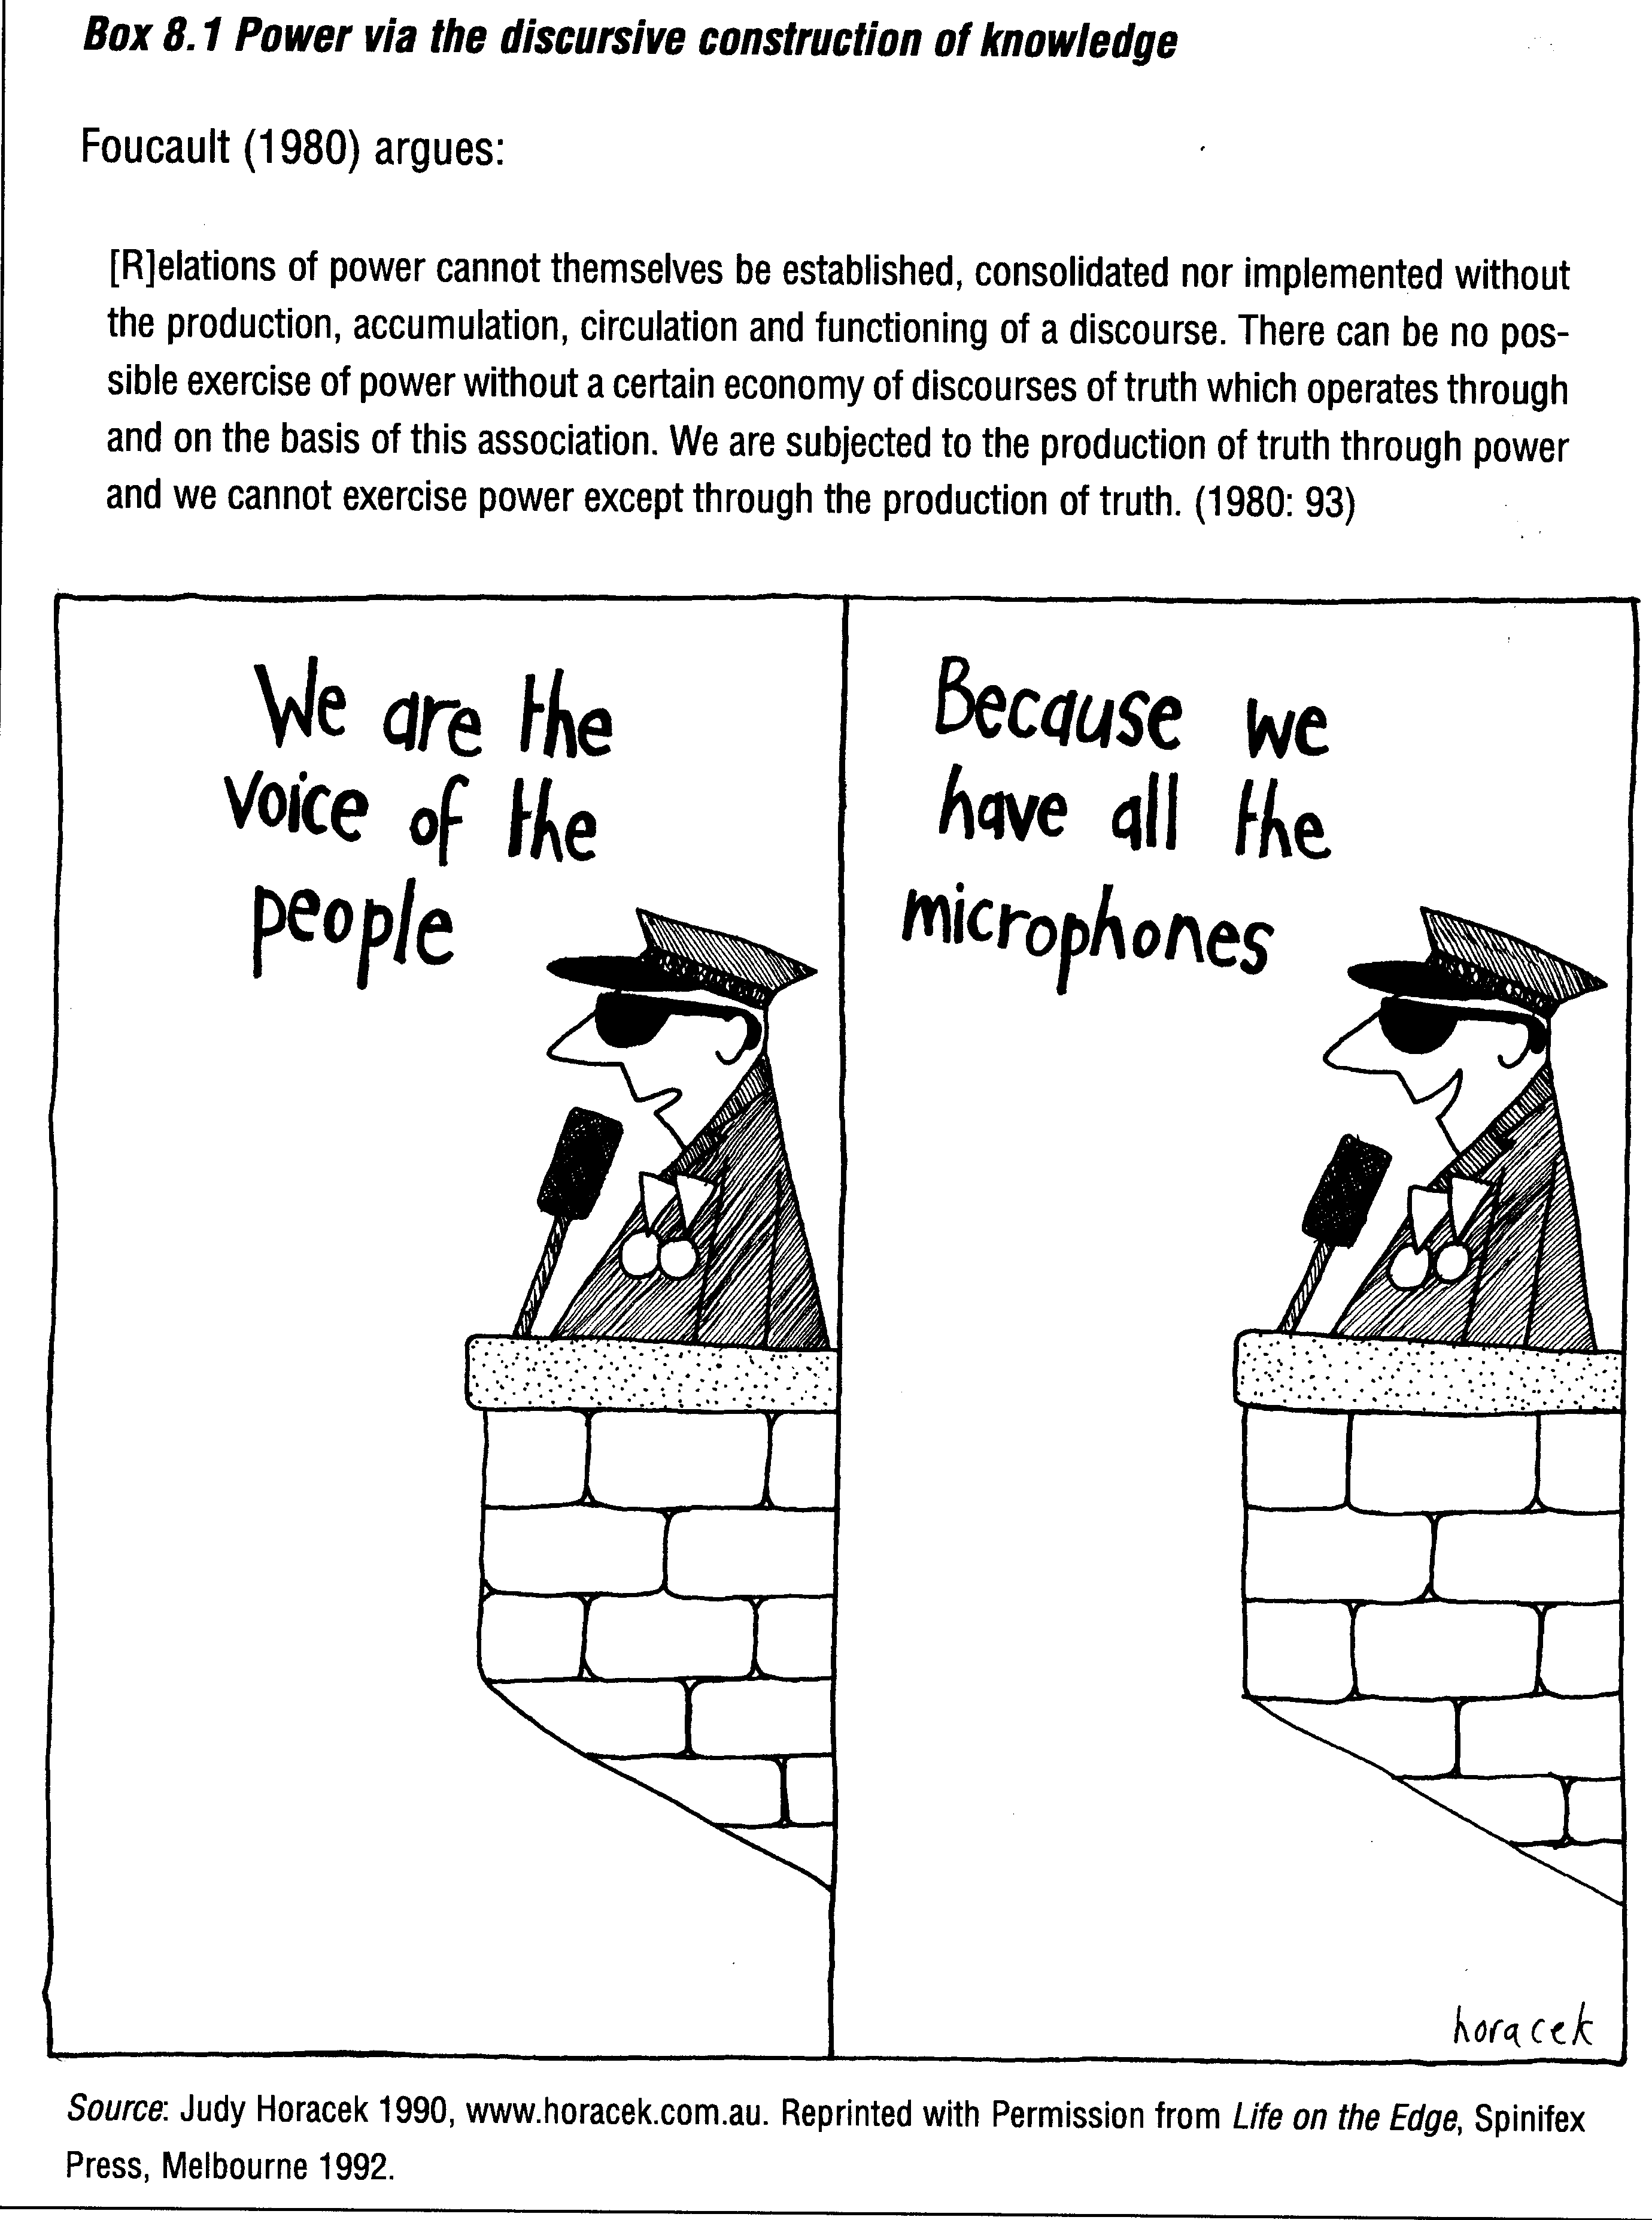

8.4 CONCLUSIONS

This chapter has shown how notions of power are integral to writing social geographies that can address the way social differences are constructed and negotiated. Different concepts of power have influenced the way social geographies have been written. Section 8.2 showed that structural accounts of power - whether conservative or Marxists - have focused on power as a form of domination or force that frequently resides in particular institutions and the relations these institutions have with groups of people. Where political geography has often concentrated on the nation state and 'its' territory and citizens, social geography (particularly Marxist and feminist geography) has focused on how institutions like the 'state' and the 'family' have enabled the reproduction of capitalist and patriarchal social relations (e.g. Fincher 1981, 1991). These foci on power through dominating relations have supported critical geographies that have analysed social formations stretching across (and linking) difference such as class and gender.
More recently, interests in identity and the politics of resistance, have encouraged some social geographers to analyse how power is practised through social groups and enactments of protest that challenge established meanings and structures. These works focus on power as resistance and include studies of how activists join across some differences (e.g. of class and ethnicity) to construct strategic identities that highlight their politics. These types of work have been important and inspiring for demonstrating that groups who are often positioned in socially marginal ways (e.g. women and homosexuals) should not be seen as 'powerless'. Indeed, margins can become powerful spaces from which to establish counter positions and politics (hooks, 1992; but also see commentary and critique by Monk and Liepins, 2000; Pratt, 1999b; Smith, 1999).
In the last decade, however, geographies which recognize the complex, entangled politics of domination/resistance and centres/margins have highlighted the importance of studying the construction of positions and boundaries, and the multiple power relations which are present simultaneously in instances of domination and resistance (Massey, 2000; Sharp et al., 2000; Smith, 1999). In section 8.3 three examples illustrate how power is engaged and negotiated in different settings, but in ways that highlight the mix of dominant and resistant relations and the entangled and discursive qualities of power. Woods and Crush illustrated how local government and commercial structures can be established as powerful, but in changing and discursive ways that always include the opportunity for challenge, and sometimes subversion. In a different fashion, research into farm women's geographies illustrates how activists develop powerful positions by both engaging with dominant relations and also nurturing resistant impulses. These groups and organizations could not be seen as 'outside' terrains and spaces of agricultural power, but rather demonstrated the potential (and sometime contradictory conflicts) of multiple positions both within and beyond mainstream agricultural arenas.
177
Geographies of power have come to be depicted as 'entangled' where forces, practices, processes and relations of power illustrate the mutually entangled powers of resistance and domination in 'countless material spaces, places and networks' (Sharp et al., 2000). This more complex view of power also encourages geographies where the spaces and subjectivities of such politics becomes more visible (Keith, 1997: 282) or 'more grounded inquiries into the practices of domination/resistance whereby specific spaces, places or "sites" are created, claimed, defended and used (strategically or tactically)' (Sharp et al., 2000: 28). These types of spatially sensitive commentary can be found in geographies of social action, for it is here that the combinations of complex social differences and the practical choices about political meanings and strategies are displayed in particular activities and places. Thus Chapter 9 provides a link between geographies of power and the material and symbolic implications that follow when people engage with specific social differences and power relations. In these instances, power is rendered temporarily visible and sited within given places and groups that are purposefully constructed.

SUMMARY

- Power is a key notion in many subdisciplines of human geography.
- In social geography, power is central to the process of understanding and the various social and spatial relations involved
- Considering power also enables social geographers to see the way different forms of social difference intersect in specific groups or places
- Different geographers have classified the many theories of power, but a useful distinction is made between three sets of thinking:
  - power, conceptualized as a capacity or possession that can be attributed to individuals, positions or regimes, and which encourages an analysis of domination, control and coercion;
  - power, conceptualized as a resource or (potentially) a possibility for resistance where different individuals and groups can mobilize power to achieve their goals and perhaps alter social conditions - both ressource mobilization theory and identity politics are used to explain these activities; or
  - power, conceptualized in terms of the technologies, strategies and practices through which power is exercised as a process or a series of entanglements and performances.
