PROPERTIES OF MATERIALS

- Discuss these questions:

a) What is your favourite material for clothing? What are advantages and disadvantages of natural or synthetic materials?
b) Do you know some modern hi-tech materials? Which ones? Where are they used? What are their advantages over traditional materials?
c) Give examples of things which were originally made of natural materials and now are made of plastics. Discuss advantages/disadvantages.

- Give the adjectives describing properties and then provide at least 2 more examples of materials or things with this property. Form nouns from the adjectives:

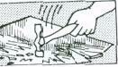 | A b…………. material or thing breaks easily;  eg. (for example, for instance, such as, like) glass, egg,. .  noun: | 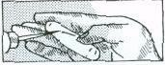 | A s……… material is easy to scratch  e.g. chalk  noun:
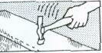 | A t………. material / thing does not break easily;  eg steel,. . .  noun: | 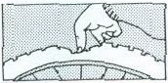 | A f…………. material bends easily: eg. rubber, ..  noun:
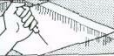 | A h……… material is difficult to scratch. eg glass, .. .  noun: | 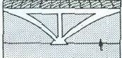 | A r………… material does not bend easily; eg concrete,...  noun:

3. Now ask and answer these questions in pairs:
a) Example: Why does a glass break if you drop it? Because it is brittle.
b) Why doesn't a plastic glass break?
c) Why is butter easy to cut?
d) Why can a diamond cut glass?
e) Why don't the walls of a house bend in the wind?

- Now complete these:

 | Some materials have a s……….. surface;  they produce little friction when they are rubbed; eg ice,...  noun: | 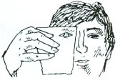 | You can see through t………… materials; eg water,. …  noun:
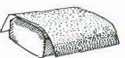 | Some materials have a r………….. surface and produce a lot of friction;  eg sandpaper, . ..  noun: | 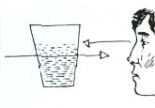 | You cannot see through t……………. materials but the light passes through them;  eg dirty water, . . .  noun:
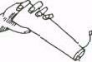 | S………. materials dissolve easily; eg salt,…  noun: | 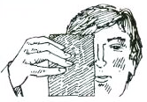 | You cannot see through o……… materials and the light cannot pass through them; eg metal,. . .  noun:
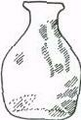 | Materials which are i…………. do not dissolve; eg glass,...  noun: | 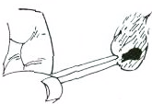 | C………… materials burn easily eg wood,...  noun:

- Complete the sentences below with appropriate words from exercises 4 and 6

a. The carbonates and phosphates of all metals are _______________ in water but _______________ in dilute acids.
b. The pale pink colour of quartz, which can range from ______________ to translucent, is known as rose quartz.
c. Some colloids are ______________ because of the Tyndal effect, which is the scattering of light by particles in the colloids.
d. System Soft Shot is a booster for dry and ____________ hair.
e. _______________ materials are liable to catch fire very easily and burn.
f. _______________ is an important property of steel.
g. This PVC tubing offers excellent wear resistance and rubber-like _________________.
h. A _____________ substance or object is stiff & does not bend, stretch or twist easily.

6. Listen and complete the gaps in the summarising sentences:

- Over the past hundred years we have discovered how the arrangement of atoms in materials influences how those materials _________ .
- The combination of new knowledge, tools and techniques is enabling scientists to create _________ that were unimaginable a few years ago.
- Our knowledge is still quite __________ in some areas.
- Scientists are creating materials that are lighter, stronger and _________ than before; materials that generate, bend and _________ light in unusual ways; materials that _________ sunlight to electricity.
- Scientists are creating materials that enable faster, more __________ computers.
- Soon we will see more and more ____________ materials being developed – like materials that __________ to their surroundings and change their behaviour accordingly and _________ materials that combine different advanced materials into super-advanced materials, even materials that _________ the boundaries between living systems and everything else.
- Now we are only limited by the laws of physics and our ____________ .

- Some other properties of materials. Form adjectives from these nouns.

Czech translation | Noun | Adjective
- pružnost | elasticity | elastic
- křehkost | fragility
- kujnost | malleability
- tažnost | ductility
- vodivost | conductivity
- žáruvzdornost | heat-resistance
- zápalnost | flammability
- jedovatost, toxicita | toxicity
- reaktivita | reactivity
- netečnost | inertness
- lehkost | lightness
- těžkost | heaviness
- savost, absorpčnost | absorbency
- viskozita, lepkavost | viscosity
- hustota | density
- trvanlivost, odolnost | durability
- odolnost proti korozi | corrosion resistance
- síla | strength

- Choose the right word in a sentence:

a) A c____ material can be used to conduct electricity.
b) If a material is easy to stretch under stress, we call it e_______.
c) If you want to improve d______ of a machine, clean it regularly.
d) H_______ is an important property of steel.
e) Concrete is used for building because it is s_______.

- Speaking:

Work in pairs. One student describes something, using as many adjectives as he or she can. The second one asks questions. You should guess what it is. You can describe the colour, size, shape, origin, appearance, use etc. Then swap roles.

Useful phrases:
The object | is | slightly  relatively  quite  extremely  very | small  soluble in water  hot  silvery  old

The | colour  shape  durability | of | the object | is | blue  circular  high

- Put verbs in brackets in the correct form and tense

Glass 1.(have)_________ many useful properties, but it 2.(be)_________ not a tough material, in fact it 3.(be)__________ very brittle. However, for many years already car producers 4.(use)__________ specially tough glass, with which they 5.(make)_________ car windows. Wood is a good building material but it is combustible. In the past people 6.(build)__________ mainly wooden houses and now we can observe that this kind of lodging 7.(become)__________ more and more popular. People like the cosy atmosphere and the nice smell that such material 8.(produce)___________. Who 9.(know)_____________, maybe in the future, with yet another kind of modern technology we 10.(be able)____________ to live in fir but non-combustible cottages?

Sources:
Adapted from: Jirků, Dana et al. English for Future Engineers. Praha: ČVUT, 2007.
Bates, Martin and Dudley-Evans, Tony: Nucleus of General Science. Longman 1990.
J.Harbord: Topic-based Vocabulary.
https://www.youtube.com/watch?v=nP2bERhM7d4
Activities I-IV and VII by courtesy of A.Rozkošná (adapted)

