Colours on maps

1. Read the introduction and discuss the questions in pairs:

Cartographers utilize colour on a map to represent certain features. Map colours are always consistent on a single map. Many colours used on maps have a relationship to the object or feature on the ground. For example, blue is almost always the colour chosen for fresh water or ocean. Political maps, which show more human created features (especially boundaries), usually use more map colours than physical maps, which represent the landscape often without regard for human modification.

- What does it mean that map colours are consistent on a map?
- Which maps disregard activities of people?
- What colour is typically used for representing the following objects on maps? Put the words in the table below.
orchards reservoirs built-up borders golf courses airports deserts railroads

Blue | lakes, rivers, streams, oceans, ………………., highways, local borders
Red | major highways, roads, urban areas, ………………., special interest sites, military sites, place names, buildings, borders
Yellow | ………………. or urban areas
Green | parks, ………………., reservations, forest, ………………..
Brown | ………………., historical sites, national parks, military reservations or bases, contour (elevation) lines
Black | roads, ………………., highways, bridges, place names, buildings, ……………….

What is colour?
Colour in its simplest form is light being reflected. How we interpret that light is how we see colour. Colours represnted in the rainbow make up the basic colour wheel.
- Can you name some colour categories?
- What ideas / feelings do we associate different colours with?
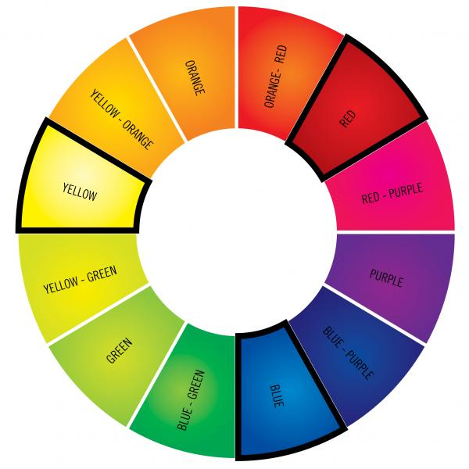

Properties of Colour

Hue: describes the colour (i.e. if it is red, green or yellow etc)
Tone: this is the property of colour that shows a colour is light or dark
Intensity: this is how to describe how bright or dull a colour is

COLOUR QUIZ

Q 1: What is a primary colour?
A Any colour of the rainbow.
B A colour made from mixing two others.
C A colour that can't be made by mixing others together
Q 2: What are the three primary colours?
A Red, green, blue
B Black, red, blue.
C Red, yellow, blue

Q 3: What do you get when you mix two primary colours together?
A A complementary colour
B A secondary colour
C A warm colour

Q 4: What secondary colour do you get when you mix blue and yellow together?
A Turquoise
B Crimson
C Green

Q 5 : What secondary colour do you get when you mix blue and red together?
A Purple
B Black
C Auburn

Q 6 : What do you get when you mix two secondary colours together?
A Black
B A neutral gray or brown
C A primary colour

Q 7 : Complementary colours sit on opposite sides of the colour wheel. If placed next to each other in a painting, what do they do for each other?
A Make each other appear brighter
B Make each other appear duller
C Nothing

Q 8: Warm colours appear closer and cool ones further away. What are generally considered warm and cool colours?
A Warm: pinks, purples, reds. Cool: blues, browns, green
B Warm: oranges, yellows, greens. Cool: purples, reds, blues
C Warm: reds, oranges, yellows. Cool: blues, green, purples

Listening: Colours on maps https://www.youtube.com/watch?v=68Njs99jTBk Geography Tutor – Map Skills

1. Pre-listening
- What can colours on maps show? Make a list.

………………………………………

………………………………………

………………………………………

………………………………………

………………………………………

………………………………………

- Listen and compare. Supplement your list.

- Here are some sentences with missing words or phrases. Try to fill in the words, then listen again and check your answers.

a) Colours show different ………………, or in Canada, different ……………… or………………
b) States are coloured to show………………
c) No states with the same colour ………………each other.
d) Rivers and lakes are ………………
e) On ……………… or physical map, colours show ………………
f) Green is for the areas with the ………………
g) The darkest shade of ……………… indicates the highest elevation.
h) Various shades between the ……………… and dark brown show the increased altitude above ………………
i) Colours also indicate climate and ………………
j) ……………… is a natural vegetation in Central Europe.
k) ……………… is very cold and dry.
l) Higher population density is shown by ………………
m) Parts of the world with most people: Japan, China, ………………, Central Europe and the North ……………… part of the USA.

- Questions:

What are adjacent regions?

How many colours do you need for a political map of the world?

Compare your answer with https://www.youtube.com/watch?v=ANY7X-_wpNs
And try to colour the regions on this peninsula:

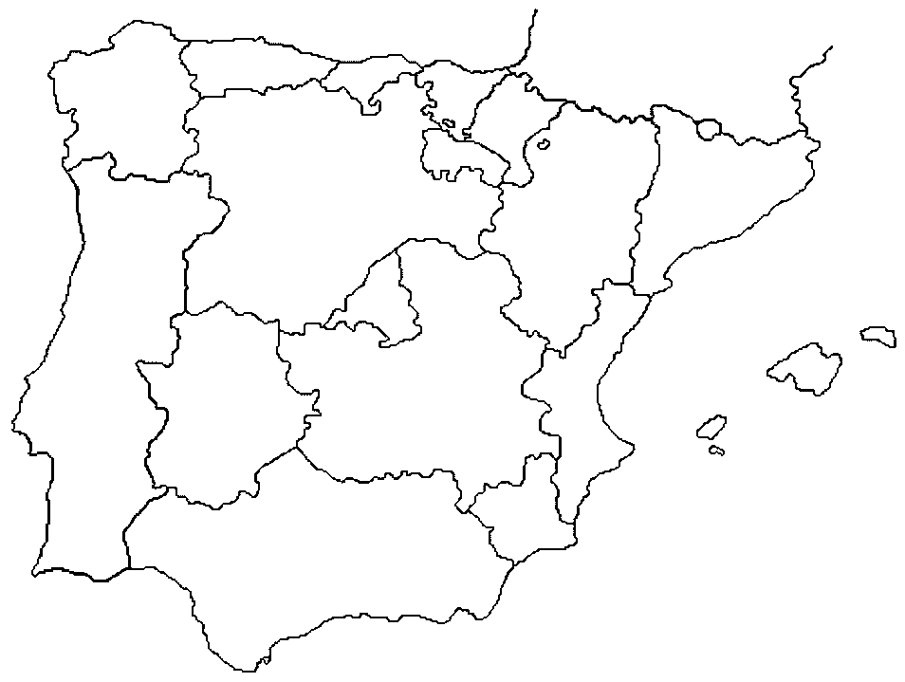

The story of the problem http://www.c3.lanl.gov/mega-math/gloss/math/4ct.html

- ……………………………
Since the time that mapmakers began making maps that show distinct regions (such as countries or states), it has been known among those in that trade, that if you plan well enough, you will never need more than four colors to color the maps that you make.

2. .……………………………
The basic rule for coloring a map is that no two regions that share a boundary can be the same color. (The map would look ambiguous from a distance.) It is okay for two regions that only meet at a single point to be colored the same color, however. If you look at a some maps or an atlas, you can verify that this is how all familiar maps are colored.

3. ……………………………
Mapmakers are not mathematicians, so the assertion that only four colors would be necessary for all maps gained acceptance in the map-making community over the years because no one ever stumbled upon a map that required the use of five colors. When mathematicians picked up the thread of the conversation, they began by asking questions like: Are you sure that four colors are enough? How do you know that no one can draw a map that requires five colors? What is it about the way that regions are arranged and touch each other in a map that would make such a thing true?
- ……………………………
The Four Color Problem was famous and unsolved for many years. When the question came to the European mathematics community at the end of the 19th century, it was perceived as interesting but solvable. Prominent and experienced mathematicians who tackled the problem were surprised by their inability to solve it.

5. ……………………………
In 1976, the conjecture was apparently proved by Wolfgang Haken and Kenneth Appel at the Universtiy of Illinois with the aid of a computer. The program that they wrote was thousands of lines long and took over 1200 hours to run. Since that time, a collective effort by interested mathematicians has been under way to check the program. So far the only errors that have been found are minor and were easily fixed. Many mathematicians accept the theorem as true.

Match the headings with the parts of the reading:
A) A special role for the computer
B) Surprising difficulty of proof
C) The boundary rule
D) Minimum colors necessary
E) Challenging the Four Color Theorem

In the text, find one word for each of the definitions below:
(part 1) clearly defined, not identical -
(part 2) having more than one possible interpretation or meaning -
(part 3) a positive statement or declaration, often without support -
(part 4) dealt with (e.g. a problem or issue)-
(part 5) an opinion or conclusion based on a guess –

HOMEWORK Exam practice: Supplying missing phrases

Quality of cartographic message depends on 1…….. and symbols. During map design process, symbol specification is often uncertain. Graphical signs 2…… to tastes, needs and context of use. Colours use is of special relevance to environmental, topographic and thematic maps whose primary purpose is to 3……. of main characteristics conveyed by the map. Communication in colour is more effective if the 4…….. . Colours choices, as mistakes or misunderstandings, are often highlighted: too many colours, 5…... , too meaningful colours, etc. involving disturbances when readers try to 6…….. .

A colours used are appropriate
B choices may be unsuitable
C understand its cartographic message
D create a mental image
E kinds of chosen data
F colours un-adapted to user’s data

sources
http://geography.about.com/od/understandmaps/a/mapcolors.htm introduction
http://painting.about.com/library/quiz/blquiz-colour1.htm quiz, Key 1C, 2C, 3B, 4C, 5A, 6B, 7A, 8C
http://www.haymespaint.com.au/explore-colours/about-colours/ wheel
http://icaci.org/files/documents/ICC_proceedings/ICC2011/Oral%20Presentations%20PDF/B1Graphical%20Semiology,%20visual%20variables/CO-084.pdf exam practice exercise, key 1E, 2B, 3D, 4A, 5F, 6C
Listening prepared by E. Čoupková, CJV MU

