140 Melt Point Wax - 4144
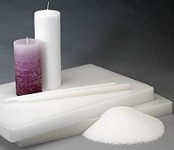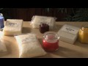

Share this product:
A 140 MP wax sold as 5 slabs in a 50 lb. Case. Applications: Votive / pillar / taper / hurricane / novelty candles. See product data sheet for recommendations.

50-pound case [W1042]
1 - 4
5 - 9
10 - 41
42 - 210
211+
$78.00
$74.50
$72.00
$70.00
$67.50

Select a Size:
10 pound slab for $19.90
[W1043]
50-pound case for $78.00
[W1042]
Qty:

Product Description
A great general-use wax for all-around candle making.

Details
Applications: Pillar/Taper
Melting Point (°F): 141
Penetration: 12
Color Saybolt: +32
Oil Content: 0.3%

Ideal For
- Pillar Candles
- Votive Candles
- Tea-Light Candles

Downloads
Product Data Sheet (PDS): Download 4144 PDS
Material Safety Data Sheet (MSDS): Download 4144 MSDS
Recommended wicks for this wax
- See more at: http://www.candlewic.com/store/product.aspx?q=c49,p523&title=140-Melt-Point-Wax---4144#sthash.6uH7Ju7z.dpuf

