Exotic main group metal complexes containing hybrid ligands

Jana Nevoralova,ª Emilie Riemlova,ª Tomas Chlupaty, Zdenka Ruzickova,ª Ales Ruzicka*ª

a) Department of General and Inorganic Chemistry, Faculty of Chemical Technology, University of Pardubice, Studentska 573, CZ-532 10, Pardubice, Czech Republic.
e-mail: ales.ruzicka@upce.cz

Stabilization of unusual¹, generally lower, oxidation states of metals in its complexes containing various types of ligands. Among other types of these ligands such as bulky silylated or terphenyl ones, various Cp's, chelating as for example pincer, enaminone or ketiminate/diketiminate, the amidinate/guanidinate ligands are of major interest because great variability and stability of target complexes. These amidinato/guanidinato complexes can be used in new areas in various catalyzed organic chemistry transformations1-3 as well as precursors for preparation of new materials.⁴

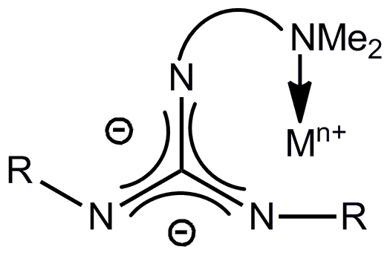
Scheme 1

Synthesis and structure of various kinds hybrid (ligands with two different types of donor functions) amidinate/guanidinate lithium, oligolithium and group 13-14 complexes will be presented along with the reactivity of these compounds with different species.

References
1 for example: (a) Jones, C., Coord. Chem. Rev., 2010, 254, 1273; (b) Sen, S.S.; Khan, S.; Nagendran, S.; Roesky, H.W., Acc. Chem. Res., 2012, 45, 578; (c) Inoue, S.; Epping, J. D.; Irran, E.; Driess, M., J. Am. Chem. Soc., 2011, 133, 8514; (d) Chlupatý, T.; Padělková, Z.; Lyčka, A.; Brus, J.; Růžička, A., Dalton Trans., 2012, 41, 5010.
2 Edelmann, F. T., Chem. Soc. Rev., 2009, 38, 2253; (b) Collins, S., Coord. Chem. Rev., 2011, 255, 118.
3 for example see: (a) Yu, Z.-T.; Yuan, Y.-J.; Cai, J.-G.; Zou, Z.-G., Chem. Eur. J., 2013, 19, 1303; (b) Kratsch, J.; Kuzdrowska, M.; Schmid, M.; Kazeminejad, N.; Kaub, C.; Oña-Burgos, P.; Guillaume, S.M.; Roesky, P.W., Organometallics, 2013, 32, 1230.
4 for example: Krasnopolski, M.; Hrib, C.G.; Seidel, R.W.; Winter, M.; Becker, H.-W.; Rogalla, D.; Fischer, R.A.; Edelmann, F.T.; Devi, A., Inorg. Chem., 2013, 52, 286.
5 Chlupaty, T.; Olejnik, R.; Ruzicka, A., In: F.L. Tabarés, Ed., Lithium: Technology, Performance and Safety, Chapter 4, Nova Science Publishers, Inc., Hauppauge NY, 2013.

Acknowledgement: The financial support of the Czech Science Foundation (Project no. P207/12/0223) is gratefully acknowledged.

