M 1 2 3 4 5 6 7 8 9 10

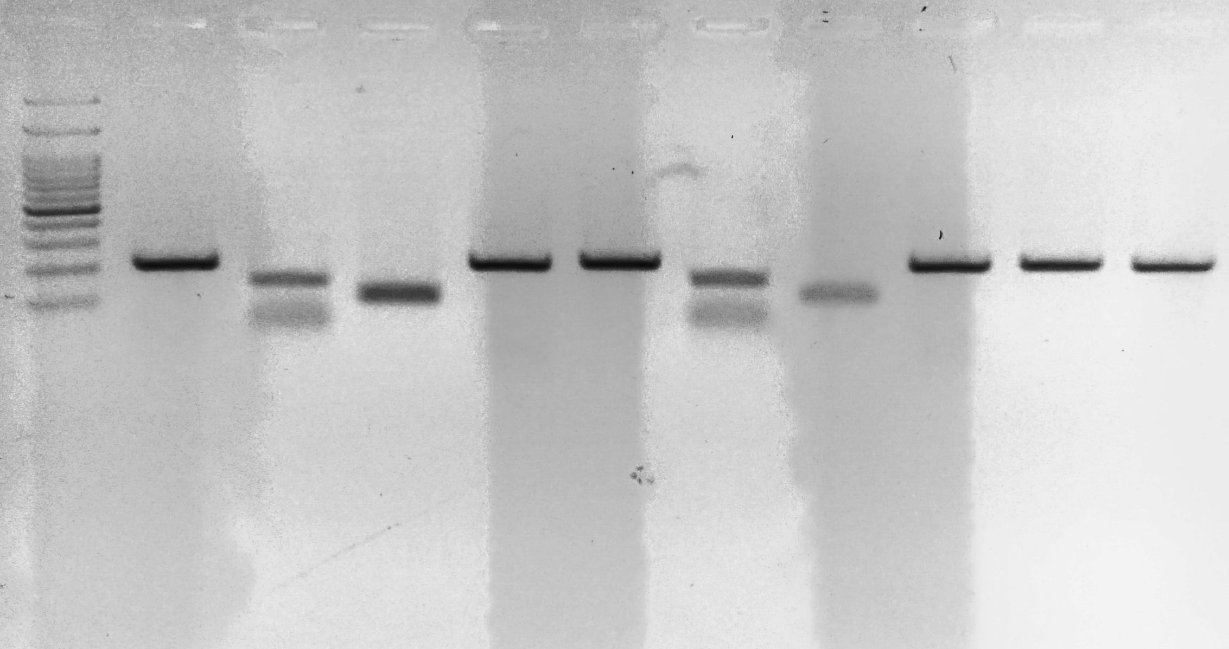

Marker: 100,200,300,400**,500**,600,700,800,900,1000,2000,3000 bp