New molecular precursors for AgCu nanoalloy preparation

Vit Vykoukal¹, Jiri Bursik², Pavla Roupcova², Vitezslav Halasta, Jiri Pinkas^{1*}

¹ Masaryk University, Faculty of Science, Department of Chemistry, Kotlarska 2, 611 37 Brno, Czech Republic
² Institute of Physics of Materials, ASCR, Zizkova 22,616 62 Brno, Czech Republic

jpinkas@chemi.muni.cz

Abstract:
Nanoparticles preparation by bottom-up methods depends strongly on using molecular precursors and the type and nature of precursors have a decesive effect of their formation and properties. They can greatly affect their resulting size, size distribution, shape and optical properties. In case of Cu, Ag, and Cu/Ag nanoparticles we can observe plasmon resonances and their close connection with the size, shape and distribution of sizes.We synthetized several new copper precursors by reduction of Cu(II) salts of carboxylic acids by triphenylphosphine. We characterized the structure of the new precursors by single crystal X-ray diffraction analyses and nuclear magnetic resonance. In addition we examined their thermal stability in oleylamine and determined the temperature of decomposition therefore the minimal temperature for nanoparticles synthesis. CuAg alloy nanoparticles were prepared by solvothermal hot-injection synthesis from the new precursors based on Cu(I) complexes. We compared benzoate and phtalate copper(I) complexes as precursors. CuAg nanoalloys were prepared from [Ag(NH₂C₁₂H₂₅)₂]NO₃ and triphenylphospinecopper(I) benzoate or triphenylphospinecopper(I) phthalate. Nanoalloy from benzoate was oblate, polydispersive and exhibited two plasmons at 393 and 569 nm. Nanoalloy from phthalate was round, monodispersive and exhibit one plasmon at 413 nm. We applied new molecular precursors in nanoalloy synthesis and demonstrated their influence on the final properties.
Acknowledgements. This research has been financially supported by the Ministry of Education, Youth and Sports of the Czech Republic under the project CEITEC 2020 (LQ1601).
Authors thank the X-ray Diffraction and Bio-SAXS Core Facility of CEITEC.
Keywords: new precursors based on Cu(I), XRD, nanoalloy, copper, silver

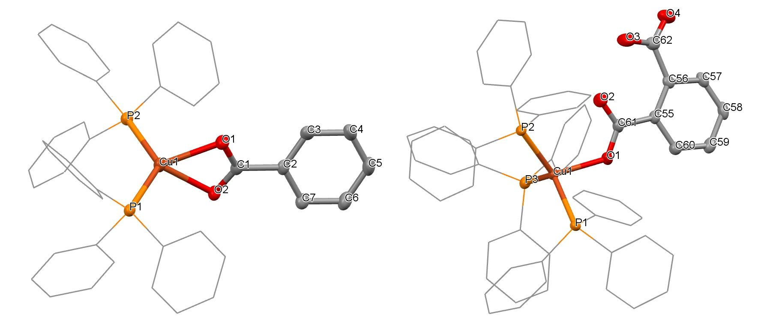
Figure 1: Molecular structure of bis(triphenylphosphine)copper(I) benzoate and tris(triphenylphosphine)copper(I) phthalate

