Engineering Plastics at the Forefront of “Made in China” Plan
Posted on September 1, 2017 by Andy Pye — Leave a Comment

Biodegradable plastics
With a developing economy comes responsibilities on the environmental scale and something of a green revolution is taking place. For example, China has decided to develop and implement carbon capture and storage (CCS) on a massive scale. The process of capturing carbon can however lead to the formation of carcinogenic chemicals, but Chinese researchers are collaborating with Norwegian colleagues in order to overcome this problem.³
The leading Chinese research groups in the field of CCS are going to collaborate with the University of Oslo institute and the Norwegian Technology Centre Mongstad (TCM), which is the world’s largest facility for testing and developing CO₂ capture technologies. The motivation is that the Norwegian researchers have an expertise the Chinese are missing themselves.
According to GCiS China Strategic Research,⁴ 135,000 tons of bio-plastics were sold in the China market in 2016. Largely driven by regulatory mandates in environmental protection, the bio-plastics market is expected to continue growing over the next five years.
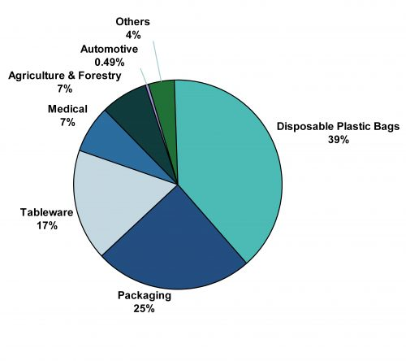China’s Bio-Plastics Revenues by Application
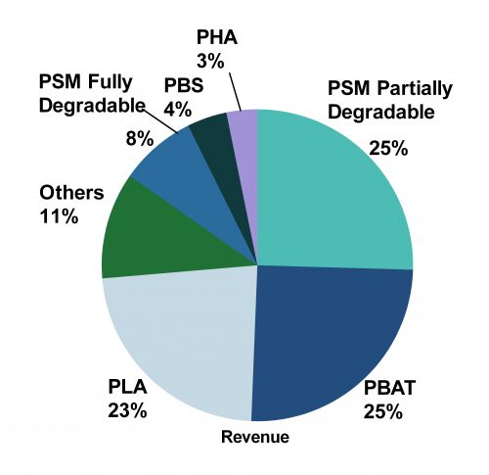
China’s Bio-Plastics Revenues by Product
Following the State Council’s order to limit plastic shopping bags in 2007, the Jilin and Jiangsu provinces have gone further to implement a ‘No Plastics Order’ in 2015 and 2017 respectively. The latter order bans the production and sale of disposable plastic bags or tableware made using non-biodegradable materials. Local Jilin officials are also made accountable as their annual performance review will incorporate performance indicators related to the implementation of the order.
While it is clear that the Chinese government is embarking on a green revolution across all sectors and industries, it is difficult to determine whether the policy will be lasting enough for this industry to achieve its environmental mandates. Unlike areas like the phasing out of hydrochlorofluorocarbons (HCFC), where there are clear phase out targets, there are no such performance targets when it comes to the biodegradable plastics sector.
In Jilin province, a ban on non-biodegradable plastics is a way to kill two birds with one stone. Prompted by a massive corn glut in recent years, the Jilin government was faced with an oversupply of aged corn that is unpalatable for consumption. By converting the unused corn into xylitol and corn starch, they can be diverted to the local bio-plastics sector for the production of biodegradable plastics.
According to GCiS, China’s bio-plastics industry is valued at close to RMB 2.5 billion of domestic sales revenues in 2016, up 13 percent from 2015. Since 2013, government funding has been flowing into the sector, to help support key domestic enterprises and develop industry bases in different parts of the country. This is part of a broader industrial policy at developing bio-plastics, amongst many others, into one of the country’s strategic new materials.
China’s bio-plastics industry is dominated by three main types of products, partially degradable plastarch material (PSM), polybutyrate (PBAT) and polylactide (PLA) – each with roughly equal market shares by revenue.
Overall, only 13 percent of companies in this sector are foreign while the rest are predominantly Chinese. Despite this, foreign companies captured around 25 percent of the total market share by revenues, mainly because of their better-quality products and premium pricing strategy.
Plastarch Material (PSM)
is a biodegradable, thermoplastic resin. It is composed of starch combined with several other biodegradable materials. The starch is modified in order to obtain heat-resistant properties, making PSM one of few bioplastics capable of withstanding high temperatures. PSM began to be commercially available in 2005.
PSM is stable in the atmosphere, but biodegradable in compost, wet soil, fresh water, seawater, and activated sludge where microorganisms exist. It has a softening temperature of 257°F (125°C) and a melting temperature of 313°F (156°C).
It is also hygroscopic. The material has to be dried in a material dryer at 150°F (66°C) for five hours or 180°F (82°C) for three hours. For injection molding and extrusion the barrel temperatures should be at 340° +/- 10°F (171°C) with the nozzle/die at 360°F (182°C).
Due to how similar PSM is to other plastics (such as polypropylene and CPET), PSM can run on many existing thermoforming and injection molding lines. PSM is currently used for a wide variety of applications in the plastic market, such as food packaging and utensils, personal care items, plastic bags, temporary construction tubing, industrial foam packaging, industrial and agricultural film, window insulation, construction stakes, and horticulture planters.
Since PSM is derived from a renewable resource (corn starch), it has become an attractive alternative to petrochemical-derived products. Unlike plastic, PSM can also be disposed of through incineration, resulting in non-toxic smoke and a white residue which can be used as fertilizer. However, concerns have been expressed about the impact of such technologies on food prices.

Polybutylene succinate (PBS)
(sometimes written polytetramethylene succinate) is a thermoplastic polymer resin of the polyester family. PBS is a biodegradable aliphatic polyester with properties that are comparable to polypropylene.
It may also be referred to by the brand names Bionolle (Showa Denko) or GsPLA (Mitsubishi Chemical). PBS consists of polymerized units of butylene succinate, with repeating C₈H₁₂O₄ units.

