**Recapture of ion-induced secondary electrons emitted from magnetron targets**

***Donald J. McClure***

*Acuity Consulting and Training*

# Abstract

**Cedric Bedoya and Edward J. Anderson**

*3M Corporate Research Laboratories*

coating systems (production, pilot, or lab scale). This is turn allows an improved understanding of the reactive sputtering

The recapture of ion-induced secondary electrons emitted from magnetron targets is a significant but underappreciated part of our sputtering processes. Recaptured electrons are secondary electrons that return to and are captured by the target without interacting with the plasma. The fraction of electrons recaptured has been estimated by other workers to be as high as two-thirds to three-quarters of those that initially leave the target. We use the method described previously to determine ion-induced secondary electron emission (ISEE) coefficients under a variety of conditions with the goal of informing our thinking about the recapture process. The magnitude of the fraction of electrons recaptured has a direct impact on the ISEE coefficient. The latter is important in that it has a strong influence on cathode voltage. The cathode voltage often changes with reactive gas additions and is frequently used as a process control set point. This paper includes measurements of ISEE coefficients for Al as a function of pressure and magnetic field strength and for AlOx and AlNx both as their respective reactive gases flows are varied and also in the fully reacted mode as a function of pressure. The results lead to a better appreciation of the significant role of electrons recaptured at the cathode surface.

# Introduction

Reactive magnetron sputtering is an important process used for producing thin films of a wide range of metal compounds (oxides, nitrides, and carbides) for applications including optical, dielectric, transparent conductive, semiconductor, protective, and barrier coatings. The principle is simple: start with a metallic target and add enough reactive gas (oxygen, nitrogen or carbon containing gas) to allow formation of the desired compound on the substrate. Unfortunately it is seldom that simple. A complexity arises because of the pronounced hysteresis observed while attempting to connect our desired process outcomes to our traditional control variables. The hysteresis separates two distinct operating modes: the process space that enables the preferred deposited-film stoichiometries at high reactive gas flows; and the process space that enables the much higher rates possible with metal targets operated at lower reactive gas additions.

We have previously shown how simple measurements of cathode heating can be used to determine the ion-induced secondary electron emission (ISEE) coefficients during reactive sputtering [1]. This method enables the determination of the ISEE coefficient at any operating point of the process in any

process, especially within its most technologically important region: those reactive gas flows or partial pressures where hysteresis effects dominate. The method was new, direct, and simple. This paper extends our method to the AlOx and AlNx systems, includes a number of new measurements, and in particular gives insights into the important role of electrons recaptured at the cathode surface.

# The importance of the oxide ISEE coefficient

Oxide ISEE coefficients have been difficult to measure under actual sputtering conditions [2]. Ion beam methods [3] are powerful but give values that may not be appropriate for magnetron systems used for coating because they don’t properly account for the large fraction of electrons that are “recaptured” by returning to the cathode surface before interacting with the sputtering gas. The recapture process is driven by the magnetic fields used in our sputter coating tools. The fraction of secondary electrons recaptured has been estimated to be between 65% and 75% [4]. A second method, based on correlating cathode voltage measurements to ISEE coefficients [5], is powerful in that it produces values for a large range of materials and has led to significant improvements in our understanding of the trends for ISEE coefficients for differing target materials, but the results are cathode and pressure specific and may be difficult to extrapolate to other systems. Moreover the oxide ISEE coefficients produced are generated only under conditions in which the targets are fully oxidized. By contrast our results for SiAlOx showed that the ISEE coefficient for a partially oxidized metal target (for oxygen flows within the hysteresis loop where most production coating systems operate) are higher than that in the fully oxidized mode.

The lack of good values for the ISEE coefficient for oxide surfaces under real sputtering conditions hamper efforts to accurately model the discharges in sputter coating systems. It has been reported that the “literature data for ion-induced emission yield of oxides are scarce” [6], and that this scarcity “is probably the most fundamental factor limiting the output of magnetron simulations” [7]. The ISEE coefficient directly and significantly affects the operating cathode voltage [8]. The cathode voltage affects the energy of the secondary electrons entering the plasma and, in turn, the many ionization reactions and energy transfer and thermalization processes that ensue.

# Recaptured secondary electrons: some background

Thornton introduced the concept of recaptured electrons in his classic paper, “Magnetron sputtering: basic physics and application to cylindrical magnetrons.”[9]. His work was focused on cylindrical post magnetrons. He estimated that about half of the ion-induced secondary electrons emitted from his magnetron sputtering targets (or cathodes) were recaptured, that is, collided with the target before and without subsequent interaction with the plasma. His Figure 2, shared here as Figure 1, is illustrative. Recaptured electrons follow the “nearly” semi- circular path drawn in the figure, don’t undergo any collisions along that path, collide with the cathode surface, and are captured there.

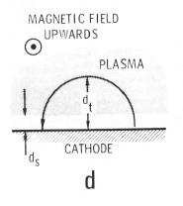

Figure 1 (from Thornton [9]). Electron motion in static electric and magnetic fields;

ds = sheath thickness; dt = turning distance.

The next major contribution to the author’s understanding of recaptured electrons came from Guy Buhle’s doctoral thesis [10]. Dr. Buhle was working in the De Gryse and Depla group at Ghent University. This was a mostly computational effort with a goal of a complete model of a d. c. planar magnetron. We will refer to it several times in what follows. By the time the thesis was completed, it had produced eleven refereed papers, three non-refereed papers, and fourteen conference presentations!

# Experimental

The experiments described here were carried out in a pilot scale roll-to-roll sputtering system using a pair of custom-made planar cathodes with face sizes of 7.82 cm x 43.28 cm (3.08 inches x 17.04 inches) operated in dual cathode mode. They were powered by an Advanced Energy Industries PEII 10K power supply operated at 40 kHz and 4 kW. Coolant temperature measurements were made using immersion thermocouples mounted in the branch of a tee with the coolant flowing in and out of the running ends of the tee so as to insure the sensor was fully immersed in the coolant flow. Measurements were made five minutes after a change in

conditions to allow the system to come to thermal steady state. The nominal coolant flow rate in the closed-loop cooling system was monitored using an in-line rotameter measurement. The coolant flow affects the magnitude of the temperature differences observed but does not otherwise impact the results. The vacuum system was diffusion pumped.

# AlOx hysteresis

Figure 2 gives the results of using our method for reactive sputtering of AlOx from an aluminum target. The ISEE coefficient with no oxygen flow is somewhat arbitrarily set to

0.1. When more appropriate ISEE coefficient values are available, the results can be revised, but we have previously shown that 0.1 is a suitable estimate for many metals and that changing that value has only a small impact on the ISSE coefficient results for systems operating in the reactive mode [1]. The ISEE coefficient for the fully oxidized target is 0.69. The hysteresis loop is relatively narrow, consistent with the relatively high pumping speed for this system.

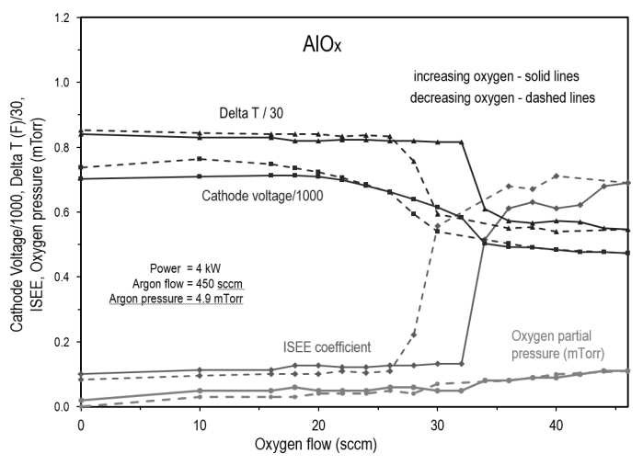

Figure 2. Reactive sputtering of AlOx from an aluminum target; data set 1. The oxygen flow was increased then decreased.

For a variety of reasons we chose to repeat the experiment, with the results shown in Figure 3. The voltage hysteresis has changed slightly with a lower value in the oxide mode, but the ISEE coefficient for the fully oxidized target is now 0.33. It was later realized that the first data set was taken with 1/4” thick targets and the second set with 1/8” thick targets. Measurements of the maximum magnetic field strength in the race track of each of the mounted target pairs gave 209 gauss for the 1 /4” thick targets and 283 gauss for the 1/8” targets. The higher magnetic field for the 1/8” targets would result in smaller radii of motion for the electrons (dt, or turning distance, in Thornton’s model) and a shorter path in the space above the target. This in turn would produce fewer interactions/collisions with the background gas and a higher fraction of electrons recaptured.

Figure 3. Reactive sputtering of AlOx from an aluminum target; data set 2. The oxygen flow was increased then decreased.

Pressure dependence of the ISEE coefficient

We then turned to Buhle’s thesis asking ourselves what other variables affect the recapture fraction. Buhle writes, “The effective SE yield, γeff, as seen by the discharge will be a factor three to four smaller than the standard SE yield of the target material.” I paraphrase another section of the thesis as, “The majority of the change in cathode voltage with changing pressure is due to the changing fraction of recaptured secondary electrons.” Based on this last observation, we next measured the voltage and ISEE coefficient for a metallic aluminum target as a function of pressure. The results are shown in Figure 4. The ISEE coefficient results are rather noisy. We’ve added the measured change in temperature (ΔT) values (cathode coolant out minus cathode coolant temperature in) as data labels to show how sensitive this data set is to that measurement. The last data point had a ΔT value of 11.8 F. We’ve added a counterfeit point at 12.3 F (in gray) to show how a change in measured ΔT of 0.5 F would impact the result. We have also added a least squares linear fit to the data as an aid to the eye (we don’t feel a linear fit is justified but are unsure of what functionality is most appropriate). Regardless the data set does indicate a strong dependence of the cathode voltage and ISEE coefficient on pressure, with the former dropping by more than 40% and the latter increasing by ~50%. The increased pressure implies more collisions (e‒ ‒ Ar interactions), reduced recapture, and thus higher ISEE coefficient. We are have not exhaustively searched the literature, but we are unaware of any other measurements of changing ISEE coefficient with pressure. The results indicate the importance of the changing recapture fraction for the process.

Figure 4. The voltage and ISEE coefficient for a metallic aluminum target as a function of pressure.

Part of the challenge in further analyzing these results comes again from Buhle’s thesis. He states, “The secondary electrons (SE) emitted from the target are brought back to the vicinity of the target because they follow the magnetic field lines. This leads to electron-target interaction, which results in recapture of the electrons. Although it has been known for a long time that this process occurs and that it can strongly influence the discharge voltage, practically no work has been done to quantitatively assess recapture” (emphasis added). He states that data on electron reflection coefficients for electrons are scarce but required for good model results, that accurate models are extremely computationally intensive, and that the time steps used need to be very small. One example of the complexity he cites is that recapture at the edge of the racetrack (a region of reduced magnetic field) is calculated to be near zero while recapture at the center of the racetrack (a region of highest magnetic field) is calculated to be near unity! Therefore comparison to experiments requires averaging over position, and other variables. He found that averages often give non- monotonic results, i.e., γeff as a function of pressure is not monotonic in his modeling efforts.

We add two more plots of ISEE coefficients as a function of pressure. Figure 5 is AlOx with the Al target surface saturated with oxygen as a function of pressure. Figure 6 is AlNx with the Al target surface saturated with nitrogen as a function of pressure. Neither plot shows any strong dependence of the cathode voltage or the ISEE coefficient on pressure. This is in strong contrast to the same measurements on the metallic aluminum target. Clearly the dependence of the ISEE coefficient on pressure is sensitive to the chemistry of the cathode surface. We draw no any further conclusions from the data, but hope it can guide/assist future modelling efforts and that others can contribute based on this data.

Figure 5. Cathode voltage and ISEE coefficient for AlOx with the Al target surface saturated with oxygen as a function of pressure. Cathode power was 4 kW.

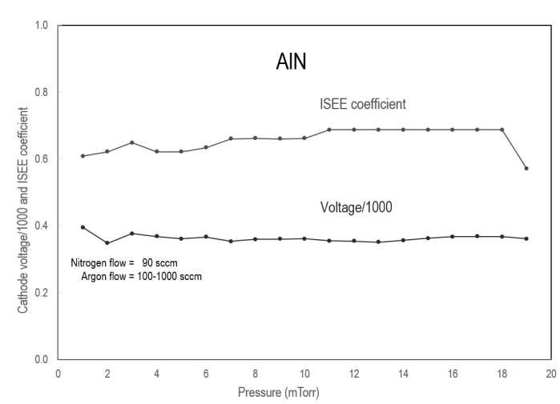

Figure 6. Cathode voltage and ISEE coefficient for AlNx with the Al target surface saturated with nitrogen as a function of pressure. Cathode power was 4 kW.

# AlNx hysteresis

For completeness we add Figure 7, with data on the cathode voltage, nitrogen partial pressure, and ISEE coefficient for AlNx as the nitrogen flow is increased and then decreased through the system’s hysteresis loop. There is little evidence of hysteresis in this data set.

Figure 7. Cathode voltage, nitrogen partial pressure, and ISEE coefficient for AlNx as the nitrogen flow increases and then decreases.

# Summary

For metallic Al targets we observed that the cathode voltage decreases and the ISEE coefficient increases with increasing pressure. We also observed that the ISEE coefficient increases with decreasing magnetic field strength. The observations can be understood in terms of the increase in electron-argon interactions and the reduction in recaptured electrons. By contrast for oxygen saturated or nitrogen saturated aluminum targets, we observed little dependence of cathode voltage and ISEE coefficient on pressure.

We observe the ISEE coefficient in this work varying with experimental conditions, including pressure, magnetic field, voltage, and cathode surface chemistry. With that in mind, “effective ISEE coefficient” is much more appropriate than “ISEE coefficient” in this work.

Detailed explanations of these effects require significant efforts using computational models which have been characterized by Buhle as very challenging. There’s lots of work remaining!

# References

1. D. J. McClure, C. Bedoya, and E. J. Anderson, “Cathode heating hysteresis in reactive magnetron sputtering: a path to accurate values of the ion-induced secondary electron yield,” *59th Annual Technical Conference Proceedings of the Society of Vacuum Coaters*, in press, 2016; and Society of Vacuum Coaters 2016 Summer Bulletin, pg. 28-33.
2. R. A. Baragiola and P. Riccardi, “Electron Emission from Surfaces Induced by Slow Ions and Atoms,” Chapter 2, page 43, in *Reactive Sputter Deposition*, D. Depla and S. Mahieu, ed. (Springer 2008). See pg. 57.
3. M. A. Lewis, D. A. Glocker and J. Jorne, “Measurements of secondary electron emission in reactive sputtering of

aluminum and titanium nitride,” *J. Vac. Sci. Technol*. A7, 1019, 1989.

1. G. Buyle, D. Depla, K. Eufinger, and R. De Gryse, “Calculation of the effective gas interaction probabilities of the secondary electrons in a dc magnetron discharge,” *J. Phys. D: Appl. Phys.* 37, 1639, 2004.
2. D. Depla, S. Mahieu, and R. De Gryse, “Depositing Aluminium Oxide: A Case Study of Reactive Magnetron Sputtering,” page 153, in *Reactive Sputter Deposition*, D. Depla and S. Mahieu, ed. (Springer, 2008).
3. A. Bogaerts, I. Kolev, and G. Buyle, “Modeling of the Magnetron Discharge,” Chapter 3, page 61, in *Reactive Sputter Deposition*, D. Depla and S. Mahieu, ed. (Springer 2008). See page 75.
4. R. A. Baragiola and P. Riccardi, “Electron Emission from Surfaces Induced by Slow Ions and Atoms,” Chapter 2, page 57, in *Reactive Sputter Deposition*, D. Depla and S. Mahieu, ed. (Springer 2008).
5. Reference 5. See page 101.
6. J. A Thornton, “Magnetron sputtering: basic physics and application to cylindrical magnetrons,” *J. Vac. Sci. Technol.* 15(2), 171, 1978.
7. G. Buhle, “Simplified model for the d.c planar magnetron

discharge,” Ph. D. thesis, University of Ghent, 2005.