A new strategy of reagents labeling (NPs, QDs) used in immunoassay with LA-ICP-MS
Michaela Tvrdonova ¹, Marketa Vaculovicova^{2,3}, Andrea Moravanska³, Tereza Vaneckova³ and Tomas Vaculovic ^{1,4}
¹Department of Chemistry, Faculty of Science, Masaryk University in Brno, Kotlarska 2, 611 37 Brno, ² Brno Univ Technol, Cent European Inst Technol, Purkynova 123, CZ-61200 Brno, Czech Republic, ³Mendel Univ Brno, Dept Chem & Biochem, Zemedelska 1, CZ-61300 Brno, Czech Republic, ⁴CEITEC Masaryk University in Brno Kamenice 5, 625 00 Brno

Laser ablation with inductively coupled plasma is still more used in life science as biology and biomedicine and the utilization of metals and proteins determination simultaneously is also growing up. ^{2, 3} We have developed a new strategy of labeling of antibody (it can specific binds to proteins) by nanoparticles and quantum dots which is composed of thousands of atoms and thus increases the sensitivity enormously and of course decreases the limit of detection, compare to lanthanoids labeling. The ability of successfully tagged antibodies bound to antigen (protein) was proved by dot blot on membrane imaged by LA-ICP-MS.
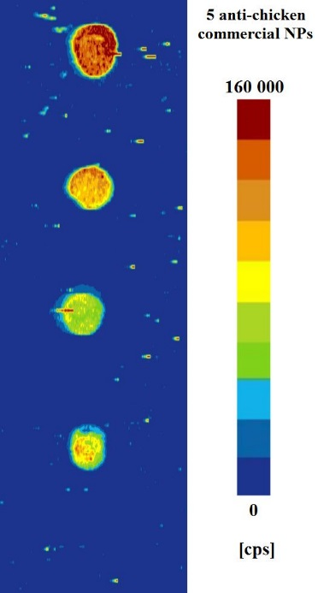

1. S. Kanje, A. J. Herrmann, S. Hober, and L. Mueller, Next generation of labeling reagents for quantitative and multiplexing immunoassays by the use of LA-ICP-MS. Analyst, 141, (2016):6374.
2. L. Waentig, N. Jakubowski, S. Hardt, C. Scheler, P. H. Roos, and M. W. Linscheid, Comparison of different chelates for lanthanide labeling of antibodies and application in a Western blot immunoassay combined with detection by laser ablation (LA-)ICP-MS. Journal of Analytical Atomic Spectrometry, 27, (2012):1311.

