Homework 5/100
Watch the video and tell your partner what you can see: video is silent, play the cut version, student A watches, student B is turned back,afterwards ss discuss in pairs what problem the video is talking about, give their ideas, elicit: vector borne diseases, ask to give examples ( Malaria, Dengue, Leishmaniasis, Lyme disease, Yellow fever, Japanese encephalitis) 5/95
Play it all with the sound on https://www.youtube.com/watch?v=q1P3QupjhYo, 2:07 – check your answers 3/90
- Look at the online poster advertising a conference, what key information can you receive from it? 5/87 show a slide

- Find on that poster phrases that refer to definitions below. First letters are given for you.
Give ss photocopies 3 + 3fdbk: 6/82
- an early plan for the conference (some details may change later – p p preliminary program
- look for further information – c b f u check back for updates
- money you must pay to attend the conference – r f registration fee
- soon – i d c in due course
- the Internet must be used to send personal information for the conference – o r o online registration only
- the last date that personal information can be sent to the conference organisers – a d application deadline
- the most important presenters at the conference – k s key speakers
- the organizers will only accept applications in the order they receive them – on a strictly f c f s b first-come first-served basis
- to send a written summary of your research because you want to present a paper – s a submit (an) abstract

- The diagram below shows how the adaptive immune system responds after vaccination with an attenuated (weakened) virus.
- In pairs, discuss what you think the diagram shows. 6/76

b answers: a1, b4, c5, d6, e3, f2, 3m + 2 pairs fdbk + 1 T-C fdbk: 6/70

Milan is an immunology PhD student researching T-cell responses to viral-based malaria vaccines. He is presenting his research at the 7th European Malaria Conference at Trinity College Cambridge.
A: 2 + 2put ss answers on the board+ ‘1:30 + 2 final fdbk: ca 8/64 Answers: 1c, 2a, 3b, 4d, 5e
B: 3/56 a) Let’s begin by looking at b) That’s all I have to say about…so now I’d like to move on to c) As I have already said d) I will be returning to those shortly e) As you can see from this image
C: pause after each excerpt and get the answer, put the phrase on the board next to a-5 (Next we’ll look at…), b-3 (We’ve looked at…so now let’s turn to…), c-1 (As I mentioned earlier), d-2 (and I’ll deal with this point later) or e-4 (the charts here indicate…) ca 6/53
Audioscript 10.3 to print from: https://is.muni.cz/auth/do/sci/jaz/backup/spol/vyuk/esp/26949537/Audioscript.pdf?lang=en
- Summing up information from previous activities:
- what makes a good poster? Get some ideas, refer to the two main visuals from the lesson 2/47
Show to ss via visualizer the two posters from CE for Scientists, pp89 and 90 (each for 5s), make them discuss in pairs/groups which one was better organized / they liked more and why. 3 disc + 2 fdbk: 5/45
b – 3 ss ind + 2 fdbk: 5/40
Answers: 1title, 2simple, 3abstract, 4contact, 5columns, 6text, 7heading, 8Number, 9white space, 10sentences, 11font, 12colours
- Imagine you will have to present a poster at a student conference. What topic will you choose? Look at the visuals below and decide which ones would be most useful for your topic. 2m prep. + 3minutes fdbk: 5/35
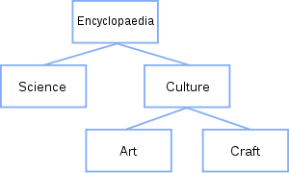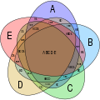
tree diagram Venn diagram
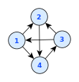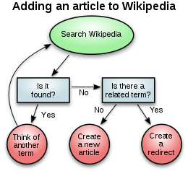
network diagram flowchart
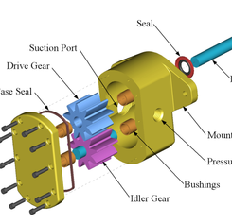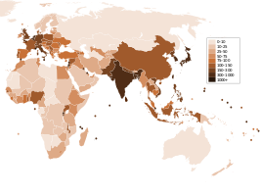
exploded view density map
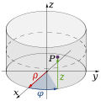 three-dimensional diagram

- Think about a design of a poster to present your topic. There is a new conference rule: your poster cannot include text except for five sentences (max of 15 words each) but it can include as many illustrations as you wish. Which statements would optimally tell about the topic to your audience?
3m indiv + 5 fdbk: 8/30
- Use an affinity map or a fishbone diagram to help you realize the most important aspects of the chosen topic. Describe it to your partner a good tool for revealing ideas and mapping relationships within a topic, helps in summarizing facts about the topic, is focused on causes and effects as well as classifications, etc. 3 ind + 4pair work (2 per student): 7/17
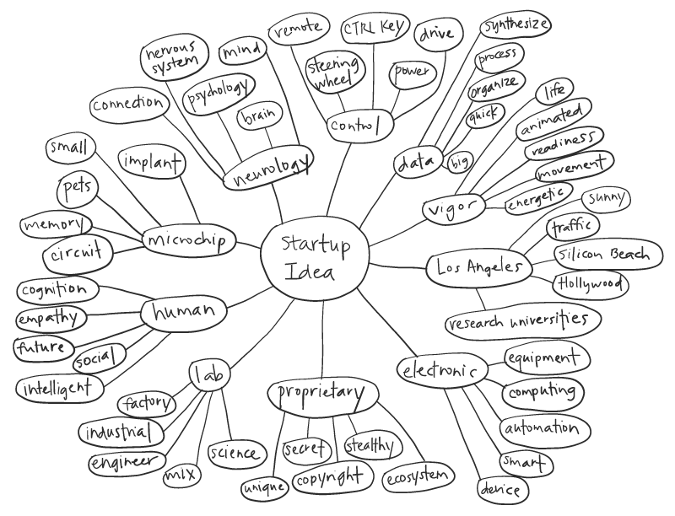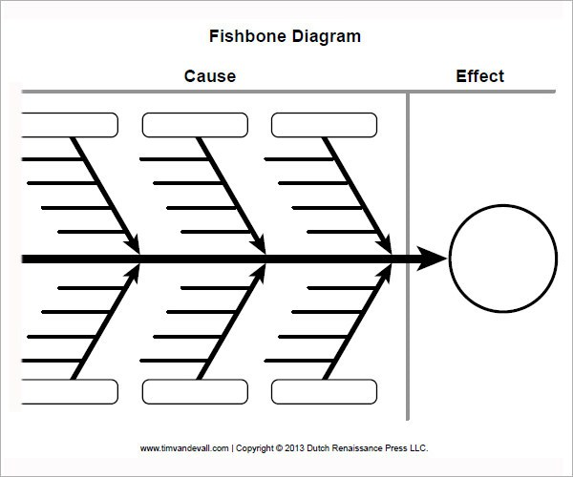
- A: Answers: 1-F: Mosi refers to most studies so far, which suggests more than a few have been done, 2-T, 3-F: Mosi used human volunteers who had not had malaria, 4-T, 5-T 1 read +‘0:54 list + 2 fdbk: 4/22
B: 1: It seems then that, 2: My research though focuses on, 3: most studies so far have, 4: As you can see in this chart/ The second graph shows 5: In this study have the script photocopied for ss: https://is.muni.cz/auth/do/sci/jaz/backup/spol/vyuk/esp/26949537/Audioscript.pdf
3 + 2fdbk: 5/17
- Reacting to questions from the audience a: in order: C, B, A 5/12
b: 1. Is that what you wanted to know about them? 2. If you want to know more…just send me an email 3. Does that answer your question? 4/7

HOMEWORK: Now design your poster. Keep to the rule of presenting info top-down, left-right. Print it on A4 paper in colour and bring it to the next class.

Lesson scanned from: Armer, T. (2011) Cambridge English for Scientists CUP, pp. 79-81, 84-85

