INORGANIC NOMENCLATURE I
- Periodic table
  - What elements do these symbols stand for?
Mn B Mg W Pb Sb I Sn K Au Fe Ag
- Mn – manganese
- B – boron
- Mg- magnesium
- W – tungsten
- Pb – lead
- Sb – antimony
- I – iodine
- Sn – tin (stannum)
- K – potassium
- Au – gold
- Fe – iron
- Ag - silver

  - Listening exercises
Explain the symbols below:
    - What do they stand for?
    - What do they mean?
    - What is an alternative way of using them? (e.g. element 112)

Uub Uut Uuq Uup Uuh Uus Uuo
Answers:
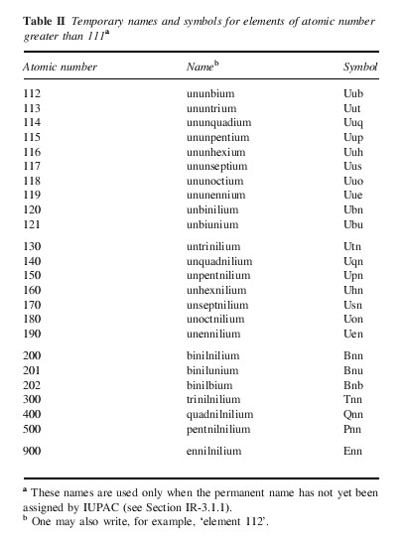

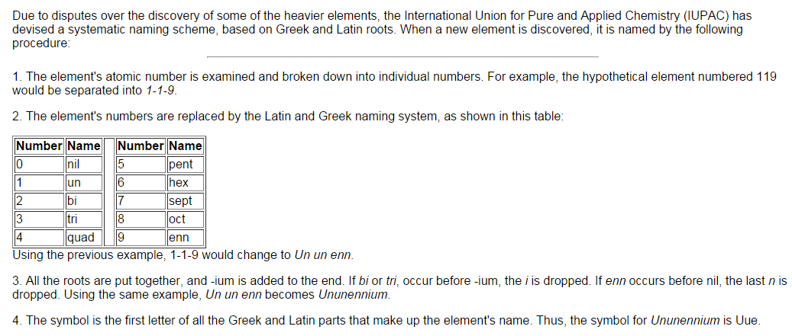

Watch the first video and answer the following questions:
Source: http://www.periodicvideos.com/videos/112.htm
1. What element is the professor speaking about?
  - He has mentioned a controversy that was linked to the symbol of the element. What was the controversy based on?
  - Who/What institution made the final decision regarding the symbol?
  - According to the professor, what role did lead play in the element synthesis?
  - Could you describe the process of the element decay as explained in the video?
Answers:
  - Copernicium / Cn
  - Originally - symbol Cp, but it is used for cyclopentadienyl by organic chemists
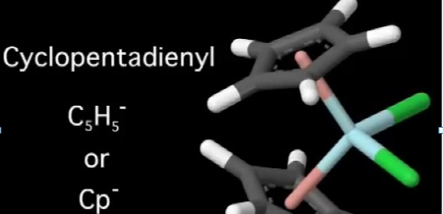
Plus the scientists realized that many years ago (in some older books and papers), the symbol Cp was used as an alternative symbol for Lutetium which was in some countries called Cassiopeium) – old books are being digitized, it could cause confusion
  - IUPAC – International Union of Pure and Applied Chemistry
  - The principle of synthesis: atoms of lighter elements are bound together to get 112, i.e. Pb (82) + Zn (30) – Zn atoms are accelerated in a high speed accelerator towards Pb atoms, 2 nuclei fuse together as a result
  - It does not blow into parts, it starts to decay by steps (112 – 110 – 109 - 107… until it gets to a number below the mass of Uranium 92 (which is stable)

Watch the second video and try to explain the meaning of the following facts / dates / expressions within the context of the talk:
Source: http://www.periodicvideos.com/videos/114.htm
Stop after the introductory part in which the scientist speaks Russian – question:
What language does he speak? Why?
(Element 114 got its official name (Flerovium) and symbol (Fl), excitement, his father was born in Russia)
The rest of the video
114 December 2011 Plutonium Fljorov
30th May 2012 Dubna memorial
Russian discussion period bombardment

114 – element 114, its atomic number

December 2011 - the name Flerovium for element 114 suggested to IUPAC

Plutonium – Pu (94) + Ca (20) – synthesis of the element

Fljorov – Russian scientist, founder of Dubna, the element named after him

30th May 2012 – the element´s name officially adapted

Dubna – Russian research centre north of Moscow

memorial – the fact that the element was named after Fljorov is kind of his memorial

discussion period – when a new name of an element is suggested to IUPEC, people are allowed to point out if there are any problems connected to it

bombardment – superheavy new artificial elements are synthesized by taking a nucleus of a heavy element and binding into it an element that is lighter – Ca atoms are accelerated rapidly and plutonium is bombarded with millions of atoms, one will eventually fuse with one atom of Pu

Follow up question:
Why does such an element need a symbol?

Not useful for day-to-day chemistry, but for physics (unstable element decay – see explanation using his tie)

- Types of chemical nomenclature
- Trivial names
HG2Cl2 – mercurous chloride (systematic - mercury (II) chloride)

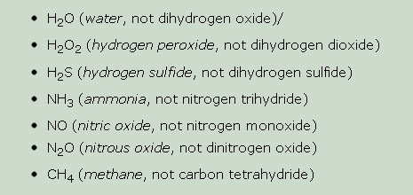

- Popular names
Chemical substances that are employed in the home, the arts, or in industry have acquired traditional or “popular” names that are still in wide use.
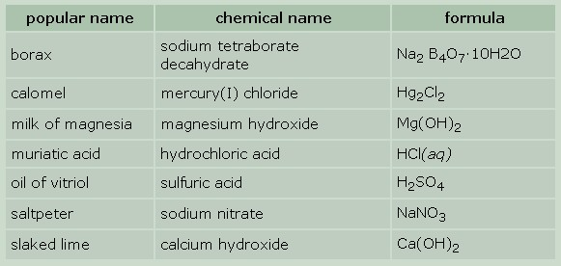
- Systematic nomenclature:
  - compositional
  - substitutive
  - additive
Example: PCl 3
- compositional: phosphorus trichloride
- substitutive: trichlorophosphane
- additive: trichloridophosphorus

- Chemical nomenclature of
  - ions
  - binary compounds
  - ternary compounds

- IONS
  - CATIONS
    - monoatomic: name of the element and charge
Na⁺ sodium (1+), /n a plus/, sodium ion, univalent positive
sodium ion,
H⁺ hydrogen (1+), /h plus/, hydrogen ion, univalent positive
hydrogen ion,
Cu²⁺ copper (2+), /c u two plus/, copper ion, divalent positive
copper ion, copper (II) ion
Cr³⁺ chromium (3+), /c r three plus/, chromium ion, trivalent
positive chromium ion,

Some of the metallic ions are multivalent, meaning that they can exhibit more than one electric charge. For these there are systematic names that use Roman numerals and endings –ous and –ic to denote the lower and higher charges, respectively. In cases where more than 2 charge values are possible, the systematic names are used.
Examples:
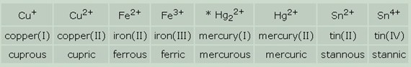
Fe²⁺ /Fe two plus/, iron (2+), iron (II), ferrous ion, divalent positive iron ion
Fe³⁺ /Fe three plus/, iron (3+), iron (III), ferric ion, trivalent positive iron ion

    - homopolyatomic:
Hg₂²⁺ /h g two two plus/, mercury (I) ion, mercurous ion,
O₂⁺ dioxygen (1+)
S₄²⁺ tetrasulphur (2+)
Bi₅⁴⁺ pentabismuth (4+)
H₃⁺ trihydrogen (1+)
Li₂²⁺ dilithium (1+)
N₅⁺ pentanitrogen (1+)
Na₂⁺ disodium (1+)
P₂⁺ diphosphorus (1+)
Si₂⁺ disilicon (1+)
    - heteropolyatomic: can follow rules for substitutive nomenclature, or non-systematic names; frequent suffix -ium
NH₄⁺ ammonium (non-systematic)
H₃O ⁺ oxidanium (substitutive) or oxonium (non-systematic)
PH₄⁺ phosphanium (substitutive)
  - ANIONS
    - compositional nomenclature (-ide)
I₃⁻ triiodide (1-)
O₂²⁻ dioxide (2-)
    - substitutive (anions based on the removal of hydrogen (1+), end in -ide
MeNH⁻ methanaminide
    - additive (end in –ate)
PS₄³⁻ tetrasulfidophosphate (3-)
Rules for adding sufix –ide:
- added directly to the name of the element (xenonide, nickelide, argonide…)
- original ending in the name of the element is substituted with –ide:
chlorine – chloride carbon – carbide sodium – sodide
nitrogen – nitride boron – boride astatine – astatide
silicon – silicide sulphur – sulphide/sulfide phosphorus – phosphide
iodine - iodide calcium - calcide hydrogen – hydride
bromine - bromide arsenic - arsenide helium – helide
tungsten - tungstide mercury - mercuride
- ending -ide is added to a Latin-based word
silver – argentide gold – auride copper – cupride
iron – ferride lead – plumbide tin – stannide
Complete these sentences.
a) The chemical symbol for the calcium ion is ___ Ca²⁺ ; calcium (2+)
b) The chemical symbol for the fluoride ion is _ F⁻ ; fluoride (1-) (cation F⁺ fluorine (1+) )
c) The chemical symbol for the ammonium ion is____ NH₄⁺
d) The chemical symbol for the magnesium ion is_____ Mg⁺ ; magnesium (1+) also Mg²⁺ ; magnesium (2+) ( anion: magneside: Mg ⁻ ; magneside (1-) )
e) The chemical symbol for the sodium ion is_ Na⁺ ; sodium (1+) (anion: Na⁻ ; sodide (1-) )
f) The chemical symbol for the aluminium ion is__ Al⁺ ; aluminium (1+) also Al³⁺ ; aluminium (3+) (anion Al⁻ aluminide (1-) )
- BINARY COMPOUNDS
- METALS WITH A FIXED CHARGE (just one oxidation state) Salts of oxo-acids, metal oxides and other binary compounds.
- metal + nonmetal with -ide [ aid ]
Examples: NaCl - sodium chloride (Czech equivalent chlorid sodný – notice the difference in order of elements)
NaCl sodium chloride
ZnCl₂ zinc chloride
CaC₂ calcium carbide
MgS magnesium sulphide
Ca₃N₂ calcium nitride
K₂O potassium oxide
ZnO zinc oxide
CaO calcium oxide
Write the chemical formulae of the following compounds:
a) sodium fluoride NaF
b) silicon carbide SiC
c) aluminium chloride AlCl₃
d) calcium nitride Ca₃N₂
e) zinc oxide ZnO

Write the names of these compounds:
a) Na₂C __________ sodium carbide
b) BaS ______barium sulphide
c) CaCl₂ _______calcium chloride
d) Mg₃N₂ ______magnesium nitride
e) CaF₂ ______calcium fluoride f) CaO ____calcium oxide
- METALS WITH A NON-FIXED CHARGE (occur in more than one oxidation state)
Metal oxides and other binary compounds with a non-fixed charge.
2 methods of nomenclature:
- IUPAC nomenclature, Roman numeral expresses oxidation state
FeO iron (II) oxide
Fe₂O₃ iron (III) oxide
Cu₂S copper (I) sulfide
CuS copper (II) sulfide FeCl₂ iron (II) chloride FeCl₃ iron (III) chloride
- trivial names
- suffix -ous - indicates lower oxidation state - suffix –ic - indicates higher oxidation state
Example:
FeO ferrous oxide (lower oxidation state)
Fe₂O₃ ferric oxide (higher oxidation state)
Cu₂S cuprous sulfide
CuS cupric sulfide
mercuric chloride and mercurous chloride are chlorides of mercury arsenic oxide and arsenous oxide are oxides of arsenic plumbic iodide and plumbous iodide are iodides of lead stannic bromide and stannous bromide are bromides of tin, etc
Important note: These suffixes have no absolute meaning. They just indicate the lower and the higher valence. Thus e.g. -ic means a valence of 2 in the case of copper and 3 in the case of iron. It is for this reason that Roman numerals are used.

c) NON-METALS (trivial names)
Greek prefixes indicate the number of atoms of the element in the compound:
mono-, di-[dai], tri-[trai], tetra-, penta-, hexa-, hepta-, octa-, nona-, deca-
+ -ide
Examples:
NO₂ nitrogen dioxide = nitrogen (IV) oxide (1 atom of nitrogen, 2 atoms of oxygen)
N₂O₄ dinitrogen tetroxide = dimer of Nit. (IV) oxide
N₂O₅ dinitrogen pentoxide = nitrogen (V) oxide
CO carbon monoxide
CO₂ carbon dioxide
P₂O₃ (di)phosphorus trioxide
OsO₄ osmium tetroxide
P₂O₅ diphosphorus pentoxide
PCl₃ phosphorus trichloride
CCl₄ carbon tetrachloride
CS₂ carbon disulfide
- PEROXIDES (An oxide containing more oxygen than some other oxide of the same element).
H₂O₂ hydrogen peroxide Na₂O₂ sodium peroxide
Write the formulae of the following binary molecular compounds:
nitrogen monoxide____NO dichlorine monoxide ___ Cl₂O
dinitrogen monoxide____ N₂O tetraphosphorus decoxide____ P₄O₁₀
sulfur trioxide____ SO₃ oxygen difluoride _____OF₂
iron (II) sulphide____FeS sodium peroxide ___ Na₂O₂
iron (III) sulphide ___ Fe₂ S₃
Write the names for the following formulae:
PI₃ phosphorus triiodide, phosphorus (III) iodide
SbF₅ antimony pentafluoride
P₂O₅ diphosphorus pentoxide
SO₃ sulphur trioxide
FeCl₃ iron (III) chloride, ferric chloride
CaO calcium oxide
ZnCl₂ zinc chloride
FeCl₂ iron (II) chloride, ferrous chloride
H₂O₂ hydrogen peroxide
SCl₂ sulphur dichloride

