- Divide the sentences below into two categories: 1) classifying from general to specific information; 2) classifying from specific to general information.

- Our range of biological sciences degrees comprises programmes in biochemistry, biology, biomedical sciences, ecology, neuroscience and others.
- Yellow fin tuna make up about 8 per cent of the world's tuna catch.
- Creutzfeldt-Jakob disease and kuru were soon classified as prion diseases.
- Living things are divided into three broad categories.
- A total of 11 scientific institutions in the UK have come together to form the Tropical Forest Research Group.
- The biological universe consists of two types of cells — prokaryotic cells and eukaryotic cells.
- The evolutionary origins of eukaryotes can be grouped into two main categories of theories; autogenous theories and symbiotic theories.
- Troops of macaques are composed of both sexes.
- Female workers constitute the majority of the labour force.
- The primates could be classified into five grades of socio-ecological adaptation.

Source: British National Corpus (and internet)

- People can be divided into 4 categories, according to their character type. Read the text below and decide what type you are.
Type 1: SANGUINE:
spontaneity, optimism, enthusiasm, high energy, mental flexibility, novelty seeking, impulsiveness and curiosity

Type 2: PHLEGMATIC:
nurturing, sympathetic, agreeable and emotionally expressive, ability to express themselves and read other people’s face expressions and body language

Type 3: CHOLERIC:
direct, focused, tough, analytical, logical and strategic; has a great deal of courage and likes to compete

Type 4: MELANCHOLIC:
calm, loyal and orderly, cautious and conventional; their favourite words are “family”, “loyal”, “respect”, “caring”, “values” and “moral”

http://www.askwomennet.com/different-types-of-personality.html

- What other categories can we use to classify people? Come up with at least four groups within your category.

- How can we classify all organisms?

- Watch the video and

- note down ways of classifying organisms, according to Aristotle.

- complete the grid with Linnaeus’s classification

1_______→domain→2________→phylum→3________→order→4_______→genus→5________

(based on de Chazal, Edward, McCarter, Sam. Oxford EAP: A Course in English for Academic Purposes; OUP 2012)

- What are plural forms of the nouns in V.b?

- How would you define the smallest taxonomic unit: species?

- Listen to a radio programme and

  - find out how many species become extinct each day, every year.

  - complete the definition of a species:

a group of similar ..................... that look quite alike, that can usually ..................... among themselves and .....................fertile ......................
- Reading: BIRDS

- Scan the text on Birds and write down / underline taxonomic units which appear in the text.

- Read it once again and complete the diagram (pyramid). Then give a brief general description of the classification of birds based upon the information contained in the pyramid (from general to specific).

The Classification of Birds

Birds are instantly recognisable creatures. Perhaps it is their ability to fly that causes this. Some people might consider that their shape was the most distinguishing feature. Everyone, however, agrees upon the characteristics that a bird possesses: two wings, feathers, two legs, a toothless bill or beak, warm blood, and it lays eggs.

The modern system of classifying birds is like a pyramid, with the base formed by 8514 different species. A convenient definition of species is: an interbreeding group of birds which do not normally mate with other such groups.

The next division above the species is the genus, a group of species showing strong similarities. The scientific name of a bird gives the genus first, then the species. Thus, the scientific (Latin) name of the golden eagle is 'Aquila chrysaetos' (eagle, golden). When there are strong points of similarity between one genus and another, these related genera are grouped together and are said to belong to the same family. The names of the 215 families of birds always end in 'idae'. The golden eagle, for instance, is one of the 'Falconidae' (falcon family).

Families with broadly similar characteristics are grouped together into 27 orders, whose names end in 'iformes'. The golden eagle falls into the order of 'Falconiformes' (falcon-like birds). The largest order is 'Passeriformes' or perching birds. This contains 63 families, and more species than all the rest put together. The feet are designed so that they can grip a perch, with three toes in front and one behind. In addition, all are known as song-birds. Two large families within this order are sparrows, with 155 species, and crows, with 100 species.
Finally, all of the orders make up the class 'Aves' (birds). This system of classification has enabled scientists to differentiate 8514 species of birds. Placing a bird in the right family depends upon a number of features. Among them are external characteristics, such as the shape of the beak and feet, and the colour pattern of the feathers. However, at the level of order, the next higher category, distinctions are based on such features as the structure of the skull, the arrangement of the muscles in the legs, and the condition of the young at the time of hatching.
Robert Jordan, Academic Writing Course
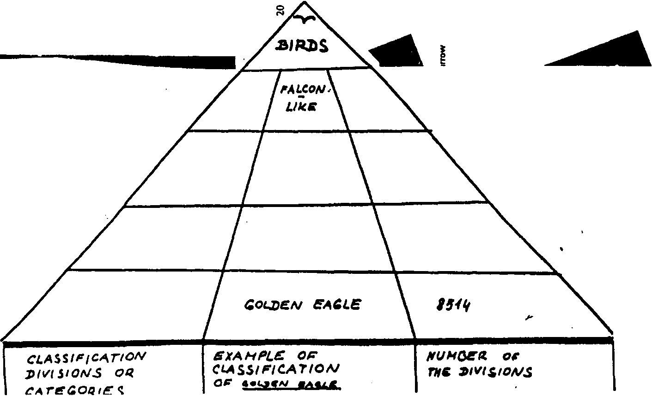

- Using DNA analyses for classification. Watch the video and complete the sentences below

- Using modern technologies, namely the _____________________ (3 words) replaced classifying ferns based on morphological features.
- Compared to classifying by morphological features, the relationships of different species can be determined more precisely by observing the pattern of DNA _____________.
- DNA analyses help us understand better the _____________ history of plants and animals.
- In order to reflect this ____________ understanding of how organisms relate to one another, the scientists have had to change the _______________ classification.
- Tmesipteris fork ferns, which are now regarded as ferns, used to be classified as _____________________ (2 words).

- What are the benefits of being able to classify organisms according to their DNA rather than morphological features? Discuss in pairs.
- Look at the sentences taken from this lesson and form questions to the underlined parts.

- DNA analyses help us understand better the evolutionary history of plants and animals.
- DNA analyses help us understand better the evolutionary history of plants and animals.
- DNA analyses help us understand better the evolutionary history of plants and animals.
- DNA analyses help us understand better the evolutionary history of plants and animals.
- DNA analyses help us understand better the evolutionary history of plants and animals.
- Everyone agrees upon the characteristics that a bird possesses.
- Everyone agrees upon the characteristics that a bird possesses.
- Everyone agrees upon the characteristics that a bird possesses.
- The name of the 215 families of birds end in “-idae”.

Sources:
British National Corpus
http://www.askwomennet.com/different-types-of-personality.html
De Chazal, E. and S. McCarter (2012) Oxford EAP, OUP
http://www.bbc.co.uk/radio4/science/homeplanet_20030715.shtml
Jordan, Robert (1980) Academic Writing Course Longman
http://sciencelearn.org.nz

