# MICROFLUIDICS & LAB ON A CHIP

**location:** ~~INBIT, Kamenice 34, ground floor, room 023~~ – MS Teams meeting

**lecturer:** Mgr. David Kovář, Ph.D. ([kovard@mail.muni.cz](mailto:kovard@mail.muni.cz))

Mgr. Michal Vašina ([437248@muni.cz](mailto:UCO@mail.muni.cz))

## I. WORKFLOW

* on-demand droplet generation and fusion
* droplet microfluidics and microscopy
* capillary microfluidic platform

## II. MOTIVATION

Microfluidics can be defined as the science and technology manipulating and analyzing fluid flow in sub-millimeter dimensions. It is becoming important technology for many emerging applications and disciplines, especially in the fields of chemistry, biology and medicine. Concrete application examples are biosensor devices for molecular diagnostics, polymerase chain reaction chips, high-throughput screening, controlled drug delivery systems, drug discovery methods, forensic analysis instruments, and so on (1).

**III. THEORETICAL BACKGROUND**

### III-A1. On-demand droplet generation

A nice technique for droplet generation, when multiple distinct samples are necessary, is the on-demand generation using the commercial microfluidic device, Mitos Dropix from Dolomite Microfluidics, UK. The scheme of the droplet generation principle is shown in Figure 1.



Figure 1: Droplet on demand – a constant suction driven flow results in the creation of a segmented flow. The timing of the ‘up’ or ‘down’ position of the sampling hook dictates the droplet volume and spacing volume respectively. The transverse position of the hook dictates the selection of the sampling well. (Source: <https://www.dolomite-microfluidics.com/wp-content/uploads/mitos-dropix-droplet-splitting-application-note-1.pdf>)

### III-A2. Droplet merging

The setup of a capillary microfluidic platform with the application of negative pressure enables the creation of concentration gradients using droplet merging. To achieve this, the initial droplets should be generated in a low flow rate and there should be droplet pairs, consisting of one smaller droplet in the front and one larger droplet right behind it (in between both of them, there is a short oil plug). After the droplet generation, the flow of droplets is stopped and subsequently accelerated to around 20x higher flow rate than the initial one. This results in paired droplets getting closer to each other, due to an imbalance of oil leaking through the corner gutters of both droplets, which behave as leaky pistons [2]. This process is visualized both in Figure 2 and in an animation TextBook_2020_SI-01.mp4.

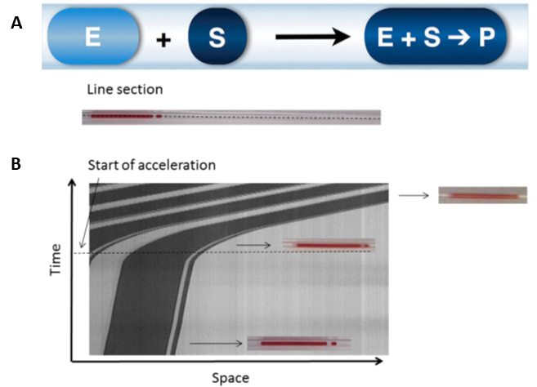

Figure 2: Droplet merging. A: Merging scheme for a pair of droplets inside a tubing. A large compartment loaded with an enzyme (E) will catch up with a smaller compartment loaded with substrate (S) placed immediately in front of it. Merging triggers the enzymatic reaction leading to the formation of product P. B: Visual representation of droplet merging (catch-up). The x-axis represents space while the y-axis represents time. Adapted from Gielen et al [2].

## III-B. On-chip droplet formation

Formation of water in oil droplets in microfluidic chip has several benefits when compared to standard technology. Amongst such benefits belong low volume of reagents consumed, chip modularity, low cost and simple fabrication. When all pros combined properly one may encounter drop costs of screening million fold [3,4].

In this practice students will put hands on microfluidic chip technology. Prepared chips are to be used for water in oil droplet generation [5]. An example will follow with encapsulation of single E.coli BL21 DE3 cells to droplets. Finally, there will be observation of single cells in emulsions generated.

## III-C. Capillary microfluidic platform

Technical setup (Figure 2) can be described separately as an optical, mechanical and microfluidic part. A precise calibration is one of the primary processes. First, the concentration of HCl must be determined by acid-base titration with potentiometric detection. Once we know the concentration of the acid, the titration of the working buffer must be performed to know the dependency between the proton concentration (pH respectively) and the fluorescence intensity of the probe. Working buffers with three different pH values are used for the “on-platform” calibration of the proton-sensitive assay – the buffer with initial pH ≈8.00 and several mixtures adjusted by titration with HCl to desired pH, respectively. The fluorescence intensity of the pH-sensitive probe must be measured at all check-points (loops) and for all ratios of reaction mixture and acid. Please note, that the fluorescent dye is temperature sensitive and therefore the calibration must be measured for all the combinations.

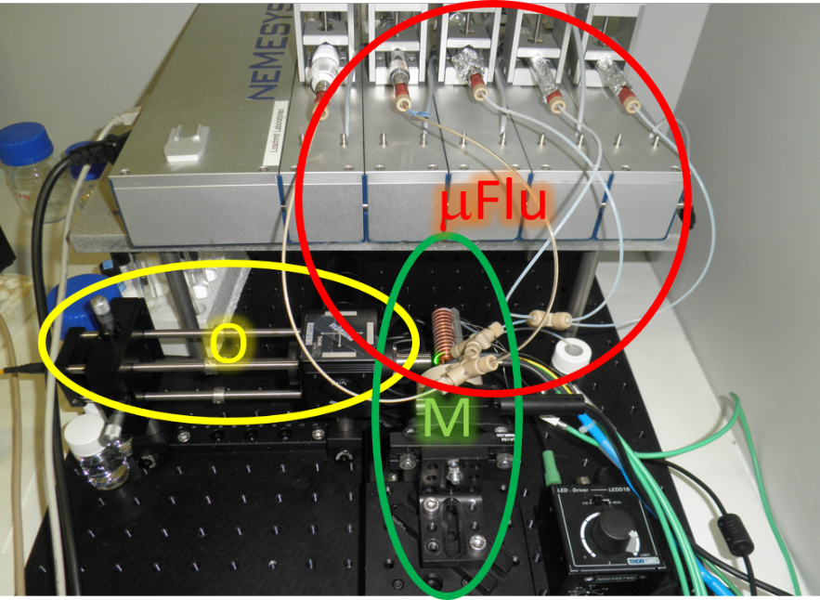

Figure 3: A photography of the capillary-based microfluidic platform with highlighted optical (O), mechanical (M) and microfluidic (mFlu) parts.

## IV-A. PROTOCOL (On-demand droplet generation and fusion)

1. Prepare 1mL of 50 μM HPTS solution out of 1 mM HPTS stock solution. Afterward, prepare 500 μL of 2 mM HCl solution out of 100 mM stock solution, diluting it with the just prepared 50 μM HPTS solution.
2. Put 20 μL of both 50 μM HPTS solution and 2 mM HCl solution into separate wells of the rack. Markdown the numbers of the wells.
3. Start the microfluidic pump at 10 μL/min in a withdraw mode.
4. Write the sequence of droplets for droplet merging into the Dropix software according to your homework.
5. Start the droplet generation on Dropix.
6. When finished wait a while, until you visually see that the generated droplets in the tubing. Then stop the pump.
7. Start the detection on the LabView detection window.
8. Change the flow rate of the microfluidic pump to 200 μL/min and start it.
9. Observe how the droplets merge – both with the naked eye and on the detector.

## IV-B. PROTOCOL (On-chip droplet formation)

**Solutions and reagents:**

* HFE-7500 or FC-40 oil
* PicoSurf-2 surfactant
* Trichloro(1H,1H,2H,2H-perfluorooctyl)silane
* 1.5M NaCl
* deionized H2O
* *E.coli* BL21 DE3 (calculate the concentration!)
* Percoll ®
* Isopropanol

**Equipment:**

* Chemyx Fusion 200 syringe pumps or precise neMesys syringe pumps
* gas-tight syringes (various volumes)
* PTFE tubing
* Microfluidic chips – various designs
* glass slide
* Inverted microscope

1. load syringes with HFE-7500 oil and 150 mM NaCl, 25 % (v/v) Percoll and properly diluted cells
2. attach PTFE tubing to the syringe and remove any bubbles
3. put syringes into the syringe pumps, lock tight and set proper syringe diameter
4. connect syringe via tubing into the chip
5. set liquid flow – 300 µL.h-1 for oil phase and 30 µL.h-1 for the aqueous phase
6. observe droplet formation under microscope at various magnification
7. verify cell occupation in emulsions on inverted microscope

## IV-C. PROTOCOL (Enzyme kinetic on the microfluidic platform - calibration)

**Solutions and reagents:**

* FC-40 oil
* 1.0M NaCl
* 50 mM Tricine
* 50 mM BisTrisPropane
* deionized H2O

**Equipment:**

* neMesys precise pump
* gas-tight syringes (various volumes)
* PTFE tubing
* Microfluidic platform
* DAD spectrophotometer

1. Prepare 5 mL of 50 μM HPTS solution (use the 1 mM HPTS stock and UB1 buffer) and 0.5 mL of 2 mM HCl solution (use 100 mM stock solution and DW)
2. Fill the gastight syringes (HPTS, HCl, FC-40) and mount them into pump
3. Start the pumps at flowrates (Oil 25 mL.min-1 / HPTS 10 mL.min-1) – generating plugs
4. Increase the flowrate of HCl for increment of 0.05 mL.min-1 till 0.5 mL.min-1
5. Collect data and plot the calibration curves

## V. HOMEWORK

1. Calculate the volumes to be pipetted to prepare both reaction solutions according to the protocol IV-A.1 and IV-C.1.
2. (Related to IV-A.) You have an oil reservoir and two starting solutions: 0 mM and 2 mM HCl solution. Your task is to think up a sequence of droplets and the exact volumes of aqueous and oil phase to generate droplets by the above-stated mechanism of droplet fusion (Figure 2, first droplet is smaller, the second droplet is larger). The merged droplets should have the final concentration of HCl in the range of 0.2 mM – 1.8 mM HCl. You should consider the following requirements:
   * The volumes of droplets should be in nanoliters (only whole numbers).
   * The volume of the smaller droplet should be constant – calculate it as a minimum sphere-droplet to fit the tubing with inner diameter d = 0.4 mm.
   * The oil space between the smaller and larger droplet is of the same volume as the smaller droplet.
   * The oil space between the larger droplet and a next smaller droplet should be at least 400 nL.
   * You should think up at least 5 distinct final concentration of HCl, including the mandatory 0.2mM and 1.8 mM.

An example of such a sequence (random volumes) is in the following table

|  |  |  |  |  |  |  |  |  |
| --- | --- | --- | --- | --- | --- | --- | --- | --- |
| **Order** | **1** | **2** | **3** | **4** | **5** | **6** | **7** | **8** |
| **Sample** | 0 mM | Oil | 2mM | Oil | 0 mM | Oil | 2 mM | Oil |
| **Volume (nL)** | 100 | 10 | 500 | 45 | 324 | 900 | 20 | 70 |

1. (Related to IV-B.) Estimate volume in pico-/femto- litres for monodisperse droplet formed at channel having dimensions 5, 10 and 20 µm, respectively (assume square cross-section forms spherical droplets of the same diameter).
2. (Related to IV-C.) For calculated droplet volumes, estimate approximate cell density in X∙10Y per mL, to put single cell per droplet. There is approximately 1∙108 cells in medium with OD600=0.5. Cultivated cells have OD600=4.8. In case that grown culture has insufficient density, calculate the factor for thickening cell media to sufficient level. Account for 10 % pipetting error.

## VI. LITERATURE

1. Dittrich, P. S., and Manz, A. (2006) Lab-on-a-chip: microfluidics in drug discovery., Nat. Rev. Drug Discov. 5, 210–218.
2. F. Gielen et al., “A fully unsupervised compartment-on-demand platform for precise nanoliter assays of time-dependent steady-state enzyme kinetics and inhibition,” Anal. Chem., vol. 85, no. 9, pp. 4761–4769, 2013.
3. Mazutis, L., Gilbert, J., Ung, W. L., Weitz, D. a, Griffiths, A. D., and Heyman, J. a. (2013) Single-cell analysis and sorting using droplet-based microfluidics., Nat. Protoc. 8, 870–91.
4. Yin, H., and Marshall, D. (2012) Microfluidics for single cell analysis., Curr. Opin. Biotechnol. 23, 110–9.
5. Teh, S.-Y., Lin, R., Hung, L.-H., and Lee, A. P. (2008) Droplet microfluidics., Lab Chip, The Royal Society of Chemistry 8, 198–220.