NAME___________________SURNAME_____________ ID CODE______
Following the guidelines showed during the lectures, provide a description of the taphonomic alterations.

1) Describe as best as you can the alterations on this bone (write at least ten lines in the table below)
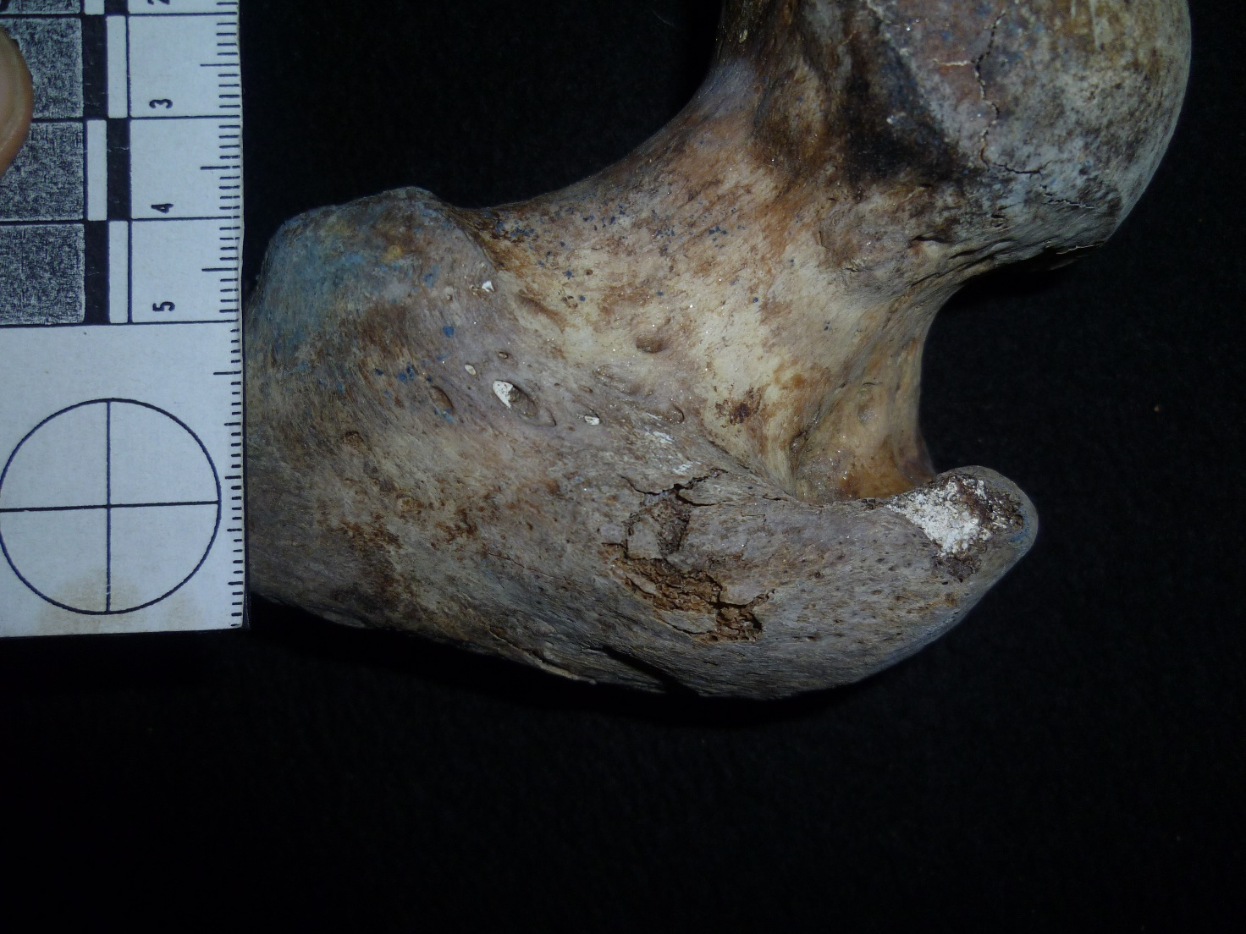

2) Describe as best as you can the taphonomy of the below fragment ((write at least ten lines in the table below)
