12. Urban development

1. Warm up: Did you grow up in the country or in a city / town? Did you enjoy or miss any things there?

2. Comparing: Study the tables with the examples of describing similarities and differences.
DISCRIBING SIMILARITIES
is similar to
A is comparable to B because …….. A resembles B in ………….
is as …………… as

Both A and B have certain advantages. Firstly, A is …… secondly,…… finally…..

DESCRIBING DIFFERENCES
much more ……... than
A is less ………….. than B.
not as ………………. as

Unlike
In contrast to A , B is more ………………. A differs from B in being ……….
In comparison to

A is ………………….., while / whereas B is …………………...

Work in pairs. Describe the differences in the three pictures A, B, and C. Compare the ways of life in these three places. Talk for about the way of life in the place, make comparisons with the other places. If you stop, your partner can go on. The winner is the one who finishes in your pair.

A 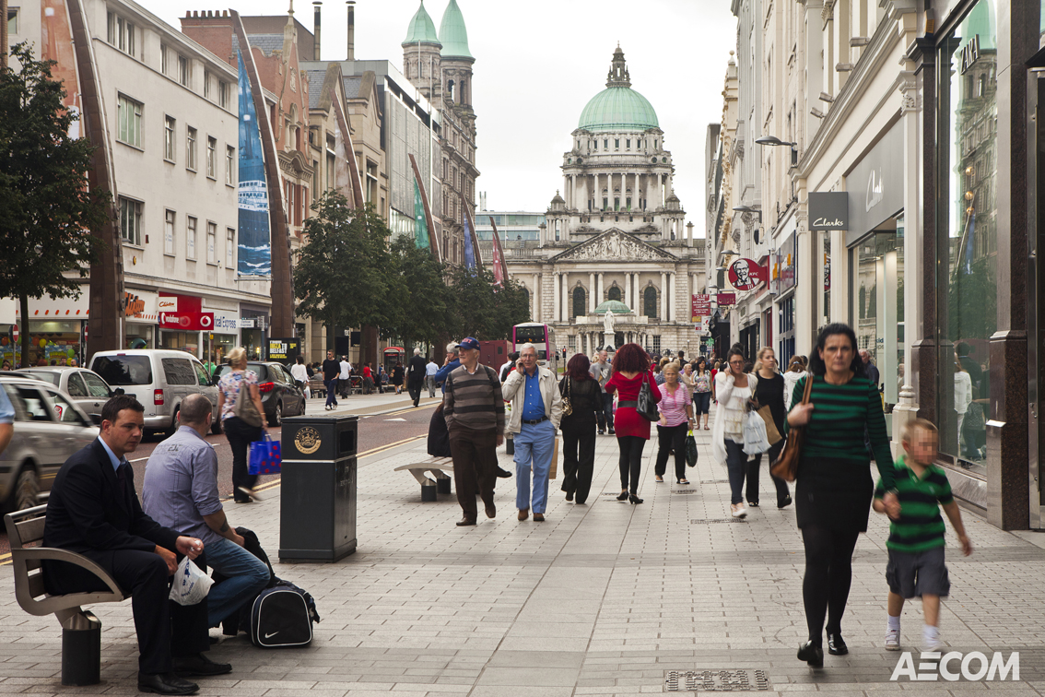 B 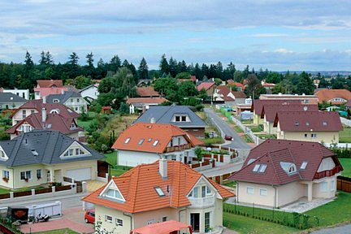

C 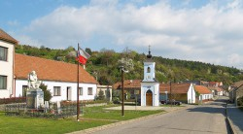
If you decide to live in a new house/flat, in what place would you like to buy your home? Why?

3. Read the text: The bid-rent theory or land value model

Introduction: The industrial progress in the 20th century also brought about the growth and development of urban settlements. Geographers have tried to map these processes. As a result of studying the structure of cities and conditions of growth, different models and theories have been developed. One of them is the so-called bid-rent theory which characterizes land use in cities from the point of view of economic geography.

Vocabulary
access- přístup
retail – maloobchod
subsidiary – vedlejší
parade – promenáda
estate – complex budov
alter – změnit
interchange - křižovatka

a) Put the connectors in right places.
because similarly therefore due to because of

The most expensive or ‘prime’ sites in most cities are in CBD, mainly 1………….. its accessibility and the shortage of space there. Shops, especially department stores, conduct their business using a relatively small amount of ground space and 2 ………… their high rate of sales and turnover they can bid a high price for the land, for which thy try to compensate by building upwards and by using the land intensively. Competing with retailers are offices which also rely upon good transport systems and, traditionally, proximity to other commercial buildings.

Away from the CBD, land rapidly becomes less attractive for commercial activities. Industry, partly 3………… it takes up more space and uses it less intensively, bids for land that is less valuable than that prized by shops and offices. Residential land is found further out from the city centre where the land values have decreased due to less competition. Individual householders cannot afford to pay the same rents as shopkeepers and industrialists.

One basis of this model is ‘the more accessible the site, the higher its land value’. Rents will 4……… be greater along main routes leading out of the city and along outer ring roads. Where two of these routes cross, there may be a secondary or subsidiary land value peak. Here the land use is likely to be a small suburban shopping parade or a small industrial estate. The ‘retail revolution’ of the 1980s, which led to the development of large edge-of-the-city shopping complexes, has altered this pattern. 5…………. large industrial estates and science parks have been located near to motorway interchanges.

b) Find these expressions in the 1st paragraph of the passage above, in the given order :
- being easy to get to or to enter -
- the amount of business done in a given time -
- to counterbalance; make up for a disadvantage -
- shops that sell goods in small quantities directly to consumers -

c) Use the words in capital letters to complete the sentences. Change the form of words.
1. Most prime sites are in the centre, mainly because of its _____________ . ACCESS
2. ___________ land is found further out from the city centre. RESIDE
3. Central Business District has a ______________ of space. SHORT
4. Further out from the centre the land values have decreased due to less ________. COMPETE
5. The ‘retail revolution’ led to the ___________ of large edge-of-the-city shopping complexes. DEVELOP

4. What do you think is a Dead Mall? Watch the report and complete the sentences.
The rise and fall of the American shopping mall. https://www.youtube.com/watch?v=I7y1FoFqtiw 0.30 – 5.30

Ferris wheel = ruské kolo

1. Teenagers are ……………………………… in.
2. The malls are in the process of ………………………. re-purposed.
3. They are …………………… bowling alleys, storage facilities, and so on.
4. The malls have …………………. to fail. In this case it’s a total re-do where we …………………………… for office uses, medical uses and retail mix within a single structure.
5. Malls are changing into so-called life-style centres, and they ………………………… be unique.
6. What’s going to draw people to shopping centres? It’s no longer the stores but ……………

5. Which grammar tenses are used for speaking about
- changes
- current trends?

Give an example of changes or trends that you have noticed in your home place.
- Has anything been re-purposed? How?
- Do you think any facilities need re-purposing? Why?
- Are there any new buildings / office parks / warehouses / sports places? Are you happy about these changes?

6. Present continuous passive. Change the sentences into the passive form.
Example: The rivals are congratulating to the hockey team.
The hockey team is being congratulated by the rivals.

1. They are building a new ring road around the city.

2. They are re-designing supermarkets regularly to make shoppers buy more things.

3. Somebody is using the laptop at the moment.

4. There’s somebody behind us, I think he’s following us.

5. (In a shop) ‘Can I help you?’ ‘No, thank you, somebody is serving me.’

