**SCIENTIFIC METHOD**

**1. Explain your opinion on the questions below:**

*“It is a capital mistake to theorize before one has data. Insensibly one begins to twist the facts to suit the theories, instead of the theories to suit the facts. ”*

*Sherlock Holmes*

* How do you understand the advice form Sherlock Holmes? Explain / paraphrase it in your own words.
* How can we get data?
* Do scientists need to use experiments? If so, for what purpose? Have you done an experiment?
* Do geographers need measurements? Why/ Why not?

**2. Describing an experiment**

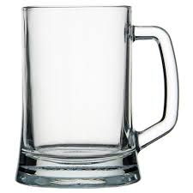 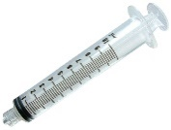 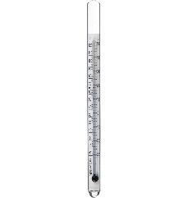 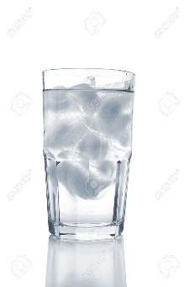 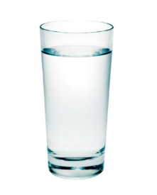

* What property/ies could you measure in an experiment using this equipment?

**3. Order the instructions correctly:**

1. Place small amounts of cold water into the warm water with the syringe.
2. Place enough cold water to drop the temperature of the water a degree or two each time some cold water is added.
3. Take a glass cup and fill it up a third of the way with warm water that is around 30℃.
4. Do this until droplets start to form on the outside of the cup.
5. Place the thermometer into the warm water.

**4. Find an adverb in sentence D above.** (adverb answers the question HOW? or WHEN? etc.)

**Supply a suitable adverb to some of the other sentences as well. Then read the instructions for the procedure to a partner to check if it makes sense to him/her.**

**5. Discuss what information about the experiment you can say under each of these headings.**

*Result Purpose Steps Conclusion Materials*

**6. Use the words from task 5 as the headings for the following parts of the text:**

1. …………………

To identify the dewpoint temperature.

2. …………………

Glass cup, ice water, warm water, any type of syringe, glass thermometer.

3. …………………

First, take a glass cup and fill it up a third of the way with warm water that is around 30℃.

Then place the thermometer into the warm water. Have another cup with you, filled with ice water.

Gradually place small amounts of cold water into the warm water with the syringe. Place enough cold water to drop the temperature of the water a degree or two each time some cold water is added. Ice cubes may need to be added if the dewpoint is near the freezing point.

Do this until condensation starts to form on the outside of the cup.

4. …………………

When droplets on the outside of the cup starts to develop then the dewpoint temperature has been reached.

5. …………………

Dewpoint is the temperature that air needs to be cooled in order for condensation to occur. If the cup temperature is below the dewpoint temperature, moisture will condense out of the air since the maximum amount of moisture that can be in the air decreases as temperature decreases.

This means that the dewpoint gives a meteorologist an assessment of the amount of moisture in the air. As dewpoint increases, the amount of moisture in the air increases.

**7. Describing an instrument**

**Do you know what these instruments are used for? Explain their purpose.**

ANEMOMETER HELIOGRAPH THERMOMETER

RAIN GAUGE BAROGRAPH

SLING PSYCHROMETER HYGROMETER OMBROMETER

**B) Read and complete the description of the psychrometer.**

It is used to determine ……………………………… and ……………………………. .

It consists of two ………………………….. .

One has a dry bulb and the other has a ……………………………. bulb – there is a ‘sock’ at the end.

Take a beaker of water and ……………………………. the sock into the water.

Next you start spinning the two thermometers around.

Spinning ………………….……….. the wind and the wind causes ………..…………………. to happen at a faster rate. Due to evaporation, the wet bulb is ……..…………………… .

Five minutes later you can read the temperatures. There is 7℃ …………….……………. .

Take this number and in the reference tables you can find the values of relative humidity and ……………………………….. .

**C) Listen and check:** Using a Sling Psychrometer0 - 2.49<https://www.youtube.com/watch?v=QbcaCxuA1LI>

**8. Presenting a measuring instrument / an experiment**

Choose one of the two topics below. Prepare a brief speech in which you will teach the class how to use an instrument or how to conduct an experiment. Show a picture to make your information clear.

* Choose any instrument you want. Prepare clear and detailed information about it. Report to the class about the instrument and teach the others how to use it.
* Think about an experiment and prepare to describe it to the class, stating its purpose, materials, steps, results and conclusions.

**9. Stages in the scientific method**

**A) Complete the collocations for describing the stages in the scientific method using the words and phrases in the box.**

|  |
| --- |
| a hypothesis an experiment (2x) conclusion data(3x) the question |

analyse ___ design ____

collect ___ draw ____

conduct (or run) ____ form ____

define ____ interpret ____

**B) Number the stages from 1-8 in the order you would normally do them.**

**C) Read the extract below and check your answers.**

The scientific method is a process in which experimental observations are used to answer questions. Scientists use the scientific method to search for relationships between items. That is, experiments are designed so that one variable is changed and the effects of the change observed. While the exact methodologies used vary from field to field, the overall process is the same. First, the scientist must define the question – what exactly they are trying to find out. Next comes the formation of a hypothesis, which is an idea or explanation for a situation based on what is currently known. The next stage of the method is the design of an experiment which will allow this hypothesis to be tested. Usually a primary run of the experiment is conducted, and any changes to the experimental set-up made. In each experimental run, data collection takes place, followed by data analysis. Finally, the data is interpreted and from this, the scientist is able to draw conclusions.

**Sources:**

[http://www.theweatherprediction.com/experiment](http://www.theweatherprediction.com/experiments/)

Armer, Tamzen (2011) ***Cambridge English for Scientists*,** CUP (adapted)

<https://web.archive.org/web/20060526174713/http://pasadena.wr.usgs.gov/office/ganderson/es10/lectures/lecture01/lecture01.html>