6 THE ATMOSPHERE

**Warm-up:**

* Name three functions of the atmosphere for sustaining life on the Earth.
* Give three names of gases in the atmosphere?

**1. Composition of the atmosphere**

The atmosphere is composed of a number of different gases. Supply their names and the percentages for the main components.

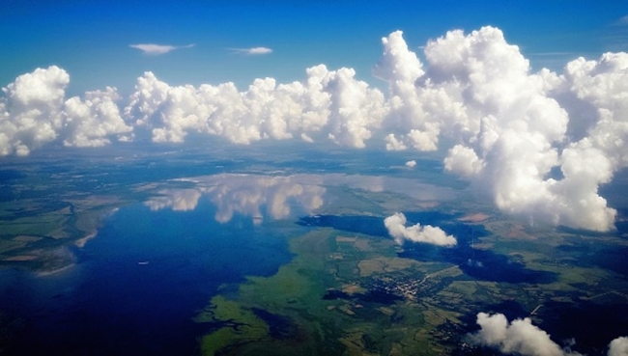

|  |  |
| --- | --- |
| *Symbol / formula* | *name* |
| O3 |  |
| CO2 |  |
| CH4 |  |
| O |  |
| N |  |
| H |  |
| He |  |
| Ar |  |

# Match these characteristics with the different components of the air given in the table.

# produced by photosynthesis; reduced by deforestation

# destroyed by chlorofluorocarbons (CFCs)

# pollutant coming from farming industry

# increased by burning fossil fuels

# the most abundant gas in the atmosphere, needed for plant growth

# these are present in trace amounts

# these gases play the main role in absorbing the heat

# present in the water vapour

# 2. Functions of the atmosphere. Number the sentences in order 1-8 to get a connected paragraph.

1. In addition, the atmosphere acts like a shield around Earth.
2. It is the special combination of gases in the atmosphere that allows life on Earth to exist.
3. Second, the nitrogen in the air is necessary for the plants that are grown for food.
4. Humans depend on the atmosphere for many reasons.
5. First, our bodies need the oxygen in the air to keep us alive.
6. Finally, some gases help control temperatures on Earth.
7. It protects us from objects that fall from space, such as meteors.
8. The ozone in the atmosphere also provides protection by blocking harmful rays from the sun, which would cause burns to living organisms.

# In the text above, find:

# Opening and closing sentence

# Some examples of ‘transitions’

**3. Look at the picture showing the structure of the atmosphere. Give your description.**

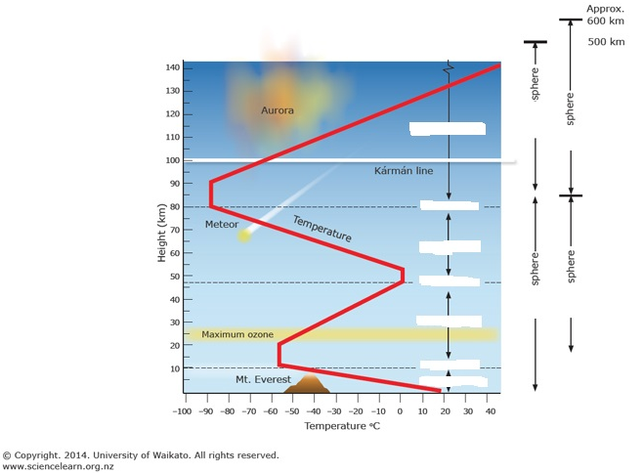

**a) Watch an extract from a lecture (open online course at the University of California) and take notes about each part of the picture.** 49.40 **-**52.52

<http://ocw.uci.edu/lectures/ess_5_lec_02_the_atmosphere_composition_and_structure_of_the_atmosphere.html>

**b) Watch another part and note down the main ideas about the other ways of dividing the atmosphere** 55.17 -59.17

**4. Vocabulary for DESCRIBING A LINE GRAPH: Suggest verbs for these directions**:

**Synonyms – complete the synonyms using the given letters**

GO UP I _ _ _ _ _ _ _ R _ _ _ G _ _ _

GO DOWN D _ _ _ _ _ _ _ F _ _ _ D _ _ _ D _ _ _ _ _ _

BE ON THE SAME LEVEL REMAIN C _ _ _ _ _ _ _ / REMAIN S _ _ _ _ _

BE CHANGEABLE F _ _ _ _ _ _ _ _

BE EXTREME REACH M _ _ _ _ _ _ / M _ _ _ _ _ _ P _ _ _

**The expressions can be use with such words as: *sharp/sharply, rapid/rapidly, slow/slowly, steady/steadily***

**5. Describe the line graph showing the temperature changes with the height in the atmosphere (in Task 3).**

**6. Complete the text with nouns for *names of layers* and verbs or nouns for the *variations of temperature*.**

The atmosphere can be divided vertically into four layers based on temperature. The bottom layer, where temperature 1________________ with an increase in altitude, is the 2________________. It is in this layer that essentially all important weather phenomena occur. The thickness of the troposphere is not the same everywhere. It varies with latitude and the season. On average, the temperature 3________________ continues to a height of about 12 kilometers, where the outer boundary of the troposphere, called the 4________________ , is located.

Beyond the tropopause is the stratosphere. In the stratosphere, the temperature 5________________ constant to a height of about 20 kilometers. It then begins a gradual 6________________ in temperature that continues until the 7________________, at a height of nearly 50 kilometers above Earth’s surface. Temperatures increase in the stratosphere because the atmosphere’s ozone is concentrated here. Ozone absorbs ultraviolet radiation from the sun and, as a result, the stratosphere is heated.

In the third layer, the 8________________, temperatures again 9________________ with height until the mesopause. The mesopause is more than 80 kilometers above the surface and the temperatures approach −90°C. The fourth layer extends outward from the mesopause and has no well-defined upper limit. It is the 10________________, a layer that contains only a tiny fraction of the atmosphere’s mass. Temperatures increase in the thermosphere because oxygen and nitrogen absorb short-wave, high-energy solar radiation.

**7. Pair work** <https://www.youtube.com/watch?v=Db0lzoYxjf0&list=TLPQMDIxMDIwMjEluKyKjDXbrA&index=1>

**Student A watches a sequence without sound and describes the action to the B classmate who is not watching.**

**Student B then tries to explain:**

* why there was that result
* what implications this phenomenon has for the environment

**8. Look at this picture. Think about what the percentage represents and suggest the missing numbers (for fresh snow, thick and thin clouds, water). Use the percentages below.**

**25-50% 70-80% 3-5% 80-85%**

50 – 80%

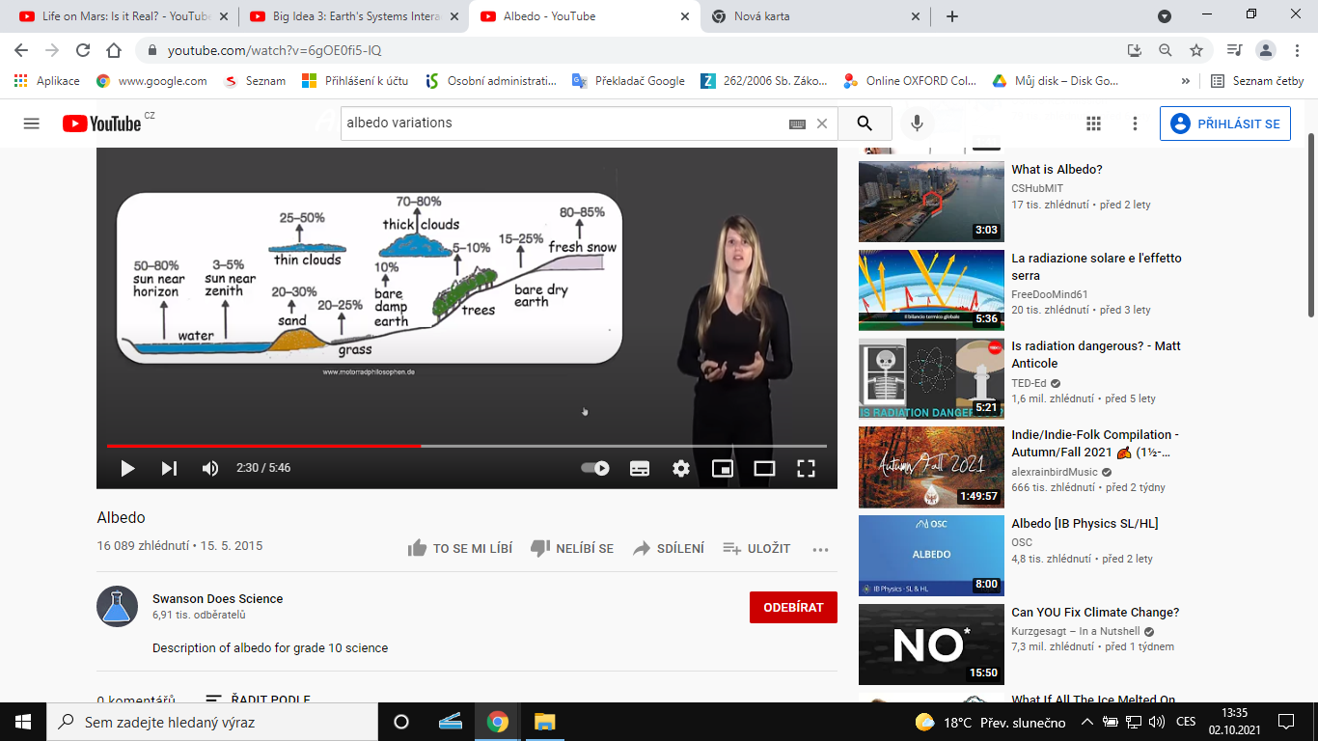

**What happens when the character of the surface changes, for instance, due to human activity? What are the consequences? Give an example.**