A Computational Study of Pb(II) Complexes with Tetraazamacrocyclic Ligands
Viktorie REICHOVÁ¹⁾, Přemysl LUBAL¹⁾

¹⁾ Department of Chemistry, Faculty of Science, Masaryk University, Kamenice 5, CZ-625 00 BRNO, Czech Republic, e-mail: reichova.viki@gmail.com

^{203/212}Pb(II) macrocyclic complexes have potential in cancer theranostics as cytotoxic α emitters [1,2]. In order to utilize these complexes in vivo and for any other applications, their behavior in various conditions must be understood. This work first experimentally examines the thermodynamic and kinetic properties of a series of Pb(II) complexes with tetraazamacrocyclic-based ligands. The rates of formation and dissociation of these complexes in varying conditions were monitored using UV-Vis spectroscopy. The most thermodynamically stable complexes with Pb(II) are formed with a ligand with four acetate-based pendant arms, while the most thermodynamically labile complexes have a larger or smaller cavity or phospinic-acid based pendant arms. The complexes with the fastest rates of formation are those with phosphinic-acid based pendant arms or a smaller cavity. The mechanisms of formation and dissociation of these complexes are also proposed.
This work further examines the investigated complexes using computational chemistry. DFT calculations using the PBE0 functional with the Def2TZVP basis set were used to optimize the geometries of the complexes and calculate parameters such as bond length. The AIMAll program was also used to calculate the delocalization indexes of the optimized complexes. These values were then correlated with experimental results, such as stability constants and rates of formation/dissociation, and certain trends were observed. Complexes with longer Pb-N bond lengths and lower complex energies have faster rates of formation, while complexes with longer Pb-O bond lengths and a higher delocalization index have enhanced kinetic inertness, a larger stability constant, and a longer complex half-life. This information can be used for the rational design of ligands having desired properties for the specific application of interest.

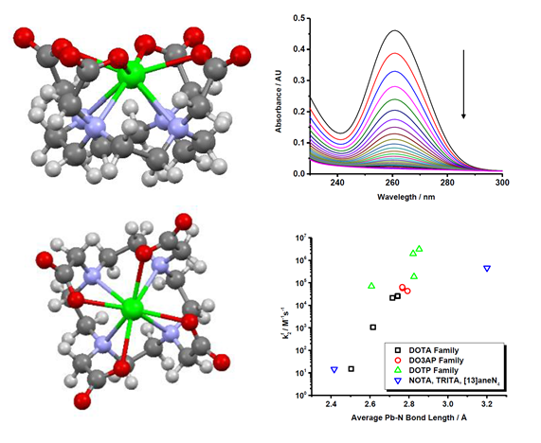
Figure 1 – a) calculated structure of the Pb(II)-DOTA complex, b) dissociation of the Pb(II)-DOTA complex in 1M HClO₄, and c) graph showing the correlation between the formation rate constant k²_{f} and the average Pb-N bond length for all investigated complexes.

Acknowledgments:
This study was supported by the Ministry of Education of the Czech Republic and Masaryk University (MUNI/A/1359/2018).

References:
[1] C.S. Cutler, H.M Hennkens, N. Sisay, S. Huclier-Markai, S.S. Jurisson, Chem. Rev., 2013, 113(2), 858- 883.
[2] C.G. Pipin, T.J. McMurry, M.W. Brechbiel, M. McDonald, R. Lambrecht, D. Milenic, M. Roselli, D. Colcher, O.A. Gansow, Inorg. Chim. Acta 1995, 239(1-2), 43-51.

