HYBRID ACID CATALYSTS PREPARED VIA TRIMETHYLSILYLATION OF ALUMINOSILICATES SYNTHESIZED BY NON-HYDROLYTIC SOL-GEL

Lucie Leonova1, Petr Sazama2, Jana Pastvova2, Jiri Pinkas1, Ales Styskalik1

1 Masaryk University, Department of Chemistry, Brno, Czech Republic, (corresponding author: [styskalik@chemi.muni.cz](mailto:styskalik@chemi.muni.cz))

2J. Heyrovsky Institute of Physical Chemistry, Czech Academy of Sciences, Prague, Czech Republic

Hybrid materials based on aluminosilicates are extensively studied for their enhanced catalytic performance. Organic groups can change acidity, hydrothermal stability, and porosity. First, we have shown, that non-hydrolytic sol-gel (NHSG) provides highly homogeneous and porous aluminosilicate materials exhibiting superior activity and long-term stability in ethanol dehydration [1]. Second, the ethylene selectivity was improved by one‑pot incorporation of organic groups [2]. Interestingly, this approach did not display the direct influence of hydrophobicity on alcohol dehydration in contrary to other reports [3].

In this study, the NHSG-prepared aluminosilicate catalysts (fully inorganic) were post‑synthetically modified by grafting trimethylsilyl groups onto their surfaces. Trimethylsilyl groups were attached to the surface using trimethylchlorosilane or trimethyl(methoxy)silane. The number of reacted ≡Si−OH moieties and thus the trimethylsilyl groups loading was controlled via a temperature‑vacuum pretreatment of aluminosilicate samples. Trimethylsilyl groups loading was evaluated by 29Si MAS NMR measurements (Figure 1). Structure, porosity, acidity, and hydrophobicity of NHSG‑prepared catalysts were closely followed by MAS NMR studies, N2 physisorption, IR-pyridine analyses, and water adsorption. Moreover, aluminosilicates were tested in a gas-phase fixed-bed catalytic reactor in ethanol dehydration and in a batch reactor in aminolysis of styrene oxide (liquid phase). These tailored NHSG-prepared aluminosilicate catalysts exhibited varying catalytic activity and selectivity in both catalytic reactions depending on trimethylsilyl groups loading in the samples.

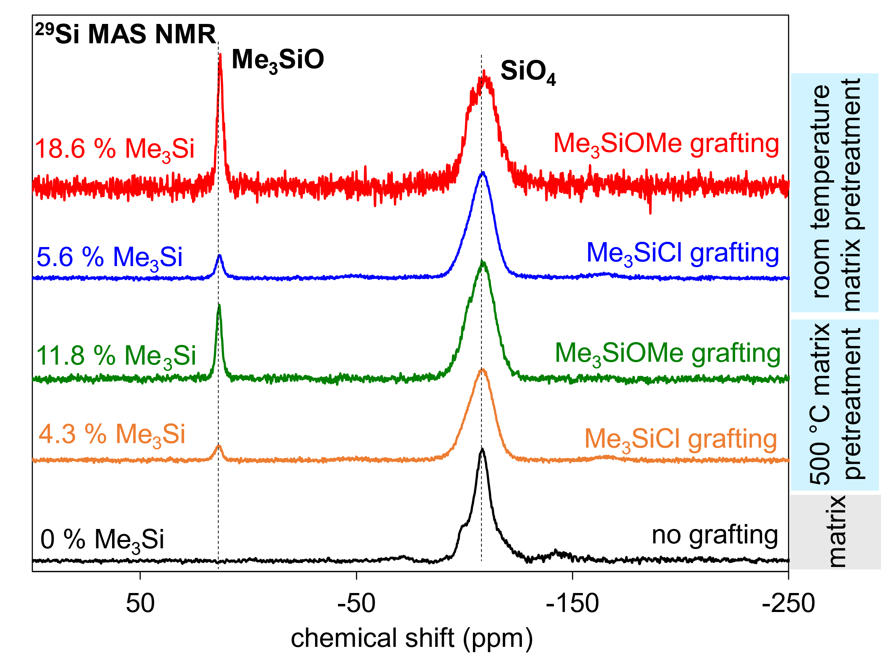

**Figure 1: Comparison of pristine aluminosilicate with post-modified aluminosilicate samples in 29Si MAS NMR**

**References**

[1] A. Styskalik, V. Vykoukal, L. Fusaro, C. Aprile and D. P. Debecker, *Appl. Catal. B Environ.*, 2020, **271**, 118926.

[2] A. Styskalik, I. Kordoghli, C. Poleunis, A. Delcorte, Z. Moravec, L. Simonikova, V. Kanicky, C. Aprile, L. Fusaro and D. P. Debecker, *J. Mater. Chem. A*, 2020, **8**, 23526–23542.

[3] R. van Grieken, J. A. Melero and G. Morales, *J. Mol. Catal. A Chem.*, 2006, **256**, 29–36.

The work has been financially supported by the Czech Science Foundation under the project GJ20-03636Y.