FABRICATION OF FOLIC ACID-BASED SUPRAMOLECULAR METALLOGELS

Mahya ASGHARIAN MARZABAD^{1,2*}, Sami Hietala³, Nonappa⁴, Radek MAREK^{1,2}, Ondřej JURČEK^{1,2,5}

¹ Department of Chemistry, Faculty of Science, Masaryk University, CZ-62500 Brno, Czechia
² CEITEC − Central European Institute of Technology, Masaryk University, CZ-62500 Brno, Czechia
³ Department of Chemistry, University of Helsinki, P.O. Box 55, FI-00014 Helsinki, Finland
⁴ Faculty of Engineering and Natural Sciences, Tampere University, FI-33101 Tampere, Finland
⁵ Department of Natural Drugs, Faculty of Pharmacy, Masaryk University, 61200 Brno, Czechia
* 491183@mail.muni.cz

The challenge of delivering medications to patients efficiently, selectively, and with fewer adverse effects motivates the need to develop novel, better drug delivery technologies. Among these new technologies, supramolecular gels have become a research hotspot.^{[1]} Unlike traditional gels, supramolecular gels are driven by weak and reversible non-covalent interactions. The supramolecular gels frequently display poor mechanical characteristics but can easily undergo various structural transformations upon external stimuli. For this reason, different components, such as macromolecular polymers, metals, or surfactants can be used to improve their mechanical strength.^{[2]}
The folate receptor (FR) which is anchored to the cell surface is overexpressed in a vast majority of cancer tissues, whereas its expression is restricted in healthy tissues and organs. As a result, the high affinity of folic acid (FA) for FRs offers a unique opportunity for precise targeting at cancer cells.^{[3]} FA itself was proven to be an efficient organo-gelator in the DMSO–water system.
In our research, we are introducing the FA metallogels, which are stable supramolecular gels (or often even supergelators) with various properties. Their synthesis, characterization, rheological properties, morphology, and possible structural transformations will be presented. Our discoveries in the field expand the library of biocompatible organic building blocks to prepare strong medicinal gels with an intriguing relevance to cancer research (Figure 1).
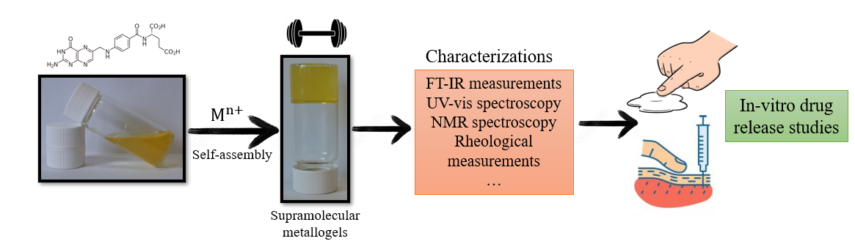
Figure 1. Graphical Abstract

• Acknowledgements: This work has received support from the Grant Agency of Masaryk University (MUNI/A/1412/2021).
______________
References:
[1] Bernard, S.; Tibbitt, M. W. Advanced Drug Delivery Reviews, 2021, 171, 240-256.
[2] Kolari, K.; Bulatov, E.; Tatikonda, R.; Bertula, K.; Kalenius, E.; Nonappa; Haukka, M. Soft Matter, 2020, 16, 2795–2802.
[3] Senapati, S.; Mahanta, A. K.; Kumar, S.; Maiti, P. Signal Transduction and Targeted Therapy 3, 7 2018, 1-19.

