A.

1. Identify cases, variables, values.
2. Identify a type of the variable (categorical (nominal or ordinal)**/**numerical (discrete or continuous)).
3. Identify a type of the distribution (bell shaped (normal)**/**left skewed**/**right skewed**/**two peaks (bimodal)).
4. 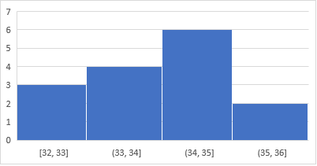Calculate, the median, the mode, and the mean.

|  |  |
| --- | --- |
| Customer | Age |
| 1 | 35 |
| 2 | 34 |
| 3 | 35 |
| 4 | 35 |
| 5 | 34 |
| 6 | 34 |
| 7 | 36 |
| 8 | 32 |
| 9 | 35 |
| 10 | 34 |
| 11 | 36 |
| 12 | 35 |
| 13 | 32 |
| 14 | 35 |
| 15 | 32 |

A.

Variable – numerical, continuous

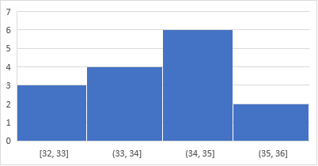Answers:

Values

Cases - customers

**Left skewed distribution**

|  |  |
| --- | --- |
| Customer | Age |
| 1 | 35 |
| 2 | 34 |
| 3 | 35 |
| 4 | 35 |
| 5 | 34 |
| 6 | 34 |
| 7 | 36 |
| 8 | 32 |
| 9 | 35 |
| 10 | 34 |
| 11 | 36 |
| 12 | 35 |
| 13 | 32 |
| 14 | 35 |
| 15 | 32 |

Mode = 35

Median = 35

Mean = 34.26667

B.

1. Identify cases, variables, values.
2. Identify a type of the variable (categorical (nominal or ordinal)**/**numerical (discrete or continuous)).
3. Calculate, the median, the mode, and the mean if applicable.

|  |  |
| --- | --- |
| Immigrant | Country of origin |
| 1 | Spain |
| 2 | China |
| 3 | Ecuador |
| 4 | Israel |
| 5 | Kyrgyzstan |
| 6 | Israel |
| 7 | Spain |
| 8 | Romania |
| 9 | Serbia |
| 10 | Australia |
| 11 | Spain |
| 12 | Chile |
| 13 | Estonia |
| 14 | Serbia |
| 15 | Spain |

B.

Answers:

Variable – categorical, nominal

Values

Cases - immigrants

|  |  |
| --- | --- |
| Immigrant | Country of origin |
| 1 | Spain |
| 2 | China |
| 3 | Ecuador |
| 4 | Israel |
| 5 | Kyrgyzstan |
| 6 | Israel |
| 7 | Spain |
| 8 | Romania |
| 9 | Serbia |
| 10 | Australia |
| 11 | Spain |
| 12 | Chile |
| 13 | Estonia |
| 14 | Serbia |
| 15 | Spain |

Median and mean are not applicable.

Mode = Spain

C.

1. Identify cases, variables, values.

2. Identify a type of the variable (categorical (nominal or ordinal)**/**numerical (discrete or continuous)).

3. Identify a type of the distribution (bell shaped (normal)**/**left skewed**/**right skewed**/**two peaks (bimodal)).

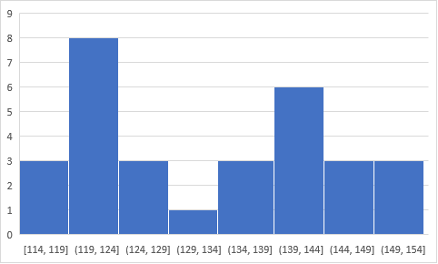

|  |  |
| --- | --- |
| Patients of the cardiac department | Blood pressure (upper number) |
| 1 | 151 |
| 2 | 128 |
| 3 | 139 |
| 4 | 121 |
| 5 | 122 |
| 6 | 124 |
| 7 | 135 |
| 8 | 146 |
| 9 | 143 |
| 10 | 127 |
| 11 | 148 |
| 12 | 144 |
| 13 | 137 |
| 14 | 124 |
| 15 | 142 |
| 16 | 124 |
| 17 | 129 |
| 18 | 130 |
| 19 | 114 |
| 20 | 151 |
| 21 | 145 |
| 22 | 143 |
| 23 | 141 |
| 24 | 120 |
| 25 | 122 |
| 26 | 154 |
| 27 | 121 |
| 28 | 118 |
| 29 | 144 |
| 30 | 117 |

C.

Answers:

Cases - patients

Variable – numerical, continuous

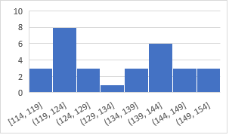

Values

**Two peaks distribution**

**(bimodal)**

|  |  |
| --- | --- |
| Patients of the cardiac department | Blood pressure (upper number) |
| 1 | 151 |
| 2 | 128 |
| 3 | 139 |
| 4 | 121 |
| 5 | 122 |
| 6 | 124 |
| 7 | 135 |
| 8 | 146 |
| 9 | 143 |
| 10 | 127 |
| 11 | 148 |
| 12 | 144 |
| 13 | 137 |
| 14 | 124 |
| 15 | 142 |
| 16 | 124 |
| 17 | 129 |
| 18 | 130 |
| 19 | 114 |
| 20 | 151 |
| 21 | 145 |
| 22 | 143 |
| 23 | 141 |
| 24 | 120 |
| 25 | 122 |
| 26 | 154 |
| 27 | 121 |
| 28 | 118 |
| 29 | 144 |
| 30 | 117 |

D.

1. Identify cases, variables, values.
2. Identify a type of the variable (categorical (nominal or ordinal)**/**numerical (discrete or continuous)).
3. Identify a type of the distribution (bell shaped (normal)**/**left skewed**/**right skewed**/**two peaks (bimodal)).
4. 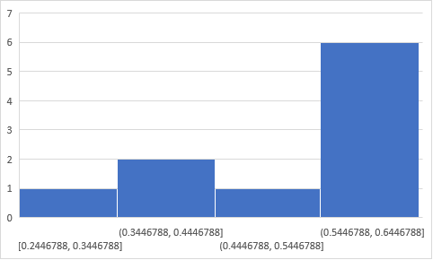Calculate, the median, the mode, and the mean.

|  |  |
| --- | --- |
| Patient | BPA level in urine (μg/L) |
| 1 | 0.4 |
| 2 | 0.6 |
| 3 | 0.5 |
| 4 | 0.3 |
| 5 | 0.2 |
| 6 | 0.6 |
| 7 | 0.6 |
| 8 | 0.4 |
| 9 | 0.6 |
| 10 | 0.5 |

D.

Answers:

Variable – numerical, continuous

|  |  |
| --- | --- |
| Patient | BPA level in urine (μg/L) |
| 1 | 0.4 |
| 2 | 0.6 |
| 3 | 0.5 |
| 4 | 0.3 |
| 5 | 0.2 |
| 6 | 0.6 |
| 7 | 0.6 |
| 8 | 0.4 |
| 9 | 0.6 |
| 10 | 0.5 |

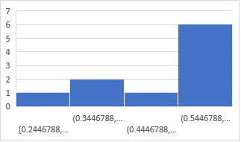

**Left skewed distribution**

Cases - patients

Values

Mode=0.6.

Median = 0.5

Mean = 0.47

E.

1. Identify cases, variables, values.
2. Identify a type of the variable (categorical (nominal or ordinal)**/**numerical (discrete or continuous)).
3. Calculate, the median, the mode, and the mean if applicable.

|  |  |
| --- | --- |
| Customer | Favorite ice-cream flavor |
| 1 | Vanilla |
| 2 | Chocolate |
| 3 | Caramel |
| 4 | Blueberry |
| 5 | Vanilla |
| 6 | Strawberry |
| 7 | Chocolate |
| 8 | Vanilla |
| 9 | Caramel |
| 10 | Raspberry |
| 11 | Chocolate |
| 12 | Strawberry |
| 13 | Vanilla |
| 14 | Mango |
| 15 | Strawberry |

E.

Answers:

Variable – categorical, nominal

Cases - customers

|  |  |
| --- | --- |
| Customer | Favorite ice-cream flavor |
| 1 | Vanilla |
| 2 | Chocolate |
| 3 | Caramel |
| 4 | Blueberry |
| 5 | Vanilla |
| 6 | Strawberry |
| 7 | Chocolate |
| 8 | Vanilla |
| 9 | Caramel |
| 10 | Raspberry |
| 11 | Chocolate |
| 12 | Strawberry |
| 13 | Vanilla |
| 14 | Mango |
| 15 | Strawberry |

Values

Median and mean are not applicable.

Mode = Vanilla

F.

1. Identify cases, variables, values.

2. Identify a type of the variable (categorical (nominal or ordinal)**/**numerical (discrete or continuous)).

3. Identify a type of the distribution (bell shaped (normal)**/**left skewed**/**right skewed**/**two peaks (bimodal)).

|  |  |
| --- | --- |
| Watermelons | Nitrates conc.(mg/g) |
| 1 | 54.1 |
| 2 | 52.9 |
| 3 | 58.2 |
| 4 | 54.1 |
| 5 | 55.3 |
| 6 | 57.6 |
| 7 | 56.2 |
| 8 | 56.4 |
| 9 | 59.4 |
| 10 | 53.8 |
| 11 | 54.4 |
| 12 | 55.7 |
| 13 | 57.1 |
| 14 | 53.3 |
| 15 | 55.9 |
| 16 | 58.3 |
| 17 | 53.3 |
| 18 | 54.9 |
| 19 | 51.5 |
| 20 | 54.1 |
| 21 | 50.5 |
| 22 | 56.5 |
| 23 | 53.8 |
| 24 | 57.8 |
| 25 | 58.2 |
| 26 | 53.9 |
| 27 | 51.5 |
| 28 | 55.5 |
| 29 | 54.5 |
| 30 | 54.7 |

F.

Variable – numerical, continuous

|  |  |
| --- | --- |
| Watermelons | Nitrates conc.(mg/g) |
| 1 | 54.1 |
| 2 | 52.9 |
| 3 | 58.2 |
| 4 | 54.1 |
| 5 | 55.3 |
| 6 | 57.6 |
| 7 | 56.2 |
| 8 | 56.4 |
| 9 | 59.4 |
| 10 | 53.8 |
| 11 | 54.4 |
| 12 | 55.7 |
| 13 | 57.1 |
| 14 | 53.3 |
| 15 | 55.9 |
| 16 | 58.3 |
| 17 | 53.3 |
| 18 | 54.9 |
| 19 | 51.5 |
| 20 | 54.1 |
| 21 | 50.5 |
| 22 | 56.5 |
| 23 | 53.8 |
| 24 | 57.8 |
| 25 | 58.2 |
| 26 | 53.9 |
| 27 | 51.5 |
| 28 | 55.5 |
| 29 | 54.5 |
| 30 | 54.7 |

Answers:

Cases - watermelons

**Bell shaped distribution**

**(normal)**

Values