Problem-based case scenario
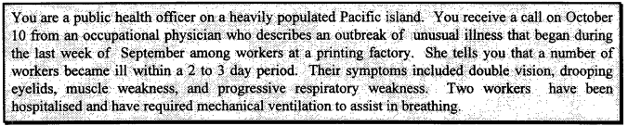

- What would you do first?

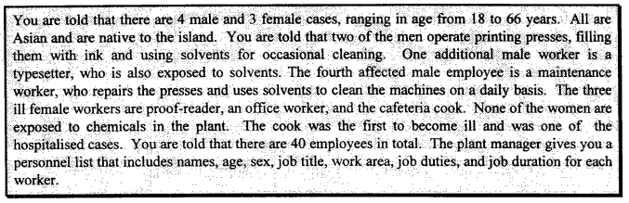

- What are your initial hypotheses about the cause of the illness?

- What information do you want next, and whom do you call?

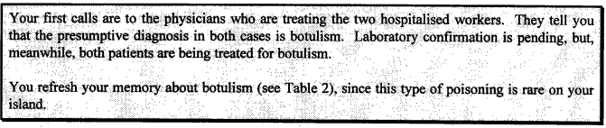
- How would you define your cases?

- What information would you want to collect next and how would you obtain it?

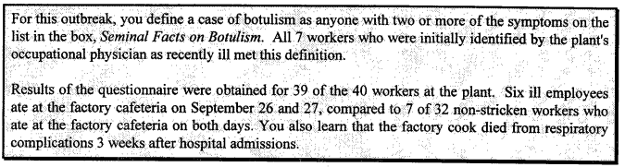

- How would you use the information from the questionnaire? How would you proceed to find out whether the disease was related to eating at the cafeteria?

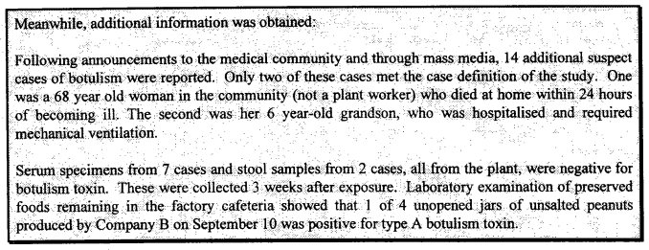

- How can you explain the occurrence of botulism in the community?

- How do you interpret the results of the serum and stool tests?

- What steps do you take to protect the health of the public?

Epilogue
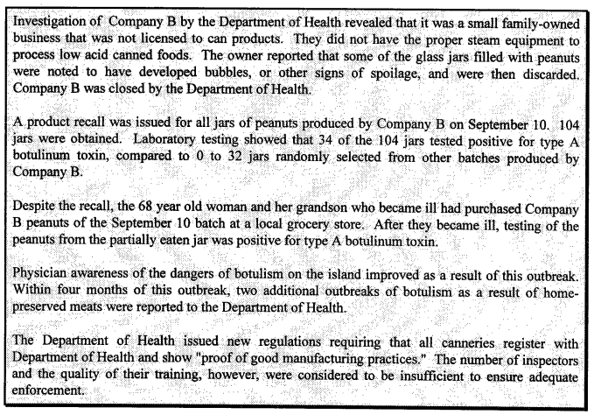

Appendices

