company policy toward reverse logistics
Alena KLAPALOVÁ
Mária KRÁLOVÁ
Masaryk University, Faculty of Economics and Administration, Lipová 41a, 60200 Brno, Czech Republic, e-mail: klapalov@econ.muni.cz, kralova@econ.muni.cz

Abstract

The paper deals with the results of questionnaire survey examining the character of companies’ policies towards management of reverse flows logistics, namely innovativeness of policy related to the reasons of involvement to manage reverse flows and to the planning system of reverse logistics. Answers from the informants and respondents from 150 Czech companies were analysed with the employment of statistical methods (frequencies, contingency tables and Man – Whitney test) to explore the potential differences among companies having more or less innovative policy when managing reverse flows. The results show that the involvement of reverse flows in planning and perceived driving forces to manage reverse logistics is linked with the policy character. The extent of policy innovativeness separate companies in case of following reasons: speeding up the flow in the distribution channel, assets recovery, competition and value retrieval but no significant differences were detected in case of customer services offering and satisfaction, in case of productivity improvement or in case of cost reduction when analysing the reasons for reverse flows involvement.

Key words

Policy, reverse logistics, reasons of interest, planning

introduction
Managers of probably every organization or company in this world must occupy and cope with some returns or reverse flows, regularly, sporadically or incidentally. Frequency is one issue from many others that can have impact on concrete manifestation of managers´ perceptions of returns importance reflected in decision making. Returns can emerge both in the internal as well as external environment of companies. They can copy the stream of value chain flowing straight back or their route can be tortuous. Companies themselves can be the initiator of the external returns flow origin – towards suppliers – and in some cases also towards customers (e.g. so called product recall, see for instance [1], [2]) or liberal return policy [3] and they can be receivers of returns from the external parties, too. Reverse flows can involve costs and sacrifices but if managed well they can bring various benefits and lead to revenues (e.g. [4] or [5]). There are various reasons why reverse flows arise but one fact is certain. It must be always decided what to do with them.
Decision making belongs to the complex of management tasks and it is grounded in particular level and character of knowledge and expectations. Decisions are linked to policy or policies that managers create and realized in the practice to achieve desired targets. It means that decisions concerning reverse flows should be a part of organizational policy.
Effective policies should react to the environmental forces and thus they reflect the flexibility of management. In other words, even policies can be described according the position of continuum from highly innovative to out-of-date or conservative. Reverse flows that are mostly the matter of reverse logistics area in companies score enormous growth due to product life cycle shortening, environmental and consumer regulations, resources shrinkages, savings needed, competition and/or rising power of customers. [6], [7], [8]
This paper presents some findings of the empirical research aimed at relations between the character of reverse flows policy in a sense of innovativeness and two closely connected issues: the reasons of involvement to manage reverse flows (or reasons of interest) and the time hierarchy of reverse logistics planning.

THEORETICAL BACKGROUND
Merriam-Webster dictionary defines policy as “a definite course or method of action selected from among alternatives and in light of given conditions to guide and determine present and future decisions” or as “a high-level overall plan embracing the general goals and acceptable procedures especially of a governmental body”. [9] Policy can perform as one of the driving forces or motive for managing reverse logistics both of the external stakeholders of a company (e.g. governmental policy and legislation or industry policy, competitors policy) [10] and of the company itself. Another view of policy regardless of the external forces implying from both definitions introduced above is that every company pursues its policy or specific types of policies to reach the objectives.
Since policy is the fundamental instrument for future direction of company assisting to sustain and improve competitiveness, it should be adequately flexible and reacts to the changes in the environment or be even proactive. Thus a company policy can be characterized on the continuum from very innovative to very conservative and can be very different when dealing with various areas of interest and knowledge of managers. Innovative policy - not only in the frame of reverse logistics - means to introduce innovations into processes and activities, organization, responsibilities, tangible resource, inputs etc. and depends on the strategic stance of the decision makers in companies. [11]
Innovations can have technological or technical and administrative, organizational or managerial form. Technological innovation refers directly to the processes of value creation, it means to processes that are applied to innovations in products or service offering while managerial innovations cover new strategies and reorganization, new procedures, acquiring new resources for technological innovation being realized and new policies.[12] [13] Hence innovation policy means “a set of policy actions to raise the quantity and efficiency of innovative activities, whereby “innovative activities” refers to the creation, adaptation and adoption of new or improved products, processes, or services…… to increase productivity, profits or market share, with the ultimate goal to increase their competitiveness in the long run”. [14, p. 9] The extent and level of innovation policy innovativeness is determined by resources and capabilities of company and by the competences of managers and their ability to recognize opportunities and threats coming from the environment and strengths and weaknesses of company, in other words by the above mentioned strategic stance.
Although companies probably had to deal with returns from the beginning of exchanges and business, the rate of speed and volume of flows running backwards the supply and value chains rises enormously rapidly during last two or three decades. [15] [16] Excellent leaders managing companies take full advantage of this situation and try to set reverse logistics programs and effective policy making. Reverse logistics is even more complex process than forward logistics with some specificities that require proper attention and proper resources and more demanding planning. [17] Among all for instance Gooley states that reverse logistics should be part of the overall business strategy. [18] The objectives of sustainable competitiveness are involved in strategic plans in comparison to actual tasks comprehended in operative planning.
Character of reverse logistics and character of innovation policy and innovative management leads to formulation of research question: How is the innovativeness of reverse logistics policy related to the reasons of involvement to manage reverse flows and to the planning hierarchy of reverse logistics?

3. METHODOLOGY

To find answers to the research question we analysed data of questionnaires filled in by managers of 150 companies doing business in the Czech Republic. For the purpose of presented paper we selected only three questions from all 23 involved in questionnaire. The extent of policy innovativeness was measured with one scale question with 7-point scale where 1 means very conservative policy and 7 means very innovative policy. For discovering driving forces (reasons for interest) respondents were asked to indicate drivers from 12 examples introduced in the list. Respondents were allowed to tick as many drivers as needed. For the purpose of this paper we analyse every individual driving force. 5 variables (namely: 1 overall business strategic plan, 2. plan of individual business function, 3. tactical plan, 4. operative plan, 5. no special plan – reverse logistics is managed ad hoc) showing if or if not reverse logistics is incorporated into some type of plan are binary variables.

Research question led to the following two hypotheses:

H1: There are statistically significant differences concerning types of driving forces/reasons of interest acknowledged by managers in the sample when analysing the extent of reverse logistics policy innovativeness;

H2: There are statistically significant differences concerning types of reverse logistics planning involvement when analysing the extent of reverse logistics policy innovativeness.

For the hypothesis verification frequencies were calculated and contingency tables and Mann-Whitney test was employed. Data were coded and analyzed in SPSS v.18.

4. RESULTS
4.1 Reverse logistics policy innovativeness and driving forces/reasons of interest for reverse logistics management
The ranking of driving forces according the frequencies and relative frequencies of positive answer is introduced in Graph No. 1:
Graph No. 1: Frequencies and relative frequencies of driving forces for reverse logistics management
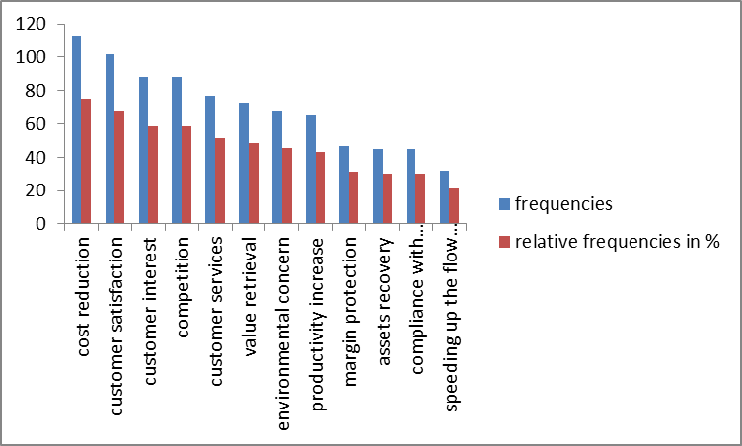
Graph shows that cost reduction is the most frequently driving force (75,3%) for companies to deal with reverse logistics. This is the internal driving force that is natural for business. Four external driving forces rank next – three are connected with customer where the highest relative frequency was found with customer satisfaction (68,0%) and one reason for interest is related to competition. Customer interest and competition can be termed as reactive. The rest 7 driving forces were mentioned in less than 50% of answers with value retrieval ranking just below the line of half (48,7%). The last three driving forces reached 30% of answers (assets recovery and compliance with the governmental requirements) and the issue of both internal and external matter - speeding up the flow in distribution channel - ranks last with the share of only 21,3%.
The split of answers to the question of reverse logistics extent of innovativeness indicates that 43,3% (65) of companies are rather very conservative (points 1 to 3 on the 7-points scale), 36,7% (55) of companies pursue policy with mixed character – it is either not conservative not very innovative (points 4 and 5 on the scale) - and the rest of companies (20,0% = 30 companies) apply very innovative policy
If we compare answers searching for driving forces with the answers to the question inquiring how much is companies´ reverse logistics policy innovate, the findings are as following (see also the Graph No. 2 and 3):
a) for the most innovative companies (point 7 on the scale):
- margin protection (10,6%), assets recovery (8,9%), speeding up the flow in distribution channel (6,5%) and customer interest (6,2%) belong to driving forces with the highest percentage;
- cost reduction (4,4%), compliance with governmental requirements (4,4%), productivity increase (4,6%) and customer satisfaction (4,9%) are driving forces with the smallest share of answers.
On the contrary
b) for the most conservative companies (point 1 on the scale):
- competition (6,8%), cost reduction (6,2%) and customer satisfaction (5,9%) are driving forces with the highest percentage;
- speeding up the flow in distribution channel (0,0%), value retrieval (1,4%) and environmental concern (1,5%) are driving forces with the smallest share of answers.
These are results for companies with just opposite evaluation of reverse logistics policy. If we joint answers and companies into groups using the logic that points on scale 1 and 2 would still comprehend companies with very conservative policy and points on scale 6 and 7 for would encompass companies with very innovative policy, the results are slightly different (see also the Graph No. 2 and 3). Assets recovery (35,6%), margin protection (31,9%) and speeding up the flow (28,1%) belong still to the driving forces with highest percentage for the most innovative companies but compliance with governmental requirements transfers from the group with the smallest share among this group (26,6%). Customer satisfaction (20,6%) and cost reduction (20,4%) stay in the group of forces with highest share for companies with very conservative policy, but compliance with governmental requirements (24,4%) and environmental concern (20,6%) can be added.
Graphs No. 2 and 3: Extent of reverse logistics policy innovativeness and driving forces for reverse logistics – differences between conservative and innovative companies
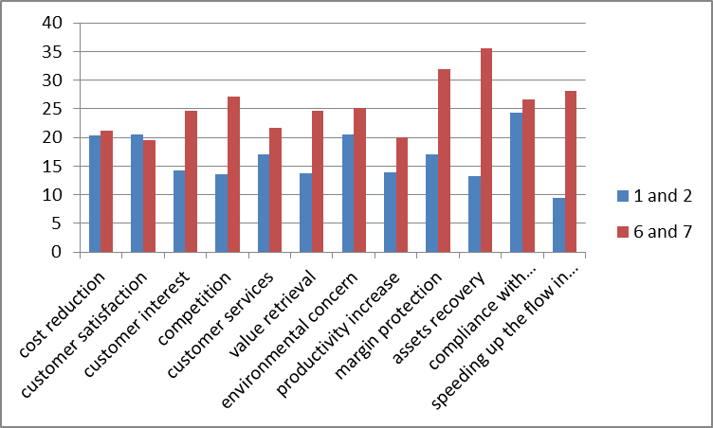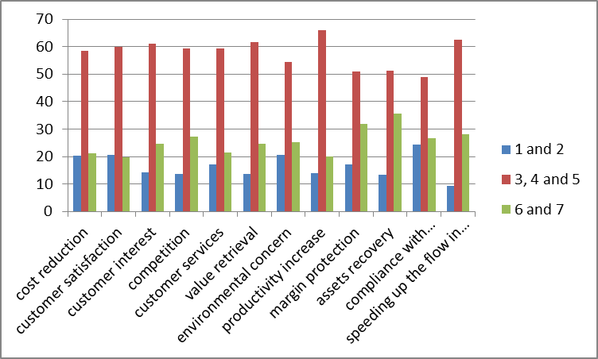
Mann-Whitney test ascertained statistically significant differences for competition (U=1040,50, p=0,000), speeding up the flow in distribution channel (U=697,00, p=0,001), value retrieval (U= 1103.50, p=0,002), assets recovery (U= 811,560, p=0,003) and customer interest/customer pressure (U= 943,50, p=0,017)
4.2 Reverse logistics policy innovativeness and reverse logistics planning
Differences confirmed as statistically significant were found also when analysing the involvement of reverse logistics into the planning system related to the extent of reverse logistics policy innovativeness. Considerable distinctions are especially with strategic plans and ad hoc planning if we compare two groups of companies (very conservative policy – points 1 and 2 on the scale) and very innovative policy (points 6 and 7 on the scale). Only few companies with conservative planning of reverse logistics involve reverse logistics into the overall business strategic and functional strategic plans and on the contrary very few companies with very innovative planning do not plan reverse logistics at all or just ad hoc (see also the graphs No. 4 and 5).
Graphs No. 4 and 5: Extent of reverse logistics policy innovativeness and reverse logistics planning – differences between conservative and innovative companies
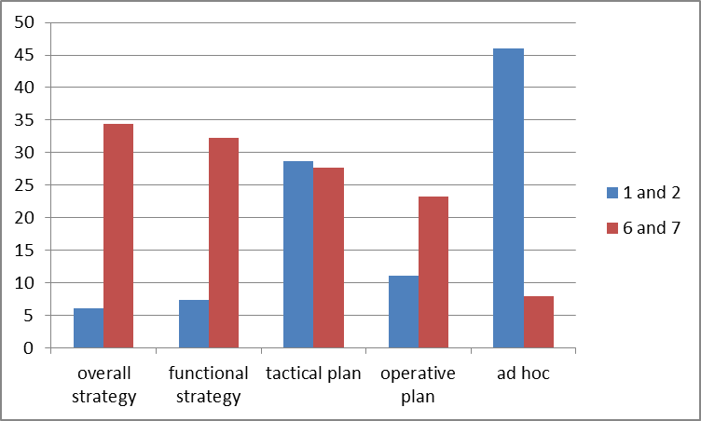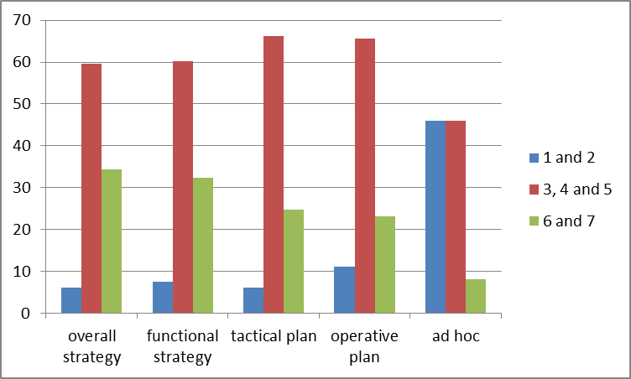
Results from the Mann-Whitney test confirm the above written findings and support statistically elaborated significance of differences (p=0,000 in all cases) even with tactical and operative plans.

5. LIMITATIONS, DISCUSSION AND CONCLUSIONS
Although only simple statistics and simple bivariate analysis has been applied and only three variables were evaluated, the results confirm both hypotheses. The different extent of innovativeness of reverse logistics policy is related to different involvement of reverse logistics into the planning system and to different driving forces for managing reverse logistics.
The most distinct differences among companies were revealed in the case of ad hoc, overall business strategic and tactical planning of reverse logistics activities and the extent of innovativeness reverse logistics policy and when concerning driving forces, the biggest differences were detected with the assets recovery (difference in relative frequencies between the two most innovative and two most conservative groups of companies is 22,3), speeding up the flow in distribution chain (18,7), margin protection (14,8), competition (13,6) and value retrieval (11,00) in favour of the most innovative companies. In other words, companies that are very innovative (points 6 and 7 on the scale) introduced these driving forces more often. On the contrary almost no distinction was found with cost reduction and customer satisfaction. Both cases should be of fundamental interest to managers, so this finding only confirms well-known reality.
Results also demonstrate that the approach of manager to reverse logistics has improved since the year 2005 when the first existing empirical survey on reverse logistics in the Czech Republic was realized. [18]
On the base of intensive literature review and in accordance with some authors (for instance in the case of proactivity and reactivity see [11]) we can confirm that issue of innovative versus conservative and reactive versus proactive behaviour in reverse logistics management has received very little attention in the literature what is quite surprising on one hand and on the other hand this fact offers several research opportunity that have both theoretical and managerial implications. Among all the extent of innovativeness can be linked to various performance measures of companies to investigate the potential relation between innovativeness and performance. In other fields of theory the relation of two concepts belongs to broadly discussed topic. The Findings can also serve as the interesting ideas for thinking about potential changes in own reverse flows policy and planning and they may stimulate to involve the question of value and asset recovery into reverse policy creation.
Besides the mentioned limitations with statistical analysis also the character of questions (closed) and quantitative character of analysis make survey quite narrow-focused. Planning on one hand and reverse logistics on the other hand are both very complex issues of management and many other research questions could be investigated within them.

ACKNOWLEDGMENT
This paper could be prepared thanks to the existence of the Specific Research Project funded by Masaryk University in Brno, Czech Republic and by Faculty of Economics and Administration of Masaryk University.

LITERATURE
- MURPHY, P. A preliminary study of transportation and warehousing aspects of reverse distribution. Transportation Journal, 1986, Vol. 25 No. 4, pp. 12-21.
- RITCHIE, L., BURNES, B., WHITTLE, P. HEY, R. The benefits of reverse logistics: the case of Manchester Royal Infirmary Pharmacy. International Journal of Supply Chain Management, 2000, Vol. 5 No. 5, pp. 226-34.
- ROGERS, D.S., TIBBEN-LEMBKE, R.S. Going backwards: Reverse Logistics Trends and Practices. Pittsburgh: Reverse Logistics Executive Council, 1998. 275 p.
- STOCK, J, SPEH, T., SHEAR, H. Many happy (product) returns. Harvard Business Review, 2002, Vol. 80, No. 7, pp.16-17.
- MOLLENKOPF, D., FRANKEL, R., RUSSO, I. Creating value through returns management: Exploring the marketing–operations interface. Journal of Operations Management, 2011, No. 29, pp. 391–403.
- DE BRITO, M. P. Managing reverse logistics or reversing logistics management, ERIM Ph.D. Series Research in Management, 35, Erasmus University Rotterdam. 2004. p. 325.
- DOWLATSHAHI, S. An effective implementation of reverse logistics. Interfaces, 2000, Vol. 30, No. 3, pp. 146 – 155.
- MEADE, L., SARKIS, J., PRESLEY, A. The Theory and Practice of Reverse Logistics. International Journal of Logistics Systems and Management, 2007, Vol. 3, No. 1, pp. 56-84.
- Merriam Webster online Dictionary. Available at: http://www.merriam-webster.com/dictionary/policy
- JAYRAMAN, V., LUO, Y. Creating competitive advantages through new value creation: a reverse logistics perspective. Perspectives - Academy of Management. Academy Of Management, 2007, Vol. 21, No. 2, pp. 56-73.
- ÁLVAREZ-GIL, M. J, BERRONE, P., HUSILLOS, F. J., LADO, N. Reverse logistics, stakeholders´ influence, organizational slack, and managers´ posture. Journal of Business Research, 2007, Vol. 60, No. 5, pp. 463–473.
- TUOMINEN, S., HYVÖNEN, M. Entrepreneurial innovations, market-driven intangibles and learning orientation: critical indicators for performance advantages in SMEs. International Journal of Management and Decision Making, 2006, Vol. 7 No. 6, pp. 643 – 660.
- JIMENEZ-JIMENEZ, D., CEGARRA-NAVARRO, J. The performance effects of organizational learning and market orientation. Industrial Marketing Management, 2007, Vol. 36, No.6. pp. 694–708.
- COWAN, R., van de PAUL, G. Innovation Policy in a Knowledge-Based Economy. Publication no. EUR 17023 of the Commission of the European Communities, Luxembourg. ECSC-EC-EAEC Brussels-Luxembourg, 2000. p. 99.
- DEKKER, R., FLEISCHMANN, M., INDERFURTH, K., Van WASSENHOVE, L. N. Reverse Logistics: Quantitative Models for Closed-Loop Supply Chains. Berlin: Springer-Verlag, 2004. ISBN 3540406964. p. 444.
- PriceWaterhouseCoopers. Reverse Logistics. How to realize an agile and efficient reverse chain within a consumer electronics industry. 2008. Available at: http://www.remanufacturing.org.uk/pdf/story/1p293.pdf
- GUIDE Jr., V. D. R, JAYRAMAN, V., LINTON, J. D. Building contingency planning for closed-loop supply chains with product recovery. Journal of Operations Management, 2003, No. 21, pp. 259-279.
- ŠKAPA, R. Reverzní logistika. Brno: Masarykova univerzita, 2005. ISBN 80-210-3848-9. s. 82.

